BenchSight
A Deployable GPU Benchmarking and Profiling Platform
for CUDA Primitives and Deep Learning Kernels
Project Report Template
Prepared for: ________________________________
Course: _____________________________________
Group Members: ______________________________
Emails: _____________________________________
Instructor / TA: _____________________________
Submission Date: _____________________________
How to use this template
• Keep the narrative sections as-is or lightly edit them to match your implementation.
• Replace bracketed placeholders and empty table cells after you complete experiments.
• Insert dashboard screenshots, benchmark plots, and profiler images where indicated.
• Delete any optional subsections that your team does not implement.

Abstract
BenchSight is proposed as a deployable GPU benchmarking and profiling platform designed to standardize how representative CUDA and deep learning workloads are executed, measured, compared, and presented. The project addresses a practical gap in performance engineering workflows: many kernel benchmarks are performed with ad-hoc scripts, inconsistent timing methodology, scattered outputs, and weak experiment tracking. BenchSight organizes this process into a reusable software system with a web dashboard, a backend API, a GPU benchmark worker, and persistent experiment storage. The workload suite covers both classical GPU primitives and modern deep learning kernels, enabling the platform to serve as both an educational benchmark framework and a practical engineering tool.
This report is written as a complete project report template. It contains the project rationale, proposed system design, implementation plan, evaluation methodology, and placeholders for results that can be filled in after experimentation. The document is intentionally written so that it already reads like a complete report, while still leaving room for inserting measured data, screenshots, plots, and discussion based on the final implementation.

1. Introduction
GPU performance optimization is important in high-performance computing, machine learning systems, scientific workloads, and real-time inference pipelines. However, performance analysis is frequently performed through one-off scripts or disconnected profiling sessions. This leads to inconsistent benchmark conditions, poor repeatability, and difficulty when comparing different kernel implementations or optimization strategies.
BenchSight is motivated by the need for a cleaner and more deployable workflow. Instead of viewing benchmarking as a small utility task, this project treats it as a software product: users should be able to select workloads, launch controlled experiments, persist results, compare baseline and optimized implementations, and review profiler-friendly artifacts through one coherent interface. This report presents the system as a benchmark platform rather than as a collection of isolated kernels.
The intended contribution of the project is twofold. First, it provides a structured environment for reproducible evaluation of representative GPU workloads. Second, it demonstrates how systems, performance engineering, and lightweight deployment can be combined into a polished project suitable for a course deliverable, technical demonstration, or portfolio artifact.

2. Problem Statement
Performance work on GPU kernels is often done with informal scripts and loosely controlled conditions. Timing may be measured using host-side wall-clock methods, warmup may be missing, repeated runs may not be standardized, and outputs may be saved only as temporary console logs. Even when advanced profilers are used, the profiling session is often disconnected from benchmark metadata such as workload size, implementation choice, run count, and software version.
As a result, the process of performance comparison becomes fragile. It is difficult to answer basic engineering questions such as: Which implementation is faster? How stable is the latency distribution across repeated runs? Are the results reproducible? Can another user rerun the same benchmark configuration? Can benchmark results and profiling artifacts be stored and reviewed later? BenchSight addresses this workflow gap by packaging execution, storage, visualization, and comparison into a single project.

3. Why This Problem Matters
Reliable benchmark infrastructure matters because poor measurement practice leads directly to poor engineering conclusions. A claimed speedup may disappear when warmup is added. A kernel that appears fast in one manual run may show unstable tail latency under repeated trials. A profiling timeline without run metadata is difficult to interpret and even harder to compare against future versions.
This problem is also educationally important. Students often implement optimized kernels but spend comparatively little time designing a correct evaluation pipeline. By building BenchSight, the project emphasizes that benchmarking methodology is part of the technical contribution, not merely an afterthought. This makes the resulting work stronger both academically and professionally.

4. Existing Approaches and Limitations
Typical approaches to GPU benchmarking fall into three broad categories. The first is the ad-hoc benchmark script, which is easy to create but usually lacks repeatability, data management, and clean visualization. The second is the use of professional profiling tools, which provide deep kernel insight but do not automatically organize experiments into a reusable benchmark product. The third is the use of large open-source benchmark repositories, which are often powerful but can be too broad or too complex for a small team project.
BenchSight is positioned between these extremes. It does not attempt to replace advanced profiling tools, nor does it aim to become a full-scale industry benchmark suite. Instead, it provides a lightweight, deployable layer above benchmark execution: a user-facing dashboard, an API, persistent storage, and a carefully chosen workload suite. This scope keeps the project realistic while still making it substantially more useful than a collection of local scripts.

5. Proposed Solution
The proposed solution is BenchSight, a deployable GPU benchmarking and profiling platform for representative CUDA primitives and deep learning kernels. The system exposes a user-facing dashboard through which benchmark configurations can be selected and launched. A backend service receives the request, dispatches the workload to a GPU benchmark worker, aggregates the resulting timing statistics, stores the metadata and outputs in a database, and returns the results to the frontend for visualization.
The system is designed around repeatability and comparability. Each benchmark run stores not only the measured metrics but also the benchmark parameters, workload category, implementation version, date of execution, and artifact references. This gives the project a product-like structure: users can compare old and new runs, export results, and maintain a structured experiment history.
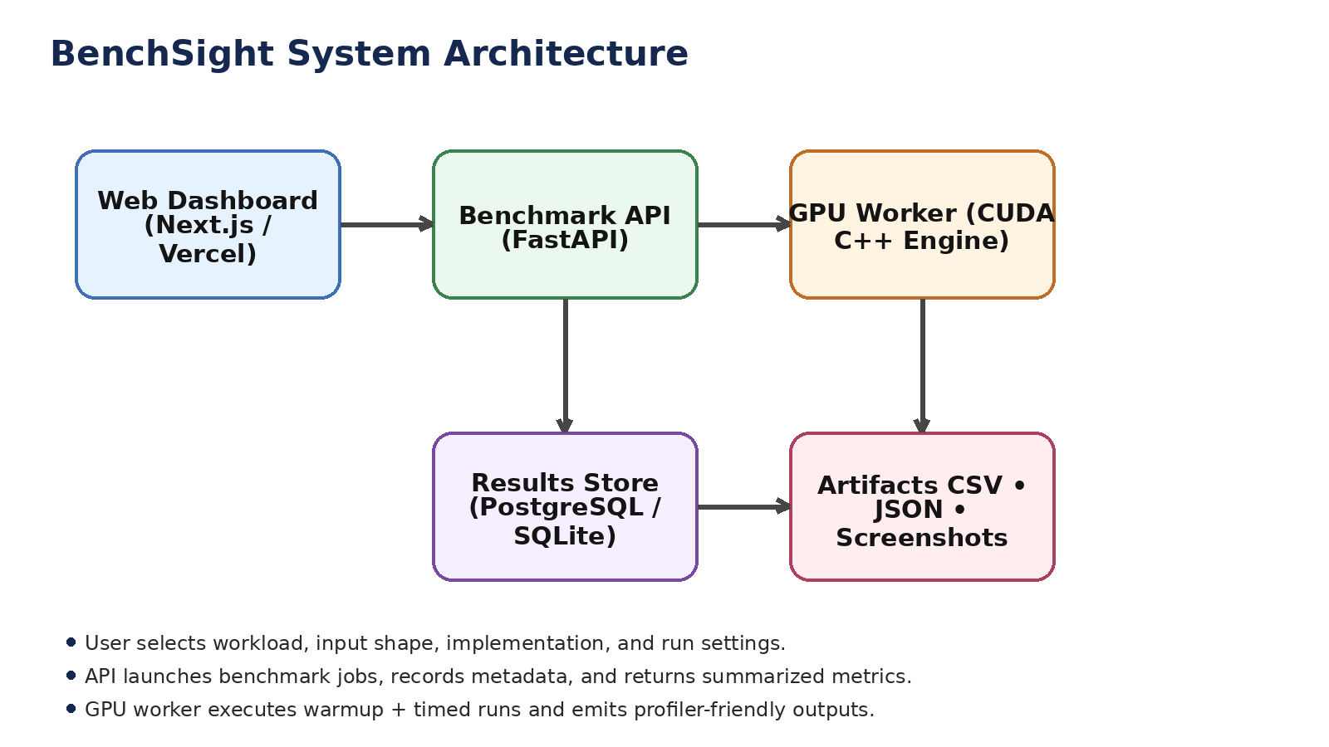
Figure 1. High-level system architecture of BenchSight.

6. Aim and Objectives
Aim: To design and implement a deployable benchmarking platform that standardizes the execution, measurement, storage, and visualization of representative GPU workloads.
• Implement a benchmark suite containing representative workloads from both classical GPU primitives and deep learning kernels.
• Provide baseline and optimized implementations for selected workloads and support side-by-side comparison.
• Measure performance using consistent methodology, including warmup iterations and repeated timed runs.
• Store experiment metadata and benchmark outputs in a structured database for later analysis.
• Visualize metrics such as average latency, median latency, p95 latency, throughput, and relative speedup through a dashboard.
• Support profiler-friendly execution so that timeline views and low-level analysis can be connected back to benchmark runs.
• Package the system as a deployable software project suitable for technical demonstration and portfolio use.

7. Scope of the Project
The project is intentionally designed to be broader than a toy benchmark while still remaining achievable within a course setting. Its primary scope includes a web-accessible dashboard, a backend API, a GPU execution engine, a persistent experiment store, a workload suite, and a clear methodology for collecting and presenting performance results.
The project does not aim to become a fully general cluster scheduler, a multi-tenant cloud platform, or a replacement for vendor profiling software. Authentication, job queues, autoscaling, and large-scale distributed benchmarking may be mentioned as future work but are not required for the core contribution. The main focus is a clean and polished single-system benchmark product.

8. Workload Suite
To make the platform meaningful, BenchSight includes workloads that span multiple GPU performance patterns. Classical kernels provide coverage for memory-bound and synchronization-heavy behavior, while deep learning kernels make the platform relevant to modern AI workloads.
Category | Workload | Type | Planned Implementations | Purpose
Primitive | Vector Add or Copy | Memory-bound | Baseline + light optimized | Calibration and sanity-check workload
Primitive | Parallel Reduction | Synchronization-heavy | Baseline + optimized | Classic speedup and tail-latency study
Primitive | Prefix Sum / Scan | Parallel primitive | Reference + optional optimized | Common building block in GPU pipelines
Primitive | Histogram | Atomic / contention-heavy | Reference + optional optimized | Shows scalability under write conflicts
DL Core | Matrix Multiplication (GEMM) | Compute-heavy | Baseline + tiled optimized | Core workload for linear algebra / DL
DL Vision | 2D Convolution | Compute + memory reuse | Baseline + optimized | Relevant to CNN inference
DL Transformer | LayerNorm or RMSNorm | Reduction + normalization | Baseline + optimized | Representative transformer kernel
DL Transformer | Softmax | Reduction + exponentiation | Baseline + optimized | Softmax / classifier / attention workload
DL Transformer | Scaled Dot-Product Attention | Modern fused workload | Reference + advanced optimized | High-impact transformer benchmark
Table 1. Proposed benchmark workload suite.

9. System Architecture
The platform is organized into four main layers: frontend, backend, benchmark worker, and storage. The frontend provides the interactive interface for configuring and reviewing runs. The backend acts as the control plane, validating input parameters, launching jobs, and exposing run history and comparison endpoints. The benchmark worker performs the actual GPU execution and emits measurement outputs. The storage layer persists results, configurations, and references to generated artifacts.
This architecture is suitable for deployment because the frontend can be hosted independently from the GPU execution backend. A dashboard hosted on a static or server-rendered frontend platform remains accessible even when benchmarks are not actively running, while the API and worker can execute on a GPU-capable machine. This separation makes the project more realistic and better aligned with modern software deployment practice.
Layer | Suggested Stack | Responsibility
Frontend | Next.js dashboard | Run configuration, history, comparison views, charts
Backend API | FastAPI service | Receive requests, dispatch jobs, aggregate results, expose endpoints
GPU Worker | CUDA C++ benchmark engine | Execute workloads, perform warmup, collect timing data
Storage | PostgreSQL / SQLite | Store benchmark metadata, metrics, and artifact paths
Artifacts | CSV, JSON, screenshots, profiler outputs | Support reproducibility and reporting
Table 2. Suggested implementation stack.

10. Benchmark Methodology
BenchSight treats benchmark methodology as part of the technical contribution. Each run should be executed under controlled conditions and recorded with sufficient metadata to support later analysis. The methodology is intended to be consistent across workloads so that comparisons remain fair and repeatable.
Each benchmark configuration should include the workload name, input shape or tensor dimensions, implementation version, launch parameters such as block size, number of warmup runs, number of timed runs, and the execution date. The benchmark engine should execute a warmup phase before timed trials. Timed trials should be repeated enough times to produce summary statistics that are more robust than a single run.
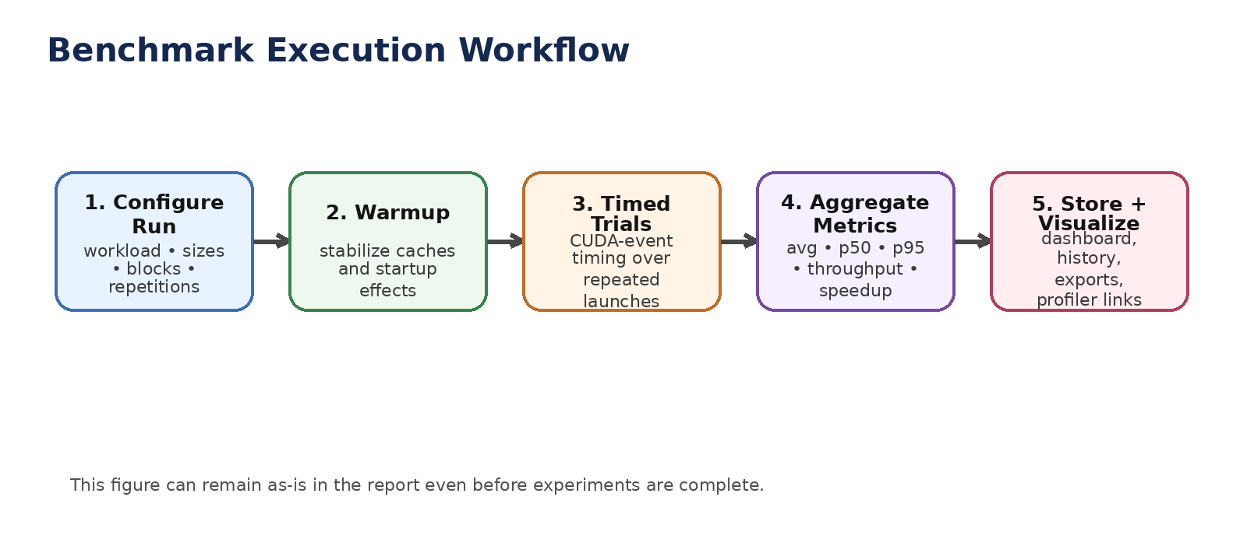
Figure 2. Standard execution workflow used for each benchmark run.
At a minimum, the project should report average latency, median latency, p95 latency, throughput, and speedup relative to a baseline implementation. Where appropriate, additional metadata such as arithmetic intensity, tensor shape, or occupancy-related notes may be included in the discussion. The exact number of repetitions can be adjusted to fit development constraints, but the final report should state the chosen values explicitly.
Placeholder for final methodology details: [Insert exact values for warmup count, timed trials, input sizes, tensor shapes, hardware details, and software configuration once experiments are complete.]

11. Implementation Details

11.1 Frontend
The frontend should provide a compact but polished interface for selecting workloads and reviewing results. A good user flow is: choose workload category, choose implementation variant, select dimensions and repetition counts, launch a run, inspect the resulting metrics, and compare current output with prior stored runs. The dashboard should also include a history page so that the project feels like a benchmark product rather than a one-time demo.

11.2 Backend API
The backend should expose endpoints for launching benchmarks, listing historical runs, retrieving detailed metrics, and exporting results. This API-oriented design keeps the system modular and supports future extensions such as asynchronous job dispatch or multiple benchmark workers. The report can briefly describe the major endpoints even if the implementation is lightweight.

11.3 Benchmark Worker
The GPU benchmark worker is responsible for the actual benchmark logic. It should parse the run configuration, dispatch the chosen workload and implementation, execute warmup and timed trials, compute summary statistics, and serialize outputs. A clean separation between worker logic and frontend/backend logic makes the project easier to reason about and easier to present.

11.4 Database and Artifact Storage
Each benchmark run should have a unique run identifier and associated metadata. The results store should retain enough information to reconstruct what was executed and under what settings. In addition to numeric metrics, the project may store paths to generated CSV files, JSON summaries, benchmark screenshots, and profiler images or reports.

11.5 Deployment
The deployment story is a key part of the project’s value. The frontend should remain accessible independently of benchmark execution, while the backend and worker operate on a machine with GPU access. The project should be packaged with clear setup instructions so that another user can understand the architecture and rerun the project. A deployment figure or screenshot may be added here if available.
Placeholder for final implementation note: [Insert actual repository structure, endpoint names, worker invocation method, and deployment commands after coding is complete.]

12. Experimental Design
The experiments should be organized so that each major workload category demonstrates a meaningful comparison. For some workloads, a simple baseline versus optimized comparison is sufficient. For more advanced kernels, the project may compare multiple implementations or use a reference path alongside an optimized variant. The experimental design should remain focused on clarity over volume; a small number of carefully chosen comparisons is stronger than many shallow runs.
Workload | Implementation A | Implementation B | Input Sizes | Primary Metric | Status
Reduction | Baseline | Optimized | [fill] | Latency / speedup | Planned
GEMM | Baseline | Tiled optimized | [fill] | Throughput / speedup | Planned
Conv2D | Baseline | Optimized | [fill] | Latency / stability | Planned
LayerNorm / RMSNorm | Baseline | Optimized | [fill] | Latency / p95 | Planned
Softmax | Baseline | Optimized | [fill] | Latency / p95 | Planned
SDPA (optional advanced) | Reference | Optimized / fused | [fill] | Latency / memory behavior | Optional
Table 3. Planned experimental matrix.

13. Evaluation Metrics
The report should evaluate benchmark runs using metrics that are directly interpretable and useful for comparison. Average latency shows overall performance across repeated runs, while p50 and p95 capture central tendency and tail behavior. Throughput helps compare workloads that process varying amounts of work per run. Relative speedup summarizes the practical value of an optimized implementation compared with its baseline.
Metric | Meaning | How to discuss it in the report
Average latency | Mean run time across timed trials | Use for primary comparison between versions
p50 latency | Median run time | Shows typical behavior less affected by outliers
p95 latency | Tail latency | Useful for stability and worst-case tendency
Throughput | Work completed per unit time | Useful for GEMM, convolution, and larger tensor workloads
Speedup | Baseline time divided by optimized time | Use to summarize optimization impact
Table 4. Core evaluation metrics.

14. Results
This section is intentionally structured so that measured results can be inserted later without rewriting the report. Each subsection should present one workload or one group of related workloads, followed by a concise interpretation. Use tables for numeric summaries and figures for the most important comparisons.

14.1 Aggregate Benchmark Summary
Workload | Version | Avg (ms) | p50 (ms) | p95 (ms) | Throughput | Speedup
Reduction | Baseline | [ ] | [ ] | [ ] | [ ] | 1.00x
Reduction | Optimized | [ ] | [ ] | [ ] | [ ] | [ ]
GEMM | Baseline | [ ] | [ ] | [ ] | [ ] | 1.00x
GEMM | Optimized | [ ] | [ ] | [ ] | [ ] | [ ]
Conv2D | Baseline | [ ] | [ ] | [ ] | [ ] | 1.00x
Conv2D | Optimized | [ ] | [ ] | [ ] | [ ] | [ ]
Table 5. Fill in this summary after experiments are complete.
Interpretation placeholder: [Insert a short paragraph explaining which workloads showed the largest gains, which workloads remained memory-bound, and whether tail latency changed between baseline and optimized implementations.]

14.2 Workload-Specific Discussion
Suggested discussion structure: for each major workload, state the implementation comparison, report the measured metrics, and explain why the observed trend makes sense. For example, an optimized GEMM may show stronger gains due to shared memory tiling and data reuse, while a memory-bound vector operation may show smaller but still stable improvements.
Placeholder paragraphs:
[Reduction discussion]
[GEMM discussion]
[Conv2D discussion]
[LayerNorm / Softmax discussion]
[Optional SDPA discussion]

14.3 Dashboard and Profiler Artifacts
Insert one dashboard screenshot and one profiler screenshot here. These visuals help connect the software product to the benchmark methodology and make the final report more credible.
Insert screenshot placeholder
Dashboard comparison view / benchmark history / profiler image
Figure 3. Replace this placeholder with an actual dashboard or profiler screenshot.

15. Discussion
The discussion section should move beyond simply restating numeric results. It should explain what the results say about workload characteristics, benchmark methodology, and software design. If some optimized kernels show only modest gains, the report should explain whether this is due to memory bandwidth limits, small problem sizes, implementation complexity, or insufficient fusion opportunities. If some workloads show strong gains, the report should connect the improvement to the underlying optimization idea.
This section can also discuss the value of the platform itself. Even if not every workload achieves dramatic acceleration, the platform remains useful because it provides a structured and repeatable way to collect and compare GPU performance data. That framing is important: the contribution is both the benchmark product and the measured workload study.

16. Challenges and Limitations
Every realistic systems project has constraints. The final report should acknowledge them clearly. Possible limitations include a restricted set of workloads, a single-GPU test environment, a lightweight deployment model, or incomplete implementation of advanced workloads such as fused attention. Other limitations may include time constraints that prevented deeper tuning or the absence of multi-user features such as authentication and asynchronous scheduling.
These limitations should not be framed as failures. Instead, they should be positioned as boundaries of the current project scope and opportunities for future improvement. A concise and honest limitations section strengthens the report by demonstrating engineering judgment.

17. Future Work
Future work may extend BenchSight in several directions. On the systems side, the platform could support background job queues, user authentication, versioned benchmark configurations, or multi-GPU comparison. On the workload side, the suite could be expanded with additional kernels such as depthwise convolution, pooling, sparse operations, or more advanced attention variants. On the analysis side, the system could ingest profiler outputs automatically and compute richer summaries.
Another promising direction is regression tracking. The platform could flag when a supposedly optimized implementation becomes slower than an earlier version or when tail latency degrades unexpectedly. This would make the system more useful for iterative development rather than only final benchmarking.

18. Conclusion
BenchSight is framed in this report as a deployable GPU benchmarking and profiling platform rather than as a simple set of CUDA experiments. The project combines representative workload coverage, structured execution methodology, persistent result storage, and a user-facing dashboard for comparison and visualization. This combination gives the project technical depth, practical relevance, and a strong presentation story.
Once experiments are complete, the placeholders in this report can be replaced with measured results, workload-specific analysis, screenshots, and deployment details. At that point, the report will read as a complete end-to-end project document suitable for academic submission, technical review, and portfolio use.

Appendix A. Suggested Figures to Add After Experimentation
• A bar chart comparing baseline and optimized latency for the three main workloads.
• A speedup chart grouped by workload category.
• A dashboard screenshot showing run history and comparison filters.
• A profiler screenshot or timeline image for one optimized kernel.
• A deployment screenshot or architecture diagram with the final implementation stack.

Appendix B. Final Fill-In Checklist
□ Insert course name, group member names, and submission date on the cover page.
□ Replace all bracketed placeholders such as [fill], [Insert...], and [ ].
□ Add final hardware and software configuration used for experiments.
□ Populate benchmark summary tables with measured values.
□ Insert at least one dashboard screenshot and one benchmark/profiler figure.
□ Update the discussion section with actual observations from the results.
□ Delete any workloads or subsections that were not implemented.

