Problem Statement : Develop the application given below by using Design Patterns.
The Storage Explorer is a small application that is designed to use several design patterns together.

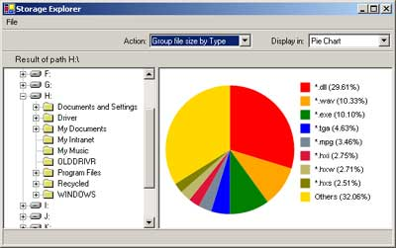
The idea of this application came when I needed an application similar to Windows Explorer that can show me the file size composition inside my storage. I want to know, for example, under the Program Files folder, which folder uses what size of space, including the numbers in percentage. I want also to know how big my mp3 total size in drive D compare to my jpg files. The information I want to see should look like this:
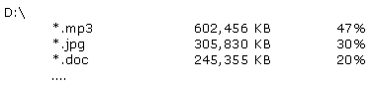
And this
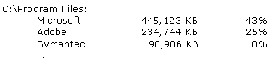
I need the information is presented in a chart to help me visualize the numbers as well.

