Project 6  
Date:31st Aug 2025

Using Terraform Crated Resources in Azure:  
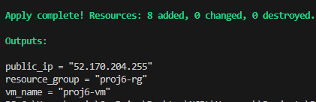

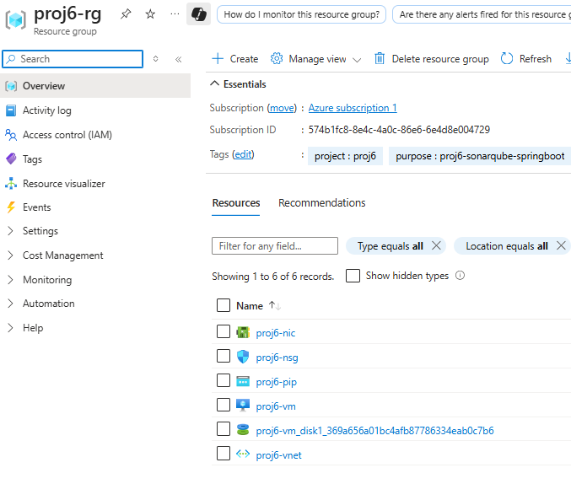

**Public: 52.170.204.255**

**SSH into VM using mobaxtream and installed Docker  
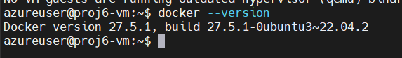**

**Install GIT  
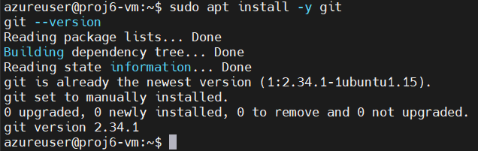**

**Install JDK  
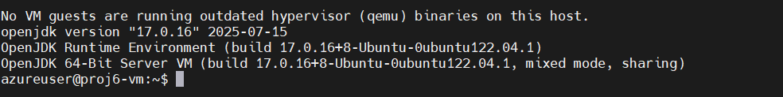**

**Install Maven  
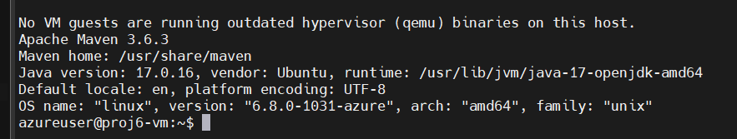**

**Installed AzureCLI  
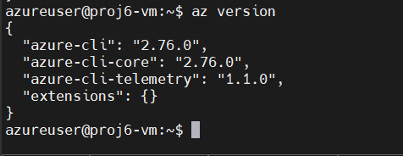**

**Sonarqube in Docker  
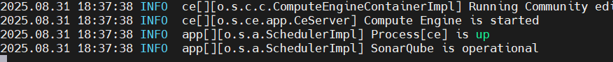**

**http://52.170.204.255:9000/projects/create  
  
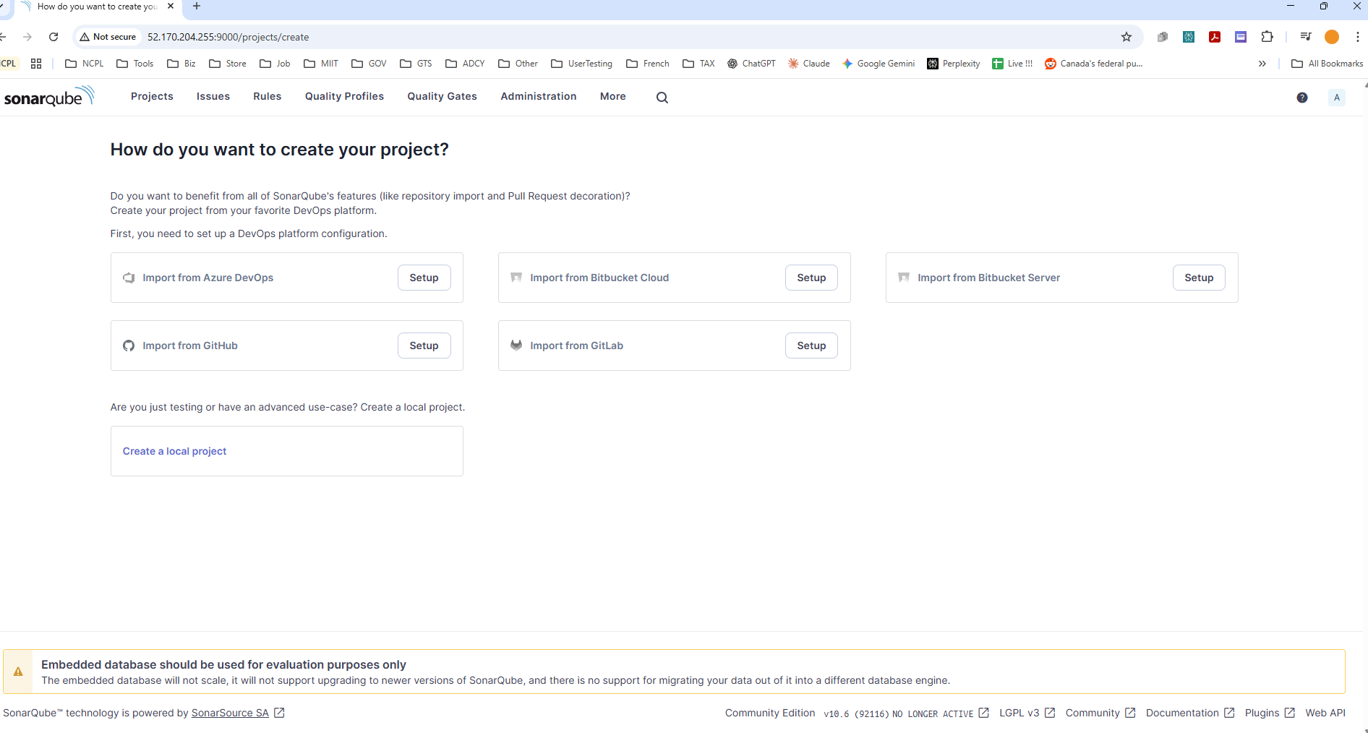**

**Run and Analysed Spring Boot Project with Maven + SonarQube**

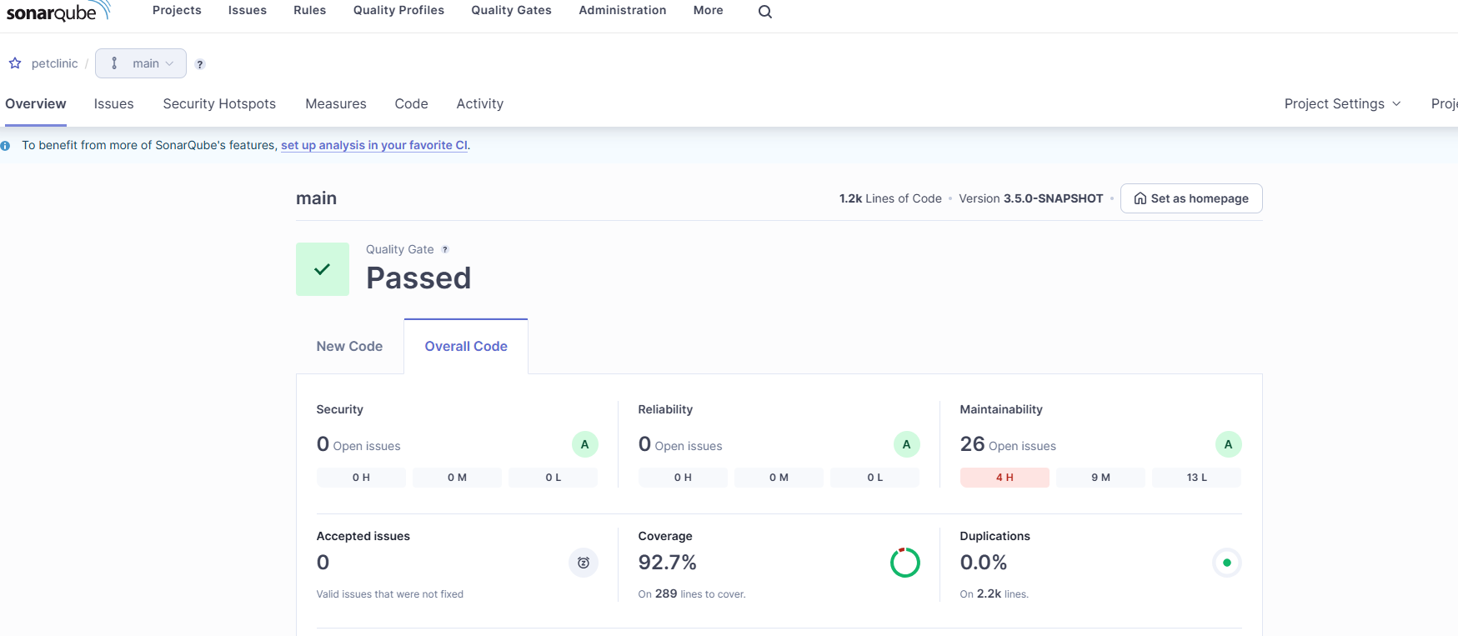

**Created .jar file  
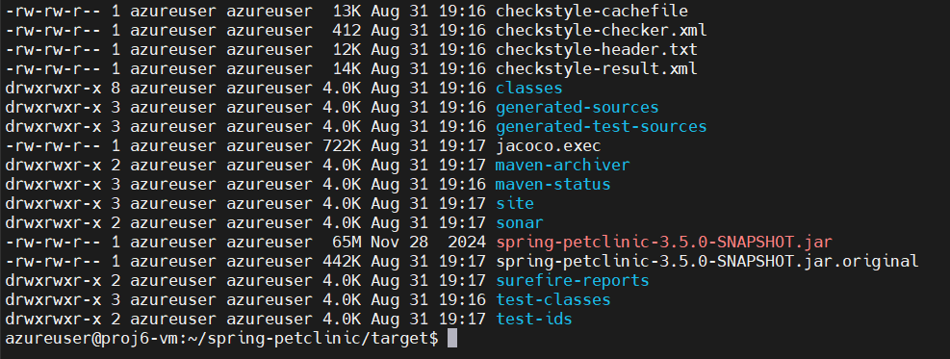**

**Deployed Webapp using Terraform**

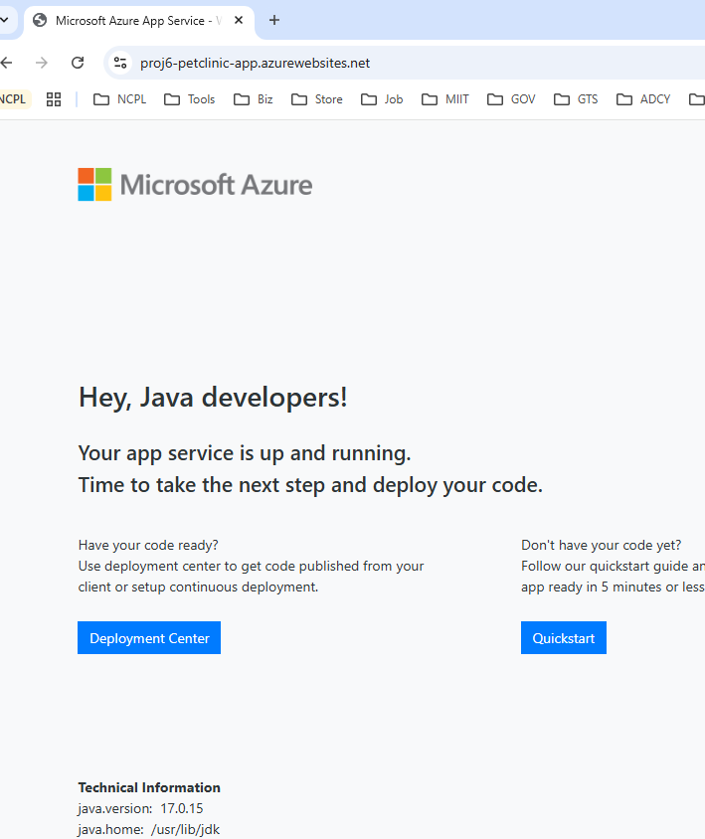

**Deployed from Powershell  
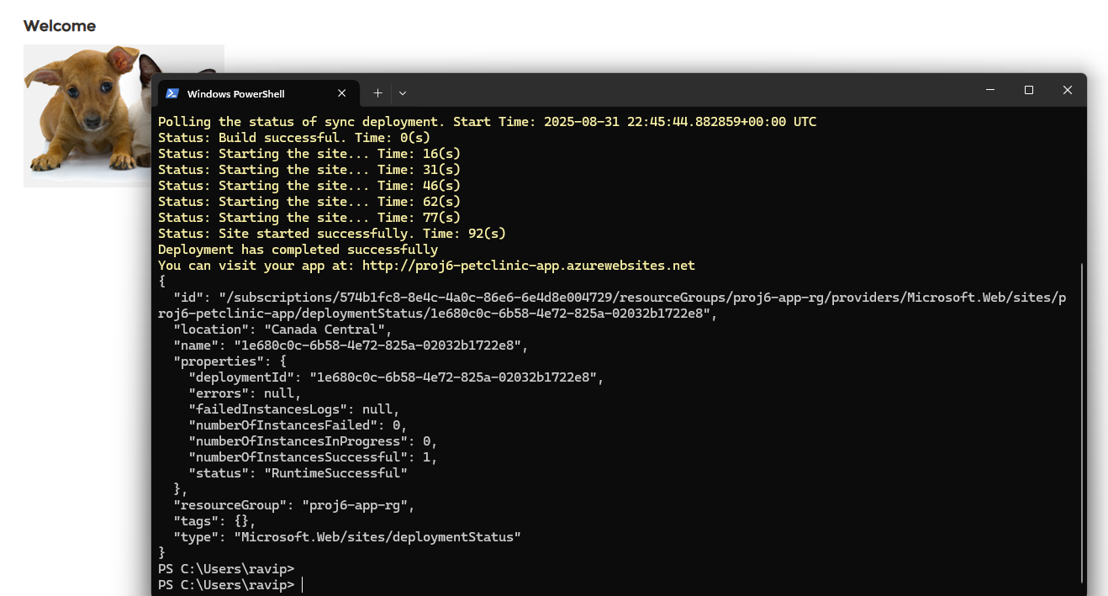  
Webapp is there now   
