Worksheet No. 7

Student Name: Ravi Ranjan Kumar UID: 25MCA20098
Branch: MCA (GENERAL) Section/Group: MCA- 1-A
Semester: II Date of Performance: 31/03/2026
Subject Name: Technical Training Subject Code: 25CAP-652

1.Aim/Overview of the practical:
Implementation of joins in PostgreSQL (inner join, left join, right join, self join and cross join)

2. Objectives:
Apply joins to a real-world database schema (e.g., Students, Courses, Enrollments, Departments)

3. Input/Apparatus Used:
    - PostgreSQL
- pgAdmin

4. Practical / Experiment Steps

1. Write queries to list students with their enrolled courses (INNER JOIN).

2. Find students not enrolled in any course (LEFT JOIN).

3. Display all courses with or without enrolled students (RIGHT JOIN).

4. Show students with department info using SELF JOIN or multiple joins.

5. Display all possible student-course combinations (CROSS JOIN)

5.Procedure/Algorithm/Code:

- Start the system and log in to the computer.

ii. Open PostgreSQL software.

iii. Create four tables using the DDL command.

CREATE TABLE Students (

Student_id int,

Student_name VARCHAR(100)

);

CREATE TABLE Courses(

course_id int,

Course_name VARCHAR(100)

);

CREATE TABLE Enrollments(

Student_id int,

course_id int,

Course_name VARCHAR(100)

);

CREATE TABLE Departments(

Department_id INT,

Department_name VARCHAR(100),

Student_id INT

);

iv. Insert records into all the tables.

INSERT INTO Students VALUES (1,'Anish');

INSERT INTO Students VALUES (2,'Anil');

INSERT INTO Students VALUES (3,'Snehasish');

INSERT INTO Students VALUES (4,'Anindita');

INSERT INTO Students VALUES (5,'Rani');

INSERT INTO Students VALUES (6,'Rajni');

INSERT INTO Students VALUES (7,'Ranibala');

SELECT * FROM Students;

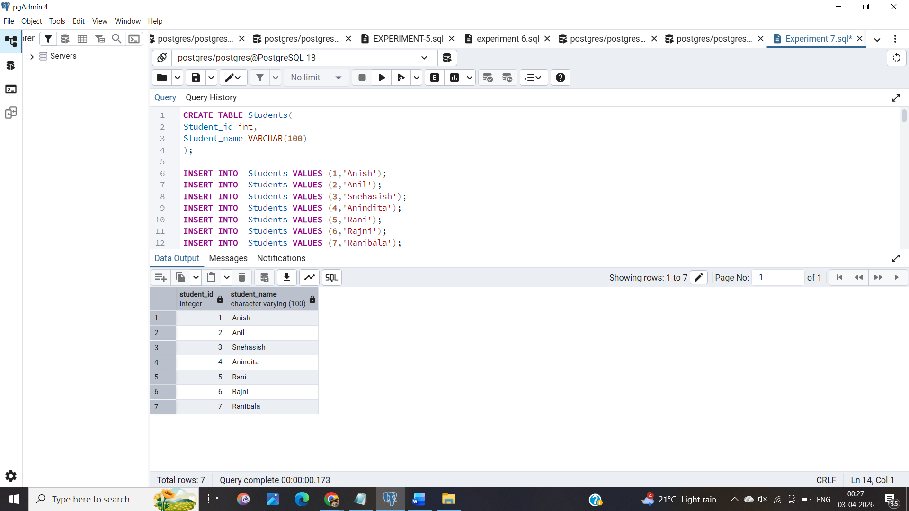

INSERT INTO Courses VALUES (101,'DBMS');

INSERT INTO Courses VALUES (102,'FRONTEND');

INSERT INTO Courses VALUES (103,'BACKEND');

INSERT INTO Courses VALUES (104,'COMPUTER NETWORKS');

INSERT INTO Courses VALUES (105,'CYBERSECURITY');

INSERT INTO Courses VALUES (106,'ADVANCED INTERNET PROGRAMMING');

SELECT * FROM Courses;

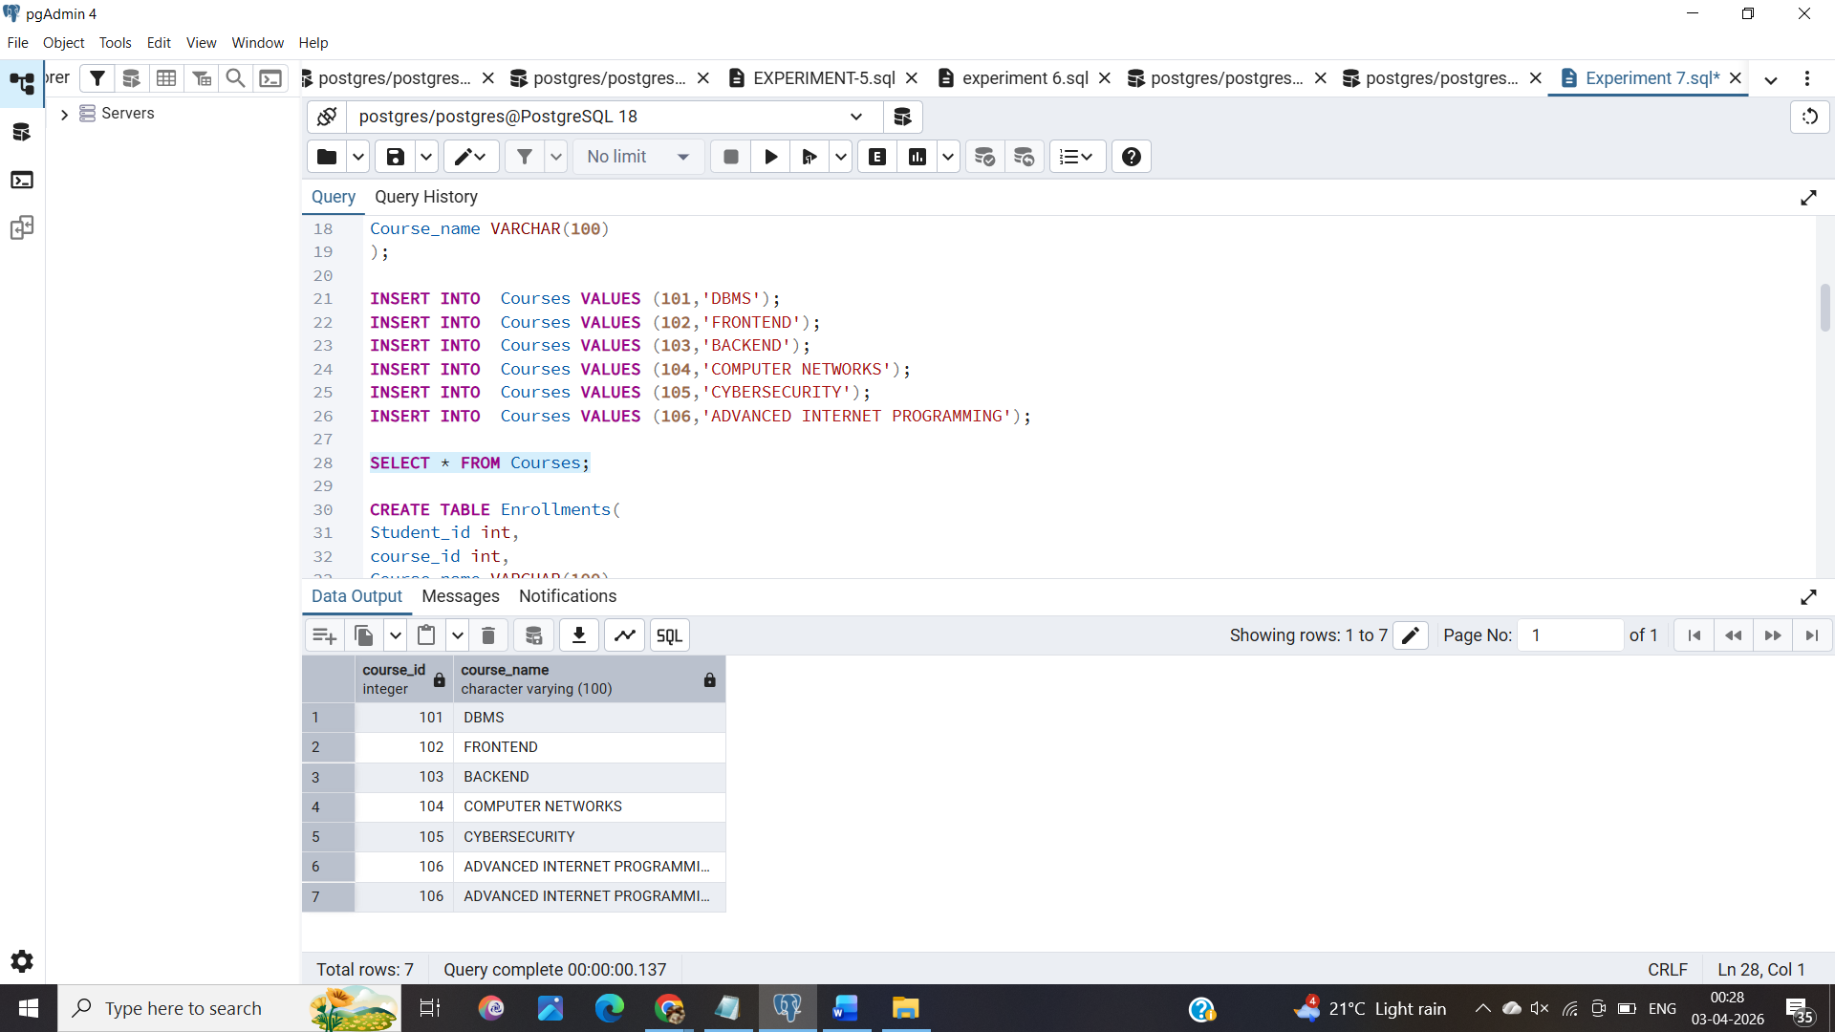

INSERT INTO Enrollments VALUES (1,101,'DBMS');

INSERT INTO Enrollments VALUES (1,102,'FRONTEND');

INSERT INTO Enrollments VALUES (2,103,'BACKEND');

INSERT INTO Enrollments VALUES (3,104,'COMPUTER NETWORKS');

INSERT INTO Enrollments VALUES (4,105,'CYBERSECURITY');

INSERT INTO Enrollments VALUES (5,103,'BACKEND');

INSERT INTO Enrollments VALUES (5,104,'COMPUTER NETWORKS');

SELECT * FROM Enrollments;

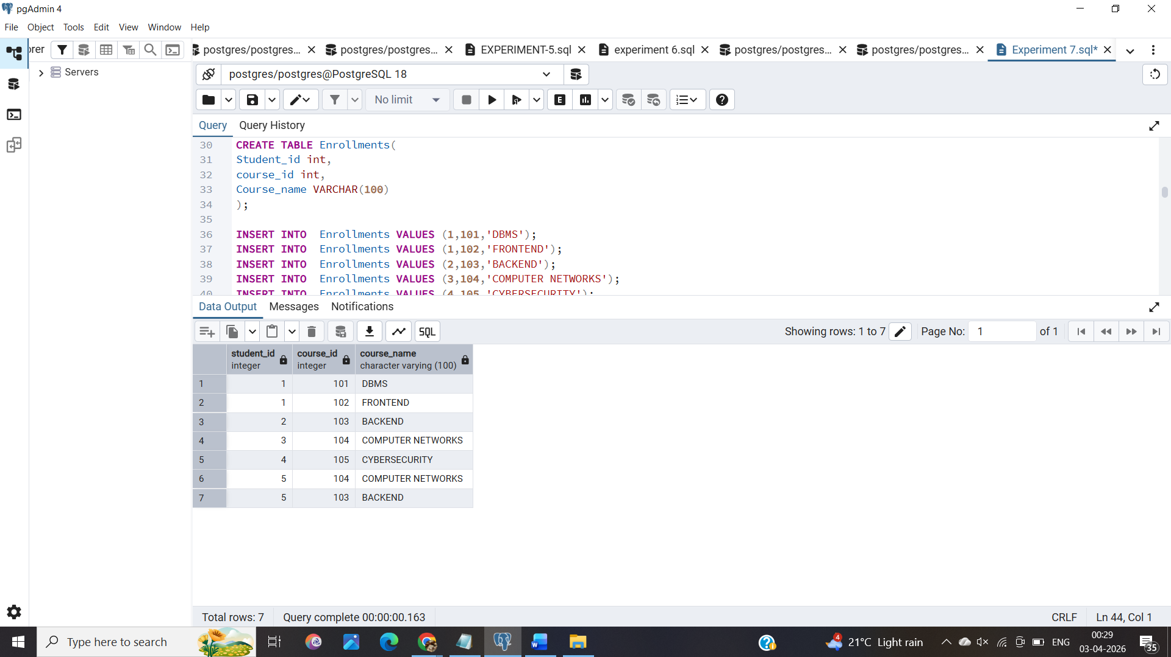

INSERT INTO Departments VALUES (1,'MCA',1);

INSERT INTO Departments VALUES (11,'MCA',2);

INSERT INTO Departments VALUES (12,'ENGINEERING',3);

INSERT INTO Departments VALUES (13,'ENGINEERING',4);

INSERT INTO Departments VALUES (12,'BCA',5);

INSERT INTO Departments VALUES (12,'BCA',6);

INSERT INTO Departments VALUES (12,'BCA',7);

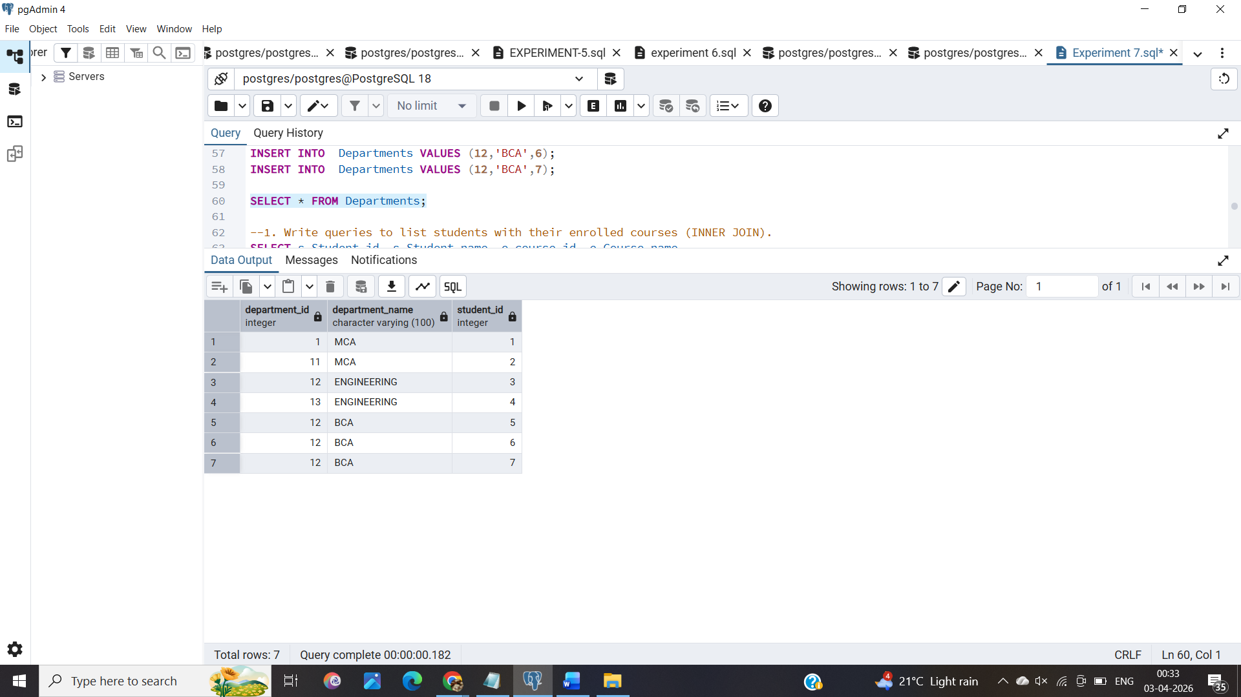

v. Write queries to list students with their enrolled courses (INNER JOIN).

SELECT s.Student_id, s.Student_name, e.course_id, e.Course_name

FROM Students AS s

JOIN Enrollments AS e

ON s.Student_id = e.Student_id

ORDER BY Student_id ASC;

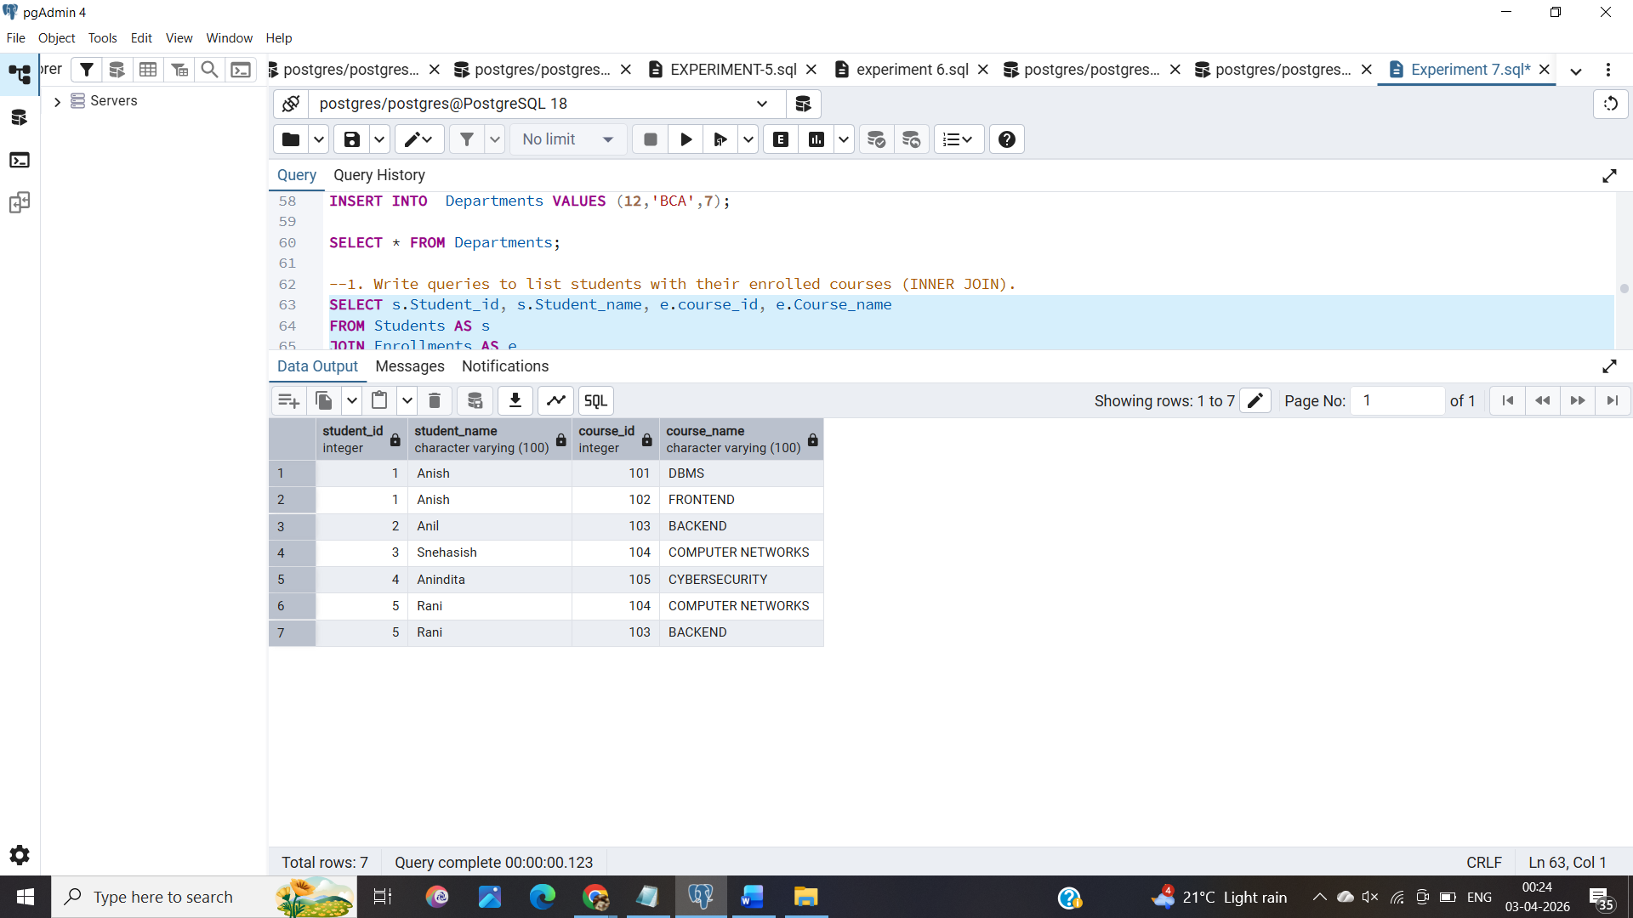

vi. Find students not enrolled in any course (LEFT JOIN).

SELECT s.Student_id, s.Student_name
FROM Students AS s
LEFT JOIN Enrollments as e
ON s.Student_id = e.Student_id
WHERE e.Student_id IS NULL
ORDER BY s.Student_id ASC;

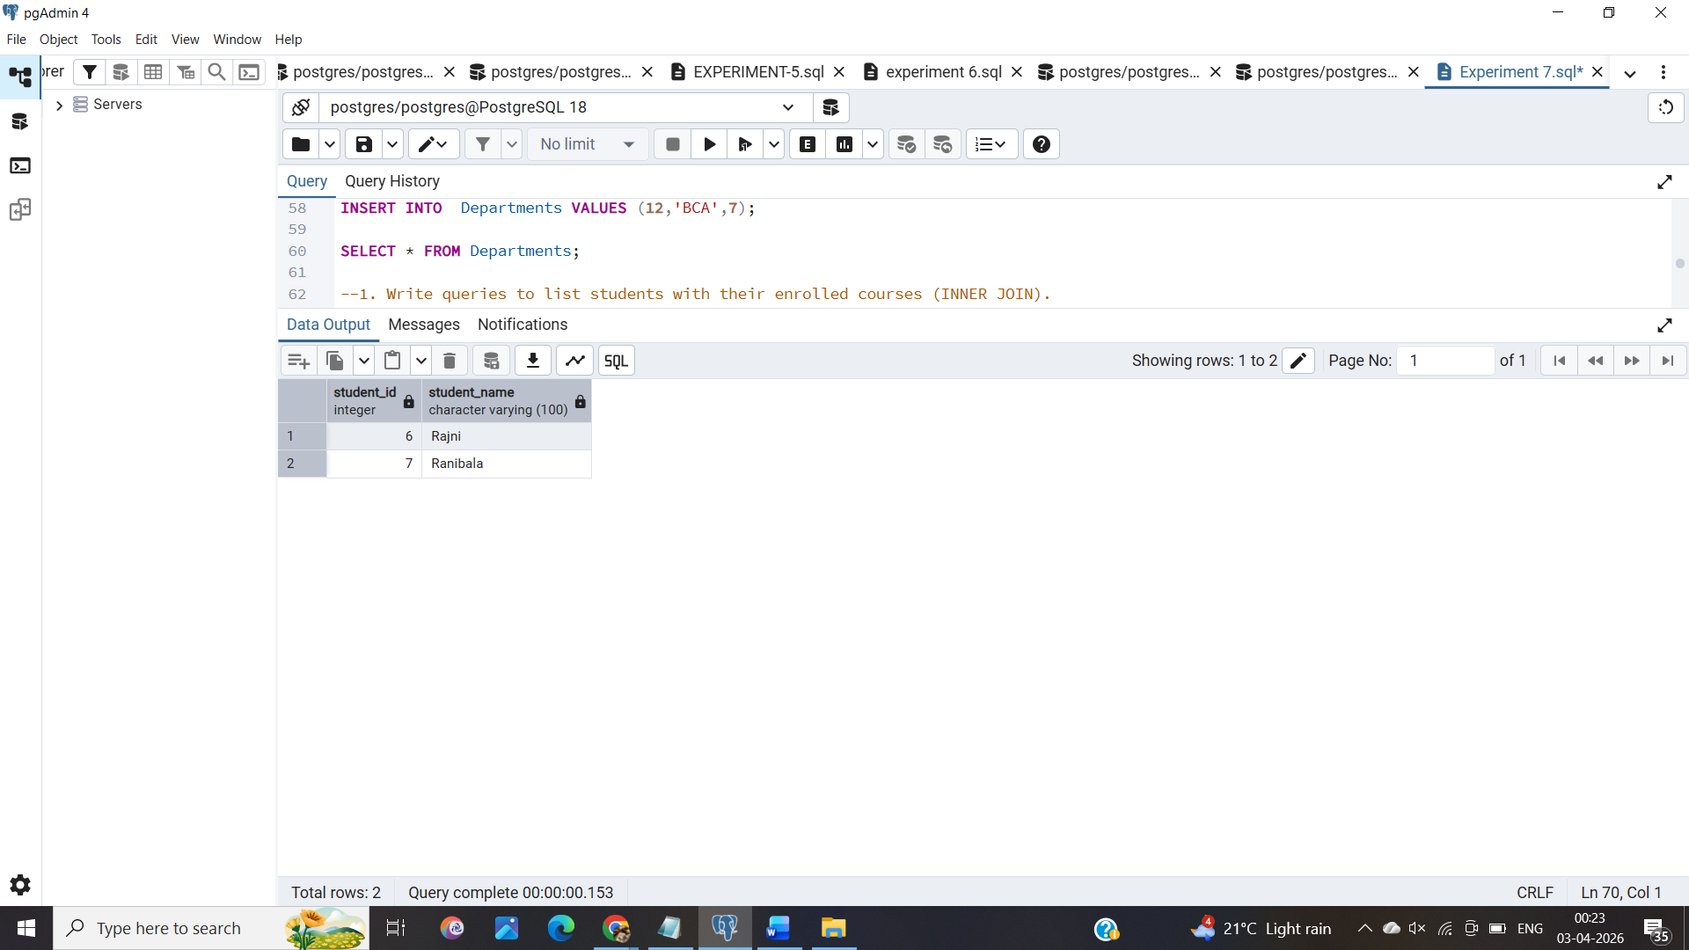

vii.Display all courses with or without enrolled students (RIGHT JOIN).

SELECT DISTINCT(c.course_id),e.Course_name
FROM Enrollments AS e
RIGHT JOIN Courses AS c
ON e.course_id=c.course_id
ORDER BY course_id ASC;

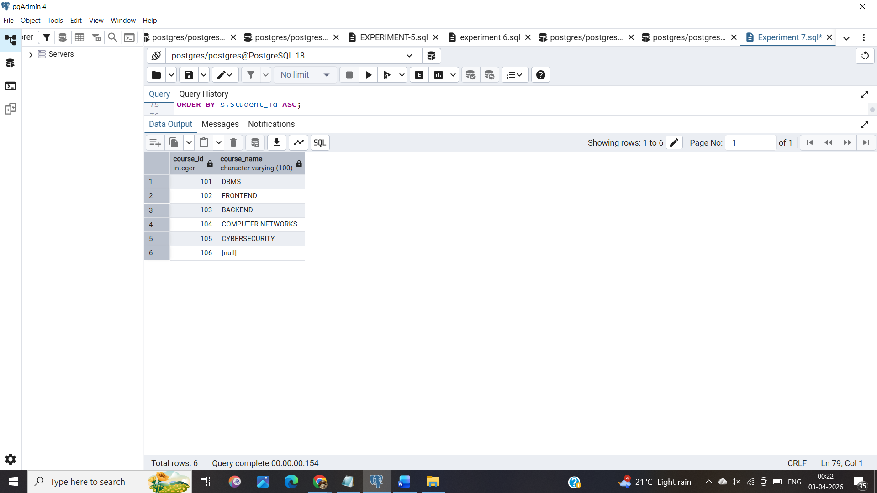
viii.Show students with department info using SELF JOIN or multiple joins.

SELECT s.Student_id, s.Student_name, d.Department_id,d.Department_name,e.course_id,e.Course_name
FROM Students AS s
LEFT JOIN Departments AS d ON s.Student_id = d.Student_id
LEFT JOIN Enrollments AS e ON s.Student_id = e.Student_id
ORDER BY s.Student_id ASC;

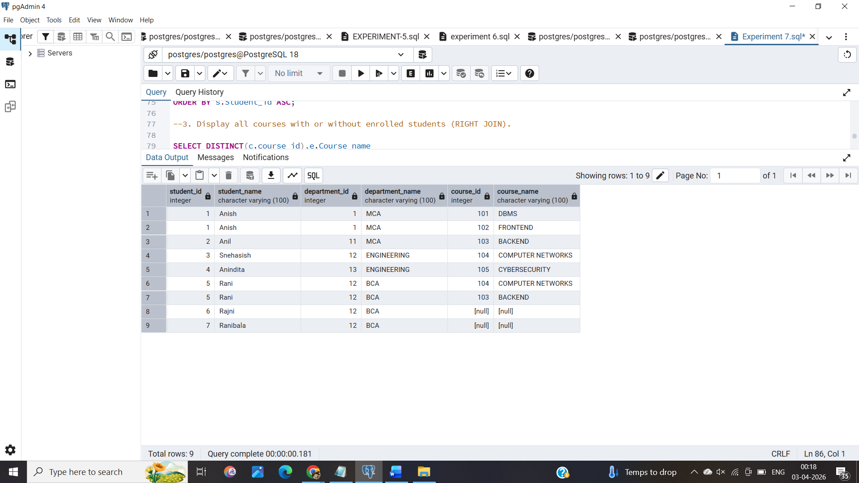

ix. Display all possible student-course combinations (CROSS JOIN).

SELECT s.Student_id,s.Student_name,c.course_id,c.Course_name,
FROM Students AS s
CROSS JOIN Courses AS c
ORDER BY s.Student_id ASC;

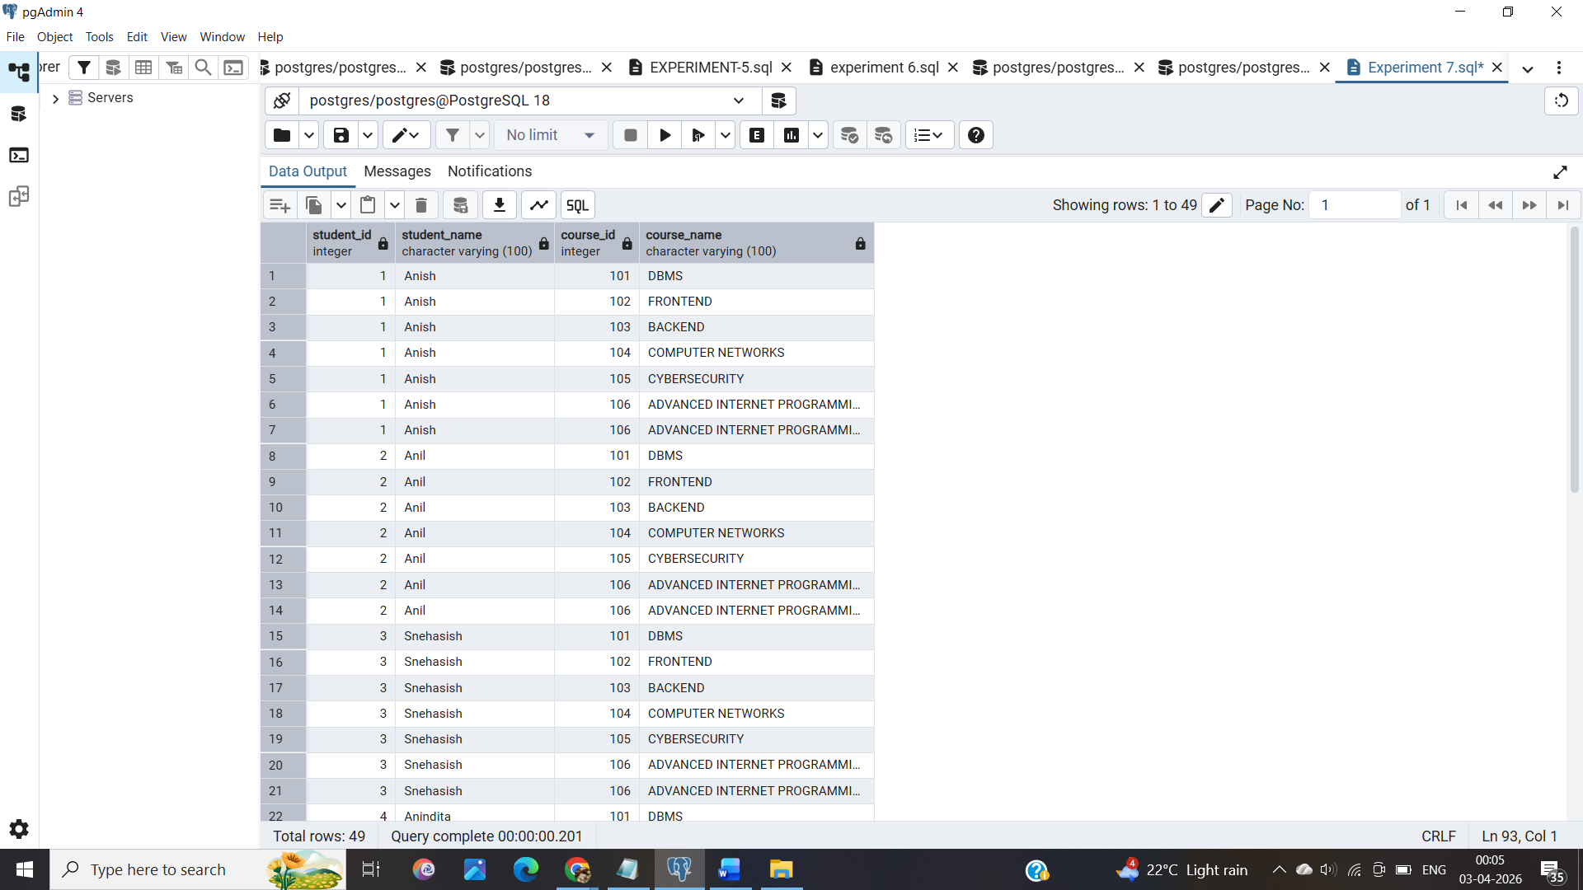
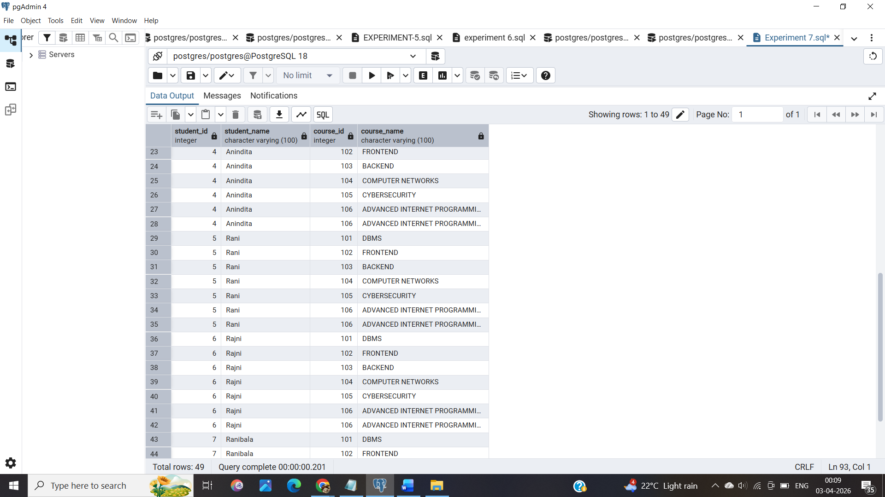
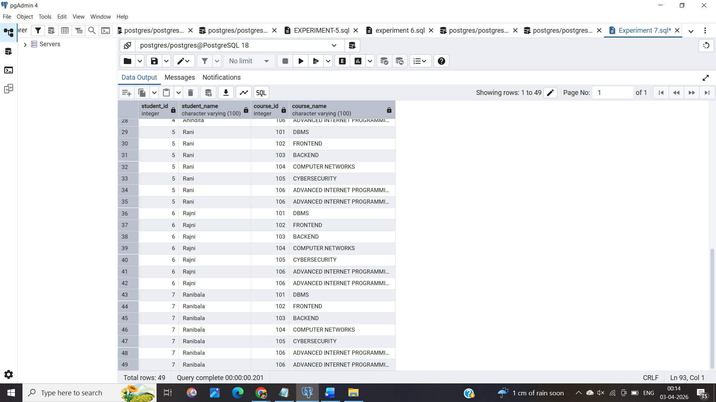

7. Learning Outcomes
- Executing SQL queries with JOINS eg. LEFT JOIN, RIGHT JOIN ,SELF JOIN and CROSS JOIN to carry out multiple functionalities.
- Implementing multiple joins to carry out a wide array of functionalities.

