Experiment 1
Student Name: RAVI RANJAN KUMAR UID: 25MCA20098
Branch: MCA general Section/Group: 25MCA_KAR-1
Semester: II Date of Performance:05-01-2026 Subject Name: Technical Training Subject Code: 25CAP-652

Aim:
To design and implement a sample database system using DDL, DML, and DCL commands, including database creation, data manipulation, schema modification, and role-based access control to ensure data integrity and secure, read-only access for authorized users.

Objective:
To gain practical experience in implementing Data Definition Language (DDL), Data Manipulation Language (DML), and Data Control Language (DCL) operations in a real database environment. This will also include implementing role-based privileges to secure data.

Implementation/Code:

-- DDL
-- DEPARTMENT TABLE
CREATE TABLE department( department_id INT PRIMARY KEY,
department_name VARCHAR(20) NOT NULL UNIQUE, salary FLOAT CHECK(salary>=0)
);

-- EMPLOYEE TABLE
CREATE TABLE employee( employee_id INT PRIMARY KEY,

employee_name VARCHAR(20) NOT NULL,
department_id INT NOT NULL REFERENCES department(department_id), employee_contact VARCHAR(20),
join_date DATE NOT NULL,
end_date DATE CHECK(end_date>=join_date)
);

ALTER TABLE employee ADD work_location VARCHAR(20); ALTER TABLE employee DROP work_location;
ALTER TABLE employee ADD status VARCHAR(20) DEFAULT 'active';

-- PROJECT TABLE
CREATE TABLE project( project_id INT PRIMARY KEY,
project_name VARCHAR(20) NOT NULL UNIQUE,
department_id INT NOT NULL REFERENCES department(department_id), start_date DATE NOT NULL,
end_date DATE CHECK(end_date>=start_date)
);

INSERT INTO department VALUES (101,'Manager',90000),
(102,'HR',70000),
(103,'EMPLOYEE',50000);
UPDATE department set salary=80000 WHERE department_id=101; UPDATE department set salary=60000 WHERE department_id=102; UPDATE department set salary=100000 WHERE department_id=103;

UPDATE department SET department_name='Employee' WHERE department_id=103;

INSERT INTO department

VALUES (104,'DEVELOPER',-30000);

INSERT INTO department VALUES (104,'DEVELOPER',30000);
DELETE FROM department WHERE department_id=104; INSERT INTO employee
VALUES
(1,'Rahul',101,8888888888,'2001-04-12','2010-07-13'),
(2,'Anuj',102,7777777777,'2003-06-10','2004-05-11'),
(3,'Aman',103,6666666666,'2006-05-20','2009-09-11'),
(4,'Naman',103,5555555555,'2006-06-25','2009-08-11'),
(5,'Karan',103,4444444444,'2006-03-12','2009-05-11');
DELETE FROM employee WHERE employee_id=3; INSERT INTO project
VALUES
(11,'P1',103,'2025-08-14','2025-09-14'),
(12,'P2',103,'2025-08-14','2025-08-30');

-- DQL
SELECT * FROM department; SELECT * FROM employee; SELECT * FROM project;

-- DCL
CREATE ROLE reporting_user LOGIN
PASSWORD

'user123';

GRANT SELECT ON department TO reporting_user; REVOKE SELECT ON department FROM reporting_user; GRANT SELECT ON project TO reporting_user;
REVOKE CREATE ON SCHEMA PUBLIC FROM reporting_user;

-- QUERY FROM reporting_user SELECT * FROM project;

Output:

Project Table

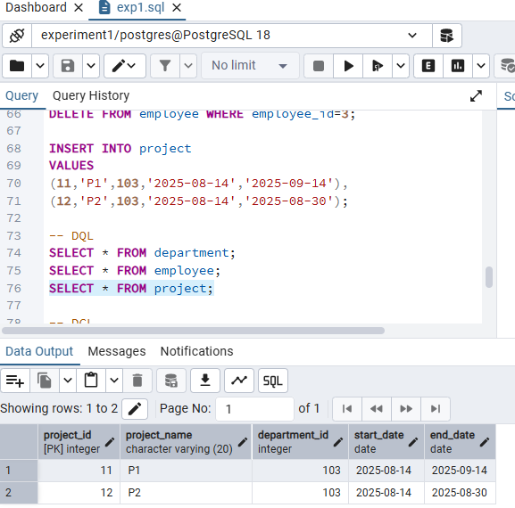

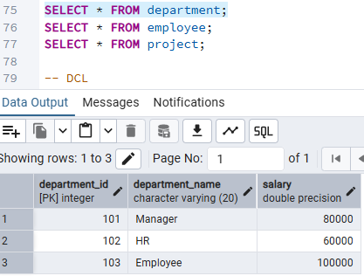

Employee Table
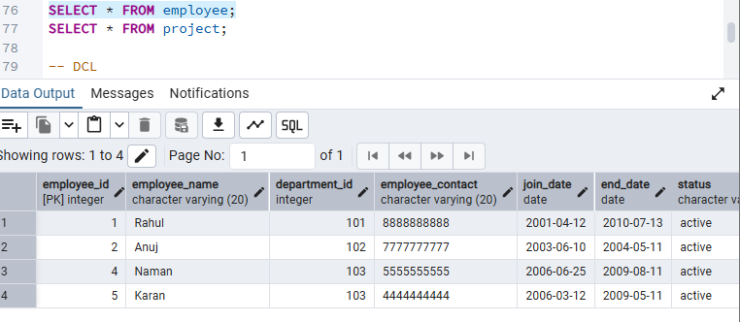
- Learning Outcomes:
  - About query writing in PostgreSQL.
  - About various DDL, DML and DCL commands.
  - About the application of CHECK constraint.
  - About role-based privileges to secure data.

