Worksheet No. 8

Student Name: Ravi Ranjan Kumar UID: 25MCA20098
Branch: MCA (GENERAL) Section/Group: MCA- 1-A
Semester: II Date of Performance: 1/04/2026
Subject Name: Technical Training Subject Code: 25CAP-652

1.Aim/Overview of the practical:
To apply the concept of Stored Procedures in database operations to perform tasks like insertion, updating, deletion, and retrieval of data efficiently, securely, and in a reusable manner within the database system.

2. Objectives:
Apply stored procedure concepts for database operations

3. Input/Apparatus Used:
    - PostgreSQL
- pgAdmin
4.Procedure/Algorithm/Code:

---CREATING A TABLE:

CREATE TABLE Employee (
empId INT PRIMARY KEY,
name VARCHAR(50),
salary INT
);

--- INSERT PROCEDURE
CREATE OR REPLACE PROCEDURE insert_employee(
eid INT,
ename VARCHAR,
esalary INT
)
LANGUAGE plpgsql
AS $$
BEGIN
INSERT INTO Employee VALUES (eid, ename, esalary);
END;
$$;

--- UPDATE PROCEDURE
CREATE OR REPLACE PROCEDURE update_salary(
eid INT,
new_salary INT
)
LANGUAGE plpgsql
AS $$
BEGIN
UPDATE Employee
SET salary = new_salary
WHERE empId = eid;
END;
$$;

--- DELETE PROCEDURE
CREATE OR REPLACE PROCEDURE delete_employee(
eid INT
)
LANGUAGE plpgsql
AS $$
BEGIN
DELETE FROM Employee
WHERE empId = eid;
END;
$$;

--- RETRIVE DATA USING FUNCTION
CREATE OR REPLACE FUNCTION get_employees()
RETURNS TABLE(empId INT, name VARCHAR, salary INT)
LANGUAGE plpgsql
AS $$
BEGIN
RETURN QUERY
SELECT * FROM Employee;
END;
$$;

--- EXECUTION PART
CALL insert_employee(1, 'John', 5000);
CALL update_salary(1, 6000);
CALL insert_employee(2, 'Rahul', 5000);

SELECT * FROM get_employees();

CALL delete_employee (1);

5. OUTPUT:

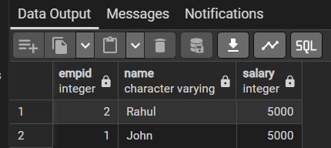

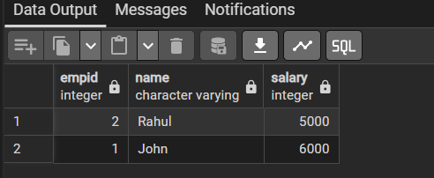

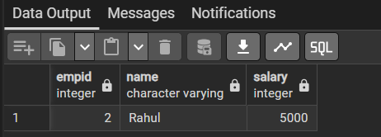
7. Learning Outcomes:
- Insert Procedure successfully adds new employee records into the Employee table.
- Update Procedure modifies existing data (e.g., updating salary based on empId).
- Delete Procedure removes specific employee records from the table.
- Function (get_employees) retrieves and displays all employee data in a structured format.
Demonstrates how procedures handle CRUD operations, while functions are used for data retrieval in PostgreSQL

