Worksheet-3
Name: Ravi Ranjan Kumar UID: 25MCA20098
Branch: MCA General Section/Group: 25MCA_KAR-1
Semester: II Date of Performance: 27-01-26
Subject Name: Technical Training Subject Code: 25CAP-652

Aim of the Session:

To implement conditional decision-making logic in PostgreSQL using IF–ELSE constructs and CASE expressions for classification, validation, and rule-based data processing.

Tools Used:

PostgreSQL — Powerful open-source relational database for storing and managing data efficiently

Objective of the Session:

The objectives of this practical session are:
- To understand conditional execution in SQL
- To implement decision-making logic using CASE expressions
- To simulate real-world rule validation scenarios
- To classify data based on multiple conditions
- To strengthen SQL logic skills required in interviews and backend systems

Practical / Experiment Steps:

Classifying Data Using CASE Expression

Steps
- Write a SELECT query to retrieve schema names and violation counts.
- Use a searched CASE expression in the SELECT clause.
- Define conditions for:
  - No Violation
  - Minor Violation
  - Moderate Violation
  - Critical Violation
- Assign appropriate labels for each condition.
- Execute the query and observe the classification result.

Applying CASE Logic in Data Updates

Steps
- Alter the existing table to add a new column named approval_status.
- Write an UPDATE statement using a CASE expression.
- Define approval rules such as:
  - Approved
  - Needs Review
  - Rejected
- Update all rows based on violation count.
- Verify the update using a SELECT query.

Implementing IF–ELSE Logic Using PL/pgSQL

Steps
- Begin a PL/pgSQL DO block.
- Declare a variable to store violation count.
- Assign a value to the variable.
- Use IF–ELSE IF–ELSE conditions to check violation levels.
- Display appropriate messages using RAISE NOTICE.
- Execute the block and observe the output.

Real-World Classification Scenario (Grading System)

Steps
- Create a table to store student names and marks.
- Insert sample student records with varying marks.
- Write a SELECT query using a CASE expression.
- Define grade categories (such as A, B, C, Fail).
- Execute the query and verify grade classification.

Using CASE for Custom Sorting

Steps
- Write a SELECT query to retrieve schema details.
- Use a CASE expression inside the ORDER BY clause.
- Assign priority values to violation severity levels.
- Execute the query to sort records based on severity.
- Analyze the ordered output.

Procedure of the Practical:
- Start the system and log in to the computer.
- Open the PostgreSQL client tool (psql / pgAdmin).
- Create a table to store schema violations details.
CREATE TABLE schema_analysis (
id SERIAL PRIMARY KEY,
schema_name VARCHAR(50),
violation_count INT
);

INSERT INTO schema_analysis (schema_name, violation_count) VALUES
('FinanceSchema', 0),
('PayrollSchema', 2),
('InventorySchema', 2),
('HRSchema', 14),
('EmployeeSchema', 9);

SELECT * FROM schema_analysis;

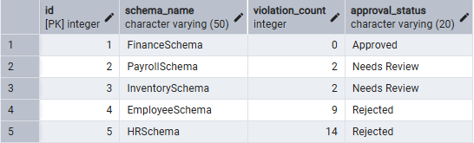
- Classifying Data Using CASE Expression.
SELECT
schema_name,
violation_count,
CASE
WHEN violation_count = 0 THEN 'No Violation'
WHEN violation_count BETWEEN 1 AND 3 THEN 'Minor Violation'
WHEN violation_count BETWEEN 4 AND 8 THEN 'Moderate Violation'
WHEN violation_count >= 9 THEN 'Critical Violation'
END AS violation_level
FROM schema_analysis;

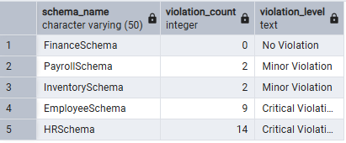

- Applying CASE Logic in Data Updates.
ALTER TABLE schema_analysis
ADD COLUMN approval_status VARCHAR(20);

UPDATE schema_analysis
SET approval_status = CASE
WHEN violation_count = 0 THEN 'Approved'
WHEN violation_count BETWEEN 1 AND 5 THEN 'Needs Review'
WHEN violation_count > 5 THEN 'Rejected'
END;

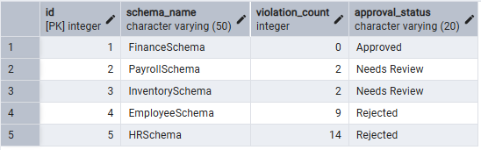
- Implementing IF–ELSE Logic Using PL/pgSQL.
DO $$
DECLARE
v_count INT := 14;
BEGIN
IF v_count = 0 THEN
RAISE NOTICE 'No Violations Found.';
ELSIF v_count BETWEEN 1 AND 3 THEN
RAISE NOTICE 'Minor Violations Present.';
ELSIF v_count BETWEEN 4 AND 8 THEN
RAISE NOTICE 'Moderate Violations Present.';
ELSE
RAISE NOTICE 'Critical Violations Present.';
END IF;
END$$;

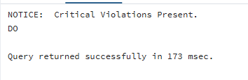
- Real-World Classification Scenario (Grading System).
CREATE TABLE students (
id SERIAL PRIMARY KEY,
student_name VARCHAR(50),
marks INT
);

INSERT INTO students (student_name, marks) VALUES
('Arjun', 92),
('Riya', 76),
('Kabir', 64),
('Simran', 48),
('Vikram', 33);

SELECT
student_name,
marks,
CASE
WHEN marks >= 90 THEN 'A'
WHEN marks >= 75 THEN 'B'
WHEN marks >= 60 THEN 'C'
WHEN marks >= 40 THEN 'D'
ELSE 'Fail'
END AS grade
FROM students;
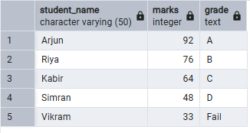
- Using CASE for Custom Sorting.
SELECT *
FROM schema_analysis
ORDER BY
CASE
WHEN violation_count >= 9 THEN 1
WHEN violation_count BETWEEN 4 AND 8 THEN 2
WHEN violation_count BETWEEN 1 AND 3 THEN 3
ELSE 4
END,
schema_name;

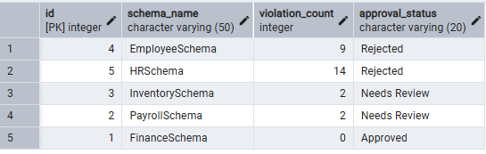
- Verify the output after execution.
- Note down the results obtained.
- Save the work and take screenshots for record.
I/O Analysis:
Input Provided
- SQL queries using CASE expressions in SELECT, UPDATE, and ORDER BY clauses
- PL/pgSQL DO block implementing IF–ELSE conditional logic
- Table data containing:
- Schema names
- Violation counts
- Sample student records with marks inserted into the grading table
Output Generated
- Classified schema records based on violation severity
- Automatically assigned approval status for each schema
- Conditional messages displayed using IF–ELSE logic
- Student grades generated based on marks
- Custom-sorted output prioritizing records by violation severity
Learning Outcomes:
- Apply CASE expressions for data classification and updates
- Implement IF–ELSE logic using PL/pgSQL
- Perform rule-based data processing within the database
- Solve real-world SQL interview and backend scenarios

