# Lets solve some questions raised while looking for best player and team i,e for brand endorsement.

1. Which team won most of the matches?

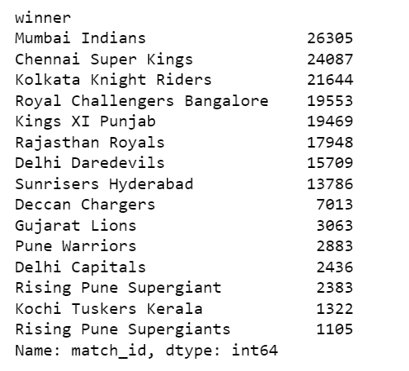

MI

1. Which team loss most of the matches?

RSP

1. Which team scored highest runs?

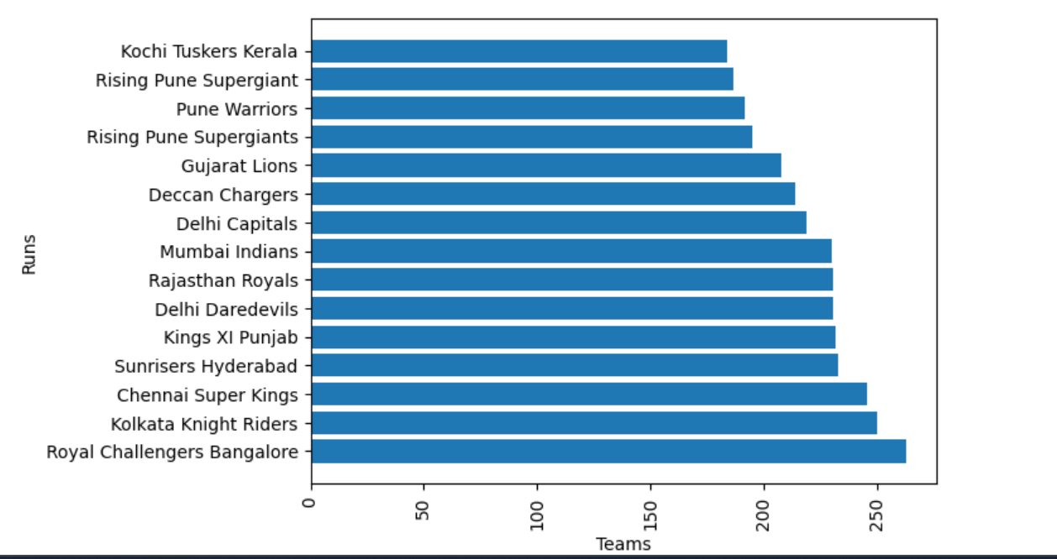

RCB scored highest runs

1. Which player scored highest runs?

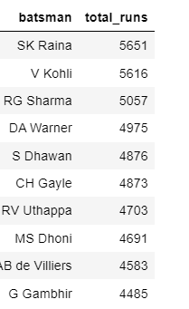

1. Highest score by Batsman

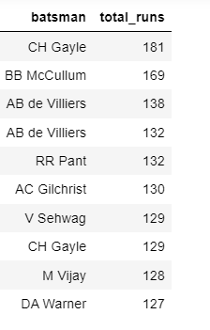

1. player with most 100s, 75s, 50s and 30s

100s

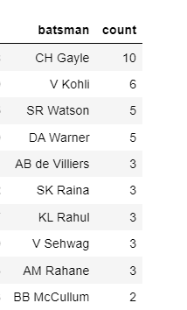

70s

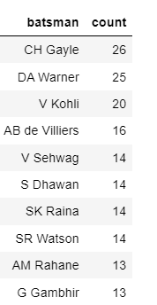

50s

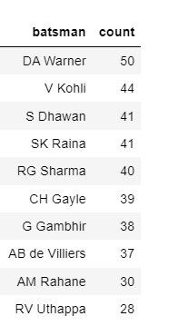

30s

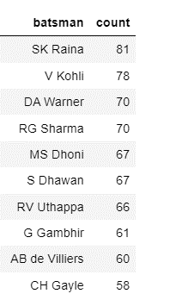

1. player with most wickets

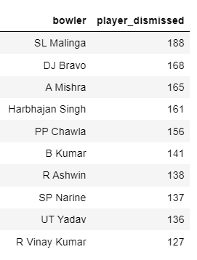

1. players with most MAN OF THE MATCHES

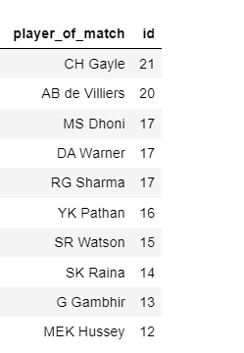

1. Team with most toss winners

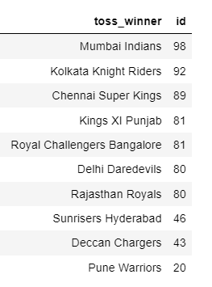

1. If toss wins, no of matches the wins too

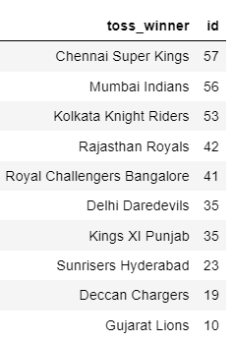

**Lets set some rules for Best Player and Best Team**

Best Team:

* It should be win most of the matches
* It should be win most of the tosses

Best Player:

* He should be score maximum runs
* He must have maximum man of the matches
* He must have most wickets
* He must be from best team if possible

**SUMMARY**

**MI –**

**CSK –**

**KKR –**