

MSc Data Science Project
7PAM2002
Department of Physics, Astronomy and Mathematics

Data Science FINAL PROJECT REPORT

Project Title:
Predictive Analysis of Cardiovascular Disease Risk Using Machine Learning
GITHUB LINK: https://github.com/ravi1563/FYP-RAVI/blob/main/README.md
Student Name and SRN:
RAVI KIRAN DEEVI
23092313

Supervisor: Hariharan Dhiamani Saravana Muthu
Date Submitted: 21/04/2026
Word Count: 5172

DECLARATION STATEMENT

This report is submitted in partial fulfilment of the requirement for the degree of Master of Science in Data Science at the University of Hertfordshire.
I have read the detailed guidance to students on academic integrity, misconduct and plagiarism information at Assessment Offences and Academic Misconduct and understand the University process of dealing with suspected cases of academic misconduct and the possible penalties, which could include failing the project or course.
I certify that the work submitted is my own and that any material derived or quoted from published or unpublished work of other persons has been duly acknowledged. (Ref. UPR AS/C/6.1, section 7 and UPR AS/C/5, section 3.6)
I did not use human participants in my MSc Project.

I hereby give permission for the report to be made available on module websites provided the source is acknowledged.

Student Name printed: RAVI KIRAN DEEVI

Student Name signature: RAVI KIRAN DEEVI

Student SRN number: 23092313

SCHOOL OF PHYSICS, ENGINEERING AND COMPUTER SCIENCE

Abstract
Worldwide cardiovascular disease operates as the primary cause of death, which necessitates early risk assessment to enable successful disease prevention and treatment methods. My research examines how machine learning algorithms use clinical health indicators to forecast cardiovascular disease development. I used three different machine learning models to analyze cardiovascular data from Mendeley Data through their study. I further assessed model performance through accuracy measurement and precision measurement and recall measurement and F1-score measurement. The Random Forest model achieved the best results with an F1-score of 0.984848. SHAP analysis identified troponin and CK-MB as the most influential risk factors. The research results show that machine learning models help healthcare professionals diagnose cardiovascular disease at earlier stages while making better clinical decisions about cardiovascular disease risk evaluation.

Contents
Abstract ii
1 Introdu ction 1
1.1 Overview 1
1.2 Purpose of the Study 1
1.3 Current Practice Liu 1
1.4 Problem Statement 1
1.5 Aim 1
1.6 Research Questions 2
1.7 Structure of Report 2
2 Chapter 2: Literature Review 3
2.1 Overview of the Chapter 3
2.2 Review of Previous Studies 3
2.3 Summary of Literature and Research Gap 4
2.4 Identified Research Gap 4
3 Dataset 5
3.1 Overview and Source 5
3.2 Original Data Collection 5
3.3 Description of Dataset Features 5
3.4 Justification of Dataset Selection 6
3.5 Exploratory Data Analysis (EDA) 6
3.5.1 Class Distribution 6
3.5.2 Feature Distribution Histograms 6
3.5.3 Feature Correlation Matrix 7
3.5.4 Outlier Detection Using Boxplots 8
3.6 Data Preprocessing 9
4 Ethical Consideration 10
4.1 Data Privacy and Anonymity 10
4.2 GDPR Compliance 10
4.3 Data Source and Permission 10
4.4 Ethical Data Collection 10
5 Methodology 11
5.1 Overview of Methodology 11
5.2 Train Test Split and Feature Scaling 11
5.3 Machine Learning Models and Technical Rationale 11
5.4 Hyperparameter Optimization 12
5.5 Model Evaluation 12
5.6 K Fold Cross Validation 13
5.7 Model Explainability Using SHAP 13
5.8 Class Balancing Techniques 13
6 Results 15
6.1 Overview of the Chapter 15
6.2 Initial Model Performance 15
6.3 Model Performance After Hyperparameter Optimization 15
6.3.1 Visualization of Best Performing Model 16
6.4 Cross-Validation Results 17
6.5 Explainable Artificial Intelligence, SHAP Analysis 18
6.6 Effect of Data Balancing Techniques 20
6.7 Addressing Research Questions 21
6.8 Practical Applicability 22
7 Analysis and Discussion 23
7.1 Overview of the Analysis 23
7.2 Interpretation of Model Performance 23
7.3 Comparison with Existing Literature 23
7.4 Feature Importance and Clinical Interpretation 23
7.5 Impact of Data Balancing Techniques 23
7.6 Practical Applicability of the Model 24
7.7 Limitations of the Study 24
7.8 Relationship to Research Questions and Objectives 24
8 Conclusion 25
9 References 26
10 Appendix: 27

Introduction

Overview
Cardiovascular disease (CVD) is a major cause of death globally, and early diagnosis is critical for the prevention and treatment of this condition. Machine learning algorithms are being employed increasingly for the analysis of medical data and the detection of risk patterns. These predictive models help doctors diagnose cardiovascular risk more effectively and efficiently.

Purpose of the Study
The aim of this research study is to examine the application of machine learning algorithms to predict the risk of cardiovascular disease based on patient health records. Machine learning algorithms can analyze the intricate patterns of risk factors such as cholesterol, blood pressure, and lifestyle factors to facilitate early diagnosis and preventive healthcare strategies(Mim et al., 2025)

Current Practice Liu
The current state of the healthcare industry employs clinical evaluations and statistical risk prediction to estimate the risk of cardiovascular disease (Liu et al., 2025). However, the traditional approach to risk prediction is often based on a few variables and may not be able to identify intricate patterns in patient health records. Recent studies have indicated that machine learning algorithms based on electronic health records can predict risks more accurately than traditional methods.

Problem Statement
Cardiovascular disease still remains a significant public health issue globally, especially in areas where there is a lack of access to early diagnostic tools. Conventional models for prediction employ statistical approaches that might not be able to accurately identify complex nonlinear relationships between clinical risk factors (Effati et al., 2024). This makes it difficult to make early predictions about high-risk patients. Machine learning algorithms have shown high predictive accuracy, but their integration with healthcare systems is still limited because of concerns regarding data quality, model validation, and interpretability (Liu et al., 2025; Mim et al., 2025)

Aim
The aim of this research study is to design and test machine learning models that can accurately predict the risk of cardiovascular disease using clinical and demographic variables for the purpose of early diagnosis and preventive healthcare.
Objectives of the Study
- To examine the cardiovascular disease datasets that include clinical and demographic variables as risk factors.
- To apply machine learning algorithms for the prediction of cardiovascular disease risk.
- To compare the performance of different machine learning models using valid evaluation metrics.
- To determine the most effective predictive model for the detection of cardiovascular disease risk.

Research Questions
- RQ1: Which supervised classification algorithm achieves the highest F1-score in accurately diagnosing cardiovascular disease based on clinical and lifestyle indicators?
- RQ2: Which risk factors (e.g., LDL Cholesterol vs. Smoking History) are the most critical drivers of heart disease prediction, and how do they influence the model's decision-making as visualized by SHAP (SHapley Additive exPlanations) values?
- RQ3: Does the application of data balancing techniques significantly improve the model's sensitivity (recall) for the minority "Heart Disease" class compared to using the original imbalanced dataset?

Structure of Report
The report contains nine chapters. The research introduction appears in Chapter 1. Chapter 2 presents the literature review. The research data description appears in Chapter 3. Chapter 4 examines the ethical considerations. The research methodology exists in Chapter 5. Chapter 6 displays the research findings. Chapter 7 provides both interpretation and analysis of the results. Chapter 8 serves as the conclusion while Chapter 9 contains the references and appendices.

Chapter 2: Literature Review

Overview of the Chapter
This chapter reviews previous research on prediction of cardiovascular disease using machine learning methods. The chapter examines studies where researchers applied machine learning algorithms to clinical and health datasets for prediction of cardiovascular risk. Each study presents different algorithms, datasets, evaluation metrics, and outcomes. The review identifies strengths and limitations within previous work. The chapter also highlights gaps in existing research which support further investigation in cardiovascular disease risk prediction through machine learning models.

Review of Previous Studies
The authors (Ogunpola et al., 2024) studied early detection of cardiovascular disease through machine learning algorithms. The research applied several models including K Nearest Neighbors, Support Vector Machine, Logistic Regression, Convolutional Neural Networks, Gradient Boost, XGBoost, and Random Forest. The study addressed dataset imbalance, a common issue in medical prediction tasks. Researchers performed model tuning and evaluation to improve predictive performance. XGBoost produced the highest results with accuracy of 98.50 percent, precision of 99.14 percent, recall of 98.29 percent, and F1 score of 98.71 percent. The findings show strong diagnostic performance through optimized machine learning models.
The researchers (Salah & Srinivas, 2022) proposed an explainable machine learning framework for long term cardiovascular risk prediction among adolescents. The research used the Add Health longitudinal dataset with more than 14,000 participants. Decision Tree, Random Forest, XGBoost, and Deep Neural Networks served as prediction models. XGBoost achieved the highest performance with an AUC ROC score of 84.5 percent. The study also applied explainable artificial intelligence methods to identify major risk factors influencing cardiovascular outcomes. Results show early risk detection during adolescence supports preventive healthcare planning.
Analysts (Dalal et al., 2023) developed a machine learning model for cardiovascular disease risk prediction through a dataset of about 70,000 patient records from Kaggle. The dataset included 11 clinical attributes linked with cardiovascular risk. The research compared several machine learning algorithms including Neural Networks, Random Forest, Bayesian Networks, C5.0, and QUEST algorithms. The proposed approach reached prediction accuracy of 99.1 percent. The results show machine learning systems support early diagnosis and clinical decision making in cardiovascular healthcare.
Researchers (Shimizu et al., 2024) developed machine learning models for prediction of major adverse cardiovascular events using hospital data from Brazil. The dataset included 6,000 cases and 6,000 non cases for training and validation. Algorithms used in the study included Random Forest, XGBoost, Decision Tree, Support Vector Machine, K Nearest Neighbors, and Naïve Bayes. Random Forest produced the best performance with an AUC score of 0.871 during internal validation. The model also showed strong performance during external validation. The researchers applied interpretability techniques such as LIME and SHAP to explain prediction outputs and support personalized clinical decision making.

Summary of Literature and Research Gap
Study | Method Used | Dataset | Key Findings | Research Gap
Ogunpola et al. (2024) | KNN, SVM, CNN, RF, XGBoost | Clinical cardiovascular dataset | XGBoost achieved 98.50% accuracy for heart disease prediction | Limited focus on real-time clinical implementation
Salah & Srinivas (2022) | DT, RF, XGBoost, DNN | Add Health longitudinal dataset | Early prediction of adulthood CVD risk among adolescents | Focus mainly on adolescents rather than broader populations
Dalal et al. (2023) | Neural Networks, RF, Bayesian Networks | Kaggle cardiovascular dataset (70k records) | Achieved 99.1% prediction accuracy | Limited explainability and real-world validation
Shimizu et al. (2024) | RF, XGBoost, SVM, Naïve Bayes | Hospital cohort dataset | Random Forest showed strong generalization with AUC 0.871 | Model validation across diverse populations still limited

Identified Research Gap
Machine learning algorithms effectively predict cardiovascular disease risk according to previous studies, yet multiple limitations still exist. The studies use specific datasets or particular population groups, which causes their models to lose ability to apply results beyond those constraints. Some research studies concentrate on achieving high accuracy, but they fail to show how their models can be understood and used in actual clinical decision support systems. The development of dependable machine learning models which provide clear explanations of cardiovascular disease risk predictions needs additional research to achieve effective performance across different population groups and healthcare environments.

Ethical Consideration

Data Privacy and Anonymity
The data set used in this study does not contain any personally identifiable information such as names, addresses, or contact details. The dataset only contains medical attributes which include age and gender and heart rate and blood pressure and blood sugar and CK-MB and troponin levels. The dataset is considered anonymized because it does not contain any information which could identify specific individuals.

GDPR Compliance
The dataset does not fall under the General Data Protection Regulation (GDPR) because it uses anonymized data which lacks personal identification information. The research does not involve collecting personal data from individuals, and therefore additional GDPR consent procedures are not required.

Data Source and Permission
The dataset was obtained from the Mendeley Data repository and is distributed under the Creative Commons Attribution (CC BY 4.0) license. This license permits researchers to use and share and analyze the data for academic and research purposes, provided they give appropriate credit to the source (Rashid & Hassan, 2022).

Ethical Data Collection
The dataset was originally collected at Zheen Hospital in Erbil, Iraq between January 2019 and May 2019. The researchers from University of Kurdistan Hewler published the dataset because they collected the data during an authentic medical research study.

Dataset

Overview and Source
This study uses a publicly available Cardiovascular Disease Dataset from the Mendeley Data repository. The dataset includes clinical and health attributes used for cardiovascular risk assessment. Variables include demographic information, physiological measurements, and lifestyle related factors linked with heart health.
Structured numerical and categorical variables appear in the dataset. Such structure supports machine learning model training and evaluation. Researchers often use similar medical datasets for predictive analysis of cardiovascular disease risk.

Original Data Collection
The researchers created the cardiovascular disease dataset through their analysis of clinical records and medical examination results. The dataset contains health indicators which include blood pressure measurements and cholesterol levels and body measurements and lifestyle factors that affect heart disease risk. The dataset enables researchers to study cardiovascular risk assessment while developing predictive models which predict early medical conditions and assist in preventive healthcare planning.

Description of Dataset Features
The dataset includes several features that represent demographic, clinical, and lifestyle information related to cardiovascular health as shown in Table 3.1.
Table 3.1: Features and Description of Dataset
Feature | Description
Age | Age of the patient
Gender | Gender of the individual
Height | Height measurement of the patient
Weight | Weight measurement of the patient
Systolic Blood Pressure | Upper value of blood pressure measurement
Diastolic Blood Pressure | Lower value of blood pressure measurement
Cholesterol | Cholesterol level category
Glucose | Blood glucose level
Smoking | Whether the patient smokes
Alcohol Intake | Whether the patient consumes alcohol
Physical Activity | Physical activity status
Target Variable | Indicates presence or absence of cardiovascular disease

Justification of Dataset Selection
- Relevant Risk Factors: The dataset includes key cardiovascular risk indicators used in medical diagnosis. Variables include demographic information, physical health measurements, and lifestyle related factors associated with heart disease.
- Suitable for Machine Learning: The dataset contains structured and organized variables. This structure supports development and testing of machine learning prediction models.
- Adequate Data for Training: The dataset provides sufficient patient records for model training and testing. Adequate data volume improves model learning and evaluation.

Exploratory Data Analysis (EDA)
Before applying machine learning models, exploratory data analysis (EDA) was performed to understand the structure and characteristics of the dataset. EDA helps identify patterns, data distribution, potential outliers, and missing values.

Class Distribution
Figure 3.1 shows distribution of cardiovascular disease outcomes in the dataset. Positive cases exceed negative cases. This pattern shows slight class imbalance. Class imbalance affects model learning during training. Models trained on imbalanced data often favor the majority class. Such behavior reduces prediction quality for minority class samples.
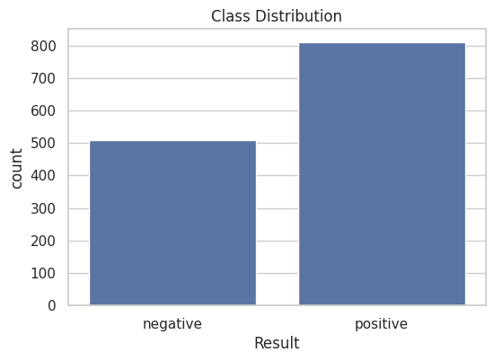
Figure 3.1: Target Variable Distribution

Feature Distribution Histograms
Figure 3.2 shows histograms for major clinical variables in the dataset. Variables include age, gender, heart rate, blood pressure, blood sugar, CK MB, and troponin. Histograms present the distribution pattern for each variable. I use such plots to examine central tendency and variability. The plots also reveal skewed distributions within several medical variables.
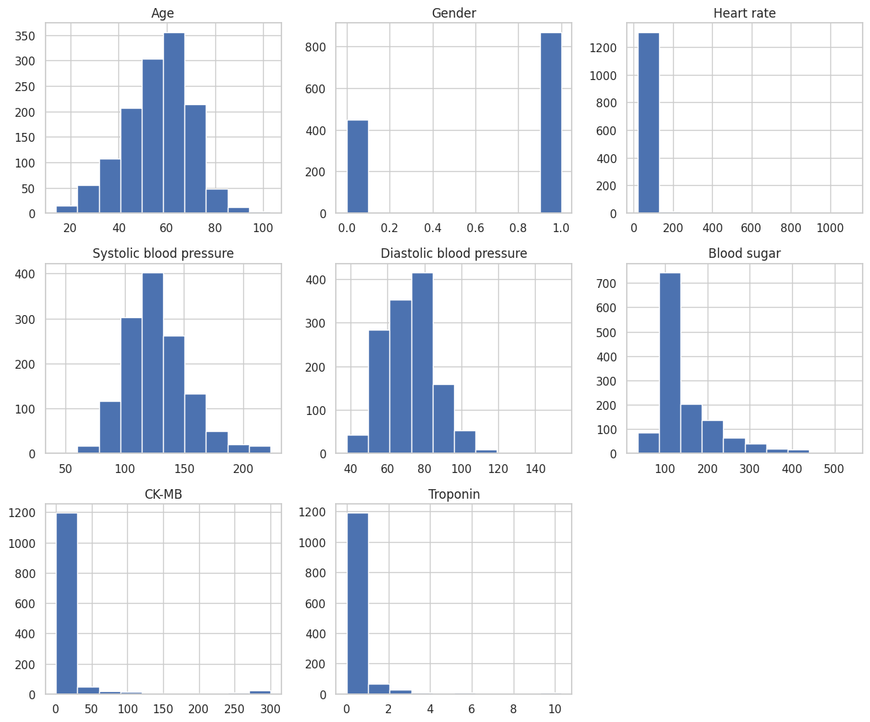
Figure 3.2: Feature Distribution of Important colom

Feature Correlation Matrix
Figure 3.3 presents correlation relationships between dataset variables. Correlation analysis measures strength of relationships between features. Systolic blood pressure and diastolic blood pressure show the strongest positive relationship. Most other variables show weak correlation values. Weak relationships suggest independent influence of several clinical attributes during cardiovascular risk prediction.
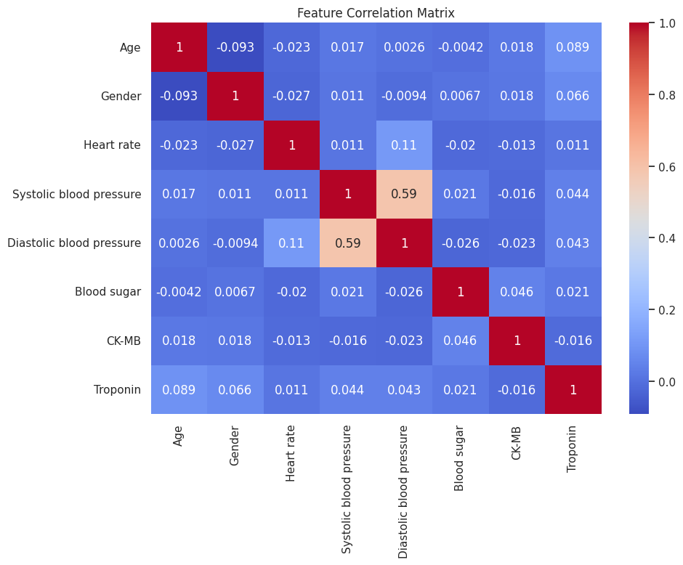
Figure 3.3: Correlation Heatmap to show Feature Relations with other feature.

Outlier Detection Using Boxplots
Figure 3.4 shows boxplots used for detection of extreme values within dataset variables. Boxplots help identify abnormal observations through distribution range and quartile spread. Variables such as blood sugar, CK MB, troponin, and heart rate show extreme values. Such values require preprocessing steps before machine learning model training. Data preprocessing improves reliability of predictive analysis.
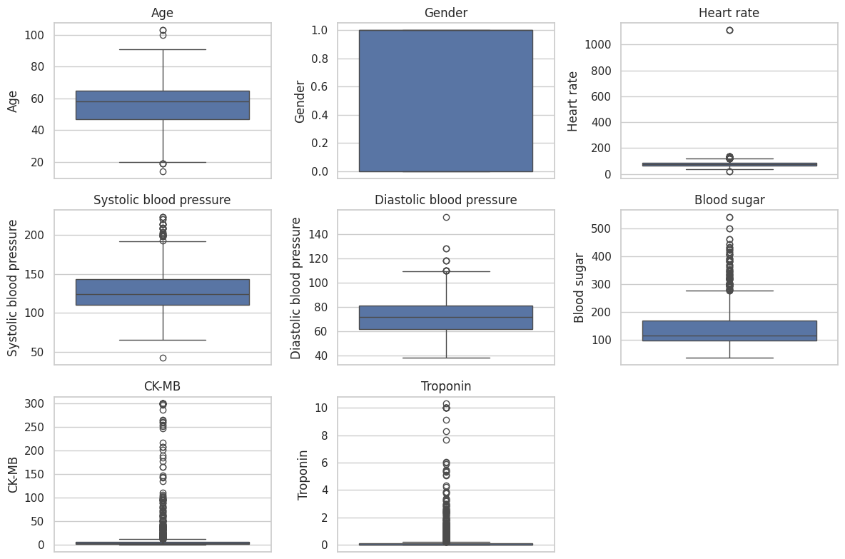
Figure 3.4: Boxplot to detect the outlier

Data Preprocessing
Label encoding was used to transform categorical data into numerical format which machine learning algorithms could process. I converted cardiovascular disease outcomes which include both positive and negative results into numeric labels for their research. The negative class was encoded as 0, while the positive class was encoded as 1. The dataset transformation created machine learning model compatibility while maintaining original class definitions used for prediction purposes.

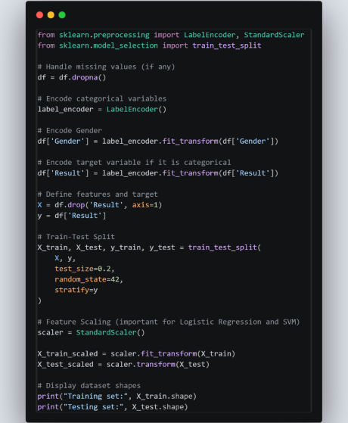

Methodology

Overview of Methodology
In this chapter I describes the methodology for development of machine learning models for cardiovascular disease risk prediction. The workflow includes data preprocessing, train test data splitting, model selection, hyperparameter optimization, model evaluation, cross validation, explainable artificial intelligence analysis, and class balancing techniques. The approach supports development of reliable and interpretable prediction models through clinical attributes including age, blood pressure, heart rate, blood sugar, CK MB, and troponin.

Train Test Split and Feature Scaling
- The dataset was divided into training and testing sets using an 80:20 ratio. Stratified sampling maintained the same class distribution in both subsets.
- StandardScaler functioned as the feature scaling method which standardized all numerical attributes. Standardization through this process prevents features with extensive numerical ranges from taking control of the learning procedure while it enhances model efficiency for both Logistic Regression and Support Vector Machine.

Machine Learning Models and Technical Rationale
Three machine learning algorithms served model development in this study. These algorithms include Logistic Regression, Support Vector Machine, and Random Forest.
- Logistic Regression served as the baseline model. Medical research often uses this algorithm for binary classification tasks. The model provides interpretable results and performs well when relationships between predictors and outcomes follow linear patterns.
- Support Vector Machine served as a kernel-based learning model. The algorithm performs well with high dimensional datasets. Kernel functions allow detection of nonlinear relationships between features. Biomedical classification tasks often apply Support Vector Machine because of strong generalization performance.
- Random Forest served as an ensemble learning model. The algorithm combines multiple decision trees to improve prediction performance. Ensemble learning reduces overfitting and improves robustness of predictions. Random Forest also captures complex interactions between variables and handles noisy data more effectively than single decision tree models.
Table 5.1 shows the initial model configuration that has been used in my study to train the models
Table 5.1 Initial Model Configuration
Model | Key Parameters | Initial Settings
Logistic Regression | Regularization parameter (C), solver | C = 1.0, solver = lbfgs
Support Vector Machine | Kernel, regularization parameter (C), gamma | Kernel = rbf, C = 1.0, gamma = scale
Random Forest | Number of trees, maximum depth | n_estimators = 100, max_depth = None

Hyperparameter Optimization
Hyperparameter optimization improved model performance through selection of optimal parameter settings for each algorithm. The study used Optuna, a Bayesian optimization framework, for automated hyperparameter search.
Table 5.2 shows the search space used for the optimization of the models
Table 5.2 Hyperparameter Search Space
Model | Parameter | Search Range
Logistic Regression | C | 0.001 – 10 (log scale)
SVM | C | 0.1 – 10
 | Kernel | Linear, RBF
 | Gamma | Scale, Auto
Random Forest | n_estimators | 50 – 300
 | max_depth | 3 – 20
 | min_samples_split | 2 – 10
The optimization process evaluated multiple trials for each model. The framework selected the parameter configuration which produced the highest performance during cross validation.

Model Evaluation
After hyperparameter optimization, the optimized models were trained with the training dataset. Evaluation used the testing dataset to measure performance on unseen data.
Several classification evaluation metrics supported performance assessment.
Accuracy: Measures the proportion of correct predictions produced by the model.
$$Accuracy=\frac{TP+TN}{TP+TN+FP+FN}$$
Precision: Measures the proportion of predicted positive cases which represent true positive outcomes.
$$Precision=\frac{TP}{TP+FP}$$
Recall (Sensitivity): Measures the ability of the model to identify positive cases within the dataset.
$$Recall=\frac{TP}{TP+FN}$$
F1 Score: Represents the harmonic mean of precision and recall. This metric provides balanced evaluation when class distribution varies.
$$F1-Score=2 X \frac{Precision X Recall}{Precision+ Recall}$$
Additional evaluation tools supported deeper analysis of model performance.
Confusion Matrix: Shows distribution of prediction outcomes including true positives, true negatives, false positives, and false negatives.
Receiver Operating Characteristic Curve: ROC curves measure classification performance across different decision thresholds.
Area Under the Curve: AUC measures the discrimination capability of the model. Higher AUC values indicate stronger classification performance.

K Fold Cross Validation
Fivefold cross validation supported additional validation of model reliability. The dataset was divided into five equal subsets.
Each iteration used four subsets for model training. The remaining subset served validation. The process repeated five times so each subset served validation once.
Average performance across all folds provided a reliable estimate of model generalization ability. Cross validation reduces bias which appears in single train test evaluation.

Model Explainability Using SHAP
Explainable artificial intelligence methods supported interpretation of model predictions through SHAP, Shapley Additive Explanations.
SHAP values measure the contribution of each feature within the prediction process. The technique improves transparency in machine learning models.
My study used SHAP analysis for several purposes.
- Identify the most influential features affecting cardiovascular disease risk prediction.
- Provide global feature importance visualization.
- Explain individual predictions through SHAP force plots.
- Interpretability holds strong importance in healthcare applications. Clinicians require transparent reasoning when machine learning systems support medical decision making.

Class Balancing Techniques
The dataset shows relatively balanced class distribution. Additional experiments examined the influence of class balancing methods on model performance.
Two oversampling techniques served this analysis.
- SMOTE, Synthetic Minority Oversampling Technique
  - This method generates synthetic minority samples through interpolation between existing observations.
- ADASYN, Adaptive Synthetic Sampling
  - This technique generates synthetic samples for minority class examples which appear difficult for model learning.

Results

Overview of the Chapter
In this chapter I presents the outcomes derived from machine learning models which I created to assess cardiovascular disease risk. I used four metrics to assess how well the model performed which included accuracy and precision and recall (sensitivity) plus F1-score. Accuracy assesses all prediction results while precision tests how dependable the model predicts positive outcomes and recall assesses how effectively the system finds heart disease patients and F1-score combines precision with recall to create an accurate performance evaluation.

Initial Model Performance
The Random Forest method achieved superior results to both Logistic Regression and SVM because it achieved an accuracy of 0.984848 and a precision of 0.984848 and a recall of 0.984848 and an F1-score of 0.984848 and a training duration of 0.777390 seconds and a testing duration of 0.048426 seconds according to Table 6.1.
Table 6.1 Initial Model Performance using Multiple performance metrics
Model | Accuracy | Precision | Recall | F1 Score | Train Time (s) | Test Time (s)
Random Forest | 0.984848 | 0.984848 | 0.984848 | 0.984848 | 0.777390 | 0.048426
Logistic Regression | 0.799242 | 0.797845 | 0.799242 | 0.798246 | 0.089797 | 0.000512
SVM | 0.746212 | 0.744949 | 0.746212 | 0.745482 | 0.462966 | 0.033583

Model Performance After Hyperparameter Optimization
According to Table 6.2 Random Forest achieved the highest performance among models by producing an accuracy of 0.981061 and precision of 0.981124 and recall of 0.981061 and F1-score of 0.981077 and training time of 0.409847 seconds and testing time of 0.017159 seconds after the hyperparameter tuning process.
Table 6.2 Optimized Model Performance
Model | Accuracy | Precision | Recall | F1 Score | Train Time (s) | Test Time (s)
Random Forest | 0.981061 | 0.981124 | 0.981061 | 0.981077 | 0.409847 | 0.017159
SVM | 0.833333 | 0.838228 | 0.833333 | 0.834573 | 0.323720 | 0.003872
Logistic Regression | 0.825758 | 0.826464 | 0.825758 | 0.826062 | 0.006938 | 0.000412
Figure 6.1 shows the comparison of accuracies pre and post optimization
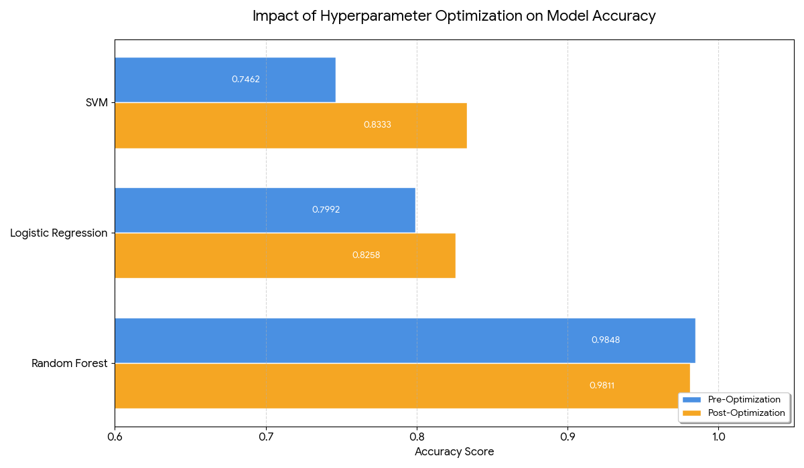
Figure 6.1: Impact of Optimization on Accuracy
Best parameters founded after optimization are
- Logistic Regression: {C': 3.16356327412739}
- SVM: {'C': 6.7193198199749755, 'kernel': 'linear', 'gamma': 'scale'}
- Random Forest:{'n_estimators': 226, 'max_depth': 3, 'min_samples_split': 2}

Visualization of Best Performing Model
The Confusion Matrix (Figure 6.2) presents the results of the Random Forest model through its confusion matrix which shows the model accuracy. The model correctly classified 100 negative cases and 159 positive cases, while only 2 false positives and 3 false negatives occurred, demonstrating highly accurate classification performance.
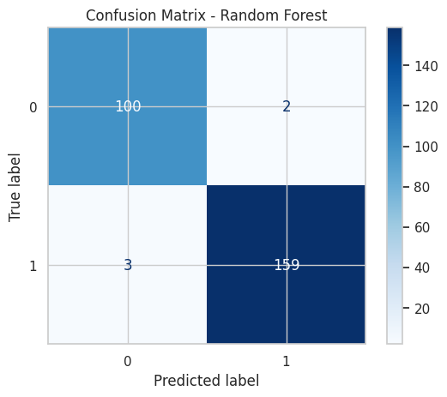
Figure 6.2: Confusion Matrix showing True positive and False Positive values of Outperform Model.
The Random Forest classifier shows its ROC curve through Figure 6.3. The model achieved an AUC value of 0.987, indicating excellent ability to distinguish between heart disease and non-heart disease cases.
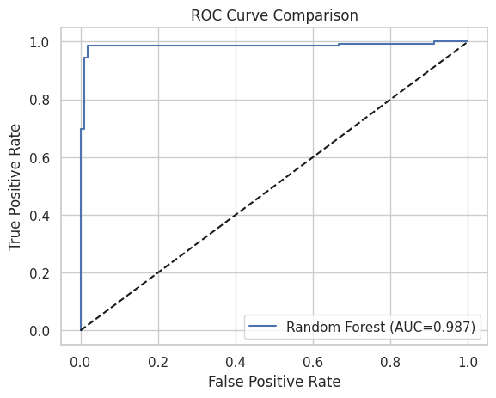
Figure 6.2: ROC curve of Random Forest Model

Cross-Validation Results
Table 6.3 shows Random Forest achieved the highest cross-validation performance with accuracy mean 0.984840, precision mean 0.985124, recall mean 0.984840 and F1 mean 0.984869, demonstrating strong generalization ability.

Table 6.3 Cross-Validation Performance Result of all three Models
Model | Accuracy Mean | Accuracy Std | Precision Mean | Precision Std | Recall Mean | Recall Std | F1 Mean | F1 Std
Random Forest | 0.98484 | 0.00535 | 0.98512 | 0.00531 | 0.98484 | 0.00535 | 0.98486 | 0.00534
Logistic Regression | 0.79227 | 0.02217 | 0.79448 | 0.01975 | 0.79227 | 0.02217 | 0.79222 | 0.02055
SVM | 0.73770 | 0.01816 | 0.73832 | 0.01701 | 0.73770 | 0.01816 | 0.73661 | 0.01798

Explainable Artificial Intelligence, SHAP Analysis
Figure 6.4 presents the SHAP summary plot showing feature influence on cardiovascular disease prediction. Troponin and CK MB show the highest SHAP values. These variables contribute the strongest impact on model predictions. Higher SHAP values indicate stronger influence on classification outcomes.

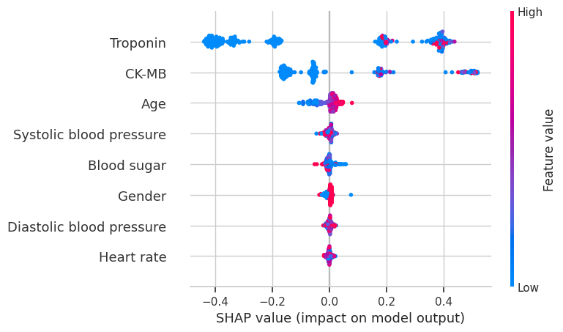
Figure 6.4: SHAP summary Plot shows feature influence
Figure 6.5 shows global feature importance based on mean absolute SHAP values. Troponin appears as the most influential predictor of cardiovascular disease. CK MB ranks second in feature importance. Age appears as the third most influential variable. These features contribute the strongest predictive signals within the model.
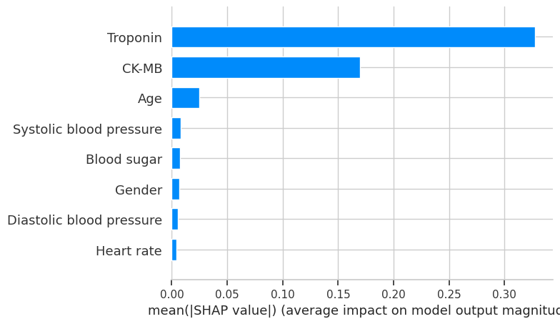
Figure 6.5: SHAP Feature Importance

Figure 6.6 shows the SHAP dependence relationship between heart rate and prediction impact. SHAP values show moderate variation across heart rate values. This pattern shows heart rate contributes moderate influence within the prediction process.
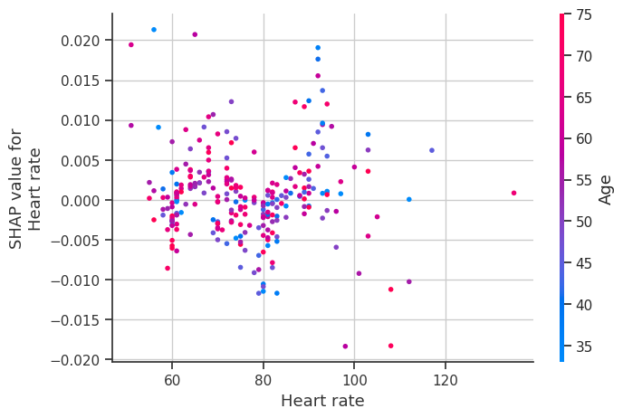
Figure 6.6: SHAP Dependence Plot for Heart Rate
Figure 6.7 presents the SHAP dependence plot for gender. SHAP values remain close to zero across both gender categories. This distribution shows gender contributes limited influence within cardiovascular disease prediction.
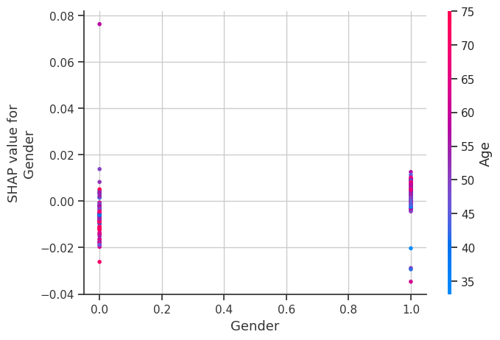
Figure 6.7: SHAP Dependence Plot for Gender
Figure 6.8 shows the relationship between age and SHAP prediction values. Higher age values correspond with positive SHAP values. This pattern indicates increasing age raises cardiovascular disease risk within the prediction model.
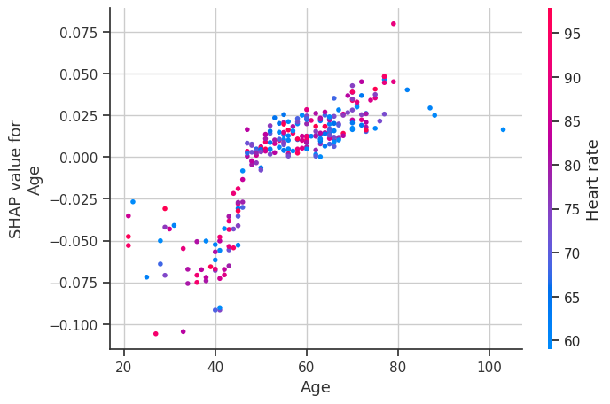
Figure 6.8: SHAP Dependence Plot for Age

Effect of Data Balancing Techniques
Table 6.4 presents the performance comparison between original dataset training and oversampling techniques. Random Forest trained on the original dataset produced the strongest results. The model achieved accuracy 0.984848, precision 0.984848, recall 0.984848, and F1 score 0.984848. Performance from SMOTE and ADASYN balanced datasets appeared slightly lower.
These results show the original dataset already maintained sufficient class distribution for effective model learning.
Table 6.4 Data Balancing Comparison(Before, After Smote, and with ADASYN)
Model | Dataset Type | Accuracy | Precision | Recall (Sensitivity) | F1 Score
Logistic Regression | Original | 0.799242 | 0.797845 | 0.799242 | 0.798246
SVM | Original | 0.746212 | 0.744949 | 0.746212 | 0.745482
Random Forest | Original | 0.984848 | 0.984848 | 0.984848 | 0.984848
Logistic Regression | SMOTE | 0.772727 | 0.788972 | 0.772727 | 0.775511
SVM | SMOTE | 0.738636 | 0.763206 | 0.738636 | 0.742055
Random Forest | SMOTE | 0.981061 | 0.981124 | 0.981061 | 0.981077
Logistic Regression | ADASYN | 0.776515 | 0.801022 | 0.776515 | 0.779438
SVM | ADASYN | 0.742424 | 0.773615 | 0.742424 | 0.745723
Random Forest | ADASYN | 0.981061 | 0.981124 | 0.981061 | 0.981077
Figure 6.9 shows the comparison of Original, SMOTE, and ADASYN on Recall
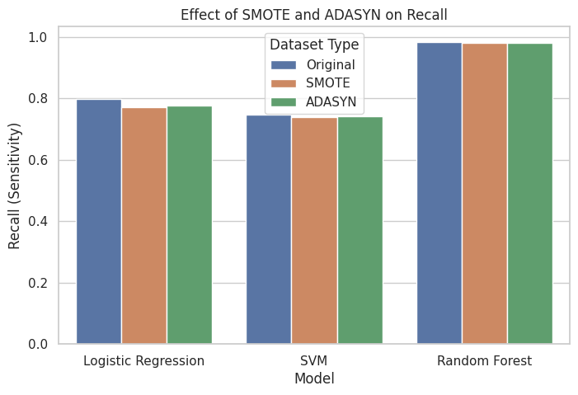
Figure 6.9: Comparison of different technique on Recall

Addressing Research Questions
- The Random Forest method produced its best results through its F1-score achievement which reached 0.984848, thus proving it functions as the most accurate method for cardiovascular disease classification.
- The SHAP analysis of RQ2 discovered that Troponin and CK-MB biomarkers function as the primary predictive elements while age and blood pressure rank as secondary predictive elements.
- The study results showed no enhancement in recall through data balancing methods which used SMOTE and ADASYN because the original dataset already contained sufficient class representation.

Practical Applicability
The Random Forest model shows its ability to function efficiently in actual healthcare operations. The model requires 0.409847 seconds for training and 0.017159 seconds for testing, which enables it to deliver fast predictions that help doctors find patients with high cardiovascular risk while supporting early diagnosis and treatment.

Analysis and Discussion

Overview of the Analysis
This chapter analyzes and interprets the results presented in Chapter 6. The analysis evaluates performance of machine learning models developed for cardiovascular disease risk prediction. The discussion explains how the results address the research objectives and research questions. The chapter also compares the findings with previous studies from the literature review. Practical relevance and study limitations also receive evaluation.

Interpretation of Model Performance
The Random Forest model achieved the highest predictive accuracy among the tested models when it produced an F1-score of 0.984848 together with accurate and precise results. The confusion matrix confirms the model's effectiveness because it shows two false positives and three false negatives which demonstrate its ability to detect cardiovascular disease risk. The ensemble learning structure explains this performance, as Random Forest combines multiple decision trees to capture complex relationships between variables such as troponin, CK-MB, and blood pressure while reducing overfitting. The Support Vector Machine model requires extensive parameter adjustments together with specific dataset features to operate effectively, while Logistic Regression restricts its predictive abilities through its assumption of direct linear relationships.

Comparison with Existing Literature
The research results match earlier studies which used machine learning models to predict cardiovascular disease. Ogunpola et al. (2024) reported strong performance from ensemble models such as XGBoost and Random Forest. achieved high prediction accuracy through their use of Dalal et al. (2023) clinical datasets. The study results demonstrate that Random Forest delivers effective classification results through its high F1-score, which proves the success of ensemble learning techniques. The study results which use SHAP for model interpretation back up the research findings of Shimizu et al. (2024), who focused on the need for explainable machine learning in healthcare decision support systems.

Feature Importance and Clinical Interpretation
SHAP analysis identified troponin and CK-MB as the most influential predictors of cardiovascular disease risk, confirming their clinical importance in diagnosing heart damage. Age positively affected the prediction results. The model showed more accurate cardiovascular disease predictions from heart rate and blood sugar and gender than from other factors.

Impact of Data Balancing Techniques
I assessed class balancing methods through the testing of SMOTE and ADASYN during their model development process. The results demonstrated that predictive capabilities remained unchanged through the testing of different methods. The Random Forest model trained on the original dataset achieved the highest F1 score among all tested models. The dataset demonstrated adequate balance which synthetic oversampling methods decreased model accuracy according to the results.

Practical Applicability of the Model
The Random Forest model shows strong potential for healthcare implementation. The model achieved high predictive performance with efficient computational speed.
Model training required approximately 0.409847 seconds. Model testing required approximately 0.017159 seconds. These processing times support rapid prediction generation.
Fast prediction capability supports integration within clinical decision support systems. Healthcare professionals could use such systems to analyze patient health indicators and identify individuals with elevated cardiovascular disease risk at an early stage.

Limitations of the Study
Several limitations require consideration.
- The dataset used in this study originated from a single hospital environment. This factor limits generalization of the model across different healthcare populations.
- The dataset also contains a limited number of clinical variables. Inclusion of additional attributes such as lifestyle habits, family medical history, or genetic indicators may improve predictive performance.
- The study also evaluated only three machine learning algorithms. Future research may examine additional models including gradient boosting algorithms or deep learning methods.

Relationship to Research Questions and Objectives
The results successfully address the research questions presented in Chapter 1.
- Random Forest achieved the highest F1 score among the evaluated models. This result answers the first research question.
- SHAP analysis identified the most influential cardiovascular risk predictors. This result answers the second research question.
- Evaluation of SMOTE and ADASYN balancing techniques showed no improvement in recall or overall performance. This result answers the third research question.

Conclusion
The research examined how well machine learning algorithms could forecast cardiovascular disease risk by using clinical health indicators as their prediction base. I created three different classification models which they tested through their implementation of Logistic Regression, Support Vector Machine, and Random Forest. The study found that Random Forest produced the best predictive results because it reached an F1 score of 0.984848 which showed accurate classification results for both heart disease and non-heart disease cases. The SHAP analysis found that troponin and CK-MB served as the main predictor variables because the machine learning model successfully detected important clinical connections throughout the dataset.
The study results prove that machine learning systems assist medical staff to identify cardiovascular disease risk at early stages while they make treatment choices. The Random Forest model showed quick computing capabilities because it required 0.409847 seconds for training and 0.017159 seconds for testing which allowed fast predictions to occur in hospital settings. These systems enable hospitals to detect patients who face the highest health risks while they create methods to maintain their health. The researchers will develop their current project through the analysis of extensive multi-hospital databases which will include extra medical and personal data and through testing modern techniques like gradient boosting algorithms and deep learning models.

References
Dalal, S., Goel, P., Onyema, E. M., Alharbi, A., Mahmoud, A., Algarni, M. A., & Awal, H. (2023). Application of Machine Learning for Cardiovascular Disease Risk Prediction. Computational Intelligence and Neuroscience, 2023(1). https://doi.org/10.1155/2023/9418666
Effati, S., Kamarzardi-Torghabe, A., Azizi-Froutaghe, F., Atighi, I., & Ghiasi-Hafez, S. (2024). Web application using machine learning to predict cardiovascular disease and hypertension in mine workers. Scientific Reports, 14(1). https://doi.org/10.1038/s41598-024-80919-9
Liu, T., Krentz, A., Lu, L., & Curcin, V. (2025). Machine learning based prediction models for cardiovascular disease risk using electronic health records data: systematic review and meta-analysis. European Heart Journal - Digital Health, 6(1), 7–22. https://doi.org/10.1093/ehjdh/ztae080
Mim, T. J. H., Hassan, M. M., Paul, B. K., & Mollah, M. S. H. (2025). Machine Learning Approaches for Cardiovascular Disease Prediction: A Comparative Study. Biomedical Materials and Devices. https://doi.org/10.1007/s44174-025-00564-2
Ogunpola, A., Saeed, F., Basurra, S., Albarrak, A. M., & Qasem, S. N. (2024). Machine Learning-Based Predictive Models for Detection of Cardiovascular Diseases. Diagnostics, 14(2). https://doi.org/10.3390/diagnostics14020144
Salah, H., & Srinivas, S. (2022). Explainable machine learning framework for predicting long-term cardiovascular disease risk among adolescents. Scientific Reports, 12(1). https://doi.org/10.1038/s41598-022-25933-5
Shimizu, G. Y., Schrempf, M., Romão, E. A., Jauk, S., Kramer, D., Rainer, P. P., da Costa, J. A. C., de Azevedo-Marques, J. M., Scarpelini, S., Suzuki, K. M. F., César, H. V., & de Azevedo-Marques, P. M. (2024). Machine learning-based risk prediction for major adverse cardiovascular events in a Brazilian hospital: Development, external validation, and interpretability. PLoS ONE, 19(10 October). https://doi.org/10.1371/journal.pone.0311719

Appendix:
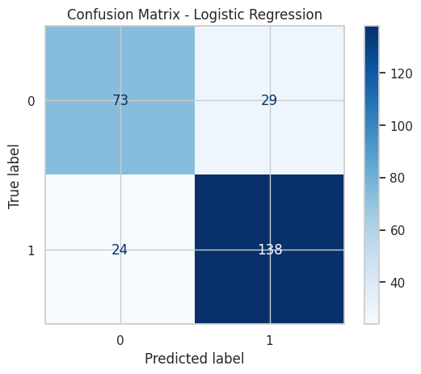
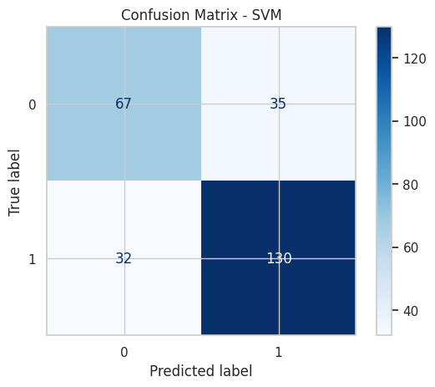
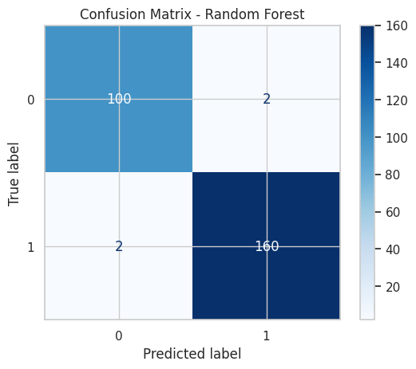
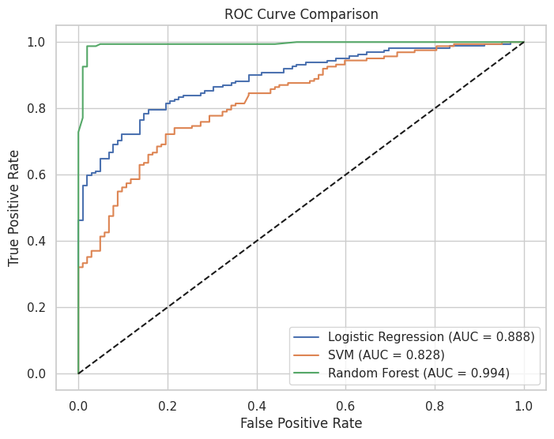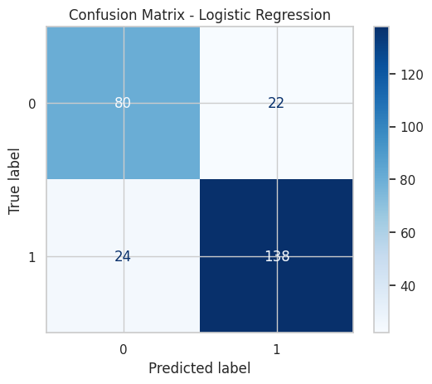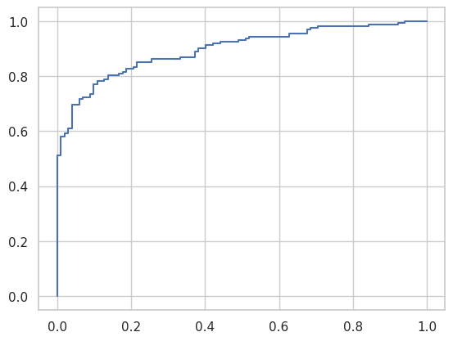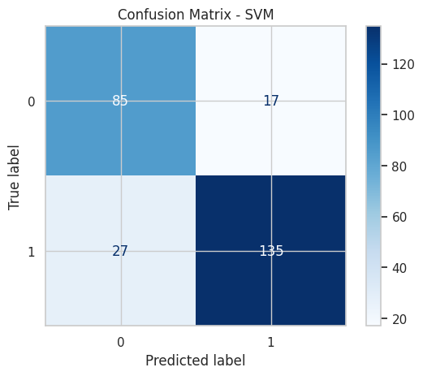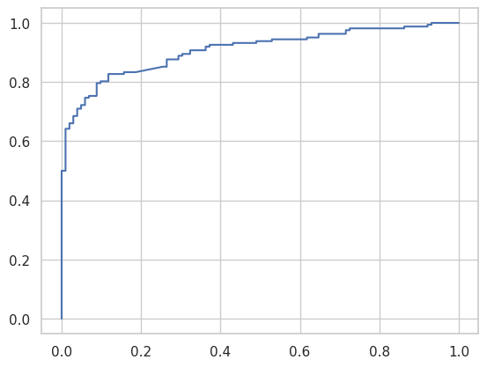

https://data.mendeley.com/datasets/wmhctcrt5v/1

