Overview
In this problem, we are given a list of buildings and would like to construct the skyline, a set of key points that describes the contour of the buildings, as shown in the picture below.
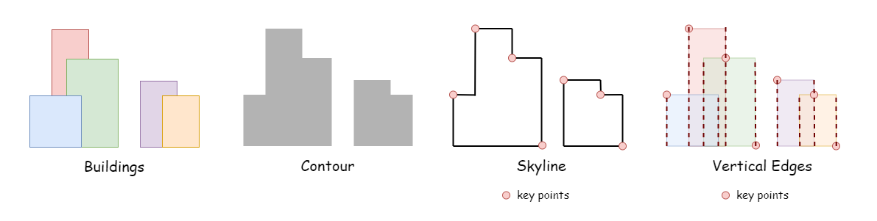
This problem is very interesting and challenging with some tricky corner cases. Here we introduce several approaches starting with two brute-force algorithms that might not pass under the limited time but can pave the way for more efficient approaches.

Approach 1: Brute Force I
Collect all the positions of the left and right edges from buildings, that's all the possible x where skyline key points are generated. For convenience, let's number these unique positions sequentially, representing these positions by indexes according to their location on the x-axis.
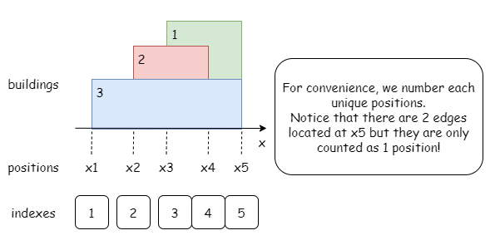
If a building with height h covers the indexes from x_i to x_j, then all the indexes from x_i to x_j (exclusive) have the height of h at least. Notice that the right edge of a building doesn't count!
Therefore, we can iterate over all the buildings, and for each building we find the positions of its left edge and right edge and their corresponding indexes left_index and right_index. Then we update the maximum height for all the indexes within the range [left_index, right_index). Finally, traverse the updated heights and output all the positions where height changes as skyline key points!

1 / 5
Algorithm
- Collect all unique positions for the left and right edges of the buildings in buildings and save them in list edgeSet.
- Initalize:
  - an empty list heights of the same length as edgeSet.
  - hashtable edge_index_map stores corresponding index and value of elements from heights.
  - empty list answer for skyline key points.
- Iterate over buildings, for each building buildings[i]:
  - Get the index of its left edge and right edge left_index, right_index, and its height height.
  - For index in [left_index, right_index), update heights[index] if necessary.
- Traverse the updated heights and add all the positions where the height changes to answer as skyline key points.
- Return answer as the skyline.
Implementation
Complexity Analysis
Let n be the length of the input array buildings.
- Time complexity: O(n2)
  - Obtaining our sorted list of positions will require an average of O(nlogn) time.
  - Then for each of the n buildings, we need to update the maximum heights at all the indexes covered by its left edge and right edge. In the worst-case scenario, we have to update n values in each iteration step, so this process will take O(n2) time.
- Space complexity: O(n)
  - The number of left and right edges is 2n, thus we need a set and an array of size O(n).
  - Then we need a hash table of indexes and an array of heights, both of size O(n).
  - We also use an answer array to store all the skyline points, of which there are at most n.

Approach 2: Brute Force II, Sweep Line
Another instinctive idea is to use a vertical line of infinite length to sweep over the ground from the left to right. The line stops by every edge and we shall record the maximum height among all the buildings that intersect with the line. As shown in the picture below, the right edge of a building doesn't count!
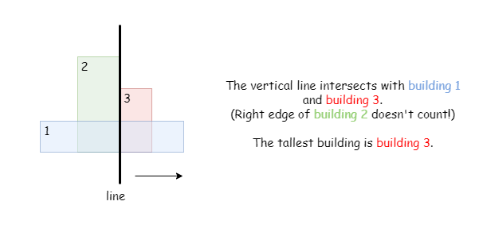
Let's refer to the slides below for an explanation:

1 / 7
For more information about Sweep Line Algorithm, please refer to wikipedia.
Algorithm
- Initialize an empty list answer for skyline key points.
- Use a set (edgeSet) to store all distinct edges in buildings.
- Iterate over the sorted positions, and for each position:
  - Check for buildings that intersect with the imaginary vertical line at position. (A building is considered to be intersecting with the line if position is within the range [left, right).)
- The max_height is the maximum height of the intersecting buildings at position, or 0 if no building intersects with the line.
- If max_height differs from that of the previous skyline point, add a new skyline point to answer.
- Return answer as the skyline.
Implementation
Complexity Analysis
Let n be the length of the input array buildings.
- Time complexity: O(n2)
  - Obtaining our sorted list of positions will require an average of O(nlogn) time.
  - Then for each of the 2n positions we need to check if any of the n buildings intersect with the line at that position. This process will take O(n2) time.
- Space complexity: O(n)
  - The number of left and right edges is 2n, thus we need a set and an array of size O(n).
  - We also use an answer array to store all the skyline points, of which there are at most n.

Approach 3: Sweep Line + Priority Queue
Intuition
In the previous sweep line approach, we had to iterate through all the buildings at each position and ended up with O(n2) time complexity. We are looking for a more efficient way of determining such intersecting buildings. (For convenience, let's call them "live" buildings from now on.)
Notice that the current height is only decided by the tallest "live" building, hence we no longer need to traverse over all the buildings if we can get the tallest "live" building directly! This can be implemented by using a priority queue. Similar to the previous approach, we can use a vertical line to sweep along the x axis. In this approach, however, we add each intersecting building to the priority queue live. Therefore, whenever we need to get the height of the tallest "live" building, we can just check the top result from live (or 0 if live is empty), rather than iterating over all the buildings!
What if we run into the right edge of a building?
Theoretically, we should remove the building from live once we run into its right edge (recall the right-edge-doesn't-count conclusion), meaning we have passed this building so it won't contribute to the skyline height anymore. As long as the tallest building is surely live, it's okay if some lower buildings that have been passed are still in live. We only need to make sure we remove a "past" building once it becomes the tallest one in live.
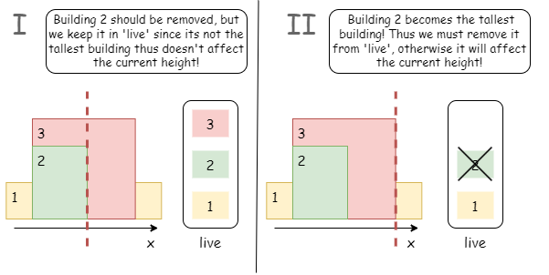
First, we need to sort all the edges in non-decreasing order for the sweep line algorithm. In order to track which building a certain edge belongs to, we should also mark each edge with the index of the building in buildings.
Since there might be multiple edges at the same position on the x-axis, we should finish handling all edges at the same position before moving on to the next position.
Take the slide below as an example!

1 / 10
Algorithm
- Iterate over buildings and store each building's edges separately with the building's index as a reference in edges.
- Sort the entries in edges by their first element.
- Iterate over the sorted edges and for each edge/index:
  - If buildings[b][0] == curr_x, meaning its a left edge and the building[b] is live, we add (height, right) to live.
  - While the tallest live building has been passed, remove it from live.
- Once we finish handling all the edges at the curr_x, we shall move on to the next position.
- After the iteration, return answer as the skyline.
Implementation
Complexity Analysis
Let n be the length of the input array buildings.
- Time complexity: O(nlogn)
  - There are 2n edges so we have at most O(n) unique positions during the iteration.
  - At each step, we need to pop out the passed buildings from priority queue live and put in the newly added building (if exist). In worse-case scenario, we have O(n) live buildings in live, both the pop and push operations take O(logn) time.
  - To sum up, the overall time complexity is O(nlogn).
- Space complexity: O(n)
  - We initalize edges of size O(2n) to store all the edges and its indexes, empty list answer to store all the skyline key points.
  - We maintain a priority queue live which has at most O(n) elements.
  - There can be at most O(n) skyline key points, thus answer takes at most O(n) space.
  - Therefore, the overall space complexity is O(n).

Approach 4: Sweep Line + Two Priority Queue
We still use a priority queue live to keep all the buildings we picked up. Recall that in the previous approaches, we have to assign an auxiliary mark (the mark could either be the position of its right edge, or its original index in buildings) to each building, thus we can get the position of its right edge, so as to judge if the top building from live should be dropped. Here, we can make this step more intuitive, by discarding this unique index and only storing the heights of buildings: Whenever we meet the left edge of a building, we just add its height to live.
But how do we know if some buildings apart from the top buildings should be removed? Since we are not expected to remove an intermediate element from a regular priority queue.
We use another priority queue (let's call it past) to keep all the buildings that should be removed from live but haven't been yet.
We can see that live works as a debt card: it can temporarily record our "debt". Once we are able to pay the "debt", that is. when the top building in live equals the top building in past, we will remove it from past. Since the "debt" has been cleared, we will remove the top building from past as well.
We repeatedly remove top building from both live and past, until:
- past is empty, meaning every building in live is literally "live".
- The top building in live is taller than the top building in past, in this case, we may still have some buildings to remove, but their height is too small to affect the height of the top building.
Take the following slides as an example:

1 / 9
Algorithm
- Initalize:
  - an empty list edges for storing all the x-values of the left and right edges.
  - an empty list answer for storing all the skyline key points.
  - an empty priority queue live for storing the live buildings.
  - an empty priority queue past for storing the buildings that should be removed already.
- Iterate over buildings, for building[i] = [left, right, height], add [left, height], [right, -height] to edges, thus we can easily distinguish if an edge is a left edge (height > 0) or a right edge (height < 0).
- Sort edges by the first elements of its elements.
- Iterate over edges, for every edges[idx] let curr_x = edge[idx][0], while curr_x = edge[idx][0]:
  - If height > 0, add height to live.
  - Otherwise, add height to past.
  - increment idx by 1.
- While past is not empty and top buildings from live and past have the same height, remove top building from both live and past.
- Get max_height from live (max_height = 0 if live is empty).
- If answer is empty or max_height changes, add [curr_x, max_height] to answer as a new skyline key point.
- After the iteration, return answer as the skyline.
Implementation
Complexity Analysis
Let n be the length of the input array buildings.
- Time complexity: O(n⋅logn)
  - We sort a list with length of 2⋅n, which takes O(n) time.
  - Then we iterate over all the sorted edges, during the iteration, we have to manipulate on two priority queues, the amortized cost of this operation is O(logn).
  - To sum up, the overall time complexity is O(n⋅logn)
- Space complexity: O(n)
  - We used an empty array edges to store the information of all the left and right edges. There are 2⋅n edges and will cost O(n) space.
  - Besides, we need to maintain two priority queues, in the worst-case scenario, each of them takes O(n) space.
  - To sum up, the overall space complexity is O(n).

Approach 5: Union Find
Algorithm
Recall the first brute-force solution with O(n2) time complexity; whenever we added a new building, we had to traverse over all the indexes covered by the building and update the appropriate values in heights. Now suppose that a building has a very small height, and many of its heights values have previously been updated by some taller buildings, thus won't update this time.
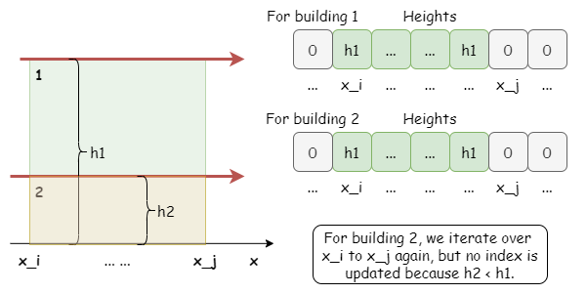
Can we find a method to avoid such "unnecessary" non-updates? The answer is: "Yes!"
Imagine if we give some indexes a billboard saying:
All the heights starting from me and ending by XXX (an index on its right) have already been updated! These heights are larger than yours, thus you don't need to bother attempting to update these heights; just jump directly to XXX and move on!
It seems feasible! Let's give it a shot by assigning a value to each edge, which equals the rightmost edge of the consecutive range having a height no less than the current edge.
What is the use of such value?
It will help identify the range of edges that we can just skip past.
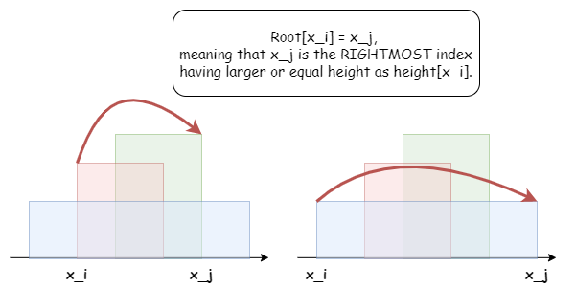
As shown in the picture below, unlike iterating over every index and updating nothing, we will first look up the current index in root to see if we can skip past any intermediate indexes that have already been updated by some taller buildings. This is the core difference between this approach and the brute-force one!
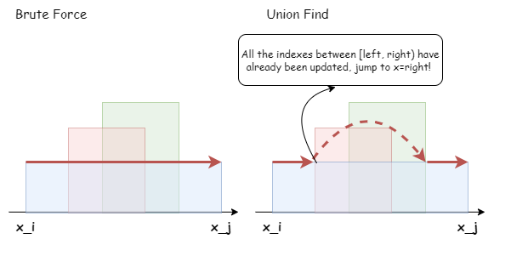
How can we maximize skips by assuring that the updates are made by taller buildings first?
We can iterate over the buildings by descending height. Therefore, for each building, all the previous updates in heights are made by buildings of larger or equal height! We can safely skip those indexes that have been updated already.
Which data structure should we use?
We can use a disjoint-set data structure to store this relation between indexes. The root of an index x_i can be regarded as the rightmost index x_j where all indexes in the range [x_i, x_j) have larger or equal heights as that of x_i.
Let's refer to the slides below as an example:

1 / 12
Implementation
- Use a set to collect all the unique positions of left and right edges of the buildings in buildings and make sure they're in sorted order.
- Iterate over all the buildings by descending height, and for each building:
  - Use the hash table to convert the left and right edges into leftIndex and rightIndex.
  - While leftIndex < rightIndex:
    - Use the UnionFind.Find() to advance leftIndex to Find(leftIndex), skipping past unnecessary indexes.
    - Update heights with the current height at the new leftIndex.
    - Use the UnionFind.Union() to set the root of leftIndex to the root of rightIndex and increment leftIndex by 1.
- Iterate over the updated heights and add every position where the height changes to answer as the skyline key points.
Complexity Analysis
Let n be the length of the input array buildings.
- Time complexity: O(nlogn)
  - Sorting the n buildings has an average time complexity of O(nlogn), though sorting algorithms vary by language.
  - There are at most 2n unique positions for 2n edges, and sorting them similarly has an average time complexity of O(nlogn).
  - The UnionFind.union() function has a time complexity of O(1) and will run at most 2n times for an overall time complexity of O(n).
  - The UnionFind.find() function has a time complexity of O(n) for the worst-case scenario, but using a collapsing find technique brings this down to O(1) with repeated use. This amortizes to an overall time complexity of O(n), as each successful find() will update a value in root, and there are up to 2n elements in root. As shown in the picture below.
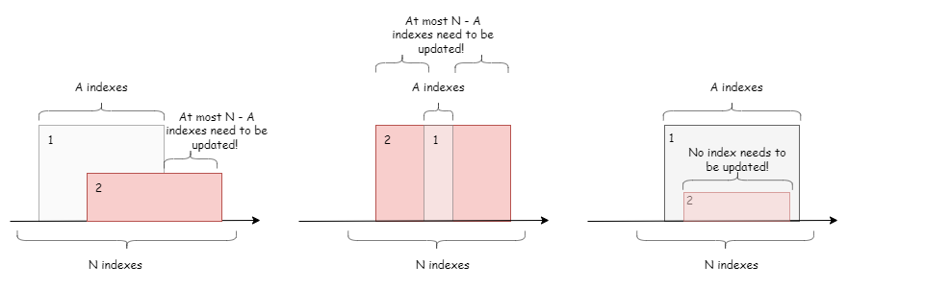
- Space complexity: O(n)
  - There are at most 2n edges, thus the set edgeSet, the lists edges, heights, and answers, the union-find's root list, and the recursion stack for the union-find's find() are each limited to O(n) space.

Approach 6: Divide-and-Conquer
Intuition
The divide-and-conqueror algorithm is a common algorithmic paradigm based on recursion with three core parts:
- Divide: Divide the original problem into a number of smaller sub-problems.
- Conquer: Solve the sub-problems recursively.
- Combine: Merge these sub-problem solutions into a solution for the original problem.
For more information on divide-and-conqueror, please refer to the LeetCode explore card.
Recall how we sort a list of numbers using merge-sort (divide-and-conqueror):
- Divide the unsorted list into two roughly even sublists.
- Sort each of the sublists recursively.
- Merge the sorted sublists back together.
Similarly, we can solve this problem using the divide-and-conquer algorithm.
- Divide the list of buildings into two roughly even sublists.
- Get the skyline from each of the sublists recursively.
- Merge the two skylines together.
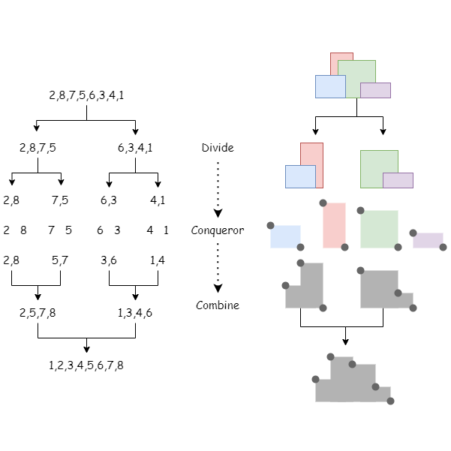
The first step is straightforward as we can simply split the list of buildings into two halves. For the base case in the second step, we can get the skyline from a single building directly. In the third part, two skylines should be merged into one skyline, we would use a much simplier version of sweep line algorithm.
Let's take the following slides as an example.

1 / 10
We always compare the heights from both skylines, even if R comes before L, we should also consider the height of L as well.
Take the picture below as an example:
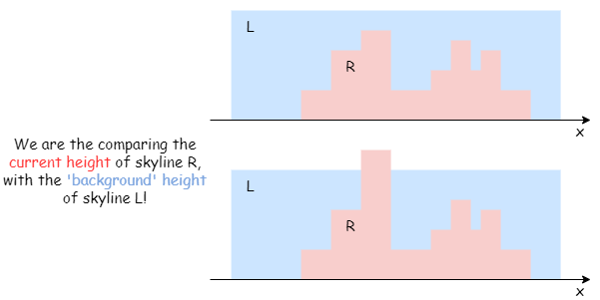
In the graphic's first case, R has many skyline points, yet we don't add any of them to our answer, That's because they're "hidden" behind the taller building in L. Hence the merged skyline's height doesn't change unless the current point's height is taller than the current height of the opposite side. In the graphic's second case, for example, we can add a skyline point where the height of R exceeds L.
Algorithm
- Recursively divide the current array buildings into two halves.
- When the recursion reaches the base case of a single building, return the simple skyline.
- Merge the resulting skylines using a line sweep algorithm moving from left to right.
- Return the fully merged skyline.
Implementation
Complexity Analysis
Let n be the length of the input array buildings.
- Time complexity: O(nlogn)
  - During the divide-and-conquer process, we recursively cut the array into two halves, thus logn steps are needed to split the original input array into single buildings and then merge them back together. In other words, the recursion stack has a depth of logn levels.
  - In each level of the recursion, it takes a total of O(n) time to merge all the sub-skylines into larger skylines.
- Space complexity: O(n)
  - We need O(n) space to create the answer array to record the merged skylines as there are at most 2n skyline key points.
  - The recursion stack also requires an additional O(logn) space.

