1.After Running the Project we will land into login page. We need to enter mobile

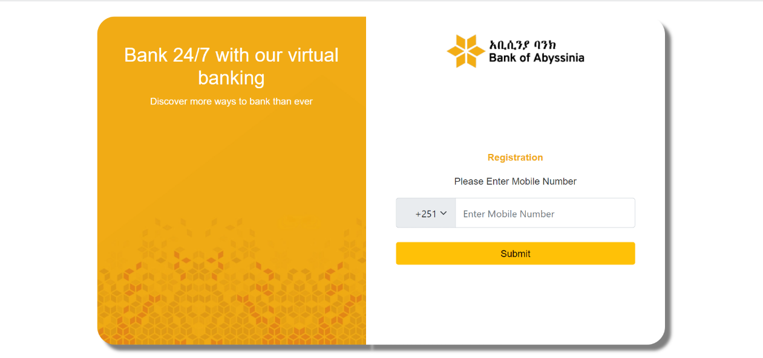

2.Once you enter the mobile number and click Submit we will redirect to password screen

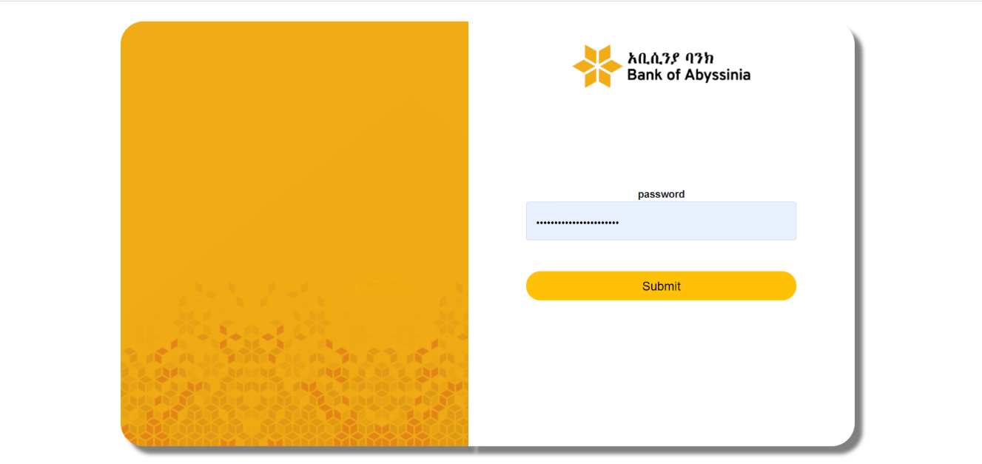

2.After entering password we need to click submit it will redirect to dashboard with 3 options
1.Create User
2.Update User
3.Logout

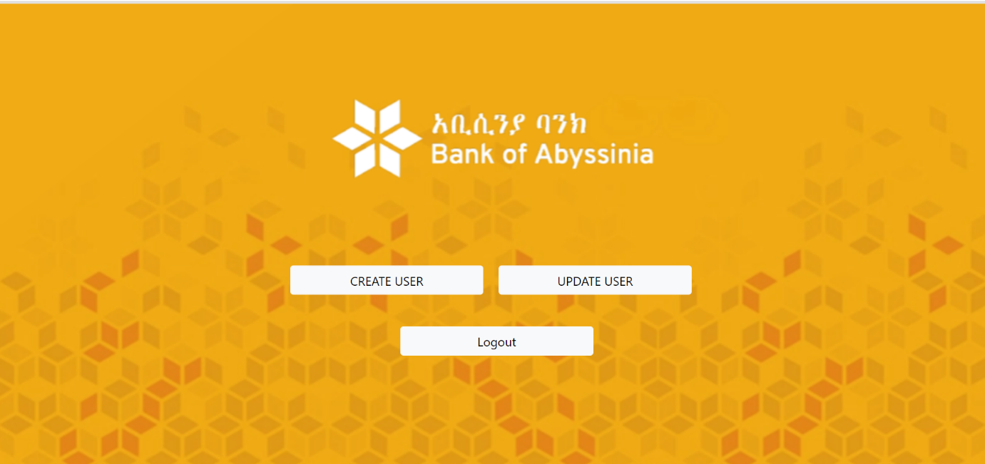

3.If we want to create User we need to create new user we need to click on Create User button then we will redirect to create user screen.

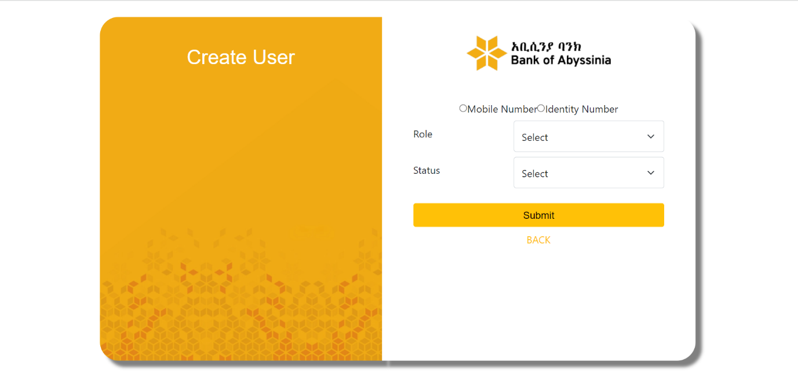

Here we can find two options to create new user
1.With Mobile Number
2.With Identity Number

If we click on mobile number radio button then mobile number text will open and we can create new user with enrolled mobile number
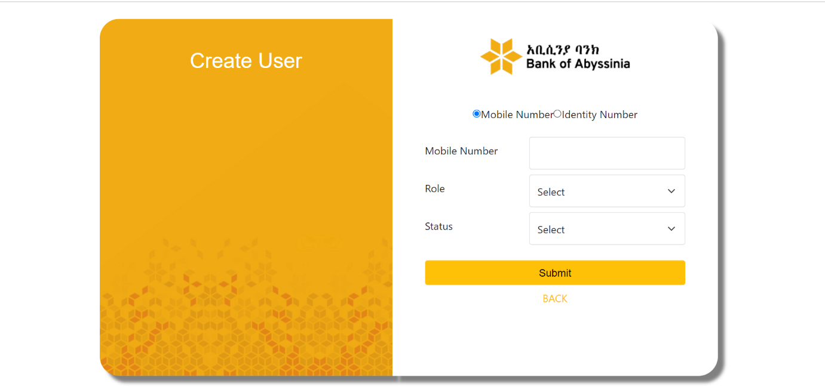

If we want to create a new user with identity number then we can click on identity number radio button then we can create new user with identity number

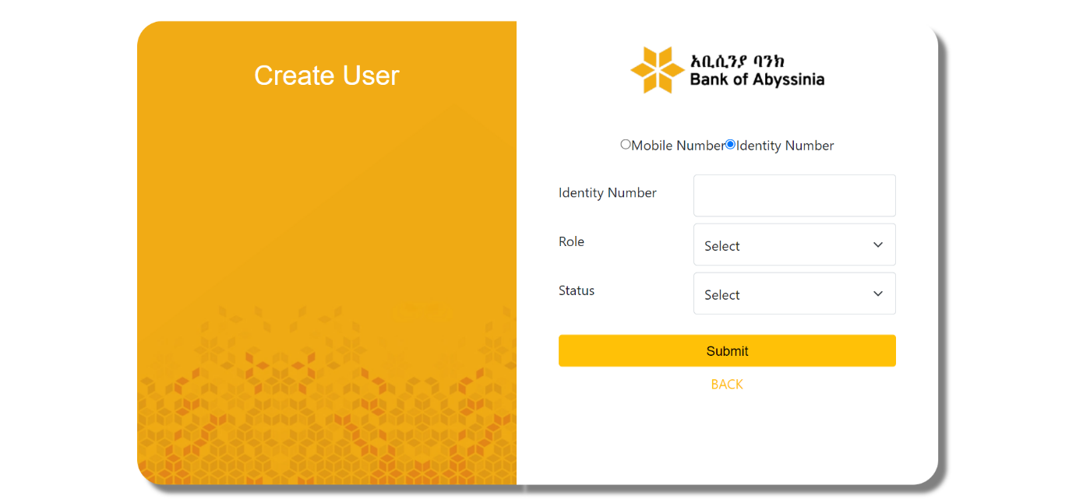

Here we need to submit all the fields, Because all fields are mandatory. After filling all the fields then need to click on submit then new user will be create based on the values you submitted.

4.If we want to update user then we need to click on update user in the dashboard screen the we will navigate to update user screen
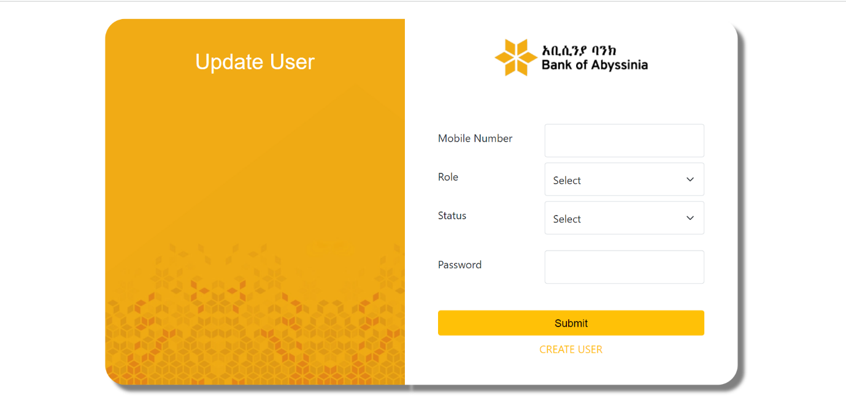

Here we need to fill all the fields and click on submit user will be updated .

5. if you want to logout the application then we need to click on logout which is in dashboard.

