**HDR Imaging and Tone Mapping Algorithms**

by

Ravi Jain

(Roll No. 2013167)

**Supervisor (s) :**

**External :**​ ​**Internal :**

Mr. Radhish Ayyappan Dr. Ayan Seal

Project Manager Assistant Professor

Canon ISDC, Bangalore PDPM IIIT DM Jabalpur



**Computer Science & Engineering (B.Tech 2013 )**

**INDIAN INSTITUTE OF INFORMATION TECHN­­OLOGY, DESIGN AND MANUFACTURING JABALPUR**

3rd Report

(12th July 2016 ­ 26th July 2016)

Due to near release date of our project in the company, I had to work on designing a dashboard using python language. The HDR imaging topic will continue after the release of this project.

**Introduction** –

* The aim of this project is to design a dashboard for certain csv(comma separated value) and log files, which would display details of these in addition to certain graphs for indicating kernel execution times.
* The python program takes as input a csv file, its corresponding log file, median value files (if any) and path to the images which can be viewed in the dashboard.
* The skills used for the development of this dashboard are python, angularjs, javascript, bootstrap, css, html, matplotlib and jquery.

**Procedure -**

The dashboard serves the purpose of displaying details such as kernel execution time, total time etc. on executing certain algorithms over several images and drawing a comparison between different test environment types.

The set of csv files include details of algorithms such as sum of squared differences, mutual induction, gradient image filter etc.

The aim was to display the logs of execution of these algorithms over certain images.

Furthermore, graphs were also made using matplotlib, including comparison plots, box plots.

Modules such as numpy were used.

The initial task was to understand use of these tools and install libraries on my system.

**Sample Files –**

**Csv file -**

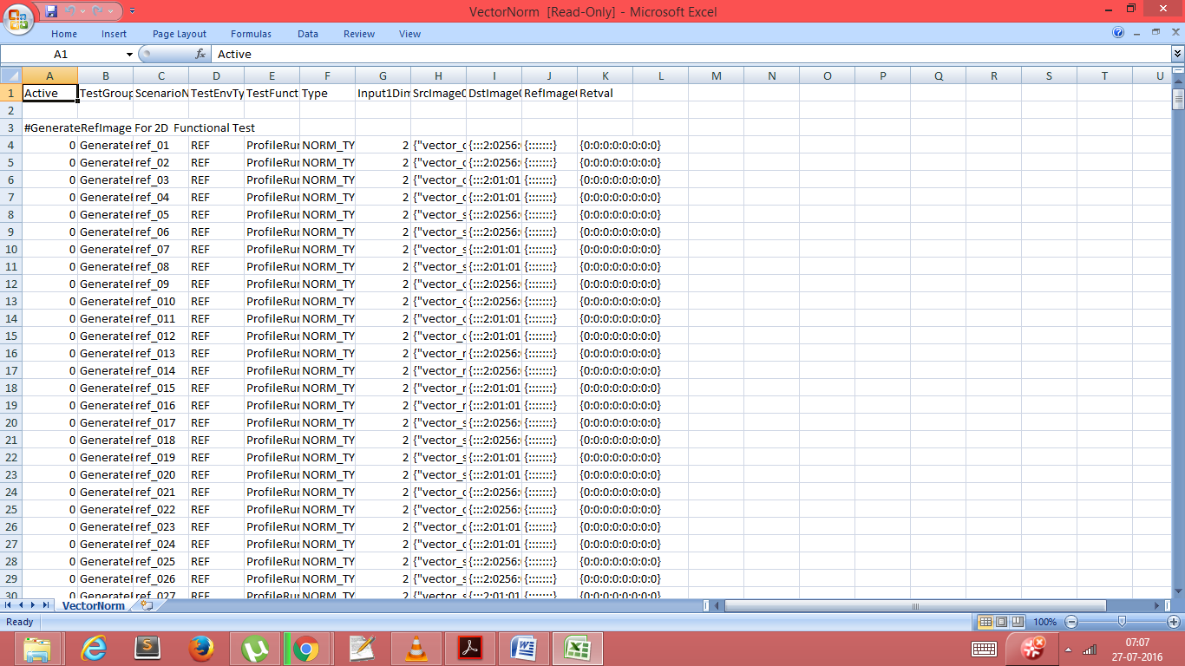

**Log file –**

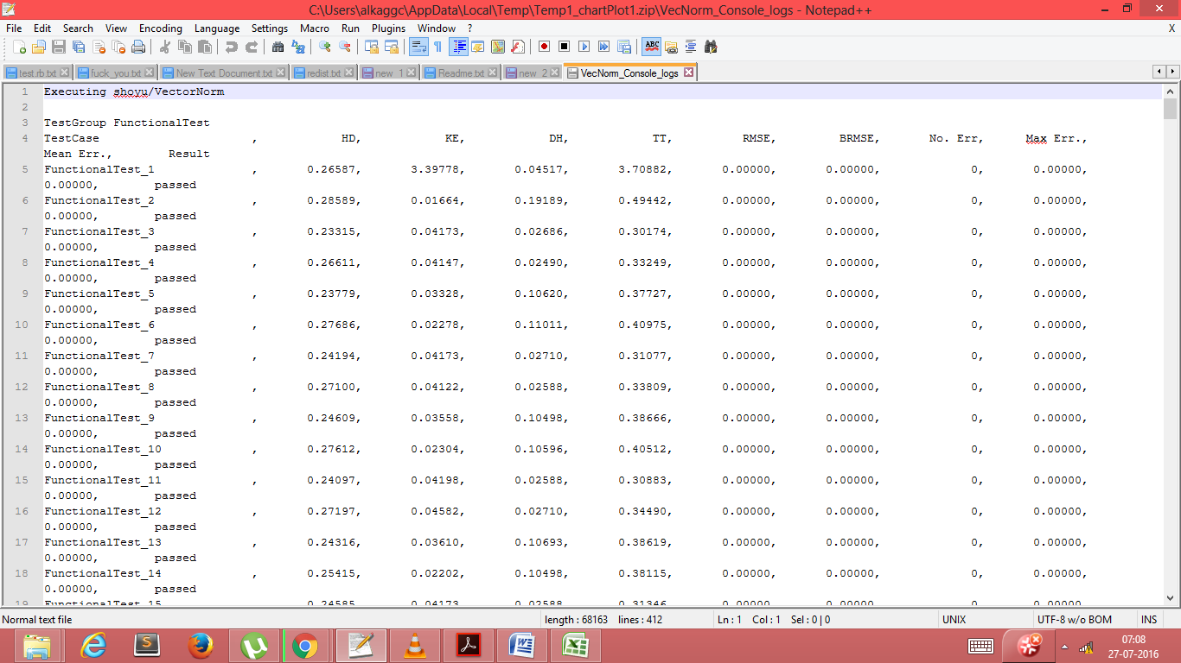

**Median log file –**

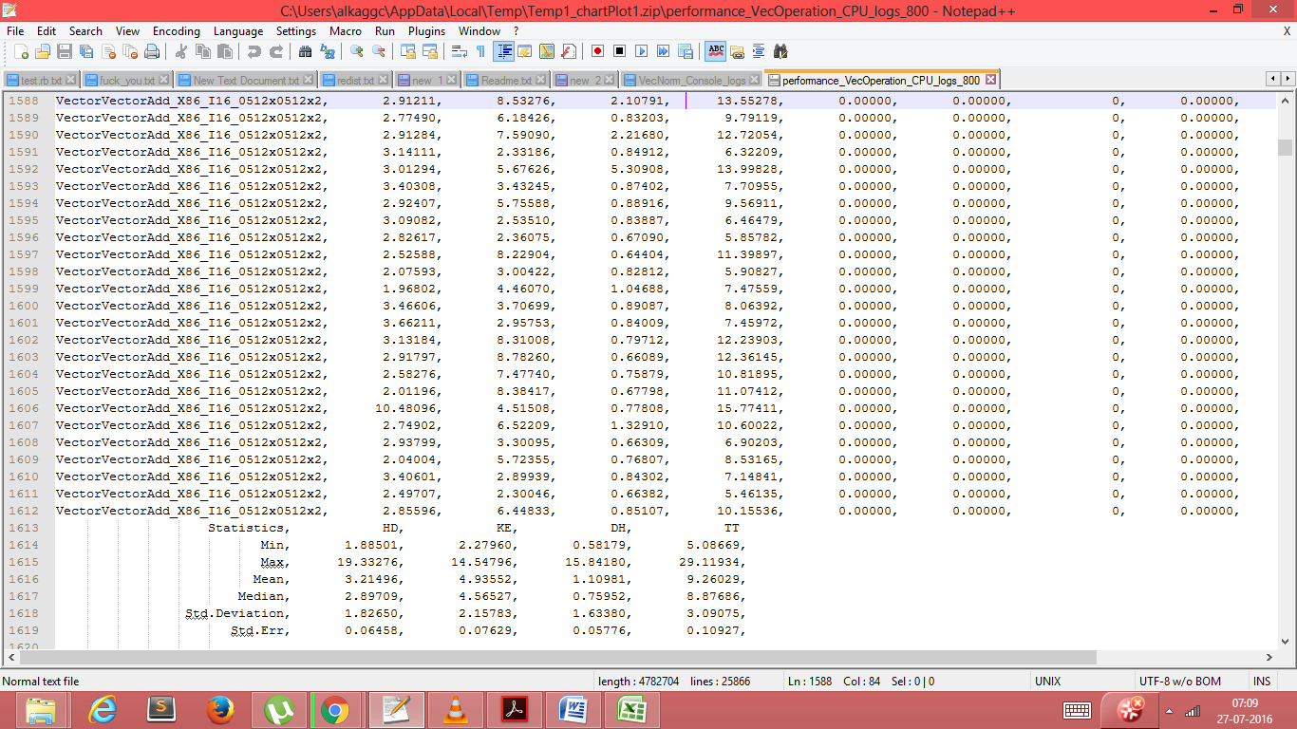

On executing the program, it generates a result.html file which displays the required details and graphs.

Angularjs and jquery are used for sorting the contents within a table, according to column.

Bootstrap, css are used for overall styling of the html file.

Python is the language in which whole code is written.

Matplotlib is used to generate comparison plots and box plots.

**Code Output –**

The graphs generated are displayed below -

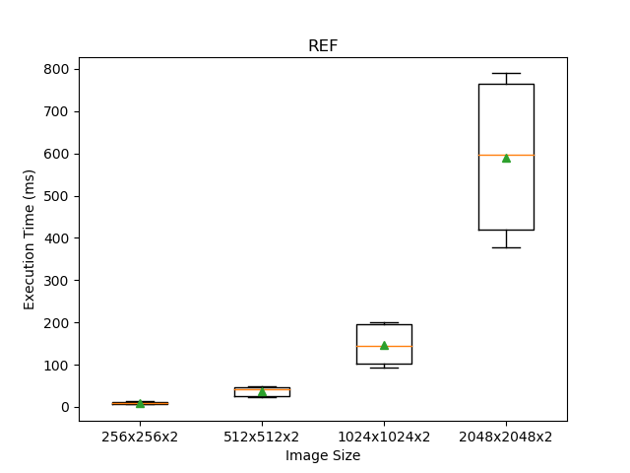

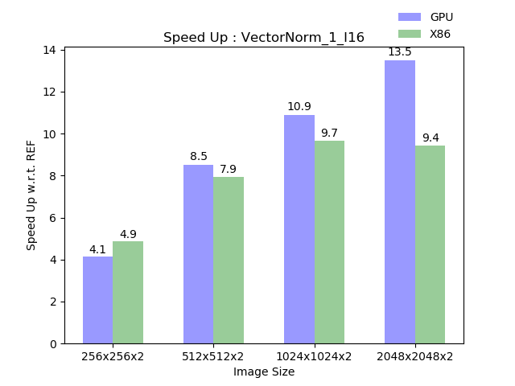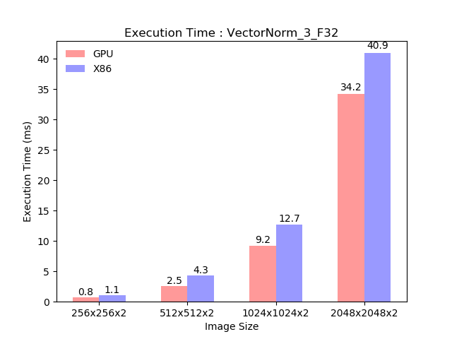

**Results –**

The program generated html file screenshots are displayed below –

**Tools Used**

* Python 2.7
* Matplotlib
* Gedit, sublime
* Jquery, javascript
* Angularjs
* bootstrap, css, html

**Conclusion –**

* The readings and output were successfully obtained.
* Certain observations were made regarding these operators.
* The python programming code was able to generate the required files..