**Analysis of Image Processing Results**

By

Ravi Jain

(Roll No. 2013167)

**SUPERVISOR(S):** **EXTERNAL:**

Mr. Radhish Ayyappan

Project Manager

Canon ISDC, Bangalore

**INTERNAL:**

Prof. Ayan Seal Professor

PDPM IIIT DM Jabalpur



**Computer Science Engineering** **(B. Tech** **2013)**

**INDIAN** **INSTITUTE** **OF** **INFORMATION** **TECHNOLOGY,** **DESIGN** **AND MANUFACTURING** **JABALPUR**

2nd Interim Report

(10th September 2016 – 10th October 2016)

**Dashboard Generation -**

**Introduction** –

* The aim of this project is to design a dashboard for certain csv(comma separated value) and log files, which would display details of these in addition to certain graphs for indicating kernel execution times.
* The python program takes as input a csv file, its corresponding log file, median value files (if any) and path to the images which can be viewed in the dashboard.
* The skills used for the development of this dashboard are python, angularjs, javascript, bootstrap, css, html, matplotlib and jquery.

**Procedure –**

* The dashboard serves the purpose of displaying details such as kernel execution time, total time etc. on executing certain algorithms over several images and drawing a comparison between different test environment types.
* The set of csv files include details of algorithms such as sum of squared differences, mutual induction, gradient image filter etc.
* The aim was to display the logs of execution of these algorithms over certain images.
* Furthermore, graphs were also made using matplotlib, including comparison plots, box plots.
* Modules such as numpy were used.
* The initial task was to understand use of these tools and install libraries on my system.
* On executing the program, it generates a result.html file which displays the required details and graphs.
* Angularjs and jquery are used for sorting the contents within a table, according to column.
* Bootstrap, css are used for overall styling of the html file.
* Python is the language in which whole code is written.
* Matplotlib is used to generate comparison plots and box plots.

## The next issue was to make sure that site runs well on all type of browsers, i.e. Chrome, Internet Explorer and Mozilla Firefox.

## After finding certain javascript issues such as certain functions involving use of iframes, issues in jquery load method and ActiveX control issues with graph, steps were taken in order to reduce the use of these and make the site run on all browsers.

## Pre – release presentation –

## As this site had to be released to other users, the software requirements and setup tools were noted.

**Software requirement -**

* System must have python >=2.7
* Use command scl enable python27 bash to enable python 2.7
* Packages required are BeautifulSoup4, matplotlib

**Setup Tools –**

* In order to install these packages use pip install package_name or go to <https://pypi.python.org/pypi> and search for the required packages
* After downloading a package, go to the folder with downloaded content and run python setup.py install

**Using certain css tools I learnt how to hide the sidebar and display only icons –**

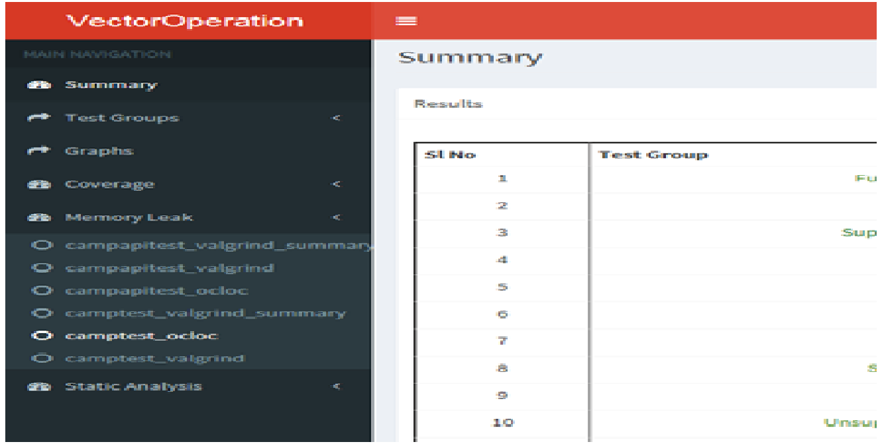

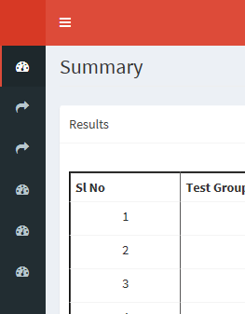

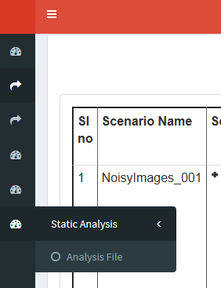

**The next step was to check that the code runs for different algorithms, which was done and certain bugs were fixed.**

**After these steps were considered, the main drawback of the site was that it took a lot of time to load.**

**Earlier jQuery hide/show methods were used for displaying certain sections of the site.**

**Now jQuery load method enabled pages to get loaded only when the user wanted so.**

## jQuery toggle()

With jQuery, you can toggle between the hide() and show() methods with the toggle() method.

**jQuery load() Method**

The jQuery load() method is a simple, but powerful AJAX method.

The load() method loads data from a server and puts the returned data into the selected element.

**Syntax:**

$(*selector*).load(*URL,data,callback*);

The required URL parameter specifies the URL you wish to load.

The optional data parameter specifies a set of querystring key/value pairs to send along with the request.

The optional callback parameter is the name of a function to be executed after the load() method is completed.

**Another drawback of the site was that it required a lot of command line arguments to be given by user.**

**To overcome this drawback a certain folder structure was defined which a user has to create before running the code which generated this website.**

**Screenshots of Output generated –**



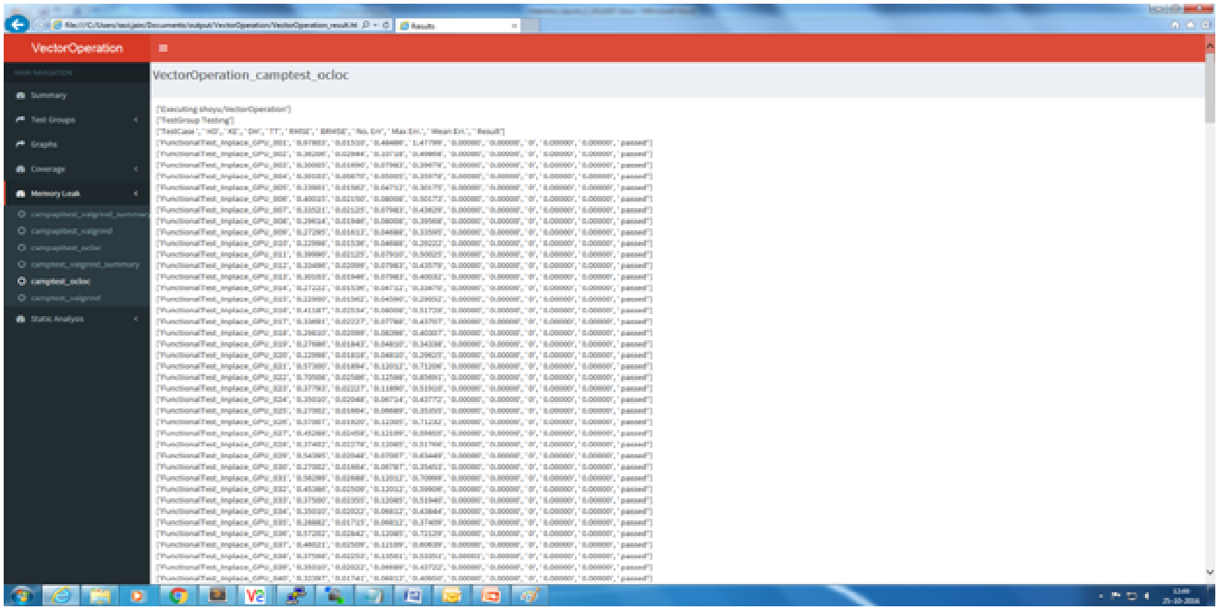

Due to company’s terms and conditions, can’t share all images.

**Tools Used -**

* Python 2.7
* Matplotlib
* Gedit, sublime
* Jquery, javascript
* Angularjs
* bootstrap, css, html
* beautiful soup

**Conclusion –**

* The readings and output were successfully obtained.
* Certain observations were made regarding these operators.
* The python programming code was able to generate the required files.