**LETTER OF RECOMMENDATION**

I am pleased to recommend **Mr. Chengannagari Ravisankar** (emp. Id. 2113556) for the master’s program at your university. I have been project manager to him for the projects based on Salesforce technology for the past one year at Cognizant Technology Solutions. My acquaintance with him during the entire journey in CTS has given me an ample scope in understanding his capabilities very closely.

Ravisankar is a highly skilled and experienced Salesforce developer with a strong ethic and a positive attitude. He has a deep understanding of the Salesforce platform and can quickly and efficiently develop solutions to complex business problems.

In addition to his technical skills, Ravisankar has always been a hard worker and I am impressed with his teamwork. I personally have a strong feeling that Mr. Chengannagari Ravisankar is a deserving candidate at your university.

I will his great success in academic and professional pursuits.

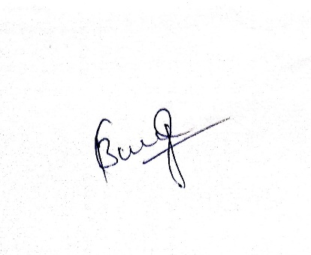

**Elangovan BoopathyRaja**

Project Manager

Mobile: 8122511154

Email: [boopathyrajae.elangovan@cognizant.com](mailto:boopathyrajae.elangovan@cognizant.com)

