Edible oil Market price prediction using

ML

**PROJECT SYNOPSIS**

**BACHELOR OF ENGINEERING**

**Computer Engineering**

SUBMITTED BY

Sagar Deshmukh Ravindra Kadam Sampada Kothari Srushti Kakade

Under the guidance of Prof.Mrs.Dr.S.A.Itkar



**Department of Computer Engineering**

**P. E. S. Modern College of Engineering, Pune.**

**2024 - 25**

# Contents

1. Title 1
2. Domain 1
3. Keywords 1
4. Team 1
5. Literature Survey 2
6. Objective 3
7. Problem Statement 3
8. Scope 3
9. Brief Description 3
10. Technical Details 4
11. Probable Date of Completion 5
12. References 5

List of Figures

1 Architecture Diagram 4

List of Tables

1. Literature Survey 3

# Title

Edible oil market price prediction using Time Series Models.

# Domain

Machine Learning

# Keywords

SARIMA, FB Prophet, LSTM-RNN, Exogenous Variables, Market Trends, Hyperparameter, RMSE, MAPE, Model Transparency.

# Team

Group Id: B6

Team Members:

* + 1. Sagar Abhay Deshmukh - 41207.
    2. Ravindra Bapu Kadam - 41221.
    3. Sampada Sujay Kothari - 41228.
    4. Srushti Satish Kakade - 41222.

# Literature Survey

|  |  |  |  |  |
| --- | --- | --- | --- | --- |
| SR.NO | TITLE | PUBLICATION AND YEAR | AUTHOR | DESCRIPTION |
| 1 | Energy Nexus:  Edible Oil Wholesale Price Forecasts via the Neural Network | Energy Nexus, 2023 | Xiaojie Xu, Yun Zhang | * Explores the prediction of edible oil prices using neural networks. * Focuses on wholesale pricing data analysis. * Investigates the energy- food nexus. |
| 2 | Forecasting Cauliflower Prices in Nepal: A Comparative Analysis Using Seasonal Time Series and Nonlinear Models | Cogent Food, Agriculture, 2024 | Anisha Giri, Vijay Raj Giri | * Analyzes cauliflower price trends in Nepal. * Compares seasonal time series models and nonlinear models. * Highlights challenges in agricultural pricing. |
| 3 | Machine Learning-Based Recommendation of Agricultural and Horticultural Crop Farming in India | Heliyon, 2024 | Biplop Dey, Jannatul Ferdous, Romel Ahmed | * Recommends crop farming practices based on NPK, soil pH, and climate variables. * Uses machine learning and DL techniques for forecasting Prices. * Focuses on India-specific farming. |
| 4 | Edible Oil Wholesale Price Fore-casts via the Neural Net-work | Published in North Carolina State University, 2003 | Xiaojie Xu, Yun Zhang | * Focuses on edible oil price forecasting using neural networks. * One of the earlier studies on the topic.. |

|  |  |  |  |  |
| --- | --- | --- | --- | --- |
|  |  |  |  | * Provides insights into price fluctuations. |
| 5 | Price Forecasting of Agricultural Products in India Using ARIMA  and Machine Learning Models | International Journal of Agricultural Sciences, 2020 | Priya Sharma, Ravi Kumar | * Focuses on predicting agricultural product prices in India. * Compares ARIMA and machine learning models for forecasting accuracy. * Analyzes price volatility in agricultural markets. |

# Objective

* + 1. To develop a robust machine learning model for predicting edible oil prices using SARIMA,FB Prophet, and LSTM-RNN techniques.
    2. To incorporate external factors (climate, market trends) for improving the accuracy of pricepredictions.
    3. To compare the performance of traditional time series models with neural network- basedapproaches for edible oil price forecasting.

# Problem Statement

To develop an advanced machine learning-based price forecasting model for edible oils by leveraging techniques such as SARIMA, FB Prophet, and LSTM-RNN.

# Scope

* + 1. Implementation of SARIMA, FB Prophet, and LSTM-RNN models for time series fore- casting of edible oil prices using historical data.
    2. Integration of exogenous variables, including oscillations in Prices and global market in- dices, to improve model performance and capture complex dependencies.
    3. Use of performance evaluation metrics like RMSE, MAE, and MAPE to assess forecasting accuracy and model reliability across various techniques

# Brief Description

The project focuses on developing a machine learning-based system for edible oil price prediction using time series models like SARIMA, FB Prophet, and LSTM-RNN. It involves data preprocessing, integrating exogenous variables such as oscillations in Prices and market trends, and feature extraction using sequential patterns from LSTM. The models will be fine- tuned through hyperparameter optimization to enhance accuracy. For model performance assessment, statistical metrics like RMSE and MAPE will be employed, and post-model analysis will include visualization of influential external factors for transparency.

Architecture Diagram :

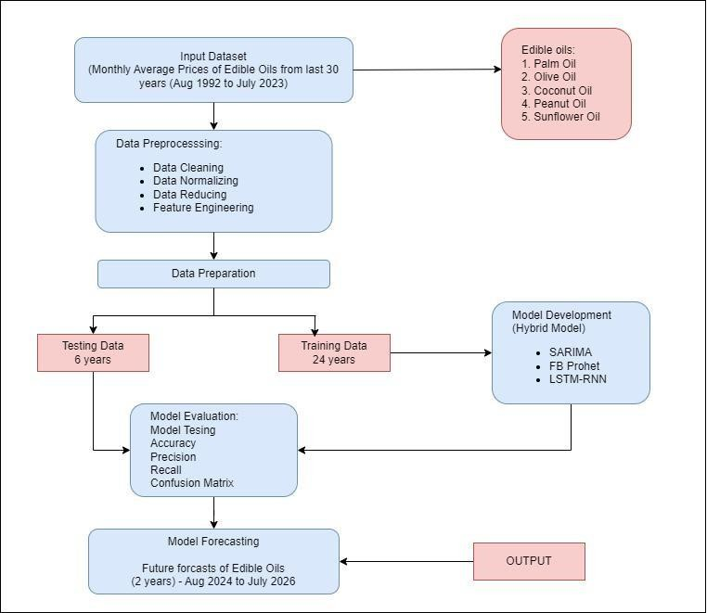

Figure 1: Architecture Diagram

# Technical Details

**Platform**

* + 1. Linux/Windows

# Software Specification

1. Python 3.x

# Hardware Specification

1. GPU (NVIDIA) for model training and optimization

# Frameworks and Libraries:

* 1. TensorFlow, Keras, Statsmodels, Prophet, Scikit-learn, Pandas

# Dataset

1. Historical Price Data of 8 Edible Oils (Commodity)

# Probable Date of Completion

May 2025

# References

* + 1. Xiaojie Xu, Yun Zhang (2023). “Energy Nexus”: Edible Oil Wholesale Price forecasts via the Neural Network[1]
    2. Anisha Giri and Vijay Raj Giri (2024). “Cogent Food ,Agriculture”: Forecasting Cauliflower Prices in Nepal: A Comparative Analysis Using Seasonal Time Series and Nonlinear Mod- els[2]
    3. Biplop Dey, Jannatul Ferdous, Romel Ahmed (2024). “Heliyon”: Machine Learning based Recommendation of Agricultural and Horticultural Crop Farming in India Under the Regime of NPK, Soil pH and Three Climatic Variables[3]
    4. Xiaojie Xu, Yun Zhang (2003). “North Carolina State University, Raleigh, NC 27695, USA”: Edible Oil Wholesale Price Forecasts via the Neural Network[4]
    5. Yong Zhang, Ming Li (2021). “Computational Intelligence”: Forecasting Agricultural Commodity Prices with Machine Learning Techniques: A Case Study on Soybean Prices in China[5]
    6. Priya Sharma, Ravi Kumar (2020). “International Journal of Agricultural Sciences”: Price Forecasting of Agricultural Products in India Using ARIMA and Machine Learning Models[6]
    7. Fahim Rahman, Sameer Das (2022). “Agricultural Economics Research Review”: Comparative Analysis of Price Prediction Models for Perishable Commodities Using Time Series Data[7]
    8. Nandita Sen, Arun Kumar (2021). “Journal of Agriculture and Food Research”: Hybrid Machine Learning Model for Predicting Rice Prices in Southeast Asia[8]
    9. Liang Wang, Chen Wu (2023). “Environmental Research Letters”: An Integrated Model for Predicting Wheat Yield and Price Based on Climate Factors and Machine Learning[9]
    10. Sunita Bhatt, Kiran Rao (2022). “Journal of Crop Improvement”: Seasonal Price Forecasting of Vegetables Using SARIMA and Neural Networks: A Case Study of Tomato Prices in India[10]