Create React App start here
npx create-react-app react-ems
npx create-react-app ecommerce-practice
cd react-ems
npm start
Create React App end here

Tailwind start here
step1: please install these
npm install -D tailwindcss@3
npx tailwindcss init
step2: tailwind.config
please add this
/** @type {import('tailwindcss').Config} */
export default {
content: [
"./index.html",
"./src/**/*.{js,ts,jsx,tsx}", // Important: Includes all subfolders in src
],
theme: {
extend: {},
},
plugins: [],
}
Step3: src/index.css please add below data in index.css
@tailwind base;
@tailwind components;
@tailwind utilities;
tailwind end here

Key clock server process starts here
Step1: Download key clock keycloak-26.4.5 zip file and unzip keycloak-26.4.5 past this folder to c:/ driver
Step2: move to and run this C:\keycloak-26.4.5\bin> kc.bat start-dev --http-port=8181
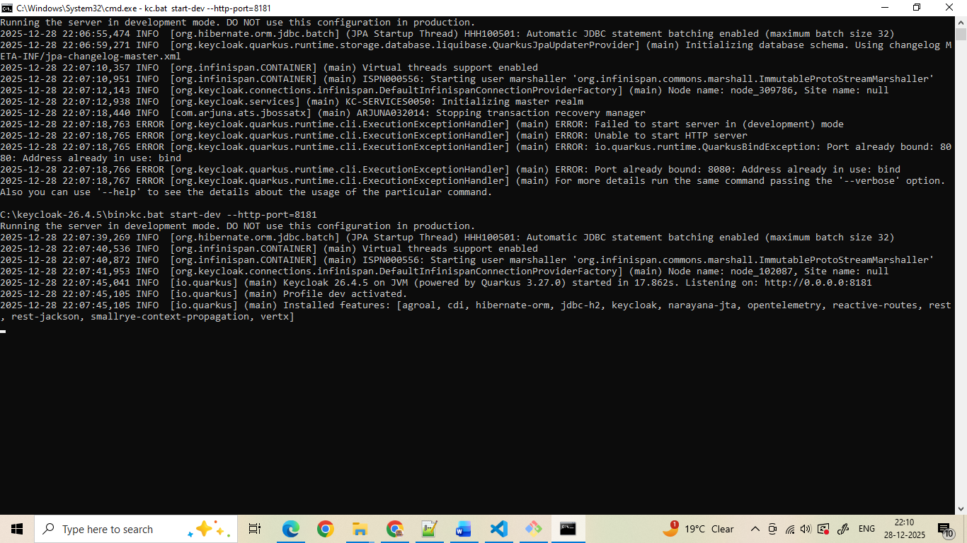
Step3: open browser and use this URIs http://localhost:8181/
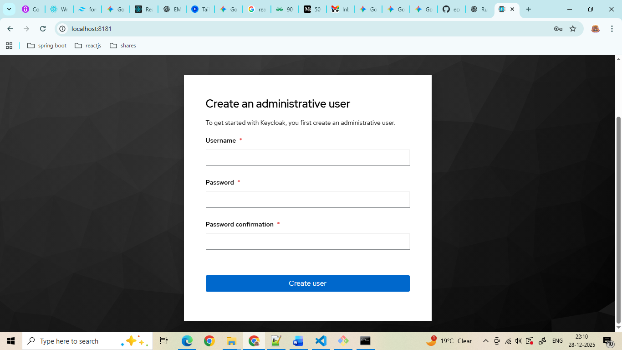
User name: admin
Password :admin
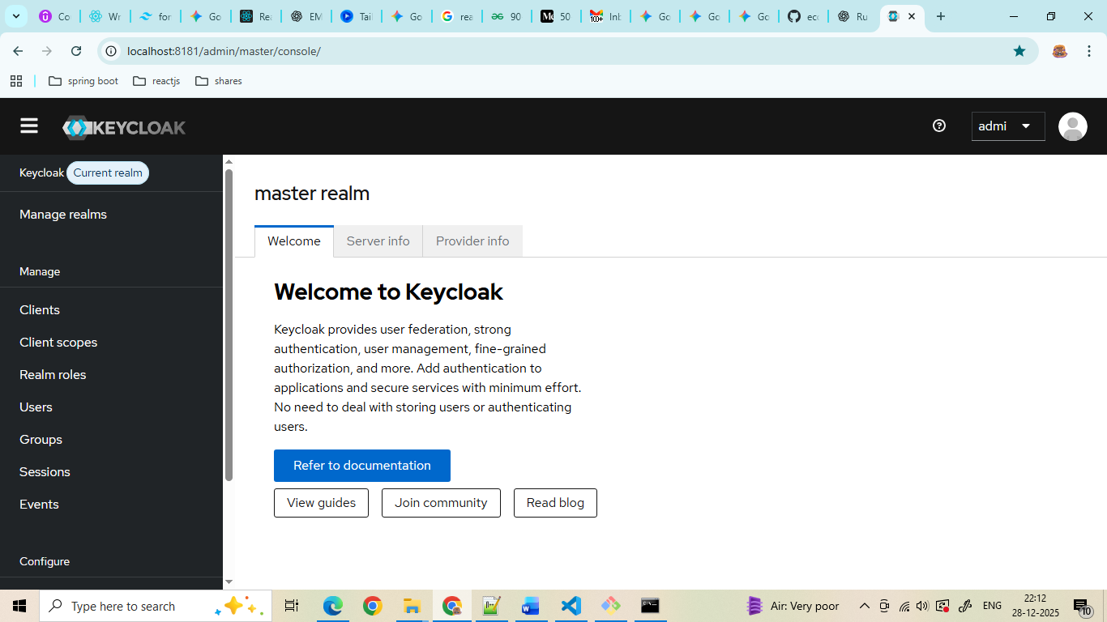
Use this url how to work keyclock https://www.youtube.com/watch?v=7Ict7nML-Yo

Client : react-client
User : test/test
Key clock server process ends here
Reacts with key clock starts here
Step1: npm install keycloak-js
Reacts with key clock starts here

