**HEALTH CARE COST ANALYSIS**

A nationwide survey of hospital costs conducted by the US Agency for Healthcare consists of hospital records of inpatient samples. The data is restricted to the city of Wisconsin and relates to patients in the age group 0-17 years. We need to answer few questions based on the given data

This project is done in R-Studio. The following the picture of R studio.

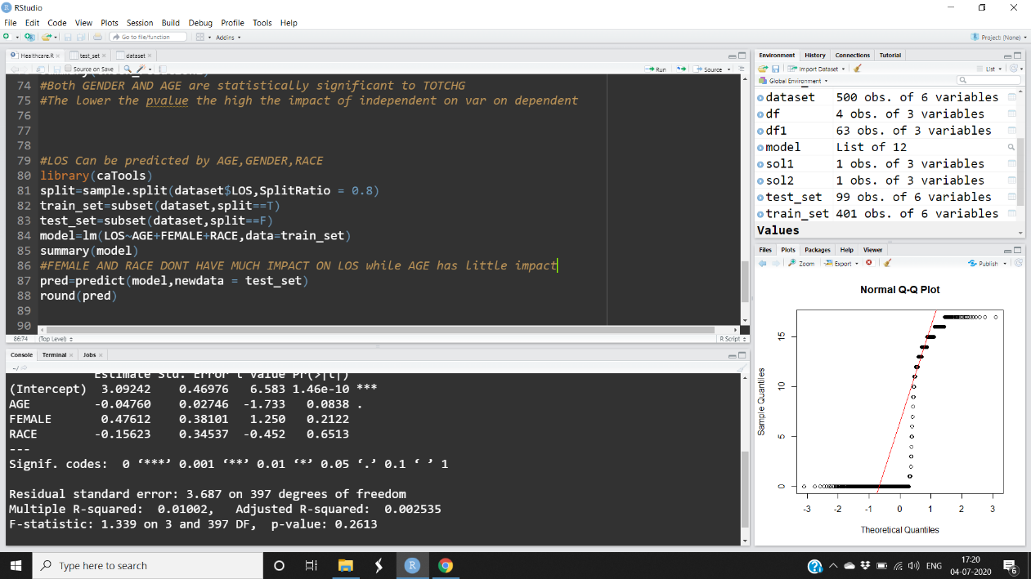

The following are the questions answered in this project.

* To record the patient statistics, the agency wants to find the age category of people who frequent the hospital and has the maximum expenditure.

**Ans**: Infants with hospital costs of 715862 and frequent visit to hospital is 3 days

* In order of severity of the diagnosis and treatments and to find out the expensive treatments, the agency wants to find the diagnosis related group that has maximum hospitalization and expenditure.

**Ans**: APRDRG of 640 has expensive treatment of 437978 and max hospitalization of 652 days

* To make sure that there is no malpractice, the agency needs to analyze if the race of the patient is related to the hospitalization costs.

**Ans:** Race is related to hospitalization costs as P>o.o5 significance level. Done using ANOVA

* To properly utilize the costs, the agency has to analyze the severity of the hospital costs by age and gender for proper allocation of resources.

**Ans:** Both GENDER AND AGE are statistically significant to TOTCHG done using Multiple linear regression

* Since the length of stay is the crucial factor for inpatients, the agency wants to find if the length of stay can be predicted from age, gender, and race.

**Ans**: FEMALE AND RACE DONT HAVE MUCH IMPACT ON LOS while AGE has little Impact on LOS.

* To perform a complete analysis, the agency wants to find the variable that mainly affects the hospital costs.

**Ans:** It seems that AGE,LOS AND APRDRG mainly affects the hospital costs

The screenshots have been been captured and uploaded as well.

Submitted by:

U. SAI RAVI TEJA