########################### Gluster-FS #############################

* 1. Make 4 VM machines with 1GB RAM, and Only 1 Core
* First 3 machines hostname is

* node1.hpcsa.in

* node2.hpcsa.in

* node3.hpcsa.in

* Last machines hostname is
* * client.hpcsa.in

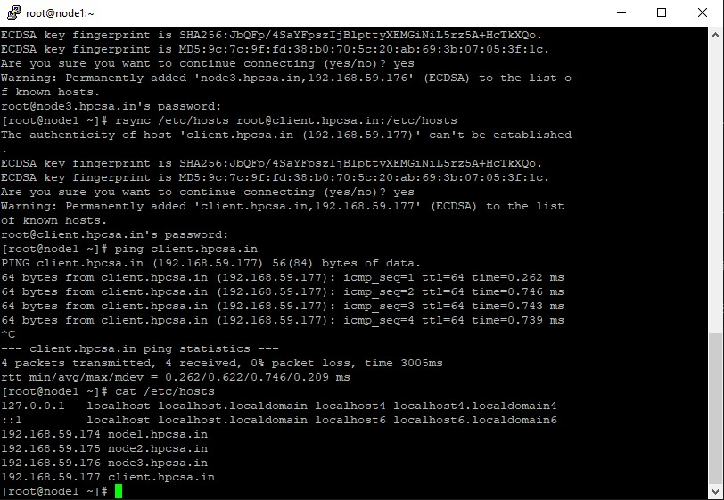

 #ON NODE 1, 2, 3

[root@node1 ~]# systemctl stop firewalld

[root@node1 ~]# systemctl disable firewalld

[root@node1 ~]# setenforce 0

[root@node1 ~]# lsblk

[root@node1 ~]# fdisk /dev/sdb

# mkfs.xfs /dev/sdb1

* mkdir /mnt/disk1
* mount /dev/sdb1 /mnt/disk1
* yum install wget centos-release-gluster epel-release glusterfs-server -y
* systemctl start glusterd
* systemctl enable glusterd
* This peer commands has to be run only on node1
* gluster peer probe node2.hpcsa.in
* gluster peer probe node3.hpcsa.in
* gluster pool list ------------ on all 3 nodes

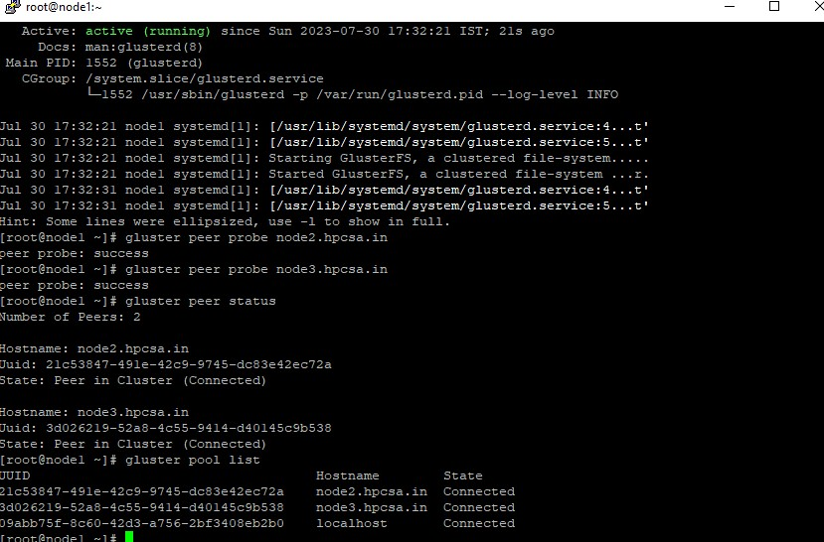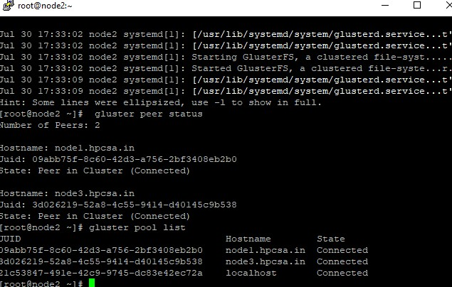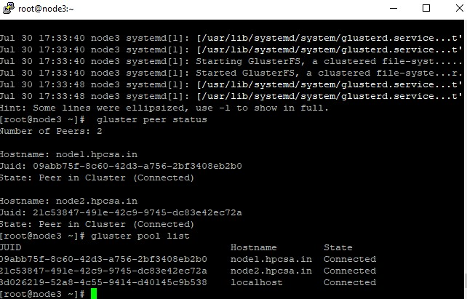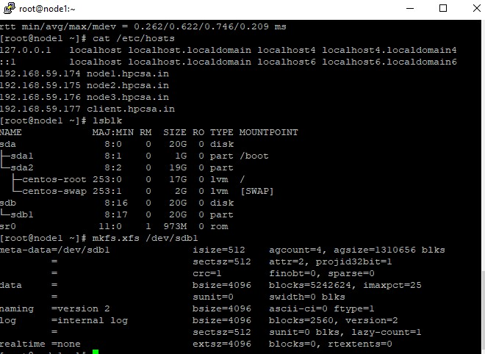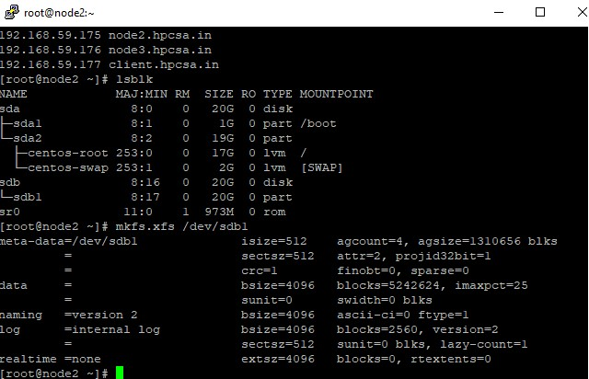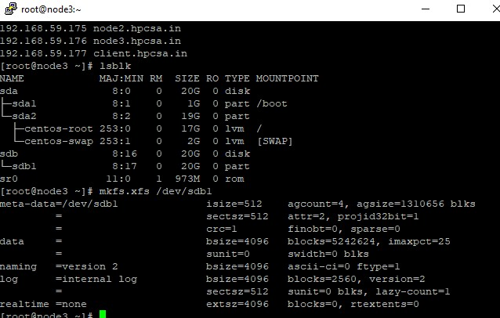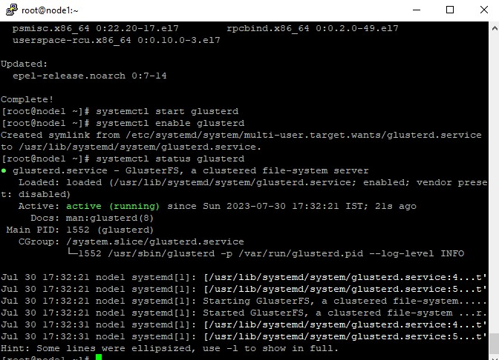

* Run Below command on all nodes.
* mkdir /mnt/disk1/diskvol
* Below command is run only on Node 1 Machine
* gluster volume create gdisk2 replica 3 node1.hpcsa.in:/mnt/disk1/diskvol/gdisk2 node2.hpcsa.in:/mnt/disk1/diskvol/gdisk2 node3.hpcsa.in:/mnt/disk1/diskvol/gdisk2

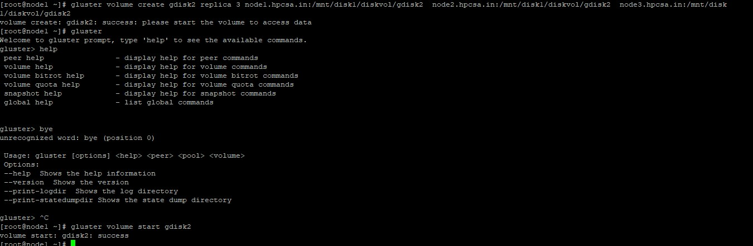

# gluster volume start gdisk2



**ON CLIENT MACHINE**

#On the client, install glusterfs-fuse package: This package allows GlusterFS volumes to be mounted via fuse:Hosts entry:

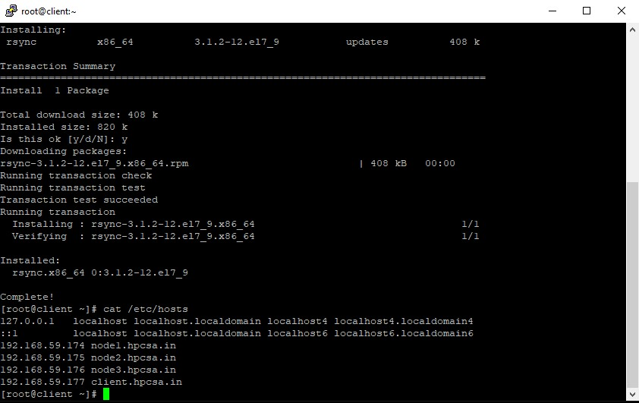

* root@client ~]# yum install glusterfs-fuse

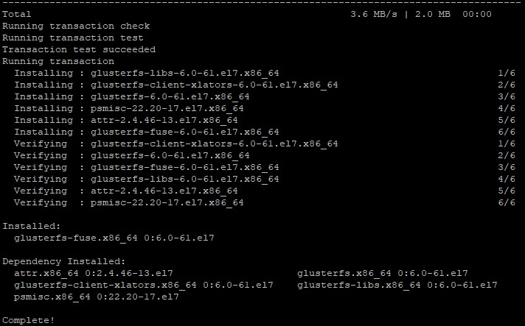

* Create a directory for mounting the Gluster volume:

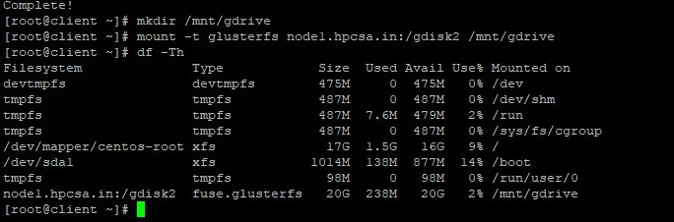

* Create an empty file to replicate it in all server
* [root@client ~]# dd if=/dev/zero of=file.data bs=1024 count=15

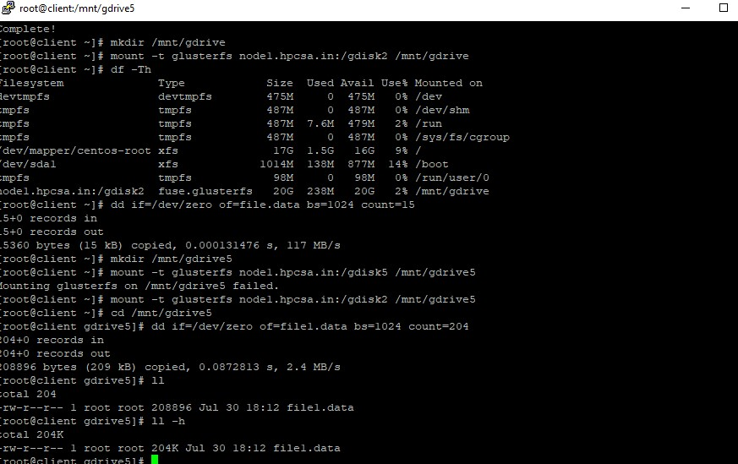

* You just need to change gdisk number and run below commands.
* gluster volume create gdisk3 disperse 3 redundancy 1 node1.hpcsa.in:/mnt/disk1/diskvol/gdisk3 node2.hpcsa.in:/mnt/disk1/diskvol/gdisk3 node3.hpcsa.in:/mnt/disk1/diskvol/gdisk3

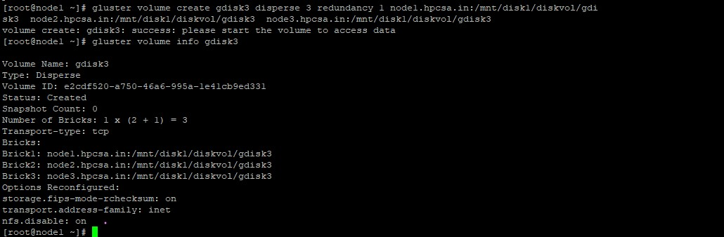

# on client machin You need to create new drive, mount that drive

[root@client ~]# mkdir /mnt/gdrive5

# mount -t glusterfs node1.hpcsa.in:/gdisk2 /mnt/gdrive5

#cd /mnt/gdrive5

# dd if=/dev/zero of=file1.data bs=1024 count=204652



* You will check on Node 1, 2, 3 that file is disperse with parity.
* ON NODE 1
* cd /mnt/disk1/diskvol/gdisk2

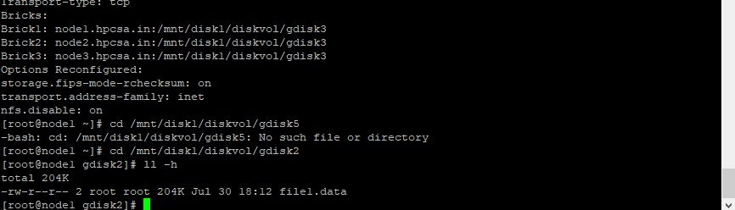

#ON NODE 2

# cd /mnt/disk1/diskvol/gdisk2

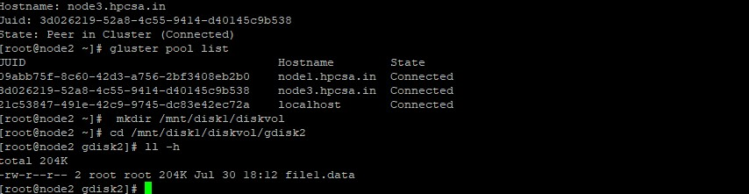

#on Node 3

# cd /mnt/disk1/diskvol/gdisk2

