Student Name: Ravi Ranjan
Student ID : 11713763
Email Address: ravi0000625@gmail.com
GitHub Link : https://github.com/ravi3398
Description:
Consider a scheduler, which schedules the job, by considering the arrival time of the processes where arrival time if given as 0 is discarded or displayed as error. The scheduler implements the shortest job first scheduling policy, but checks the queue of the processes after the every process terminates and time taken for checking and arranging the process according to the shortest job is 2 time unit. Compute the waiting time, turnaround time, average waiting time, and turnaround time of the processes. Also, compute the total time taken by the processor to compute all the jobs.
The user should provide the inputs for the number of requirements, arrival time and burst time.
Consider the following units for reference.
Process Arrival time Burst Time
1 0 6
2 3 2
3 5 1
4 9 7
5 10 5
6 12 3
7 14 4
8 16 5
9 17 7
10 19 2
Develop a scheduler, which submits the processes to the processor in the defined scenario, and compute the scheduler performance by providing the waiting time for process, turnaround time for process and average waiting time and turnaround time.

Algorithm:
Step 1:Taking Input ‘n’ for no of processes
Step 2: Taking Input BT[10],p[10],n,temp,i,j,wt[10],sum=0,s=0,turntime[10]
Step 3: enter total no process
sum+=wt[i];
avg=(float)sum/n;
turntime[i]=BT[i]+wt[i];
Step 4: enter burst time for each process
s=s+turntime[i];
avgturn= s/n;
Step 5: waiting time for each process
Code :
#include<stdio.h>
#include<conio.h>

int main()
{
int BT[10],p[10],n,temp,i,j,wt[10],sum=0,s=0,turntime[10];
float avg;
printf("enter total no process:");
scanf("%d",&n);
printf("\n enter burst time for each process:");

for(i=0;i<n;i++)
{
printf("\nburst time of process P %d:",i);
scanf("%d",&BT[i]);
p[i]=i;
}

for(i=0;i<n-1;i++)
{
for(j=i+1;j<n;j++)
{
if(BT[i]>BT[j])
{
temp=BT[i];
BT[i]=BT[j];
BT[j]=temp;
temp=p[i];
p[i]=p[j];
p[j]=temp;
}
}

}
wt[0]=0;
for(i=1;i<n;i++)
{
sum+=wt[i];
}

avg=(float)sum/n;
printf("\n waiting time for each process:");
for(i=0;i<n;i++)
{
printf("\n waiting time for process p%d is %d sec.",p[i],wt[i]);

}

printf("\n Average waiting time is %f sec.",avg);

for (i=1;i<n;i++)
{
turntime[i]=BT[i]+wt[i];
printf("\nTurnaround time for p[%d] is : %d ",i,turntime[i]);
s=s+turntime[i];

}

int avgturn= s/n;
printf("\nAverage turn around time : %d ",avgturn);
getch();
return 0;
}
Test case 1: When User Enter Process = 0
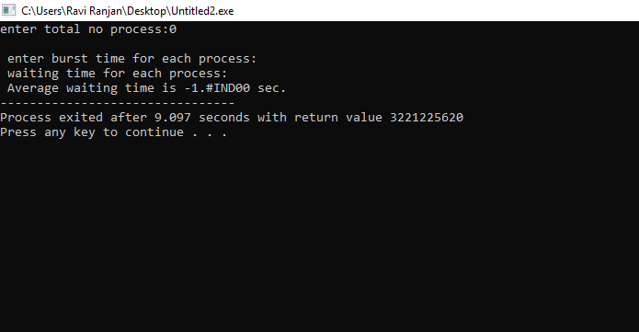
Test Case 2: When User Enter Process < 0
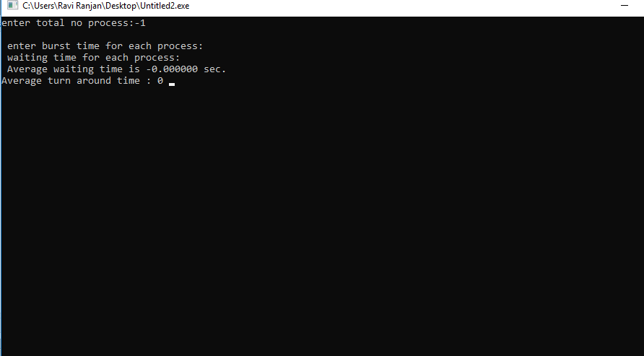
Test Case 3: When User Enter Process > 0, Then, Interface Prompt User to Enter Burst time for each Process.
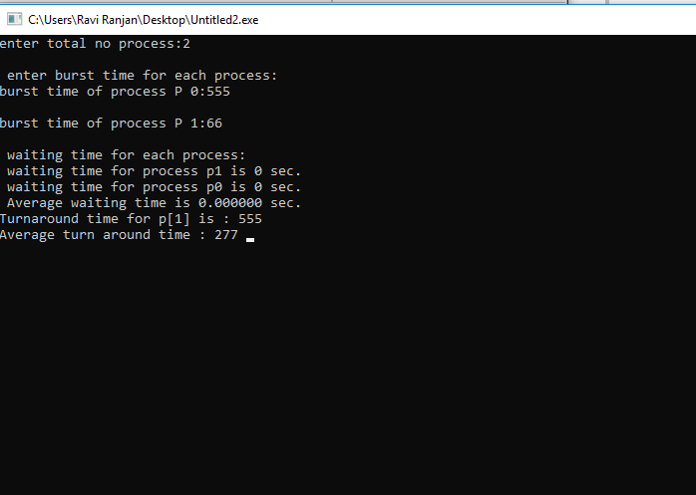
Test Case 4: When user Enter Burst time = 0
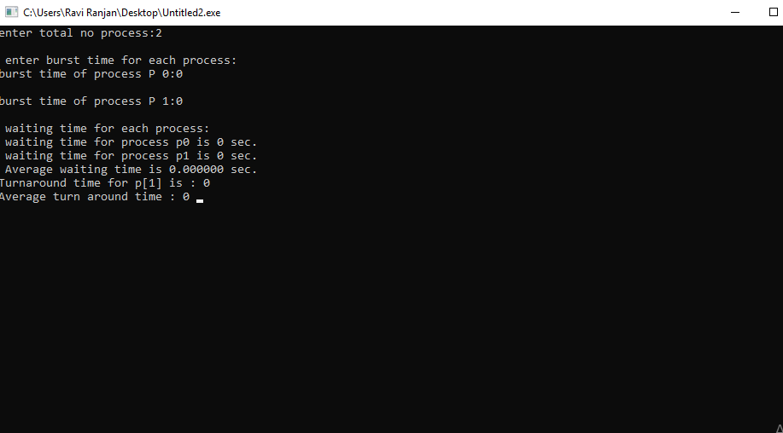

Test Case 5: When User enter Burst time < 0
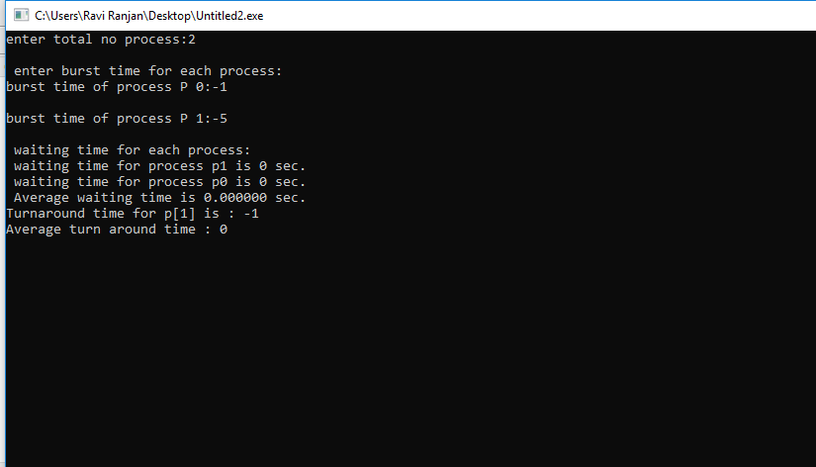

Test Case 6: When user enter Burst time > 0
