1. **Create web pages using Basic HTML Tags, Table, List, Image, and Frame Tags.**

**lab.html**

<!DOCTYPE html>

<html>

<head>

<title>EXP1</title>

</head>

<body style="background-color: whitesmoke;">

<center >

<a href="basic.html">BasicHTMl</a>

<br>

<br>

<a href="lists.html">Lists</a>

<br>

<br>

<a href="tables.html">Tables</a>

<br>

<br>

<a href="image.html">Images</a>

<br>

<br>

<a href="frames.html">Frames</a>

<br>

<br>

</center>

</body>

</html>

**Output:**

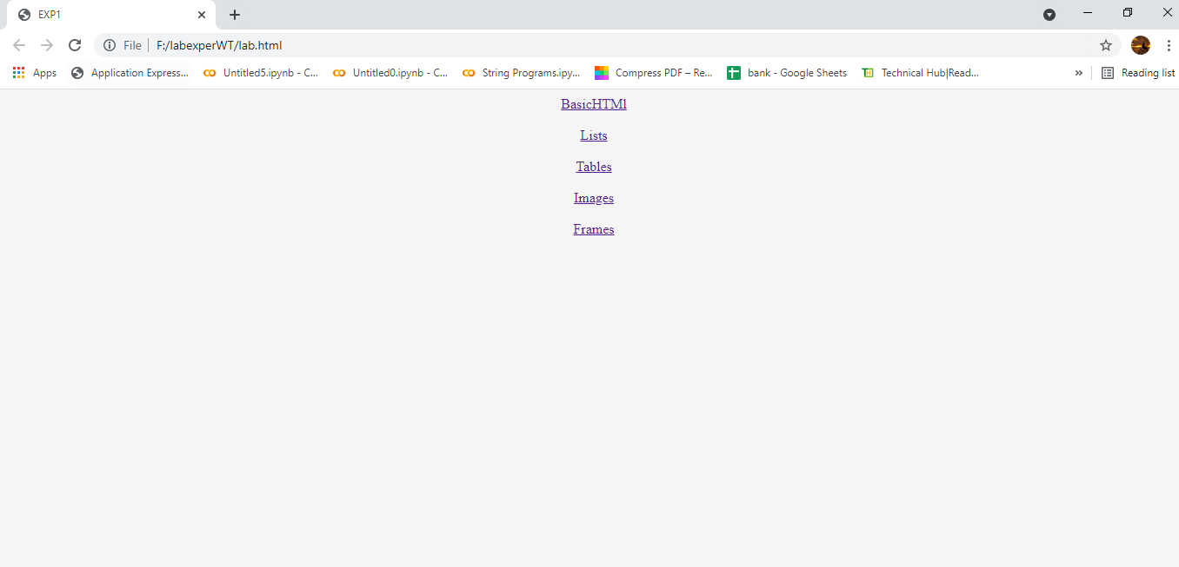

**Lists.html**

<!DOCTYPE html>

<html>

<head>

<title>Lists</title>

</head>

<body style="background-color:lightgrey; ">

<h1 style="background-color:lavender;">Unordered list</h1>

<ul type="square">

<b>

<li>milk</li>

<li>tea</li>

<li>coffee</li>

</b>

</ul>

<h1 style="background-color:lightpink;">Ordered list</h1>

<b>

<li>Beverages</li>

<li>SOFT DRINKS</li>

</b>

</ol>

<h1>Definition list</h1>

<dl>

<dt>WT</dt>

<dd>Web Technologies</dd>

</dl>

<h1>Miscallenous list</h1>

<ul>

<li><h3>SUB</h3>

<ul>

<li>HCI</li>

</ul>

</li>

<li><h3>LABS</h3>

<ol>

<li>C</li>

</ol>

</li>

</ul>

<button style="background-color:lightcoral;"><a href="lab.html">go back</a></button>

</body>

</html>

**Output:**

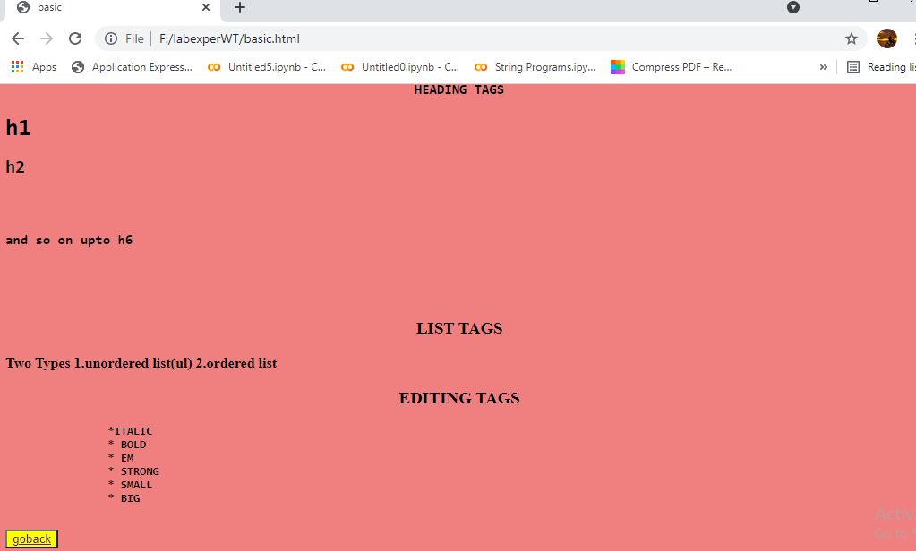

**lists.html**

<!DOCTYPE html>

<html>

<head>

<title>Lists</title>

</head>

<body style="background-color:lightgrey; ">

<h1 style="background-color:lavender;">Unordered list</h1>

<ul type="square">

<b>

<li>milk</li>

<li>tea</li>

<li>coffee</li>

</b>

</ul>

<h1 style="background-color:lightpink;">Ordered list</h1>

<b>

<li> Beverages </li>

<li> SOFT DRINKS </li>

</b>

</ol>

<h1>Definition list</h1>

<dl>

<dt>WT</dt>

<dd>Web Technologies</dd>

</dl>

<h1>Miscallenous list</h1>

<ul>

<li><h3>SUB</h3>

<ul>

<li>HCI</li>

</ul>

</li>

<li><h3>LABS</h3>

<ol>

<li>C</li>

</ol>

</li>

</ul>

<button style="background-color:lightcoral;"><a href="lab.html">go back</a></button>

</body>

</html>

**Output:**

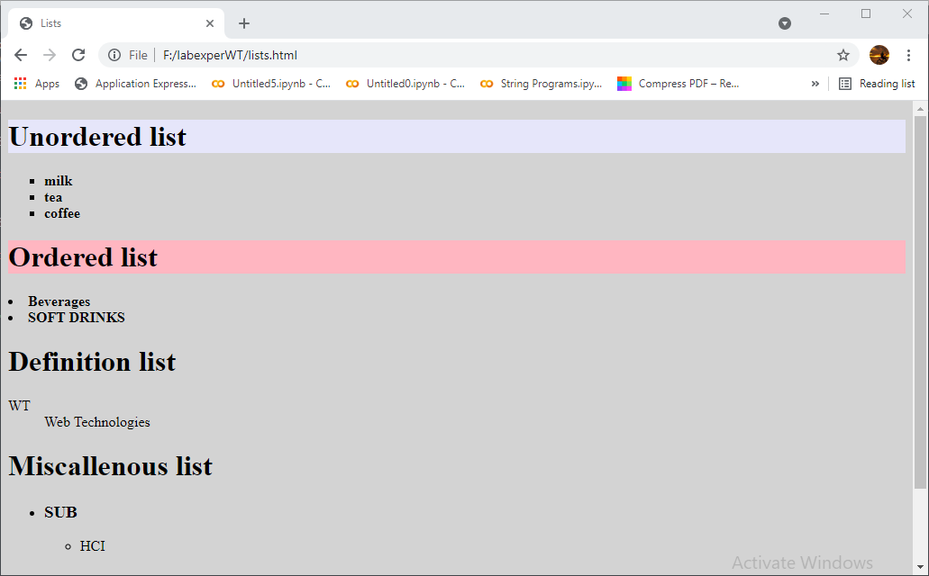

**tables.html**

<!DOCTYPE html>

<html>

<head>

<title>tables</title>

<style type="text/css">

td{

border: 0px;

text-align: center;

}

tr{

text-align: center;

}

</style>

</head>

<body bgcolor="green">

<center>

<h1>TIME TABLE</h1>

</center>

<table border="0 px" align="center">

<tr>

<th>Day</th>

<th>9:30 - 10:20</th>

<th>10:20 - 11:10</th>

<th>11:00 - 12:00</th>

<th>12:00 - 12:50</th>

</tr>

<tr>

<td>MONDAY</td>

<td>DMDW</td>

<td>WT</td>

<td>E.COM</td>

<td>HCI</td>

</tr>

<tr>

<td>TUESDAY</td>

<td>CN</td>

<td>WT</td>

<td>E.COM</td>

<td>HCI</td>

</tr>

<tr>

<td>WEDNESDAY</td>

<td>DMDW</td>

<td>WT</td>

<td>E.COM</td>

<td>CN</td>

</tr>

<tr>

<td>THURSDAY</td>

<td>DMDW</td>

<td>WT</td>

<td>E.COM</td>

<td>HCI</td>

</tr>

<tr>

<td>FRIDAY</td>

<td>DMDW</td>

<td>WT</td>

<td>E.COM</td>

<td>HCI</td>

</tr>

<tr>

<td>SATURDAY</td>

<td>DMDW</td>

<td>WT</td>

<td>E.COM</td>

<td>HCI</td>

</tr>

</table>

<button style="background-color: yellow;align-self: : center;"><a href="main.html">return</a></button>

</body>

</html>

**Output:**

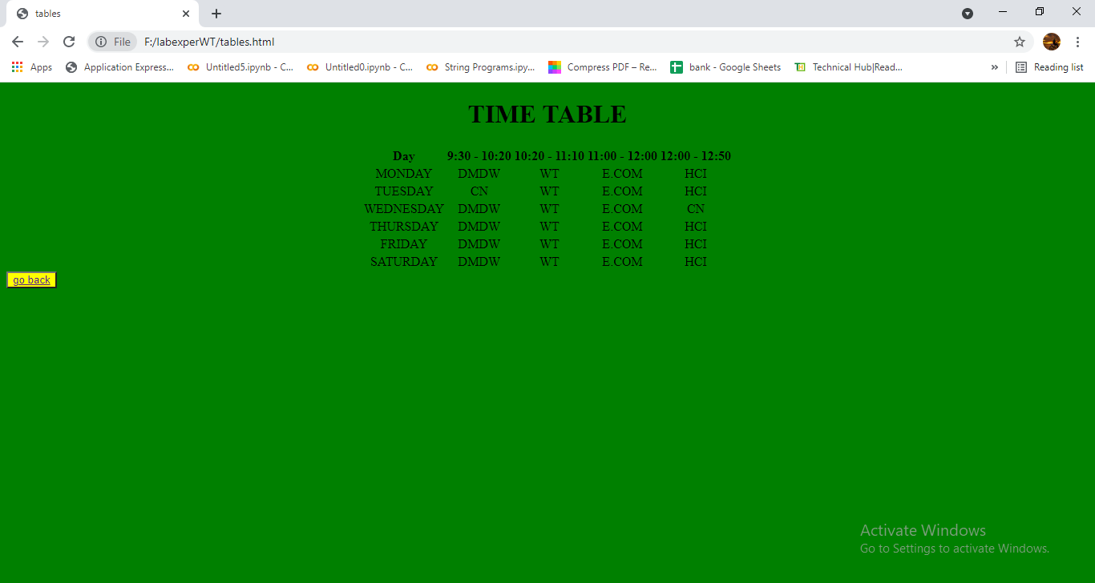

**images.html**

<!DOCTYPE html>

<html>

<head>

<title>Images</title>

</head>

<body bgcolor="lightgreen">

<div style="height: 315px;width:100%">

<img src="img3.jpg" height="300px" width="50%" align="center">

</div>

<div style="height: 315px;width:100%">

<img src="img.jpg" height="300px" width="50%" align="center">

</div>

<button style="background-color: yellow;align-self: : center;"><a href="main.html">return</a></button>

</body>

</html>

**Output:**

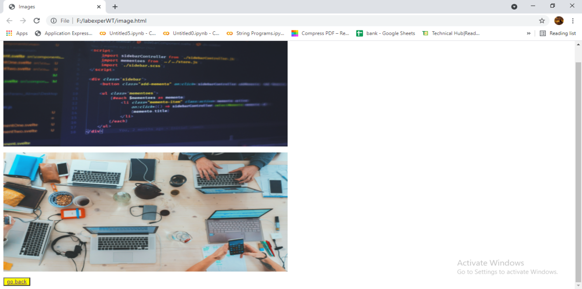

**frames.html**

<!DOCTYPE html>

<html>

<head>

<title>Working with Tables</title>

</head>

<frameset rows="20%,70%,10%" noresize="noresize" >

<frame style="background-color:lightpink ;" src="top.html">

</frame>

<frameset cols="20%,*">

<frame style="background-color: lightpink;" src="middle.html">

<frame style="background-color: lightpink;" src="right.html" name="rf">

</frameset>

<frame style="background-color: lightgreen" src="bottom.html">

</frame>

</frameset>

</html>

**top.html**

<!DOCTYPE html>

<html>

<head>

<title></title>

</head>

<body>

<h1 align="center">Aditya Engineering College</h1>

</body>

</html>

**middle.html**

<!DOCTYPE html>

<html>

<head>

<title></title>

</head>

<body>

<h3><a href="formm.html" target="rf">login</a></h3><br>

<h3><a href="tables.html" target="rf">table</a></h3><br>

</body>

</html>

**right.html**

<!DOCTYPE html>

<html>

<head>

<title></title>

</head>

<body style="background-color: white">

<h1 align="center">WELCOME</h1>

<footer>

<div align="center">

<button style="background-color: yellow;align-self: : center;"><a href="lab.html">go back</a></button>

</div>

</footer>

</body>

</html>

**bottom.html**

<!DOCTYPE html>

<html>

<head>

<title></title>

</head>

<body>

<h4 align="center">WEB PAGE</h4>

</body>

</html>

**Output:**

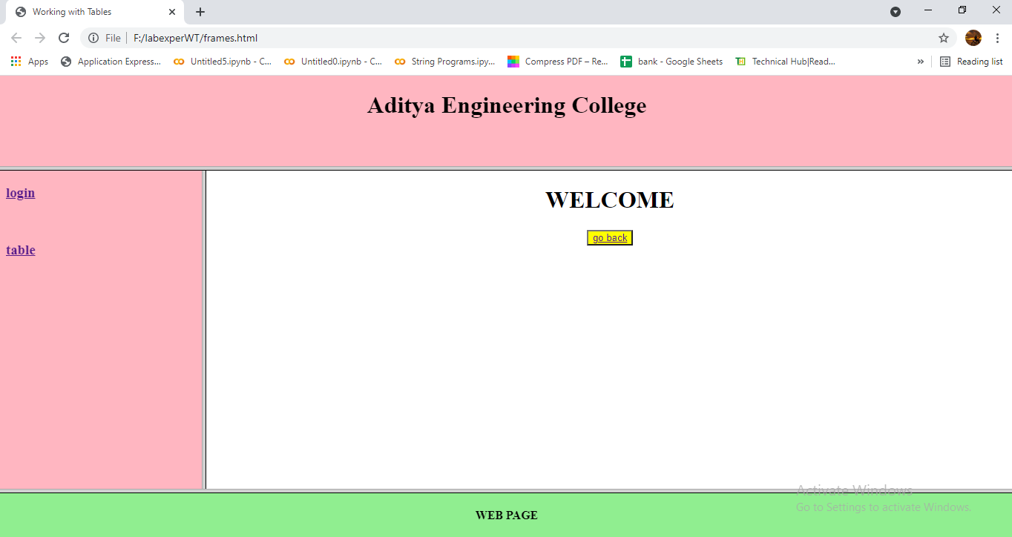

**2)Using Form Tags**

**2.1) Create a Login Form**

<!DOCTYPE html>

<html>

<head>

<meta charset="utf-8">

<title>formpage</title>

<style>

body {

background-color:lightcyan;

margin: 0px;

padding: 16px;

}

.social-icon {

width: 50px;

height: 50px;

padding-top: 16px;

padding-bottom: 16px;

padding-left: 32px;

padding-right: 32px;

}

form {

background-color: mintcream;

width: 600px;

margin-left: auto;

margin-right: auto;

text-align: center;

border: 1px solid #ccc;

}

#form-heading {

font-size: 32px;

padding-top: 56px;

padding-bottom: 32px;

}

#social-wrapper {

background-color: #f2f6ff;

padding: 24px;

}

#input-wrapper {

padding-top: 80px;

padding-bottom: 40px;

padding-left: 80px;

padding-right: 80px;

}

.input-box {

font-size: 18px;

padding-bottom: 12px;

margin-bottom: 36px;

border: 0;

border-bottom: 1px solid #ccc;

width: 100%

}

#btn-submit {

background-color: #0056ff;

padding-top: 12px;

padding-bottom: 12px;

padding-left: 24px;

padding-right: 24px;

font-size: 18px;

color: white;

border: none;

}

</style>

</head>

<body>

<form>

<h1 id="form-heading">Register</h1>

<div id="social-wrapper">

<div id="input-wrapper">

<div >

<input class="input-box" type="text" name="username" placeholder="Username">

</div>

<div>

<input class="input-box" type="email" name="email" placeholder="Email">

</div>

<div>

<input class="input-box" type="password" name="password" placeholder="Password">

</div>

<div>

<input class="input-box" type="password" name="confirmpassword" placeholder="Confirmpassword">

</div>

<div>

<!--<input onclick="myFunction()" id="btn-submit" type="submit" value="Register">-->

<button onclick="myFunction()">Register</button>

</div>

</div>

</form>

<script>

function myFunction()

{

alert("succesfully Registered");

}

</script>

</body>

</html>

**Output:**

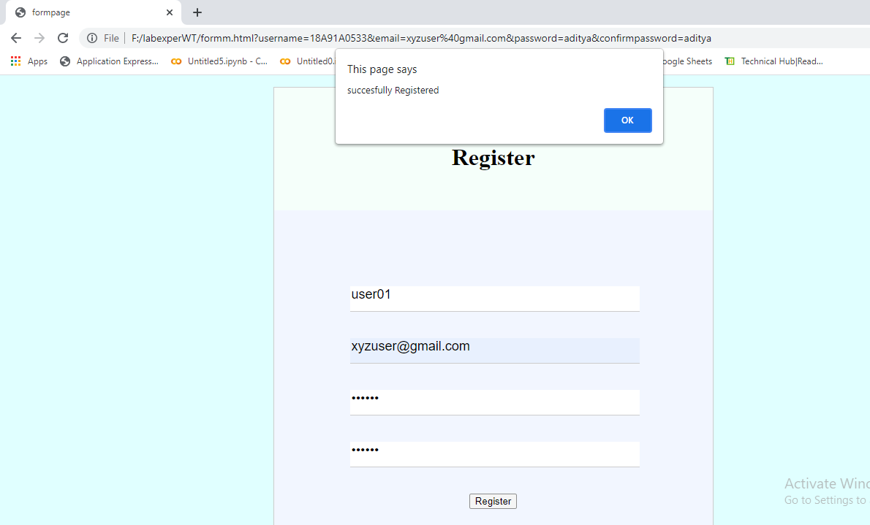

**2.2) Create a “Registration Form ”**

<!DOCTYPE html>

<html>

<head>

<title>wtforms</title>

</head>

<body>

<h1 align="left" style="">Registration Form</h1>

<form autocomplete="on" action="#">

<fieldset style="border:0px;">

<table align="left" style="border: 2px solid;height: 500px;width: 1100px; background-color:lightsalmon;" >

<tr>

<td><label for="username"><b>NAME</b></label></td>

<td><input type="text" name="name" id="un" placeholder="Enter Name"></td>

</tr>

<tr>

<td><label for="password"><b>PASSWORD</label></td>

<td><input type="Password" name="Password" id="pwd" placeholder="Enter Password" minlength="9"></td>

</tr>

<tr>

<td><label for="email"><b>EMAIL</b></label></td>

<td><input type="email" name="email" id="em" required="email"></td>

</tr>

<tr>

<td><label for="tel"><b>PHONE NUMBER</b></label></td>

<td><input type="tel" name="tel" id="tel" required="on"></td>

</tr>

<tr>

<td><label for="date"><b>DOB</b></label></td>

<td><input type="date" name="date" id="date" required="option" placeholder=" "></td>

</tr>

<tr>

<td><label for="gender"><b>GENDER</b></label></td>

<td>

<input type="radio" name="gender" id="male" value="male"><label>Male</label>

<input type="radio" name="gender" id="female" value="female"><label>Female</label>

<input type="radio" name="gender" id="other" value="other"><label>Other</label>

</td>

</tr>

<tr>

<td><label for="lang"><b>LANGUAGES</b></label></td>

<td>

<input type="checkbox" name="te" id="te" value="Telugu"><label>Telugu</label>

<br>

<input type="checkbox" name="hi" id="hi" value="Hindi"><label>Hindi</label>

<br>

<input type="checkbox" name="en" id="en" value="English"><label>English</label>

<br>

<input type="checkbox" name="ta" id="ta" value="Tamil"><label>Tamil</label>

</td>

</tr>

<tr>

<td><label for="Qual"><b>QUALIFICATION</b></label></td>

<td >

<select name="Qual">

<option value="">BTech</option>

<option value="">MTech</option>

<option value="">Phd</option>

<option value="">BSc</option>

<option value="">B.Pharm</option>

<option value="">M.pharm</option>

</select>

</td>

</tr>

<tr>

<td><label for="address">ADDRESS</label></td>

<td>

<textarea rows="5" cols="25" placeholder="Type address" style="text-align: center;"></textarea>

</td>

</tr>

<tr>

<td align="right"><input type="submit" value="submit"></td>

<td align="center"><input type="reset" value="reset"></td>

</tr>

</table>

</fieldset>

</form>

</body>

</html>

**Output:**

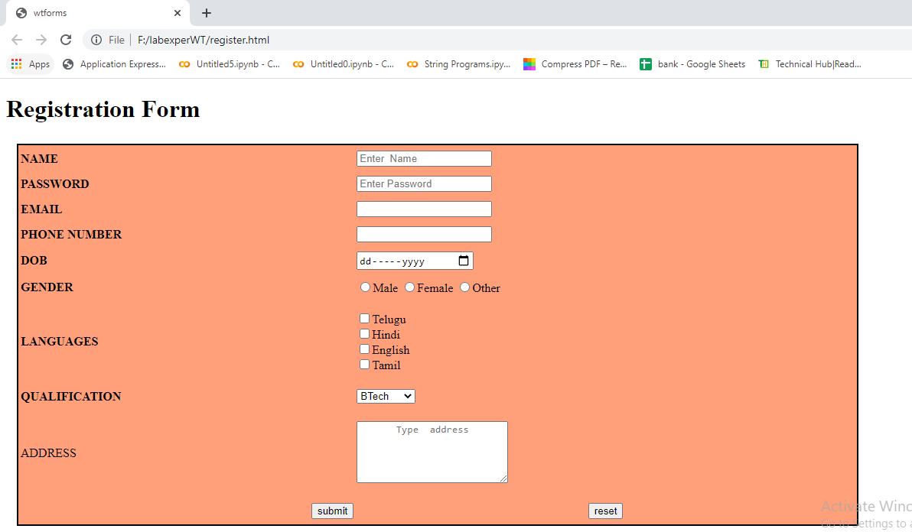

**3) CSS & Java Script**

**3.1) Design a web page using CSS (Cascading Style Sheets) which includes the following:**

**3.1.1) Use different font, styles: In the style definition you define how each selector should work (font, color etc). Then, in the body of your pages, you refer to these selectors to activate the styles.**

**Style.css**

<!DOCTYPE html>

<html>

<head>

<meta charset="utf-8">

<title>Usage of different font,styles and colors</title>

<link rel="stylesheet" type="text/css" href="style.css"/>

</head>

<body>

<h1>web technology</h1>

<h2>html</h2>

<h3>xml</h3>

<p>For many people the differences between the internet and the web are not clear and in many cases in day to day conversations these terms are used interchangeably to mean the same thing. Therefore to help understand the impact of the web, it would also be helpful to understand how it differs from the internet which this essay will first explain. </p>

</body>

</html>

**31.html:**

h1

{

color:indigo;

font-family:caStellar;font-size:30pt;

text-decoration:underline;

}

h2

{

color:orange;

font-family:Chiller;font-size:25pt;

text-decoration-line:overline;

}

h3

{

color:cyan;

font-family:Trebuchet MS;font-size:28pt;

text-decoration:blink;

}

p

{

font-family:fantasy;font-size:16pt;

font-style:italic;

text-decoration-line:line-through;

}

**Output:**

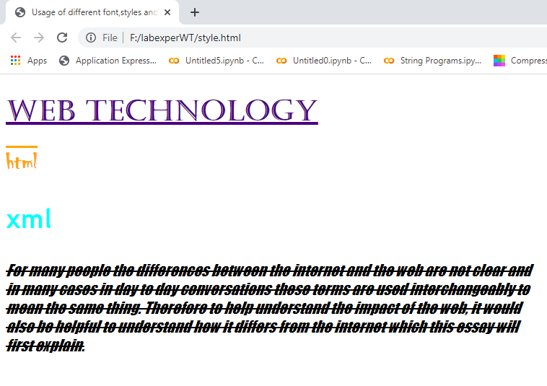

**3.1.2) Set a background image for the web page and control the repetition of the image with the background-repeat property.**

<!DOCTYPE html>

<html>

<head>

<meta charset="utf-8">

<title>Controlling background image</title>

<style type="text/css">

body

{

background-image:url("sam.jpg");

background-repeat:no-repeat;

}

</style>

</head>

<body bgcolor="antiquewhite">

<body text="antiquewhite">

<h1>sea blue!!!</h1>

</body>

</html>

**Output:**

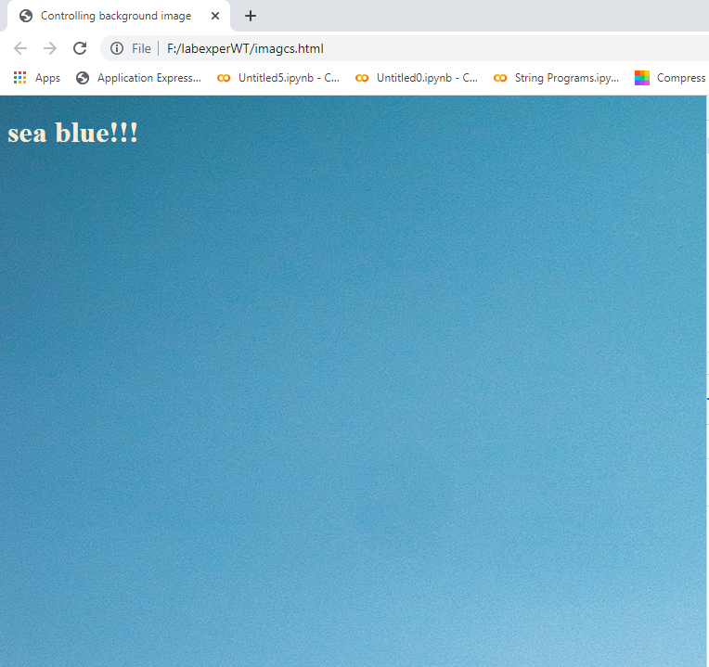

**3.1.3) Define styles for link as visited, active, hover & link**.

<!DOCTYPE html>

<html>

<head>

<meta charset="utf-8">

<title>CSS Webpage</title>

<style type="text/css">

body{background-image:url(sam.jpg);background-repeat:no-repeat;}

p{color:darkgoldenrod;font-size:20pt;font-family:chiller;background-image:url(img.jpg);}

a:link{font-size:20pt;background-color:white;}

a:hover{font-size:20pt;background-color:pink;cursor:crosshair;}

a:active{font-size:20pt;background-color:cyan;cursor:help;}

a:visited{font-size:20pt;background-color:tan;}

</style>

</head>

</head>

<body>

<br>

<p>

Welcome to home page .click the below link for registration

</p>

<a href="formm.html"><center>click here for Register</center></a>

<br>

</body>

</html>

**Output:**

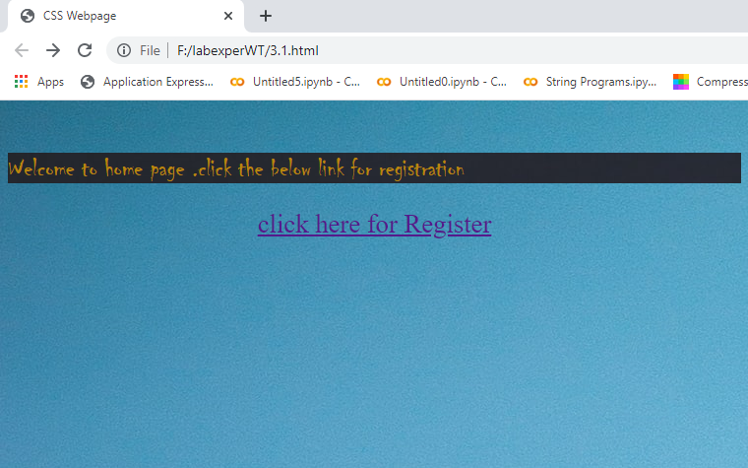

**3.2) Write a JavaScript that takes a number from one text field in the range of 0-999 and display it in other text field in words. If the number is out of range, it should show “out of range” and if it is not a number, it should show “not a number” message in the result box.**

<!DOCTYPE html>

<html>

<head>

<meta charset="utf-8">

<title></title>

<script language="javascript">

function convert_number_to_words(number)

{

hyphen='-';

conjunction='and';

separator='.';

dictionary={0:'zero',1:'one',2:'two',3:'three',4:'four',5:'five',6:'six',7:'seven',8:'eight',

9:'nine',10:'ten',11:'eleven',12:'twelve',13:'thirteen',14:'fourteen',15:'fifteen',16:'sixteen',

17:'seventeen',18:'eighteen',19:'nineteen',20:'twenty',30:'thirty',40:'fourty',50:'fifty',

60:'sixty',70:'seventy',80:'eighty',90:'ninety',100:'hundred',};

if(number<0 || number>999)

{

alert("enter a number range between 0 and 999");

return "";

}

switch(true)

{

case(number<21):

string=dictionary[number];

break;

case(number<100):

tens=parseInt(number/10)*10;

units=number%10;

string=dictionary[tens];

if(units){

string+=hyphen+dictionary[units];

}

break;

case(number<1000):

hundreds=parseInt(number/100);

remainder=number%100;

string=dictionary[hundreds]+ ' ' +dictionary[100];

if(remainder){

string+=conjunction+convert_number_to_words(remainder);

}

break;

default:

break;

}

return string;

}a=prompt("Enter a number");

num=parseInt(a);

document.write(convert_number_to_words(num));

</script>

</head>

<body bgcolor="lightcyan">

<h2 style="background-color: greenyellow;" align="title">WELCOME TO JAVASCRIPT</h1>

</body>

</html>

**Output:**

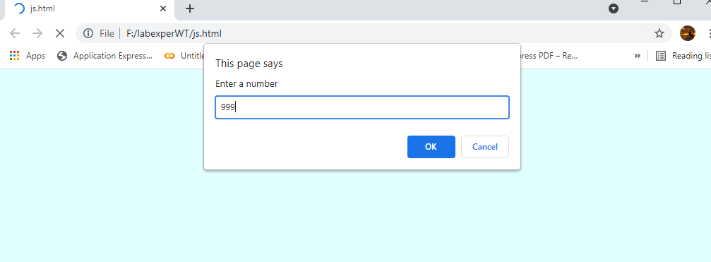

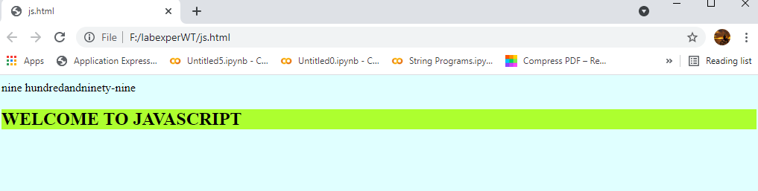

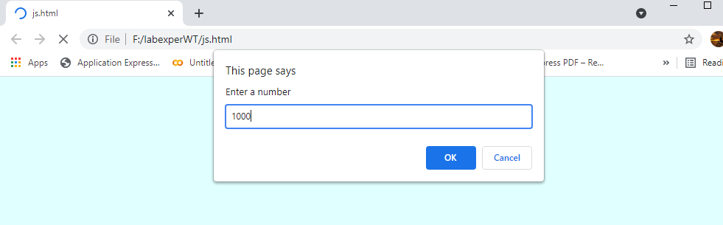

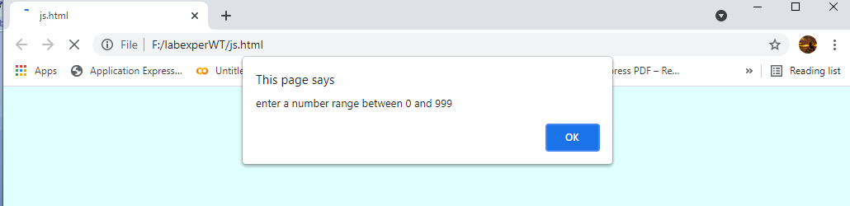

**4) Java Script & XML**

**4.1) Write a JavaScript to validate the following fields in a registration page created in week 2**

**a. Name (start with alphabet and followed by alphanumeric and the length should not be less than 6 characters)**

**b. Password (it allows alphanumeric, special symbols and should not be less than 6 characters)**

**c. E-mail (should not contain invalid email addresses)**

<!DOCTYPE html>

<html>

<head>

<meta charset="utf-8">

<title>form validation</title>

<script language="javascript">

function validation()

{

var x=f.un.value;

var len=x.length;

var val=x.charCodeAt(0);

var p=f.pw.value;

var c=f.cpw.value;

var a=f.email.value;

var atpos=a.indexOf("@");

var dotpos=a.lastIndexOf(".");

if(len<6||x==""||x==null)

{

alert("check your username! must be minimum 6 characters");

}

else if(val<65 || val>90&&val<97 || val>122)

{

alert("username must be begin with an alphabet");

return false;

}

else if(p==" || c==" || p.length<6 || c.length<6 || p!=c)

{

alert("password and confirm password should be same and greater than 6 characters!");

return false;

}

else if(atpos<6 || dotpos<atpos+6 || dotpos+2>=a.length)

{

alert("Not a Valid email id");

return false;

}

else{

alert("Congratulations!you have submitted successfully");

}

}

</script>

</head>

<body bgcolor="lemonchiffon">

<h1 align="left" style="">Registration Form</h1>

<table align="left" style="border: 1px solid;height: 500px;width: 600px; background-color:lightgoldenrodyellow;" >

<form name="f" action="jsform.html" onsubmit=" return validation();" method="post">

<tr>

<td><b>USERNAME</b></td>

<td><input type="text" name="un" placeholder="Please Enter Name"></td>

</tr>

<tr>

<td><b>PASSWORD</b></td>

<td><input type="password" name="pw" placeholder="Please Enter password"></td>

</tr>

<tr>

<td><b>CONFIRM PASSWORD</b></td>

<td><input type="password" name="cpw" placeholder="Please Enter Again Password "></td>

</tr>

<tr>

<td><b>E-mail ID:</b></td>

<td><input type="text" name="email" placeholder="Please Enter E-Mail"></td>

</tr>

<tr>

<td><label for="tel"><b>PHONE NUMBER</b></label></td>

<td><input type="tel" name="tel" id="tel" required="on" placeholder="Please Enter Phone Number"></td>

</tr>

<tr>

<td><label for="date"><b>DOB</b></label></td>

<td><input type="date" name="date" id="date" required="on" placeholder=" "></td>

</tr>

<tr>

<td><label for="gender"><b>GENDER</b></label></td>

<td>

<input type="radio" name="gender" id="male" value="male"><label>Male</label> <input type="radio" name="gender" id="female" value="female"><label>Female</label>

<input type="radio" name="gender" id="other" value="other"><label>Other</label>

</td>

</tr>

<tr>

<td><label for="lang"><b>LANGUAGES</b></label></td>

<td>

<input type="checkbox" name="te" id="te" value="Telugu"><label>Telugu</label>

<br>

<input type="checkbox" name="hi" id="hi" value="Hindi"><label>Hindi</label>

<br>

<input type="checkbox" name="en" id="en" value="English"><label>English</label>

<br>

<input type="checkbox" name="ta" id="ta" value="Tamil"><label>Tamil</label>

</td>

</tr>

<tr>

<td><label for="Qual"><b>QUALIFICATION</b></label></td>

<td >

<select name="Qual">

<option value="">BTech</option>

<option value="">MTech</option>

<option value="">Phd</option>

<option value="">BSc</option>

<option value="">B.Pharm</option>

<option value="">M.pharm</option>

</select>

</td>

</tr>

<tr>

<td><label for="address"><b>ADDRESS</b></label></td>

<td>

<textarea rows="5" cols="25" placeholder="Please Type Your Address" style="text-align: center;"></textarea>

</td>

</tr>

<tr>

<td></td>

<td><input type="Submit" name="Submit"/></td>

</tr>

</form>

</table>

</body>

</html>

**Output:**

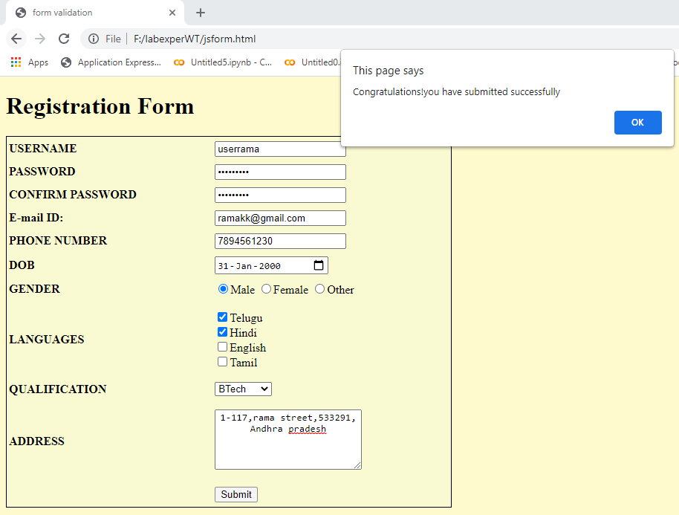

**4.2) Write an XML file which will display the Book information which includes the following: a) Title of the book ;b) Author Name ;c) ISBN number ;d) Publisher name e) Edition ;f) Price Write a Document Type Definition (DTD) to validate the above XML file and display the details in a table (to do this use XSL).**

**buk.dtd:**

<!ELEMENT bookdetails(books+)>

<!ELEMENT books(title,author,isbn,publisher,edition,price)>

<!ELEMENT title(#PCDATA)>

<!ELEMENT author(#PCDATA)>

<!ELEMENT isbn(#PCDATA)>

<!ELEMENT publisher(#PCDATA)>

<!ELEMENT edition(#PCDATA)>

<!ELEMENT price(#PCDATA)>

**Book.xml:**

<?xml version="1.0"?>

<!DOCTYPE bookdetails SYSTEM "buk.dtd">

<?xml-stylesheet type="text/xsl" href="buk.xsl"?>

<bookdetails>

<books>

<title>C</title>

<author>Balaguruswamy</author>

<isbn>123456</isbn>

<publisher>Oxford</publisher>

<edition>Edition-II</edition>

<price>$30.00</price>

</books>

<books>

<title>C++</title>

<author>yaswanth kanethkar</author>

<isbn>654321</isbn>

<publisher>Tata McHill</publisher>

<edition>Edition-I</edition>

<price>$35.00</price>

</books>

<books>

<title>JAVA</title>

<author>Herbert Schildt</author>

<isbn>789456</isbn>

<publisher>Cenage</publisher>

<edition>Edition-IV</edition>

<price>$50.00</price>

</books>

<books>

<title>DBMS</title>

<author>RAGHU RAMA KRISHNAN</author>

<isbn>789456</isbn>

<publisher>McGraw Education</publisher>

<edition>Edition-III</edition>

<price>$11.00</price>

</books></bookdetails>

**buk.xlx:**

<?xml version="1.0"?>

<xsl:stylesheet version="2.0" xmlns:xsl="http://www.w3.org/1999/XSL/Transform">

<xsl:template match="/">

<html>

<head><center>Book Details</center></head>

<body>

<hr width="50%"/>

<table border="1" align="center">

<tr>

<th>TITLE</th>

<th>AUTHOR</th>

<th>ISBN</th>

<th>PUBLISHER</th>

<th>EDITION</th>

<th>PRICE</th>

</tr>

<xsl:for-each select="bookdetails/books">

<tr>

<td><xsl:value-of select="title"/></td>

<td><xsl:value-of select="author"/></td>

<td><xsl:value-of select="isbn"/></td>

<td><xsl:value-of select="publisher"/></td>

<td><xsl:value-of select="edition"/></td>

<td><xsl:value-of select="price"/></td>

</tr>

</xsl:for-each>

</table></body></html></xsl:template>

</xsl:stylesheet>

**Output:**

