**Food Delivery Data Analysis**

**Project Documentation**

# 1. Introduction

In the modern food delivery industry, businesses rely heavily on data to optimize customer experience, improve restaurant partnerships, and streamline delivery operations. However, raw food delivery data is often scattered and lacks structure.

This project was developed to design, build, and analyze a relational SQL database for a food delivery platform. The system efficiently manages customers, restaurants, delivery partners, menu items, and orders, while enabling business insights through SQL queries.

# 2. Business Problem

The food delivery platform faced several challenges:

- Data was unorganized, making it difficult to track customers, restaurants, and delivery partners.

- No centralized system to measure:

- Customer spending behavior (top spenders, repeat customers).

- Best-selling menu items & popular cuisines.

- Revenue-generating restaurants.

- Performance of delivery partners.

- Lack of actionable insights for marketing, customer retention, and operational efficiency.

# 3. Approach (Methodology)

Database Design:

- Designed a relational SQL database with six main entities: Customer, Restaurant, DeliveryPartner, MenuItem, Orders, OrderDetail.

CREATE DATABASE IF NOT EXISTS food_delivery;

USE food_delivery;

-- CREATE TABLES

-- Customers

CREATE TABLE Customer (

customer_id INT PRIMARY KEY,

first_name VARCHAR(100) NOT NULL,

last_name VARCHAR(100) NULL,

email VARCHAR(150) NOT NULL,

phone VARCHAR(50),

city VARCHAR(100),

state VARCHAR(100),

country VARCHAR(100)

);

-- Restaurants

CREATE TABLE Restaurant (

restaurant_id INT PRIMARY KEY,

name VARCHAR(150),

city VARCHAR(100),

cuisine VARCHAR(100),

rating DECIMAL(3,1)

);

-- Delivery Partners

CREATE TABLE DeliveryPartner (

partner_id INT PRIMARY KEY,

name VARCHAR(100),

phone VARCHAR(20),

vehicle_type VARCHAR(50),

rating DECIMAL(3,1)

);

-- Menu Items

CREATE TABLE MenuItem (

item_id INT PRIMARY KEY,

restaurant_id INT,

name VARCHAR(150),

price DECIMAL(8,2),

category VARCHAR(50),

FOREIGN KEY (restaurant_id) REFERENCES Restaurant(restaurant_id)

);

-- Orders

CREATE TABLE Orders (

order_id INT PRIMARY KEY,

customer_id INT,

restaurant_id INT,

partner_id INT,

order_date DATE,

total_amount DECIMAL(10,2),

FOREIGN KEY (customer_id) REFERENCES Customer(customer_id),

FOREIGN KEY (restaurant_id) REFERENCES Restaurant(restaurant_id),

FOREIGN KEY (partner_id) REFERENCES DeliveryPartner(partner_id)

);

-- Order Details

CREATE TABLE OrderDetail (

order_detail_id INT PRIMARY KEY,

order_id INT,

item_id INT,

quantity INT,

FOREIGN KEY (order_id) REFERENCES Orders(order_id),

FOREIGN KEY (item_id) REFERENCES MenuItem(item_id)

);

select * from Customer;

select * from Restaurant ;

select * from DeliveryPartner ;

select * from MenuItem ;

select * from Orders ;

select * from OrderDetail ;

- Relationships were built using primary keys and foreign keys to ensure data integrity.

# ER diagram:

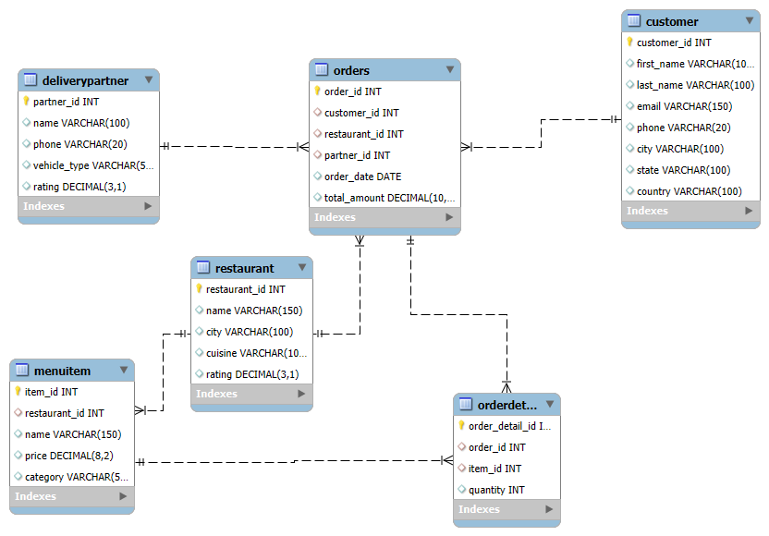

**Data Import & Setup:**

- Created database & tables in MySQL (food_delivery).

- Imported bulk data via CSV files.

- Verified foreign key constraints to ensure relational integrity.

**Query Development:**

- Wrote 15+ SQL queries ranging from basic joins to advanced analytics with CTEs and window functions.

- Categories: Customer insights, Restaurant insights, Menu analysis, Delivery partner performance, Sales trends.

# 4. Questions performed on the database to find insights

**📋 List of Questions Performed in the Food Delivery Project**

**Basic Queries (Q1 – Q15)**

1. **We want to understand our customer base better — can we list all customers along with their city and country?**
2. **If we want to promote only the best-performing restaurants, which are the top 5 restaurants based on customer ratings?**
3. **To measure customer loyalty, how many orders has each customer placed so far?**
4. **Which restaurant is contributing the most revenue to our platform, so we can strengthen our partnership with them?**
5. **What is the single most popular menu item that customers order again and again?**
6. **Who is our busiest delivery partner in terms of completed deliveries?**
7. **Which cuisine is the most popular among customers, based on the number of orders?**
8. **On which days did we record the highest sales, and what are the top 5 revenue days?**
9. **We are planning to reward premium customers — who are the customers that have spent more than 5000 in total?**
10. **Which city has the largest number of customers using our service?**
11. **Among delivery partners, who has the highest average rating for service quality?**
12. **Who are the top 5 customers who ordered the most food items overall?**
13. **Which restaurants offer the widest variety of food items on their menu, and who are the top 5?**
14. **Which food category (like pizza, desserts, etc.) is ordered the most by our customers?**
15. **Which are the top 3 highest-value orders, and which customers placed them?**

**🔎 Advanced Analysis Queries**

1. **Who are our top 3 customers by spending, if we rank all customers based on total money spent?**
2. **How have our sales trended month by month — are there any patterns or seasonal spikes?**
3. **What is the most popular food category in each city, so we can customize offers regionally?**
4. **What is the Customer Lifetime Value (CLV) for each customer — how much do they spend overall, and on average per order?**
5. **Within each cuisine type, which are the top 3 restaurants contributing the most revenue?**

# 5. Business Insights from Queries

Customer Insights:

- Identified top 5 customers based on spending and quantity of items ordered.

- Found customers who spent more than 5000, useful for loyalty programs.

- Calculated Customer Lifetime Value (CLV).

Restaurant Insights:

- Discovered the top revenue-generating restaurants.

- Ranked restaurants within each cuisine using DENSE_RANK.

- Found top 5 restaurants with the largest menu variety.

Menu & Cuisine Insights:

- Most popular food item and most frequently ordered category identified.

- Determined most popular cuisine overall and per city.

Delivery Insights:

- Identified the busiest delivery partner (highest deliveries).

- Highlighted partners with highest ratings.

Sales & Trend Analysis:

- Found top 5 days by revenue.

- Monthly sales trends showed seasonal demand peaks.

# 6. Solutions to Business Problems

- Customer Retention → Use CLV analysis to create loyalty programs and reward top spenders.

- Menu Optimization → Promote best-selling items and categories.

- Restaurant Partnerships → Focus on high-performing restaurants for exclusive deals.

- Delivery Partner Efficiency → Allocate orders based on performance (speed & ratings).

- Marketing Campaigns → Plan around peak sales days and seasonal demand patterns.

# 7. Project Workflow (End-to-End)

1. Requirement Gathering → Identified business needs (customer insights, sales, delivery efficiency).

2. Database Design (ERD) → Created schema with 6 entities and relationships.

3. Implementation → Wrote SQL scripts to create tables and relationships.

4. Data Loading → Imported test data via CSV files.

5. Query Writing → Wrote step-by-step queries for insights (basic → advanced).

6. Validation → Cross-checked query outputs for accuracy.

7. Visualization & Reporting → Summarized insights in PowerPoint presentation.

# 8. Recommendations

- Focus promotions on high-spending customers.

- Run seasonal campaigns during high-sales months.

- Encourage restaurants with high ratings to expand menu categories.

- Monitor delivery partner performance for faster and more reliable service.

- Introduce customer referral and loyalty programs based on CLV insights.

# 9. Conclusion

This project successfully transformed unstructured food delivery data into a structured SQL database capable of generating actionable business insights.

Through ER modeling, table design, and advanced SQL queries, we:

- Identified top customers, restaurants, and menu items.

- Measured sales trends and revenue drivers.

- Improved delivery partner allocation strategies.

Ultimately, this project demonstrates how SQL-based analytics can enhance marketing, operations, and customer engagement in the food delivery industry.

# 10.Access the data sets here 🡪 [Datasets link](https://drive.google.com/drive/folders/1xKr2d6OUT9rqI31G8BXi58O1Jk9xx2Xd?usp=drive_link)