**Patent Search and Analysis Report (PSAR)**

**Submitted as a part of the**

**PROJECT REPORT**

***CRM for Admission***

***Submitted by***

**CHACHAPARA JAY – 160890107004**

**DHADUK JENISH – 160890107007**

**HINGRAJEEYA HEMAL – 160890107010**

**PALALIYA RAVIRAJ – 160890107017**

***In partial fulfilment for the award of the degree of***

**BACHELOR OF ENGINEERING**

***In***

**Computer Engineering**

**Shri Labhubhai Trivedi Institute Of Engineering & Tech, Rajkot**

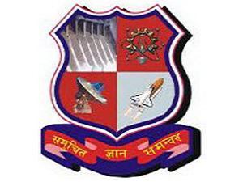 

**Gujarat Technological University, Ahmedabad**

October-2019