1. **Introduction**

Our project is “CRM FOR ADMISSION” will help faculties of the college and any person who is related to the admission process of the college.

In our project there are two main modules

1. Admission Process
2. Expanse

It is tedious task to manage admission related process information carry manually. So, our project helps the college easily manage admission process. Our project provides student admission related report, expense related project, lead forwarding from one faculty to another and also provide notification about to admission related task that give by higher authority.

## Document Purpose

The main purpose behind this project is to provide the faculty of the college, principle, admission head a simple and easily manageable interface to admission process, school visit, college visit and much more and reduce burden from faculty to working on admission process.

## Product Scope

This product is built to provide easy interaction to admission coordinator, department head and faculty with the existing system. They can easily transfer the lead, generates the response and expense related report, generates schedules to visit school and college, easily manage student information and much more other thing.

## Intended Audience and Document Overview

This document is for developers, project managers, marketing staff, students, teachers, testers and documentation writer of the SLTIET and project team. The reading sequence of this document is starting from introduction to overall description of the project, external interfaces and system functionalities and at last the revision history.

## Definitions, Acronyms and Abbreviations

The project is of making a CRM to handle admission and expense process in college or organization

Here the currently manual process is going to be transmit online

Response, lead forwarding, expense approval, report generation all are done in one click

## Document Conventions

Every requirement specification statementis having their own same level priority and not any external or distinguished priority set for any requirement.

## References and Acknowledgments

We got the idea of “CRM FOR ADMISSION” because we show to face lots of difficulties and delays during admission process of the college.

1. **Overall Description**

## Product Perspective

The system surely gone by updated after release since data are continuously updating and data cleaning. Also required for memory efficiency. It provides interface for admin and faculty both but with different functionalities.

Admin user an allowed to do much more important things compare to faculty user.

Basically, the product is established in the form of website further more it may extend to android and IOS application as few difficulties and suggestions.

## Product Functionality

Student data provide, lead forwarding, response and expense related report, school and college visit schedule, team generation, notification, remotely access of all the functionalities provided by the admin user.

## Users and Characteristics

Principal and admission coordinator: validate expanse

Head of the department: Forward leads, registration

Faculty: school and college visit add expense

## Operating Environment

The product can be run on any operating system. It requires internal connection and a browser to run the site and stay updated with the current situation of the databases.

## Design and Implementation Constraints

The products need to be completed within one year. The technologies that are used to build the product is bootstrap, HTML, CSS, JavaScript and PHP. The developer team has used tool like sublime text, XAMPP, Dreamweaver, simple local database with SQL and XAMPP is used for the demonstration.

## User Documentation

User will be provided how to use, help, contact us, features to solve any quires regarding the product than also provide proper horizontal and vertical navigation bar to follow proper activity.

## Assumptions and Dependencies

Assumption-

We have assumption to make online payment for expense module.

In this module faculties will give their expense details and it is sent to admission coordinator for approval.

Right now, we are just giving the verified PDF document regarding payment which they have to submit in account department.

But instead of doingthat we assume that we may give online payment option.

Once the details have been verified then organization will directly pay to the requester in his/her account.

Dependency-

All the data are of students so the complete project is depending on the student data.

If it is not given by any students then it may result into some unconditional errors.

1. **Specific Requirements**

## External Interface Requirements

### User Interfaces

Faculty

-Login page with submit button

-After successfully login there will be homepage with

-Notification

-Navigation links

-About us

-Contact us

-Site map

-Apply for expanse revenue

-Take response from student

-CRUD operation on database.

Admin

- Login page with submit button

- After successfully login there will be homepage with

-Add notification

-Gives student data to faculty

-approve expanse

-Generate team for school visit and college visit

-Generate report

-Provide schedule to visit

-CRUD operation on database

-Lead forwarding

### Hardware Interfaces

For hardware interface few things are required which are any device like computer or mobile phone from the user and admin side to complete the process and server on the admin sir to store and retrieve the data.

### Software Interfaces

Software interface include interaction and passing of data between databases tables for the process of taking response from students, school and college visit data and many more things.

For example, for the response report the report generation page will make request to the database to display the all the student response or return requested report will be provided to admin.

### Communications Interfaces

This product requires email and browser network server and HTTP communication over the internet.

## Functional Requirements

Provide student data from different platform like school and college visit data

-Reception student data

-Many other sources

That call data collected in one plate-form.

Lead forwarding

-In this function one product user transfer the control to another user.

Report generation

-Response related report

-Expanse related report

Notification

-School and college visit schedule

-Reception work notification

-Many other information

Team generation

-Team generate area via

-Relationship via

## Behaviour Requirements

### Use Case View

CRM behavior theory represents inter-related perspective of Customer Relationship Management relating to managing corporate customer relationship.

This involves 52 personal interviews with services providers and their corporate lines.

1. **Other Non-functional Requirements**

## Performance Requirements

Easily generate response and expense report. Any transaction will not take more than 20 second. Easily forward lead from one user to another. Different-different perspective vice you can generate the team. Easily maintain different type of student data. Provide notification as a remainder.

## Safety and Security Requirements

For the shake of safety back up device are required to save the data if server get crash or any other harming things happened on server.

Not put incorrect data on database.

For the shake of security, the user and admin a suggested do not to share their personal detail like password and user id with other and not to use any third tool to access the site. We provide password encryption on database.

## Software Quality Attributes

The additional attributes in the product is as follow:

We provide region wise faculty information. So, admin user easily generate team for school and college visit.

We can provide response and expense report. So, admin easily maintain college admission and their college expense.

For the reliability of admin user, we provide are central database so that easily transfer the lead.

1. **Other Requirements**

The other requirements which is most required thing is providing a domain and the server to the product to run. Addition to this the detail of all the people which directly or indirectly connected with admission process of the college.

We can also find mail server or SMS source. So, provide user to forget password functionalities.

**Appendix A–Design Engineering Canvas**

**AEIOU Canvas**

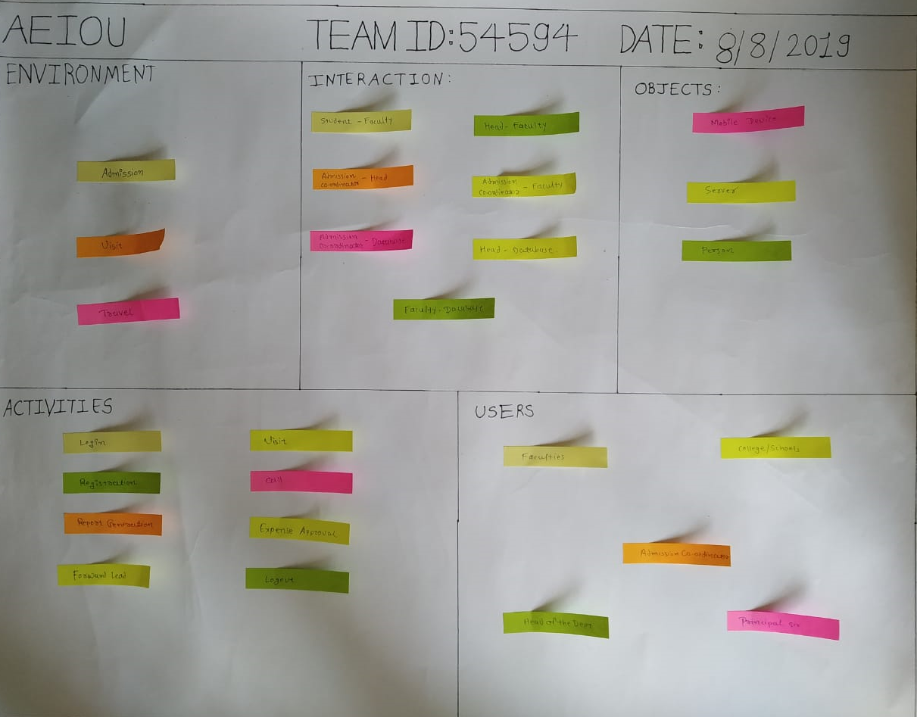

**Empathy Canvas**

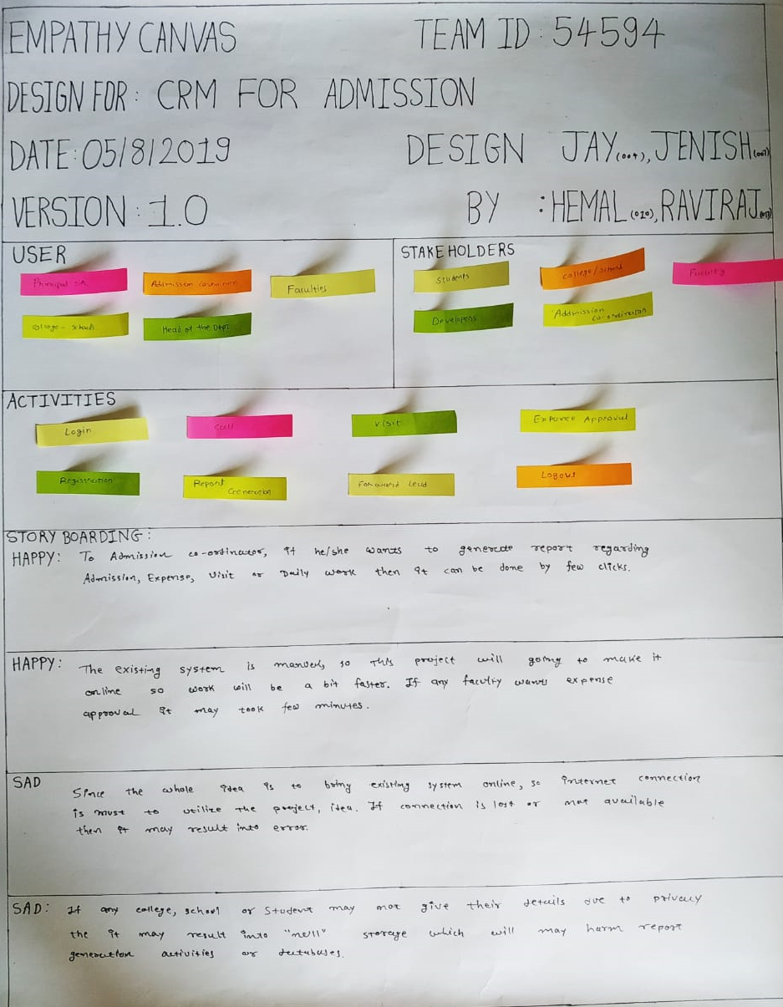

**Ideation Canvas**

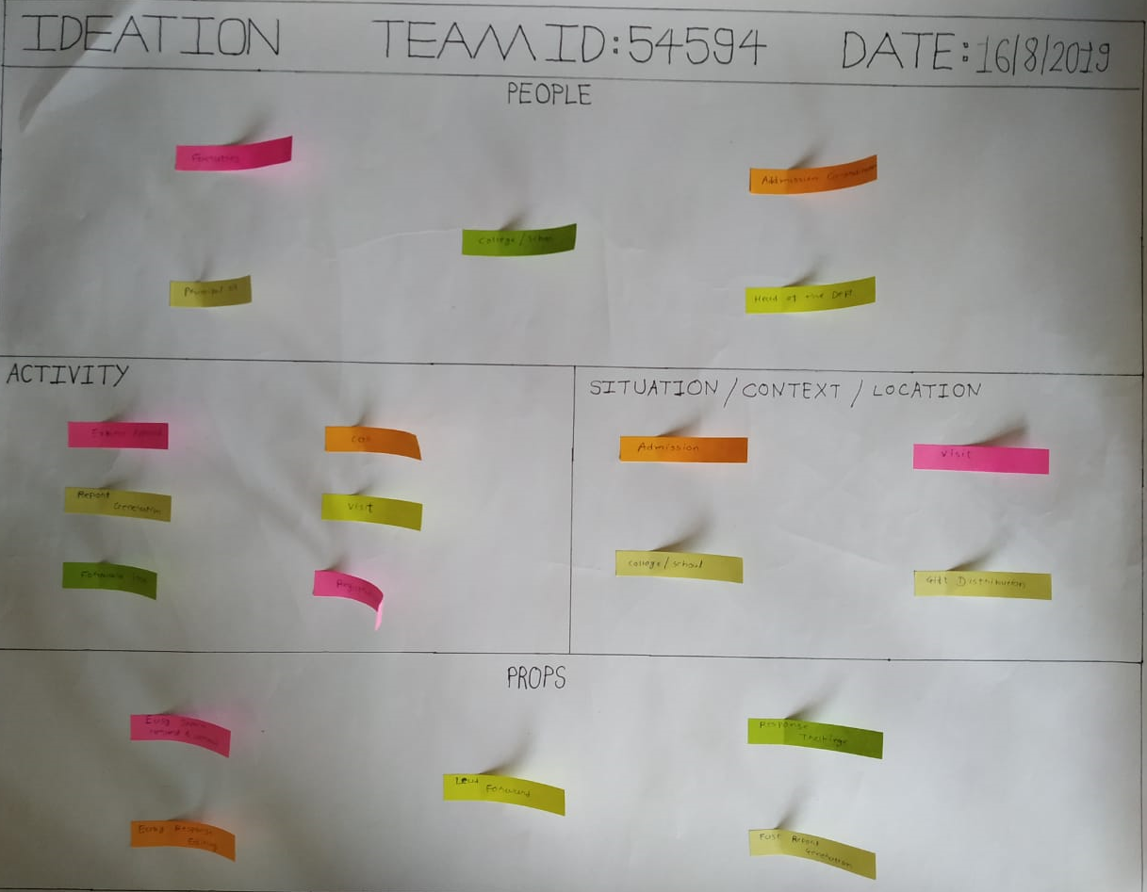

**Product Development Canvas**

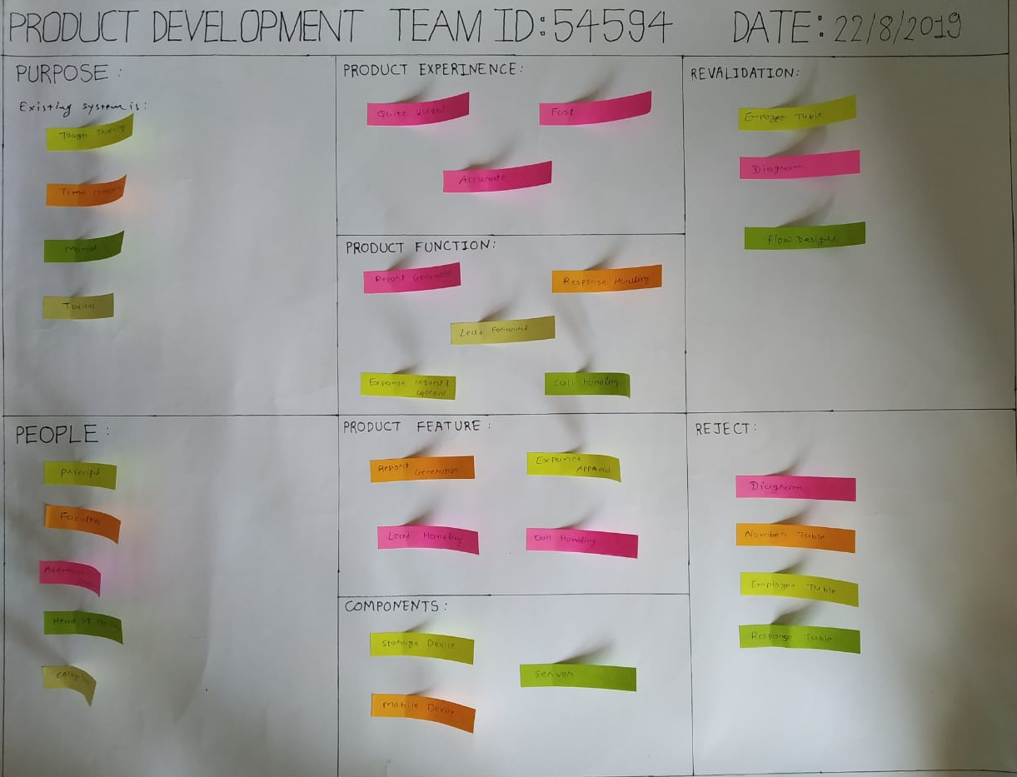

**Appendix B - System Design**

**Activity Diagram** (Login)

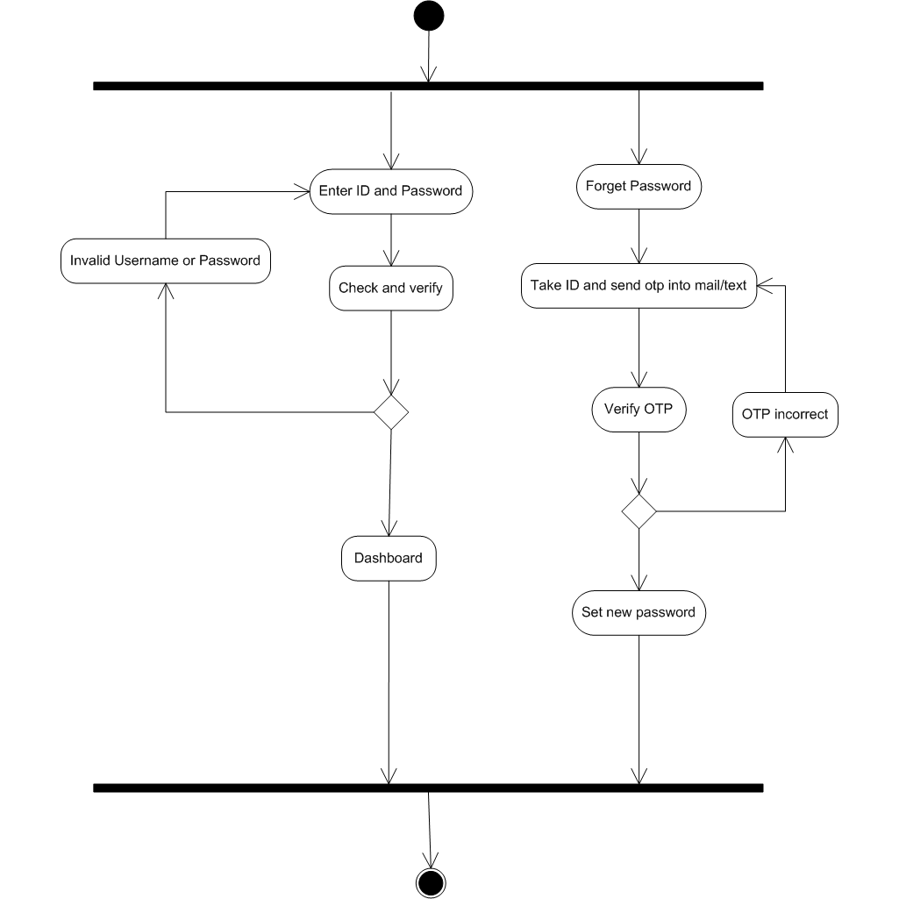

**Activity Diagram**(Admission)

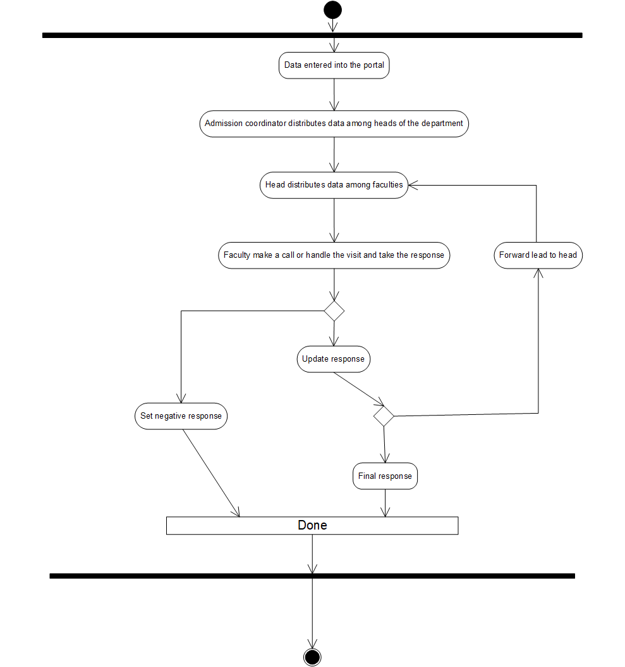

**Activity Diagram**(Team)

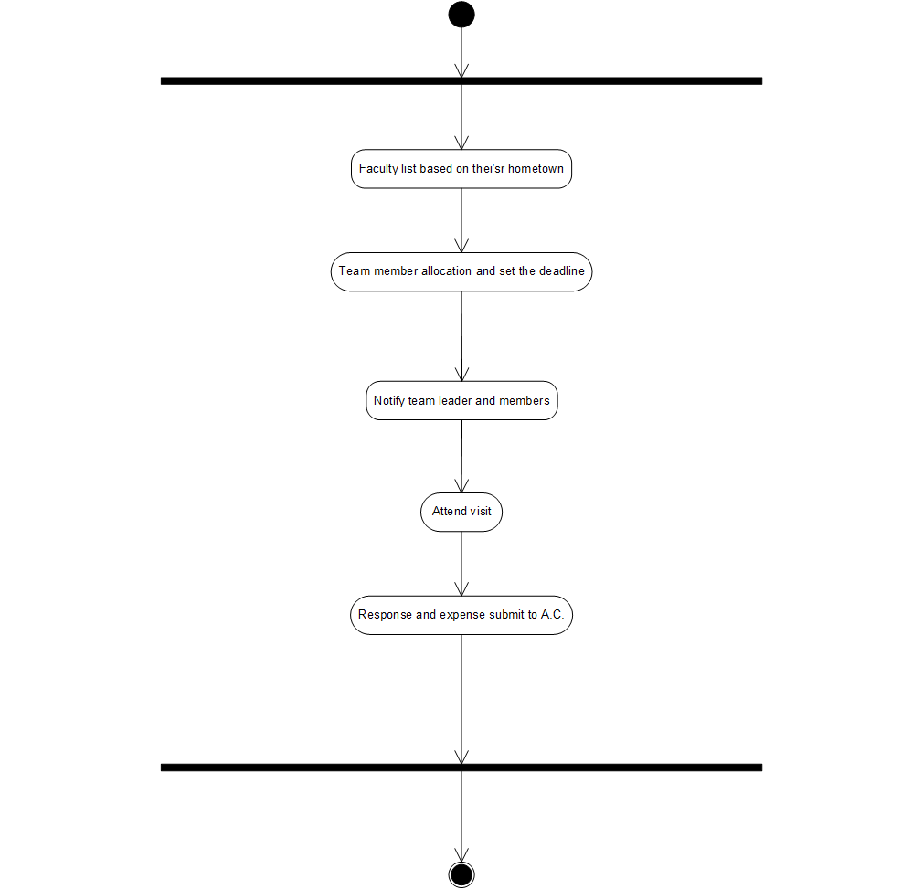

**Activity Diagram**(Expense)

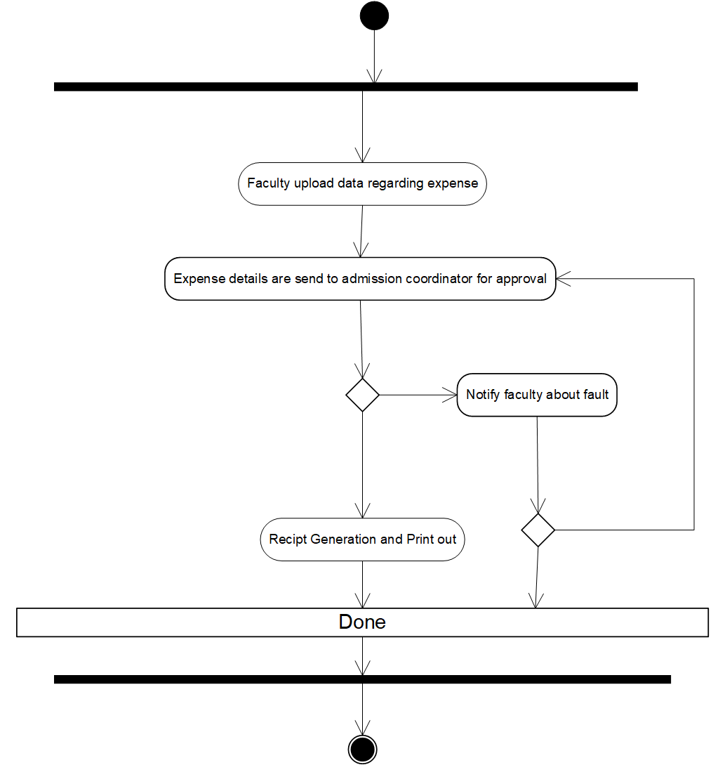

**Activity Diagram**(Report)

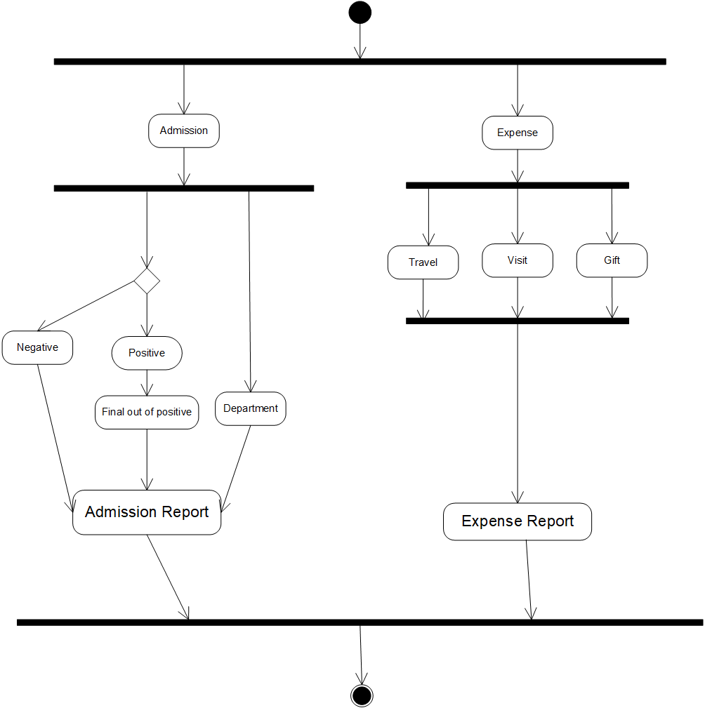

**Class Diagram**

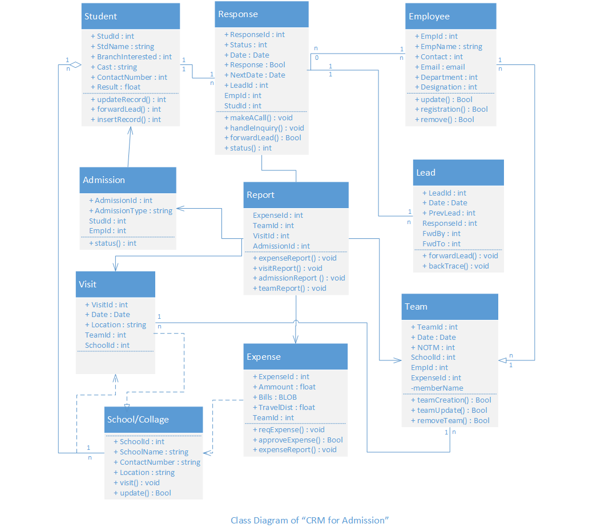

**Data Flow Diagram** (Level-0)

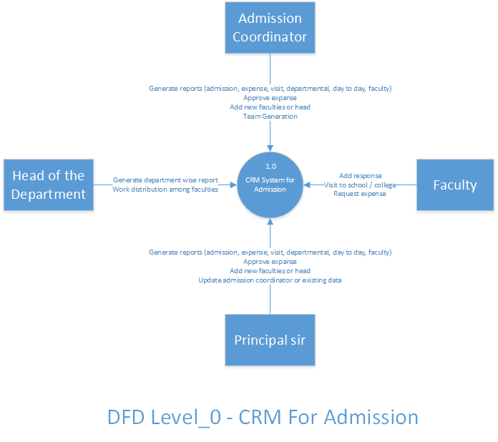

**Data Flow Diagram**(Level-1)

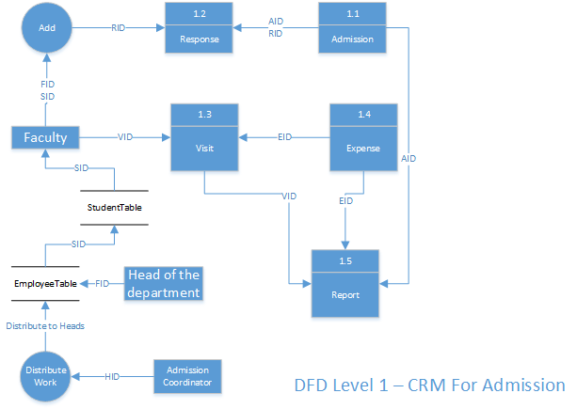

**Data Flow Diagram**(Level-2)

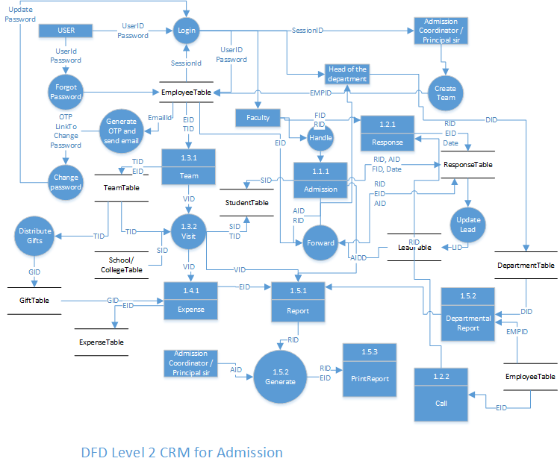

**ER Diagram**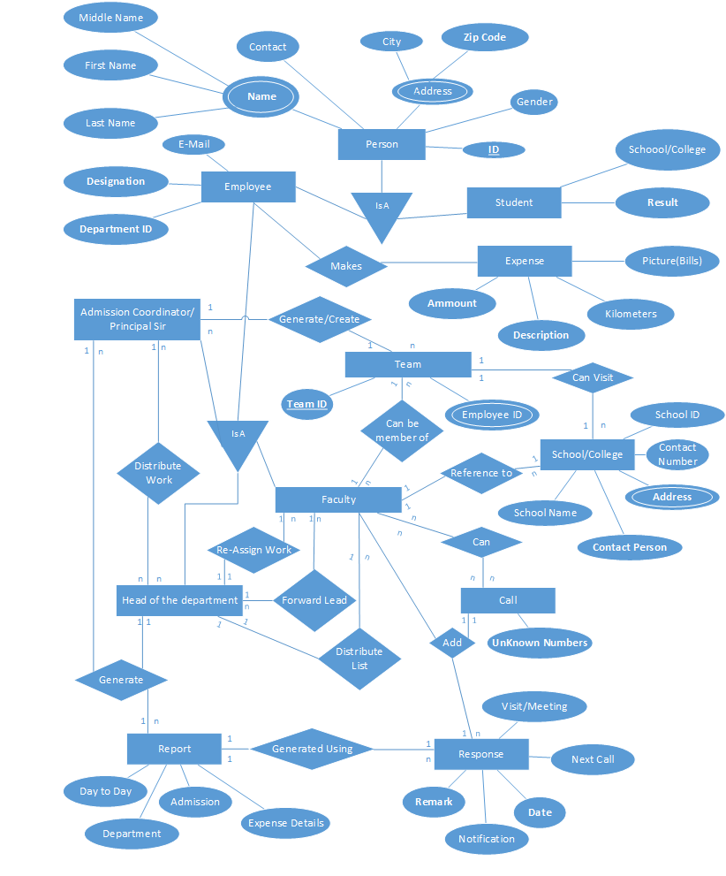

**Sequence Diagram** (Admission Coordinator)

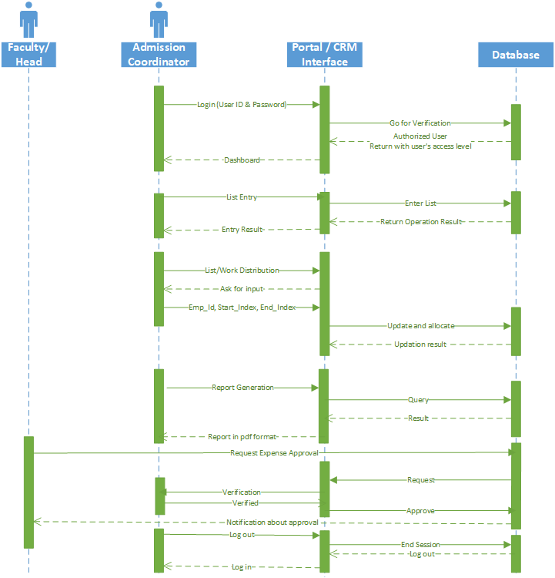

**Sequence Diagram**(Head and Faculty)

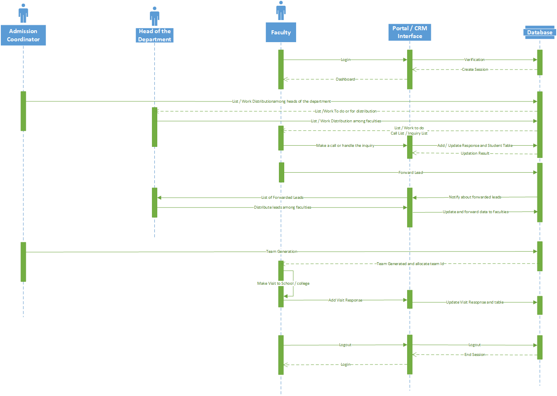

**Use Case Diagram**

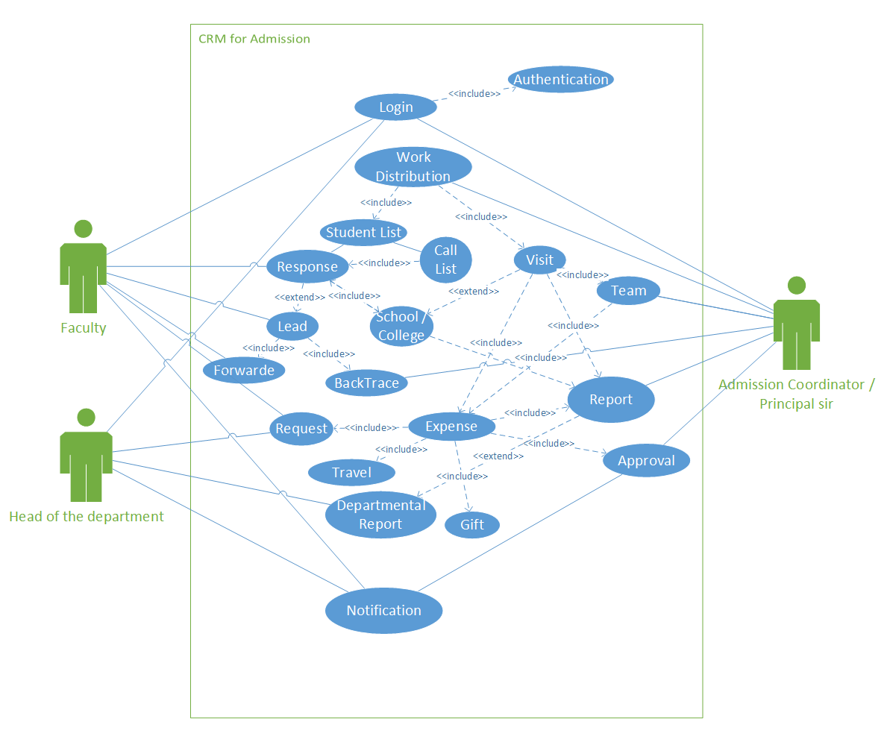

**Appendix C – Data Dictionary**

**Department Table**

|  |  |  |
| --- | --- | --- |
| **Field Name** | **Field Type (Size)** | **Field Constraints** |
| **Dept_Id** | **Int (2)** | **Primary Key** |
| **Dept_Name** | **String (30)** | **Not Null** |

|  |  |
| --- | --- |
| **Dept_Id** | **Dept_Name** |
| **01** | **Degree Computer Engineering** |
| **02** | **Degree Mechanical Engineering** |
| **03** | **Degree Civil Engineering** |
| **04** | **Degree Electrical Engineering** |
| **11** | **Diploma Mechanical** |
| **12** | **Diploma Civil** |
| **13** | **Diploma Electrical** |
| **21** | **Humidity and R. Department** |

**Designation Table**

|  |  |  |
| --- | --- | --- |
| **Field Name** | **Field Type (Size)** | **Field Constraints** |
| **Design_Id** | **Int (1)** | **Primary Key** |
| **Designation** | **String (30)** | **Not null** |

|  |  |
| --- | --- |
| **Design_Id** | **Designation** |
| **1** | **Principal** |
| **2** | **Admission Coordinator** |
| **3** | **Head of the department** |
| **4** | **Faculty** |

**Employee Table**

|  |  |  |
| --- | --- | --- |
| **Field Name** | **Field Type** | **Field Constraints** |
| **Emp_Id** | **Long Int (12)** | **Primary key** |
| **First_Name** | **String (20)** | **Not null** |
| **Last_Name** | **String (20)** | **Not null** |
| **Contact** | **Decimal (12)** | **Not null** |
| **Email** | **Email (30)** | **Not null** |
| **Dept_Id** | **Int (12)** | **Foreign key** |
| **City** | **String (15)** | **Not null** |
| **Address** | **Varchar (50)** | **Not null** |
| **Design_Id** | **Int (1)** | **Foreign Key** |
| **Password** | **Password (30)** | **Not null** |

**Student Table**

|  |  |  |
| --- | --- | --- |
| **Field Name** | **Field Type** | **Field Constraints** |
| **Type** | **Bool(0-Student,1-Calls) (1)** | **Not Null** |
| **Student_Id** | **Long int (10)** | **Primary** |
| **First_Name** | **String (20)** | **Not null** |
| **Last_Name** | **String (20)** | **Not null** |
| **Gender** | **Boolean (1)** | **Not null** |
| **Contact** | **Decimal (12)** | **Nullable** |
| **Cast** | **String (10)** | **Nullable** |
| **Income** | **Float (10)** | **Nullable** |
| **Date** | **Date** | **Not Null** |
| **City** | **String (15)** | **Nullable** |
| **Year** | **Integer (4)** | **Not Null** |
| **Result** | **Float (5)** | **Nullable** |
| **Group** | **Int (5)** | **Null** |
| **Emp_Id** | **Long int (12)** | **Foreign key** |
| **School / College** | **String (30)** | **Nullable** |
| **Admission Type** | **String (30)** | **Nullable** |

**Expense Table**

|  |  |  |
| --- | --- | --- |
| **Field Name** | **Field Type** | **Field Constraints** |
| **Expense_Id** | **Int (10)** | **Primary key** |
| **Team_Id** | **Long int (12)** | **Foreign key** |
| **Gift_Id** | **Int (10)** | **Foreign Key** |
| **Date** | **Date** | **Not Null** |
| **Details** | **Text (100)** | **Not Null** |
| **Amount** | **Float (10)** | **Not Null** |
| **Picture(3)** | **BLOB (Up to 10MB)** | **Null** |

**Gift Table**

|  |  |  |
| --- | --- | --- |
| **Field Name** | **Field Type** | **Field Constraints** |
| **Gift_Id** | **Int (10)** | **Primary Key** |
| **Emp_Id** | **Long int (12)** | **Foreign key to employee table** |
| **Date** | **Date** | **Not Null** |
| **Broacher** | **Int (4)** | **Not Null** |
| **Beg** | **Int (4)** | **Not Null** |
| **Other** | **Int (4)** | **Not Null** |

**School/College Table**

|  |  |  |
| --- | --- | --- |
| **Field Name** | **Field Type** | **Field Constraints** |
| **School_Id** | **Int (3)** | **Primary Key** |
| **School_Name** | **String (30)** | **Not null** |
| **Address** | **Varchar (50)** | **Not null** |
| **City** | **String (20)** | **Not null** |
| **Contact_Person_Name** | **String (20)** | **Not null** |
| **Contact** | **Decimal (12)** | **Not null** |
| **Emp_Id (Reference Faculty)** | **Long int (12)** | **Foreign key to employee table** |

**Allocation Table**

|  |  |  |
| --- | --- | --- |
| **Field Name** | **Field Type** | **Field Constraints** |
| **Tab_Specification** | **Bool (1)** | **Not Null** |
| **Emp_Id** | **Int (12)** | **Foreign key** |
| **Start_Index** | **Int (5)** | **Not Null** |
| **End_Index** | **Int (5)** | **Not Null** |

**Response Table**

|  |  |  |
| --- | --- | --- |
| **Field Name** | **Field Type** | **Field Constraints** |
| **Response_Id** | **Int (5)** | **Not Null** |
| **Emp_Id** | **Long Int (12)** | **Foreign Key** |
| **Student_Id** | **Int (10)** | **Foreign Key** |
| **Date** | **Date** | **Not Null** |
| **Status (Init / Pending / Completed)** | **Int (1)** | **Not Null** |
| **Response (Positive / Negative)** | **Bool** | **Not Null** |
| **Next Date (To Call/ To Visit)** | **Date** | **Null** |
| **Remark** | **Text (100)** | **Null** |
| **Lead_Id** | **Int (10)** | **Foreign Key** |

**Lead Table**

|  |  |  |
| --- | --- | --- |
| **Field Name** | **Field Type** | **Field Constraints** |
| **Lead_Id** | **Int (10)** | **Primary key** |
| **Emp_Id** | **Int (12)** | **Foreign key** |
| **Response_Id** | **Int (10)** | **Foreign Key** |
| **Date** | **Date** | **Not Null** |
| **Forwarded_By_Emp_Id** | **Int (12)** | **Not Null** |
| **Forwarded_To_Emp_Id** | **Int (12)** | **Not Null** |

**Team Table**

|  |  |  |
| --- | --- | --- |
| **Field Name** | **Field Type** | **Field Constraints** |
| **Team_Id** | **Int (12)** | **Primary key** |
| **Emp_Id** | **Int (12)** | **Foreign Key** |
| **School_Id** | **Int (3)** | **Foreign key** |
| **Gift_Id** | **Int (10)** | **Foreign key** |
| **Expense_Id** | **Int (10)** | **Foreign Key** |
| **NOTM** | **Int(2)** | **Not Null** |

**Team Member Table**

|  |  |  |
| --- | --- | --- |
| **Field Name** | **Field Type** | **Field Constraints** |
| **Team_Id** | **Int (12)** | **Primary key** |
| **Emp_Id** | **Int (12)** | **Foreign Key** |

**Appendix D – Periodic Progress Reports**

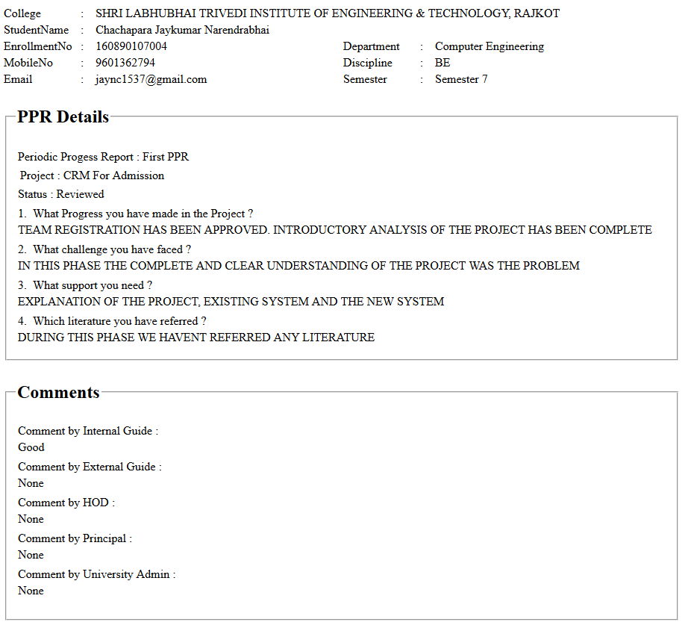

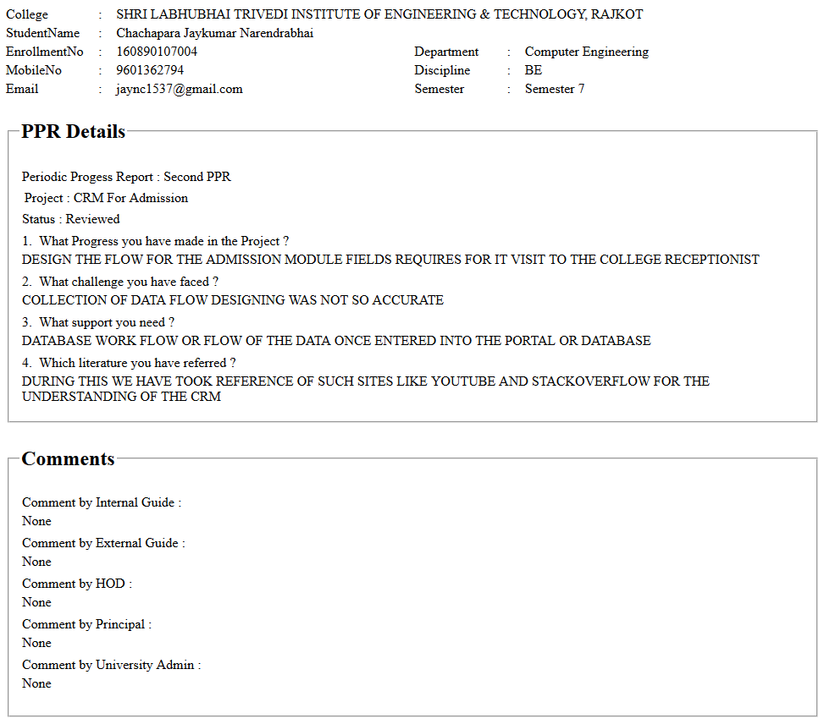

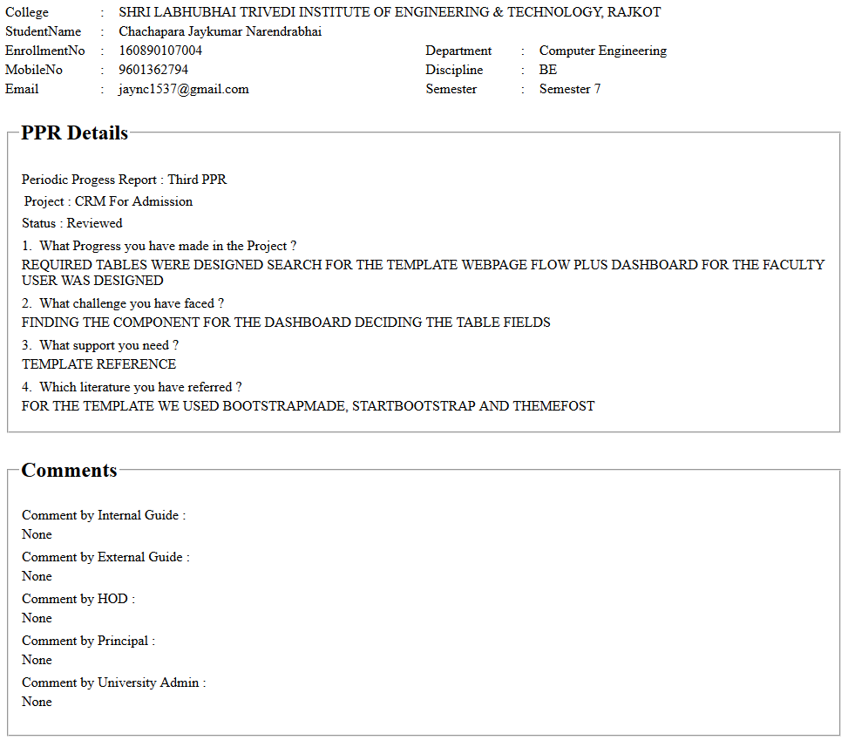

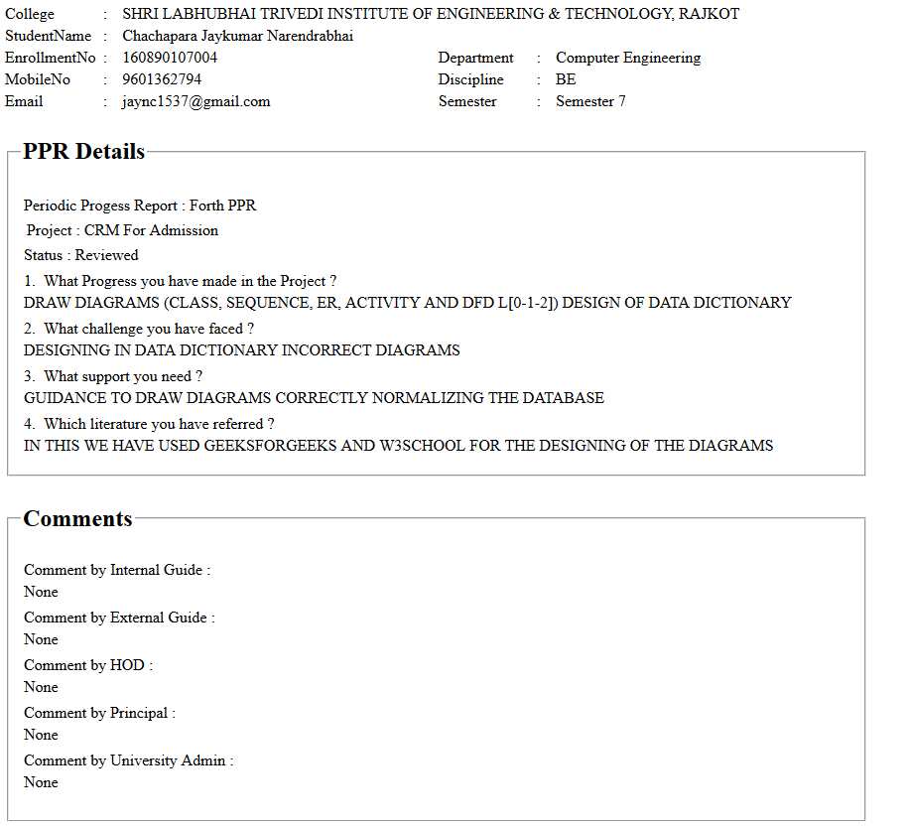

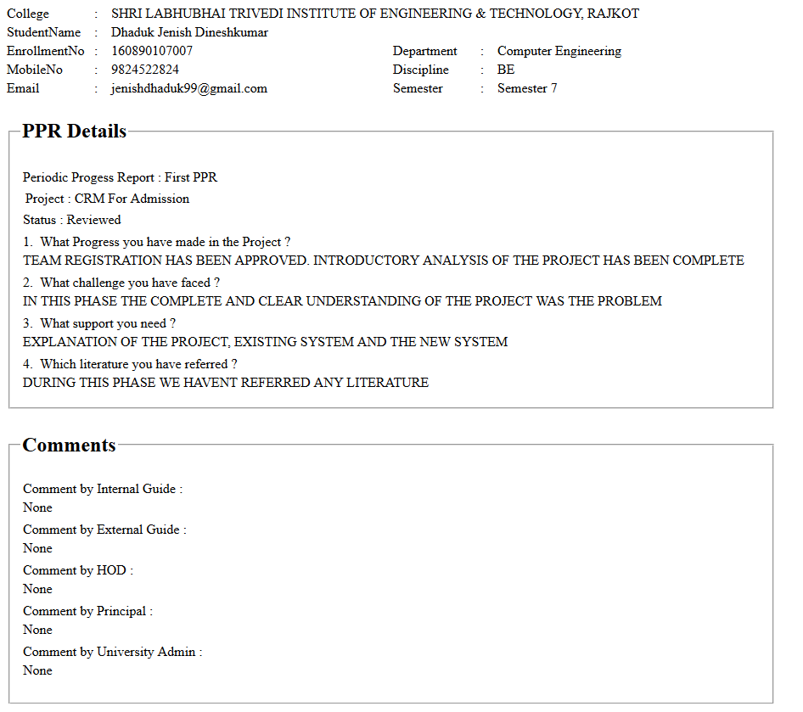

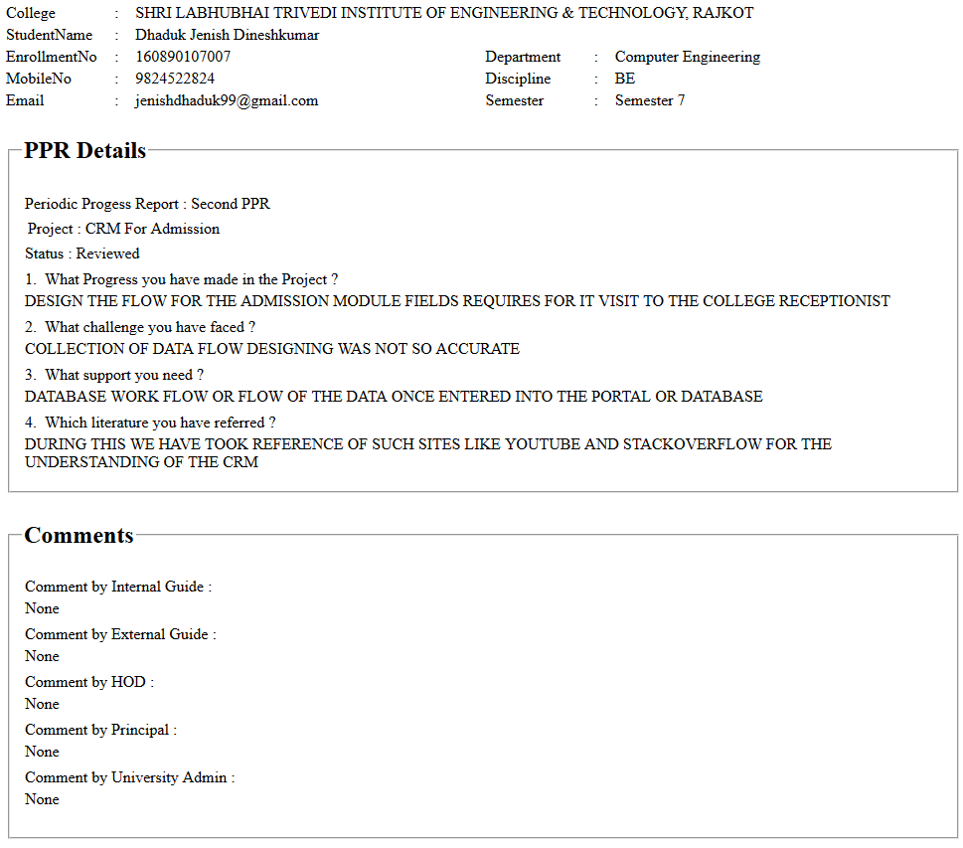

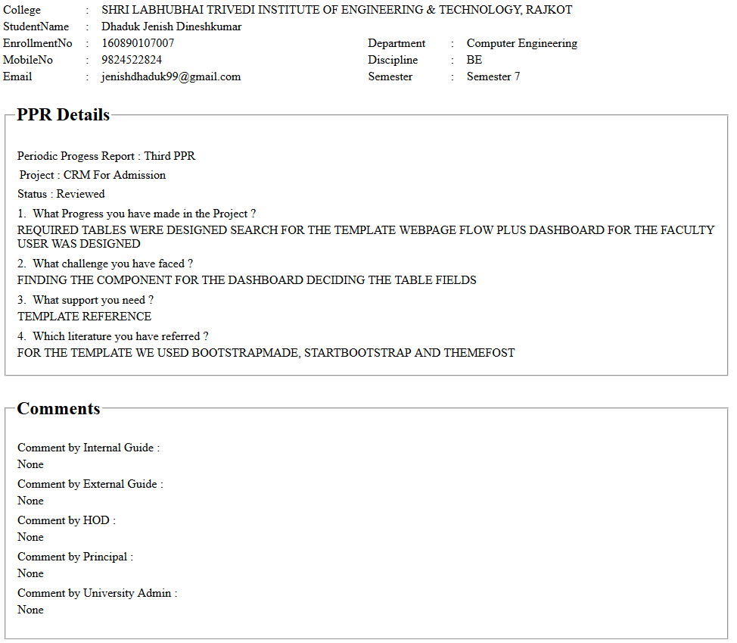

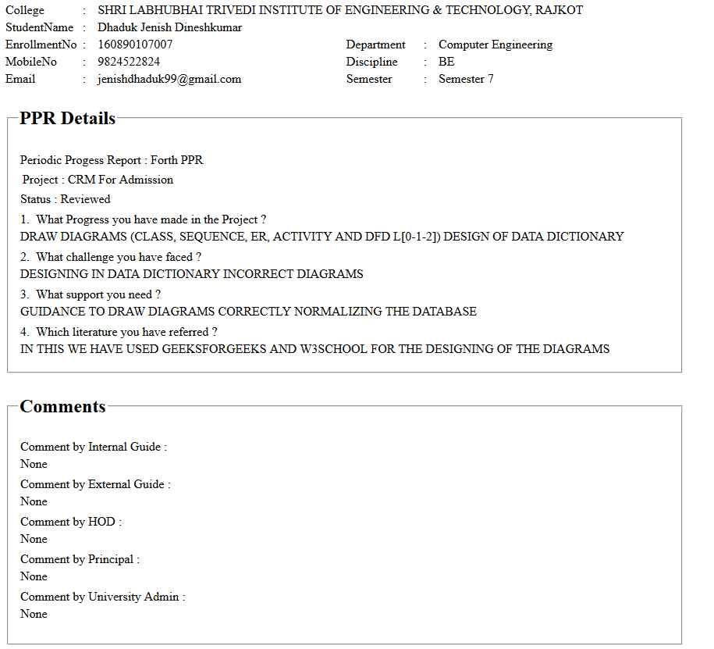

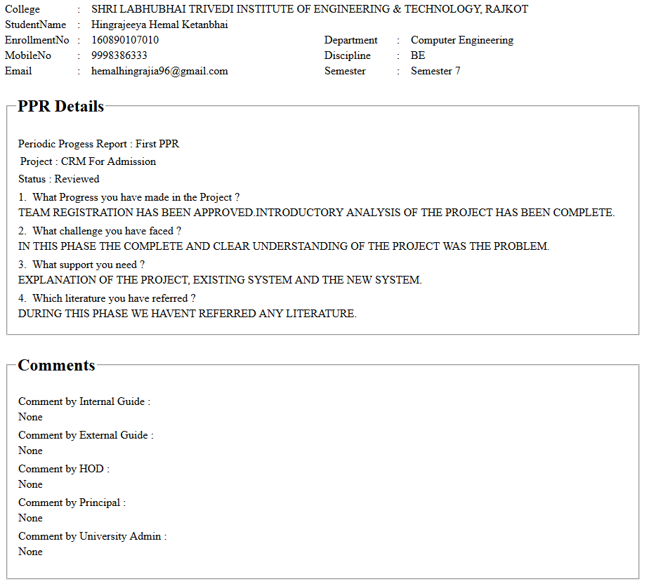

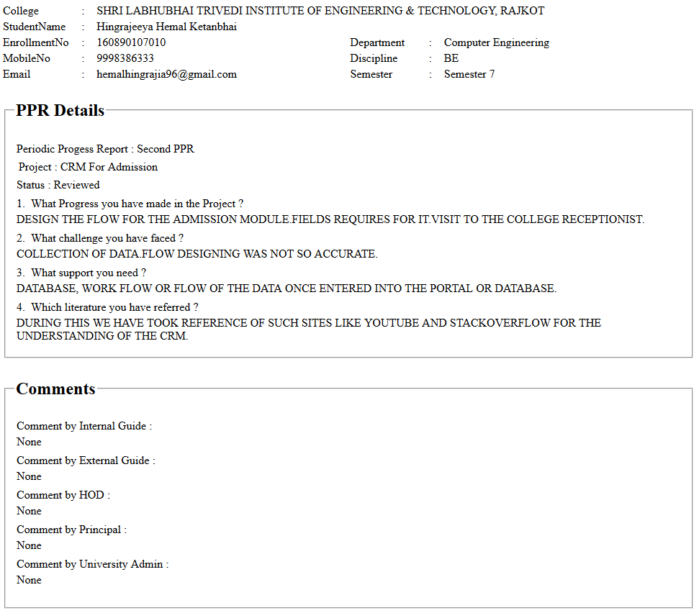

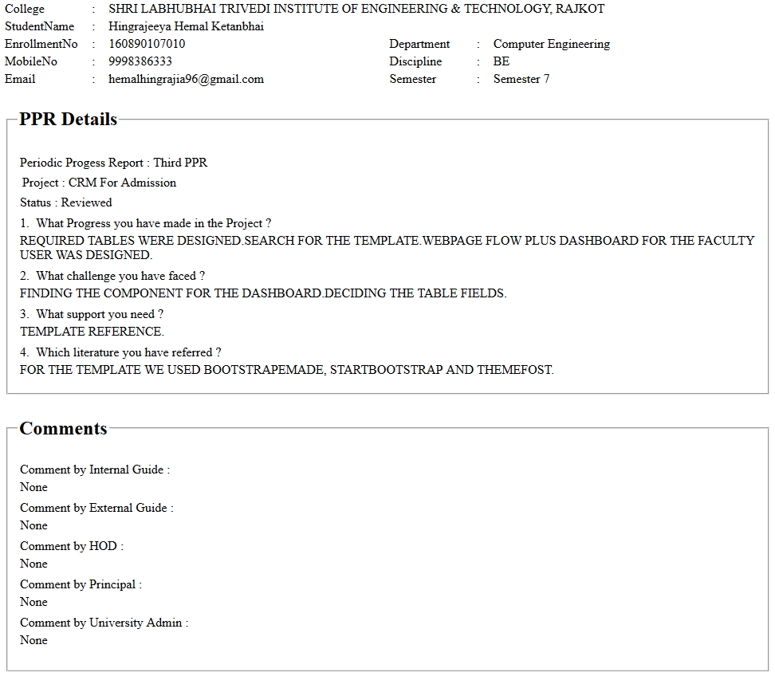

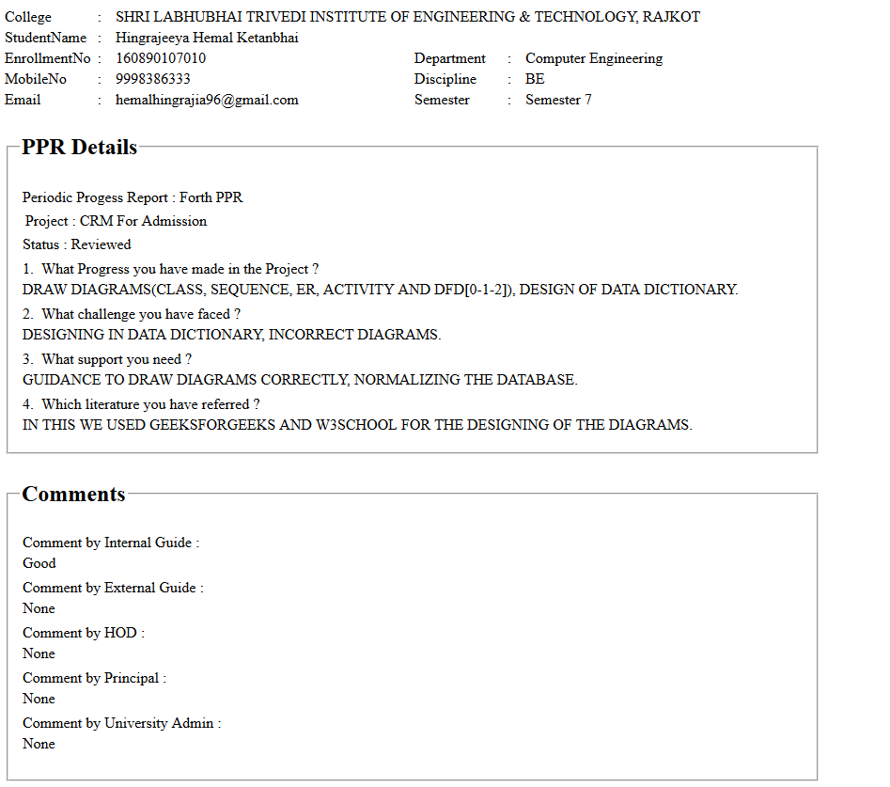

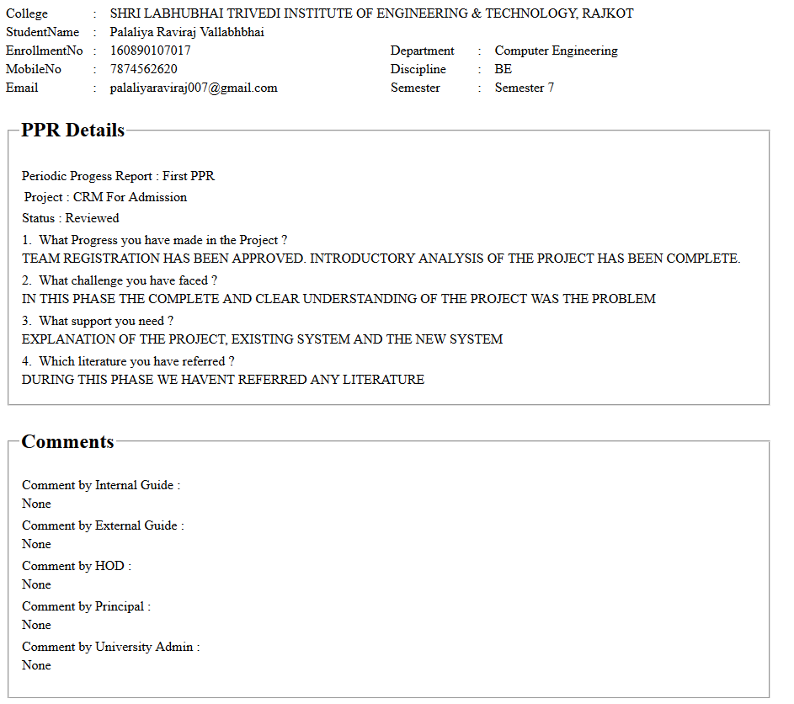

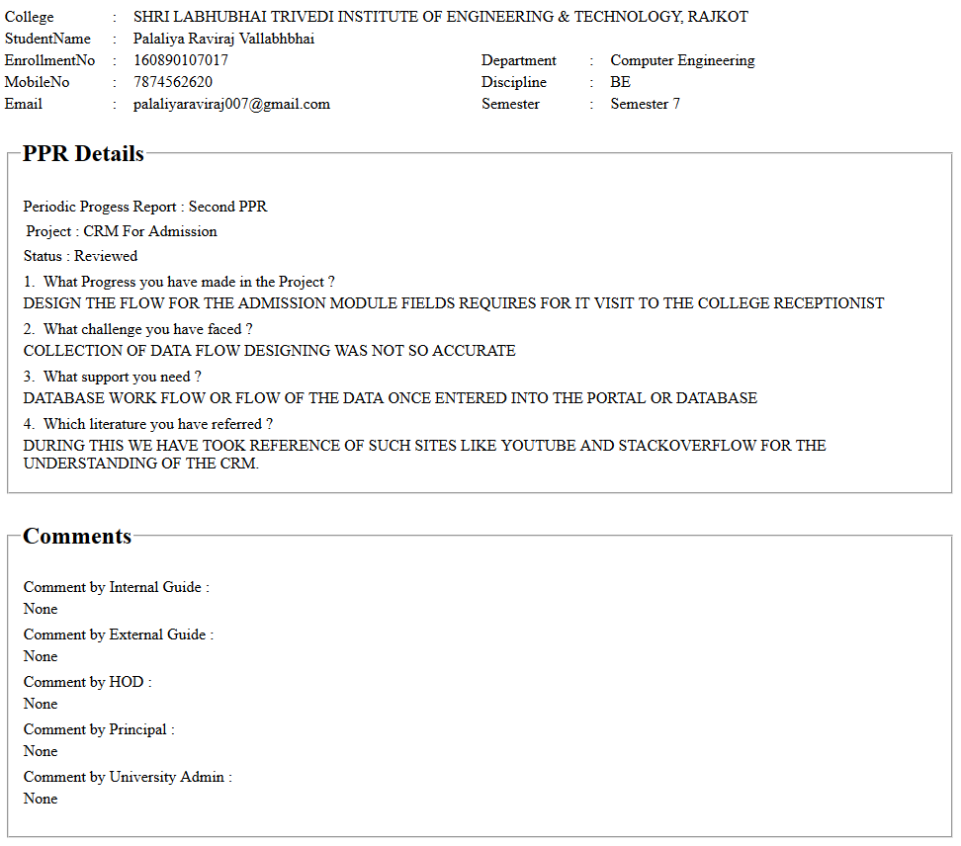

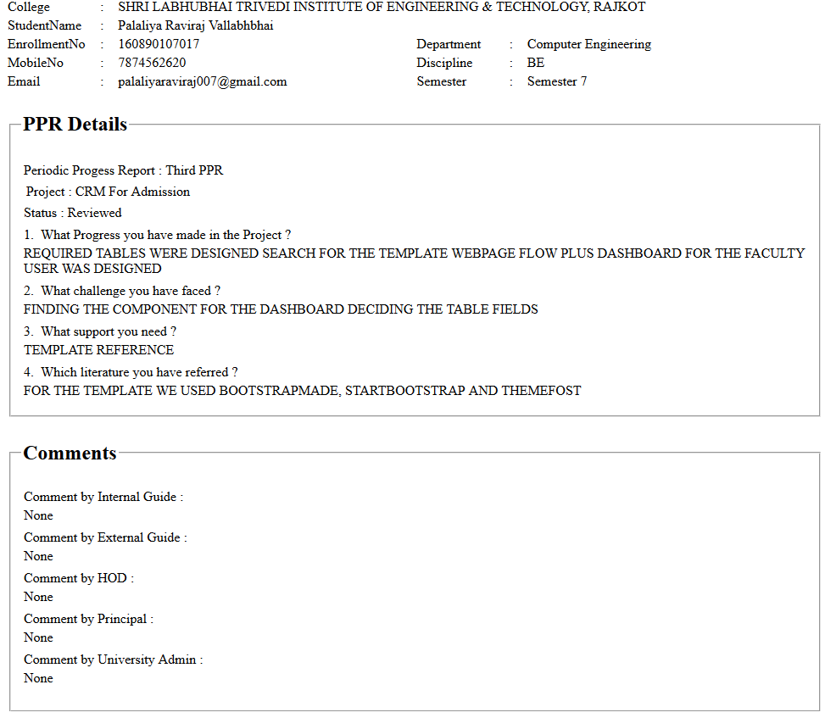

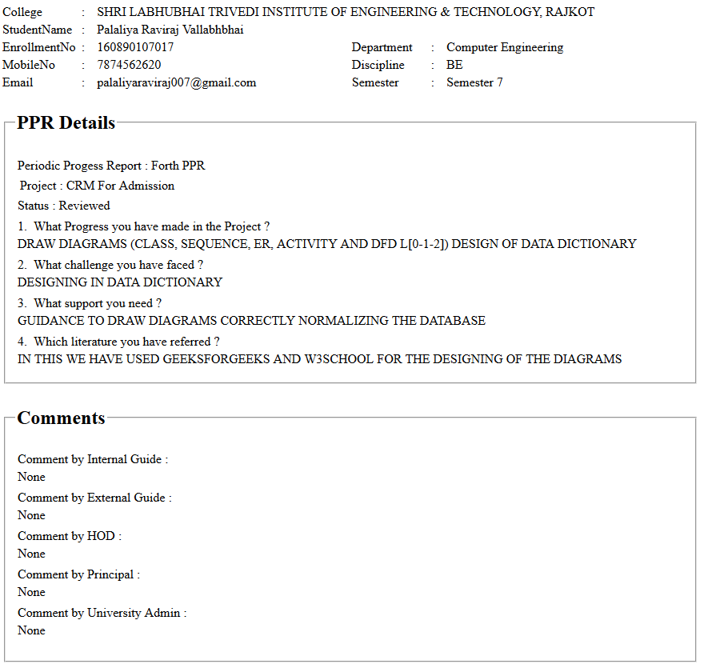

**Appendix E – Plagiarism Report**





