**Assignment 2**

**Cloud based Collaborative Whiteboard**

**Architecture**

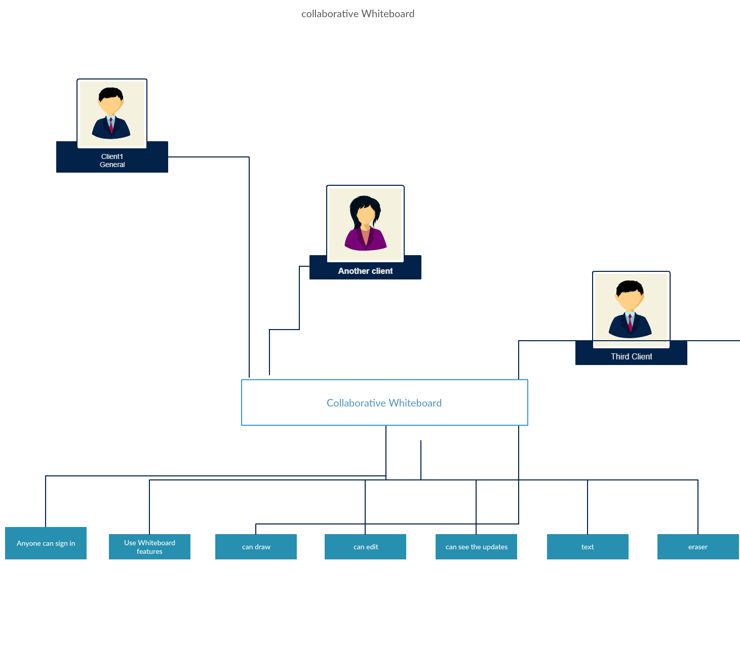

**Striking Features of the plan**

**1.** Works on most tablets out of the case, interface proposed for contact interfaces

2. Multiple rooms, pages for facilitated exertion

3. Take expedient reviews of the board

4. Upload pdf and explain on whiteboard

5. Support for SSL, and check

6. Fast, handles lots of customers simultaneously

7. Draw on the whiteboard and all various customers will see you drawings live.

8. Sticky notes with signature maintain.

9. Multiple whiteboards maintain.

10. Undo/Redo maintain.

11. Docker Help (optional).

Online whiteboards can be utilized for a similar reason as a genuine whiteboard, yet without the impediments of a genuine whiteboard. The last is restricted by space, the quantity of things which you can add (have you ever attempted to put a video on a genuine whiteboard?) and is simply accessible to the individuals which are in a similar room.

Online whiteboards are programming arrangements that tag along as applications or program based apparatuses. They uphold groups to work together outwardly throughout distance progressively.

Every member of a gathering signs in to a similar online whiteboard space and can add his substance, while all the others see what he is doing continuously and they can interface if necessary with all the substance.

Utilizing genuine whiteboards to team up in video gatherings is possible, yet ought not be the method of cooperating in this current Scenario. Online whiteboards permit groups to move their shared exercises to the following level and increment their profitability and innovativeness.

Online whiteboards are to be sure the expansion to video gatherings that takes them from unadulterated correspondence to genuine collective meetings.

**Innovation Choices Made**

Node.js is an especially staggering JavaScript-set up stage worked regarding Google Chrome's JavaScript V8 Engine. It is used to make I/O raised web applications like video constant objections, single-page applications, and other web applications. Node.js is open source, thoroughly free, and used by countless originators around the world

Node.js runs in a lone string mode, yet it uses an event driven perspective to manage synchronization. It furthermore supports creation of child cycles to utilize equivalent taking care of on multi-focus CPU based systems.

Youngster measures gauges reliably have three streams child.stdin, child.stdout, and child.stderr which may be bestowed to the stdio floods of the parent cycle.

Hub gives child_process module which has the going with three critical ways to deal with make a child cycle.

**Docker**

Docker licenses you to package an application with its present situation and the aggregate of its conditions into a "container", called a holder. Regularly, a holder includes an application running in a stripped-to-stray pieces transformation of a Linux working structure. An image is the diagram for a holder, a compartment is a running instance of an image.

**Administration Implementation Details**

1. Start npm and start center js

2. Start the dashboard

3. Run docker-make up - d - create

4. Open http://localhost:8880 in your program.

5. Draw

**Screenshots**

Npm start

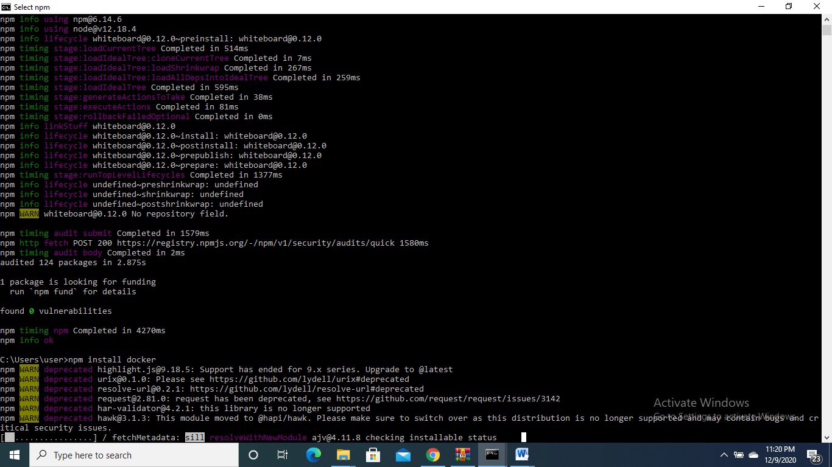

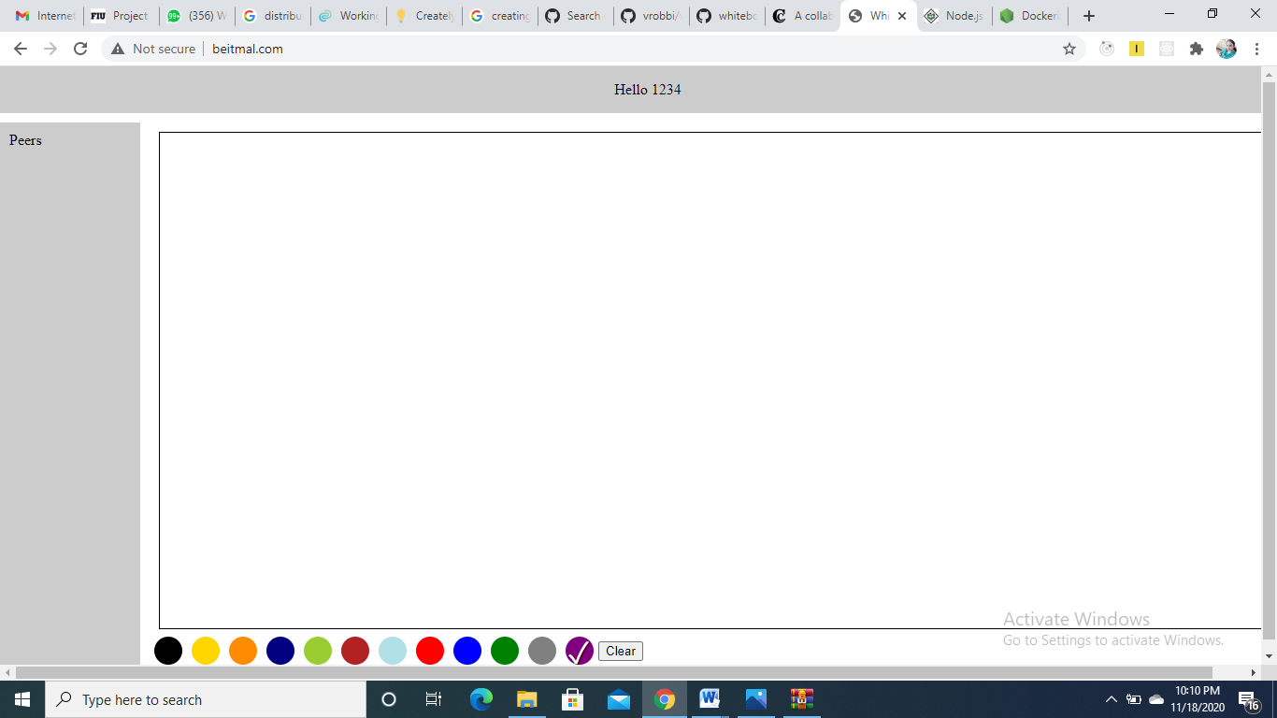

**Install docker**

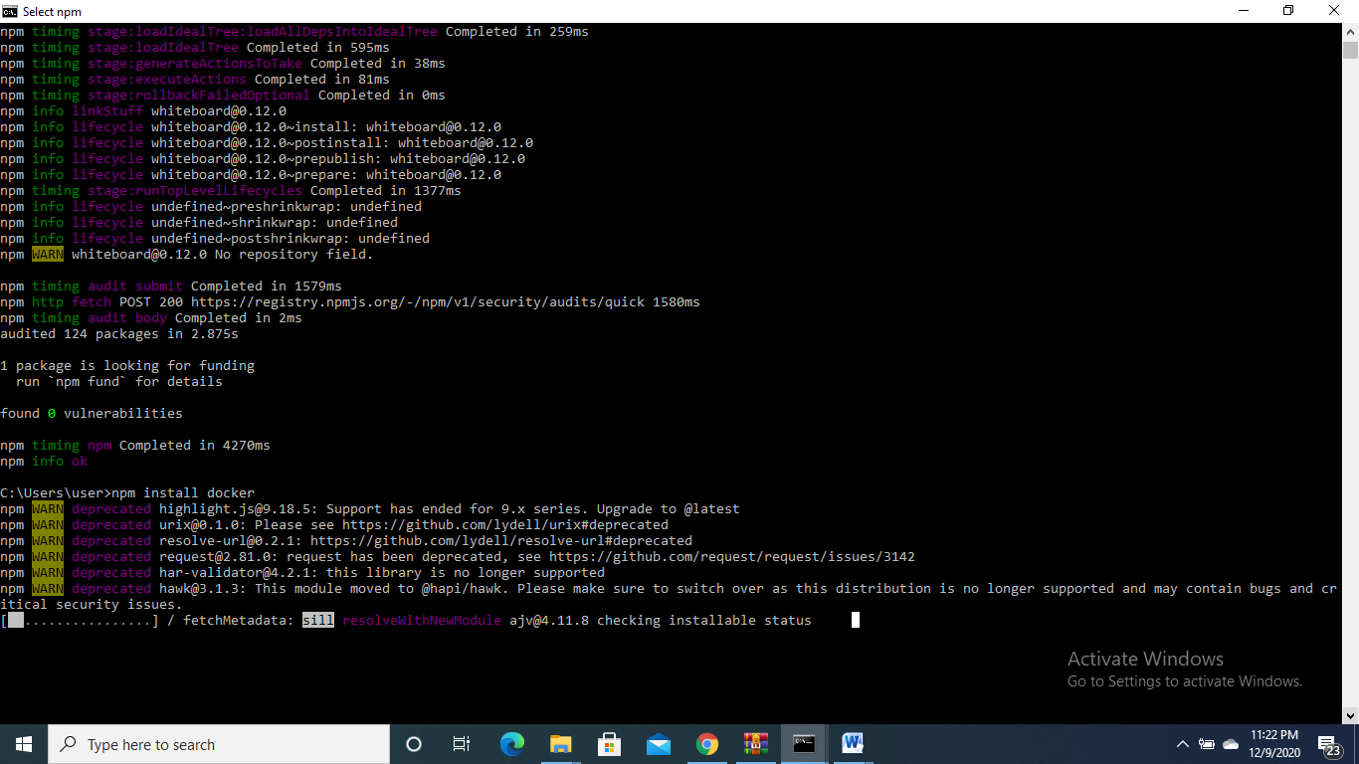

**If no action takes place**

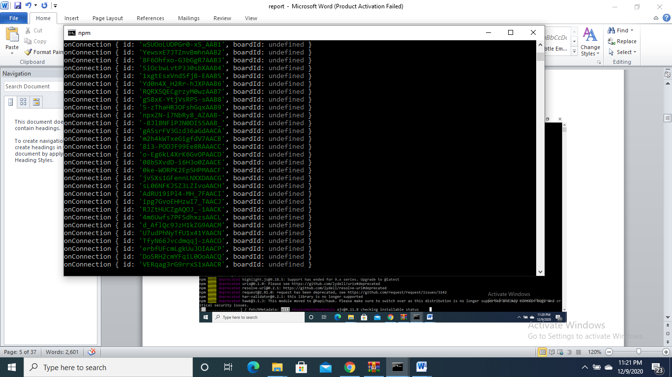

**Start the local host**

**Localhost:3000**

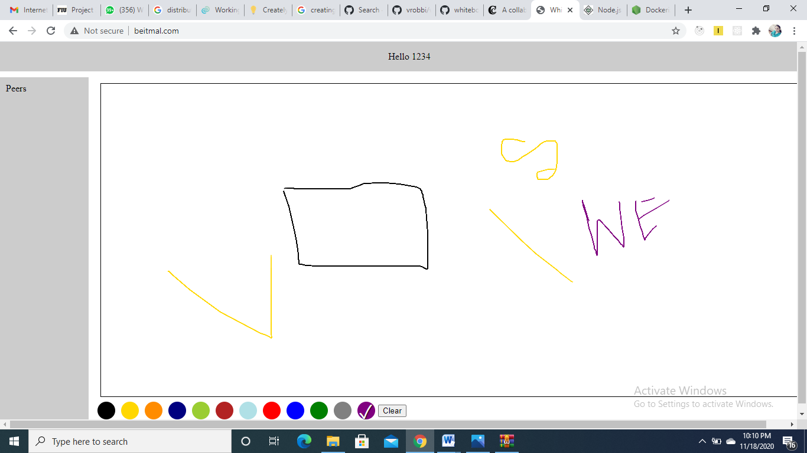

**Code**

