**Name: Ravi Suriyaarachchi**

**Date :7/27/2020**

**Course: Foundations of Programming: Python**

**Assignment: Number 3**

**1.What is pseudo-code?**

It is another term used to define programs logic. Typically, pseudo-code consist of logical path and relevant notes that how the programmer thinks how the program will run. This is not a code and programmer need to add condition and statements to turn pseudo-code to actual programming code.

**2. What are "conditional" statements?**

There are two conditional statements in majority of the programming languages. They are “if-else” and “switch-case”. Python only has “elif “( else if). Condition statements helps to build the coding logic.

**3. How do you use multiple conditional expressions?**

Python allows you to use “or “ and “and” to do multiple conditions. For an example

intX = 1

strY = Ravi

if (intX == 1 and strY==”Ravi”)…..

**4. What are comparison operators?**

"There are eight comparison operations in Python. They all have the same priority (which is higher than that of the Boolean operations). Comparisons can be chained arbitrarily; for example, x < y <= z is equivalent to x < y and y <= z, except that y is evaluated only once (but in both cases z is not evaluated at all when x < y is found to be false)."

(Python doc, 2015, https://docs.Python.org/3.5/library/stdtypes.html)

**5. What are the Boolean values for the integers 0, 1, and 2?**

0 = false

1= true

2= false

**6. What is a Loop?**

Loops Loops allow you to perform a command multiple times, a task that is so handy that all programming languages have some way of doing this. However, each language may use different commands, and some have more looping options than others. In Python, there are only two options, the "while loop" and the "for loop."

**7. Name the most common programming loop?**

The most common loop in programming is the "while loop." It looks and works very much the same in any language you decide to learn. The way it works is to execute one or more statements repeatedly when an expression is true. You need to be careful to tell it to stop, or it loops indefinitely!

**8. How do you pass arguments into a script?**

When you add arguments to the command, they are passed in as a list of values. In Python, these values are stored in a built-in system variable called "argv" (which stands for "Argument Values"), but something similar is used in other languages. You access the individual values in argv, by indicating an id number, or "index."

**9. What statement allows you to write data into a file?**

: objFile.**write** (strUserInput + "\n") objFile.close()

**Step 5 - Apply your knowledge:**

**Household item inventory script**

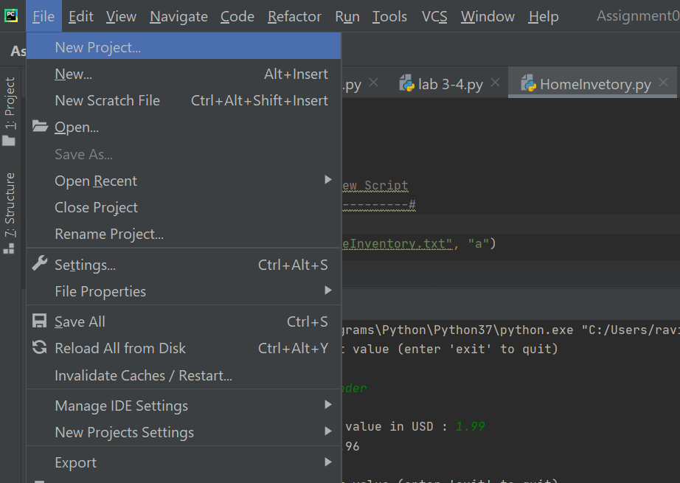

**New Project-🡪 create a folder --🡪 right click standing on the Project folder and create a file**

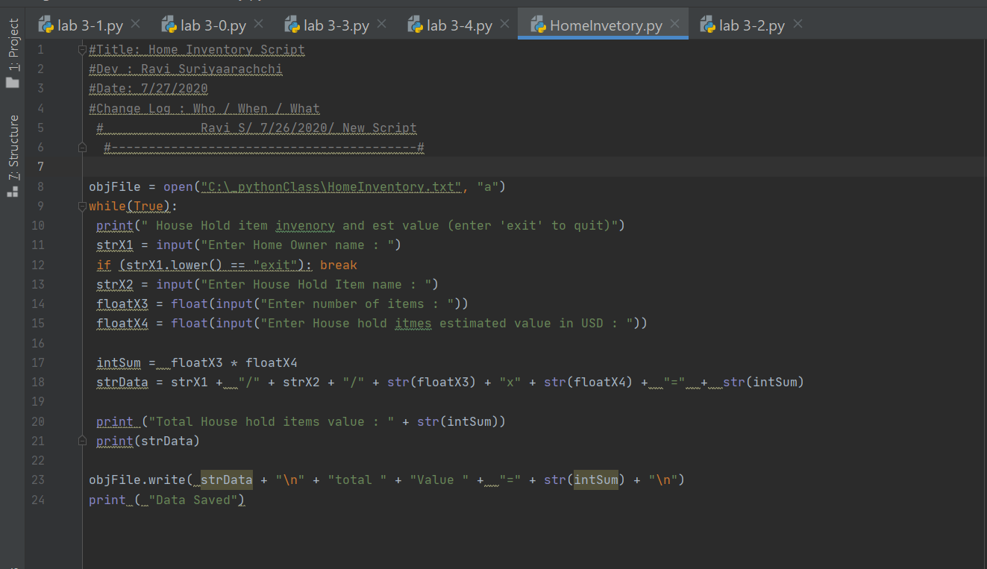

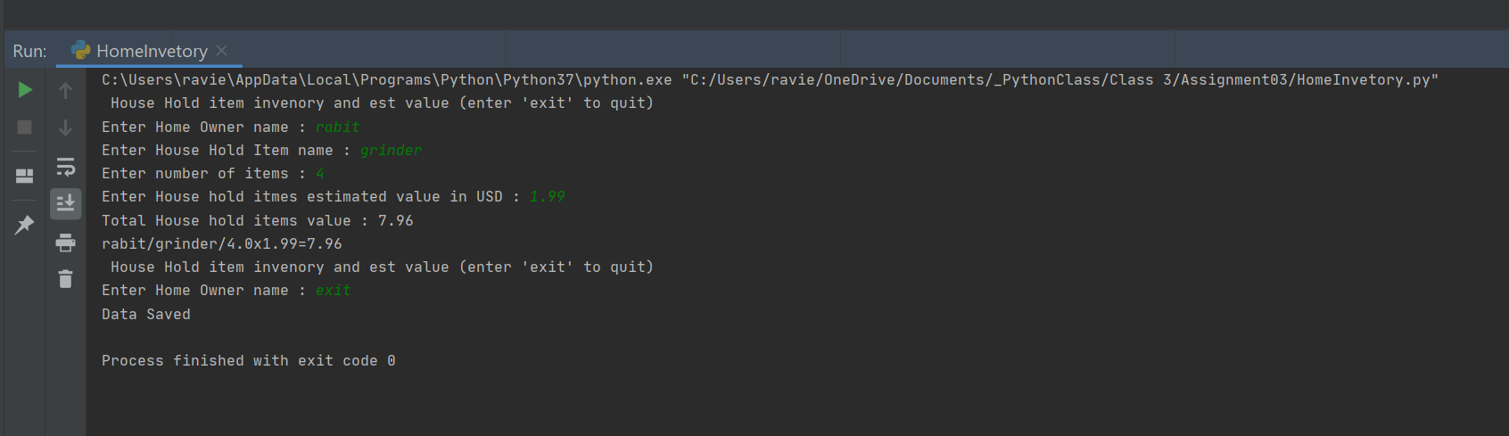

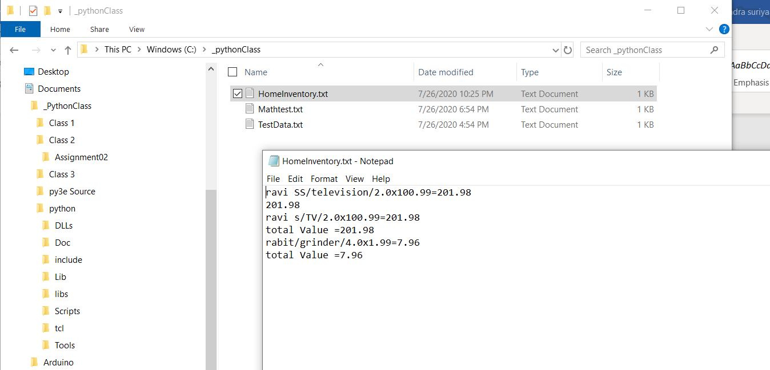

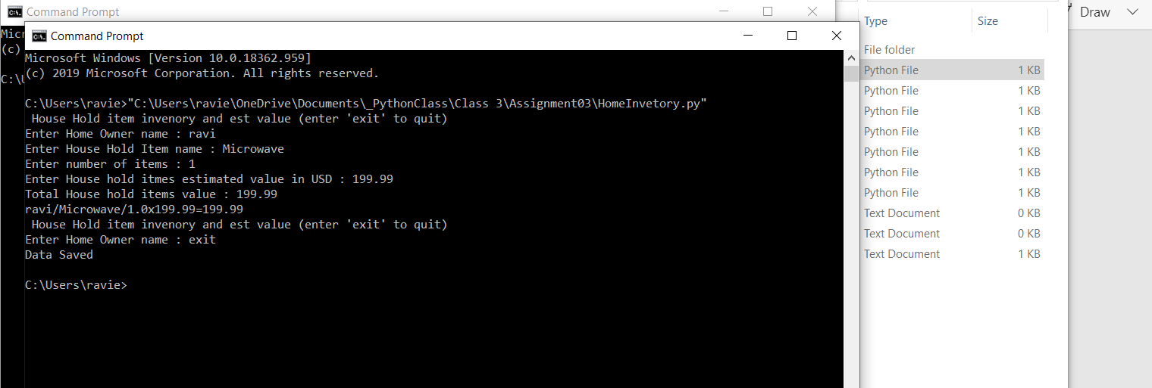

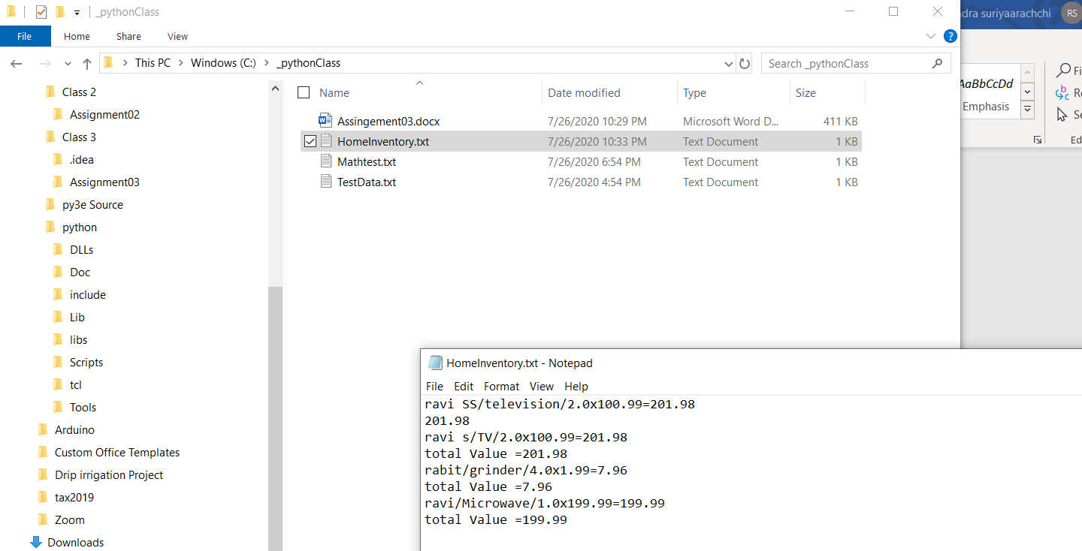

**Document your knowledge**

Creating the script if straight forward. Mod 2 and Mod 3 lab work helped to develop the script. Primary problem was synteex errors and couple of logic concerns.

I sketched the logic and isolated each statement and ran individually statements to ensue each individual statement is correct. Then start adding the “ if “ else statements. I also added a additional line to calculate the total value.

What I don’t know and could not figure out how to create how to give an error message if the person enter incorrect type and giving the person a chance to re-enter