🧠 Core PostgreSQL Concepts
🔹 What is MVCC in PostgreSQL?
MVCC (Multi-Version Concurrency Control) allows concurrent transactions without locking rows. PostgreSQL maintains multiple versions of a row:
- Readers see a snapshot (consistent view).
- Writers create a new version instead of overwriting.
- Old versions are cleaned up by VACUUM.
🔧 Use case: Enables high-throughput telemetry ingestion without blocking reads.
🔹 JSON vs JSONB
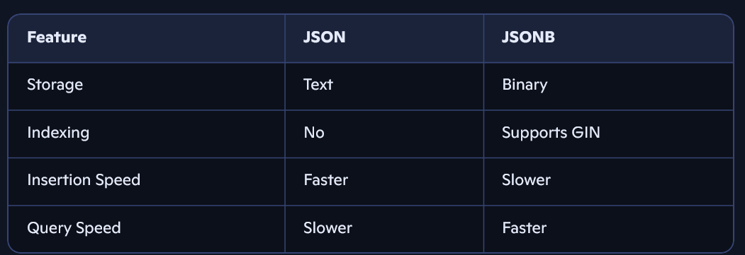
🔧 Use case: Use JSONB for querying structured telemetry blobs; JSON for logging raw payloads.
🔹 Types of Indexes
- B-tree: Default, for equality and range.
- GIN: For JSONB, full-text search.
- GiST: Geospatial, fuzzy matching.
- BRIN: Large, append-only tables (e.g., time-series).
🔧 Use case: GIN on JSONB fields for fast filtering of device metadata.
🔹 ACID Compliance
PostgreSQL ensures:
- Atomicity: All-or-nothing via WAL (Write-Ahead Logging).
- Consistency: Enforced via constraints, triggers.
- Isolation: MVCC + isolation levels.
- Durability: WAL ensures recovery after crash.
⚙️ Query Optimization & Performance
🔹 Analyzing a Slow Query
- Use EXPLAIN ANALYZE.
- Check for:
  - Sequential scans on large tables
  - Missing indexes
  - Nested loops
- Optimize with:
- Indexes (partial, composite)
- CTE refactoring
- Materialized views
🔹 Partial Index
An index on a subset of rows:
CREATE INDEX idx_active_devices ON devices(id) WHERE status = 'active';
🔧 Use case: Speeds up queries on active devices without bloating index size.
🔹 Query Planner
- Estimates cost of different plans.
- Chooses cheapest based on:
- Row estimates
- Index availability
- Join strategies (nested loop, hash join)
Use SET enable_seqscan = off; to test index usage.
🔁 Transactions & Concurrency
🔹 Isolation Levels
- Read Committed (default): sees committed data.
- Repeatable Read: same snapshot throughout.
- Serializable: strictest, prevents phantom reads.
🔧 Use case: Use Repeatable Read for OTA batch updates to avoid mid-process changes.
🔹 Deadlocks
- Occur when two transactions wait on each other.
- Prevent by:
- Lock ordering
- Short transactions
- NOWAIT or SKIP LOCKED
Use pg_stat_activity and pg_locks to debug.
🔹 Optimistic vs Pessimistic Locking
- Optimistic: Assume no conflict; use version checks.
- Pessimistic: Lock rows early (SELECT FOR UPDATE).
🔧 Use case: Optimistic for telemetry ingestion; pessimistic for critical config updates.
🛠️ Schema Design & Advanced Features
🔹 Time-Series Telemetry
- Use partitioning by time or device.
- Consider TimescaleDB for hypertables.
- Index on timestamp, device_id.
🔹 Materialized Views
- Store query results physically.
- Use REFRESH MATERIALIZED VIEW to update.
🔧 Use case: Precompute daily device health summaries.
🔹 Soft Deletes
- Add is_deleted or deleted_at column.
- Filter in queries; optionally archive.
Trade-offs:
- Simpler recovery
- Slower queries unless indexed
🧪 Real-World Scenarios
🔹 OTA Update Logs Schema
CREATE TABLE ota_logs ( id UUID PRIMARY KEY, device_id UUID, status TEXT, timestamp TIMESTAMPTZ, payload JSONB );
- Index on (device_id, timestamp)
- Use partitioning for scale
🔹 Ensuring Data Integrity
- Use foreign keys, constraints, and transactions.
- Validate telemetry schema with CHECK constraints or JSON schema validation.
🔹 Schema Migrations
- Use tools like Alembic or Flyway.
- Strategy:
- Backward-compatible changes
- Blue-green deployments
- Rollback scripts
🧰 Tools & Extensions
🔹 PostgreSQL Extensions
- pg_stat_statements: query performance
- uuid-ossp: UUID generation
- PostGIS: geospatial queries
- pg_partman: partition management
🔹 Monitoring PostgreSQL
Track:
- Slow queries (pg_stat_statements)
- Connection count
- Cache hit ratio
- Lock contention
- WAL write rate
Use tools like pgAdmin, Prometheus + Grafana, or pgBadger.

