DSA Concepts – Core Ideas & Quick Recall
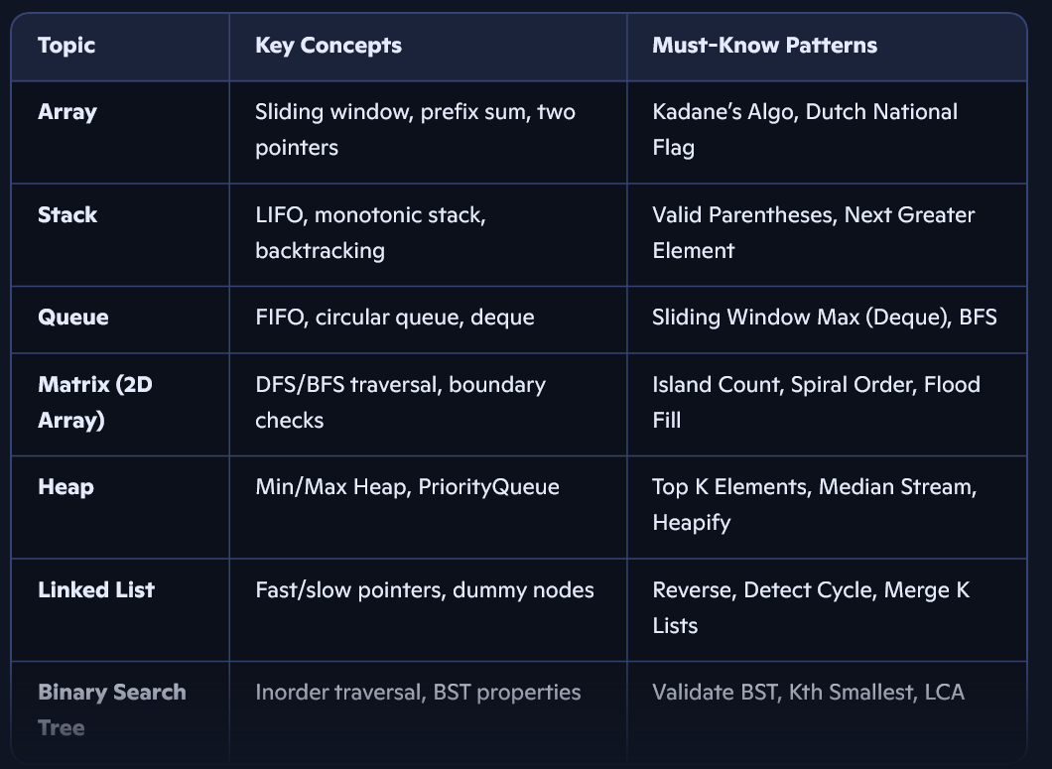f
📌 Time Complexities: Know insert/search/delete for each structure. E.g., Heap insert = O(log n), BST search = O(h)
🔍 Sample Questions Breakdown
✅ LRU Cache (Leetcode 146)
- Use OrderedDict (Python) or HashMap + Doubly Linked List
- Operations: get(key) and put(key, val) in O(1)
- Core idea: Move accessed node to front; evict least recently used from tail
✅ Max Size of Island (Leetcode 695)
- Use DFS or BFS on 2D grid
- Track visited cells, explore 4 directions
- Return max area of connected 1s
- Time: O(m × n), Space: O(m × n)
🧱 Design Patterns – Interview-Ready Summary
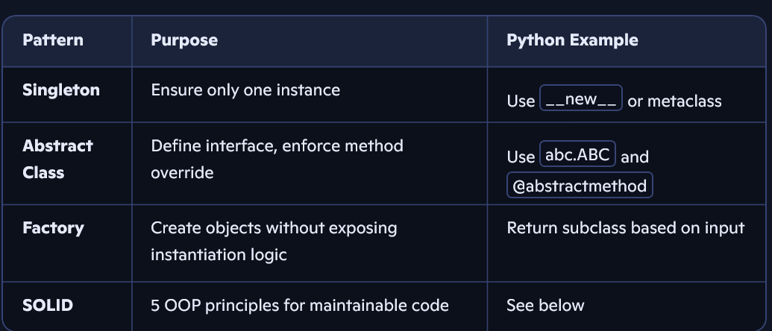
🔑 SOLID Principles
- S: Single Responsibility – One reason to change
- O: Open/Closed – Open for extension, closed for modification
- L: Liskov Substitution – Subtypes replace base types without breaking
- I: Interface Segregation – Prefer many small interfaces
- D: Dependency Inversion – Depend on abstractions, not concretions
🧩 Practice Resources
- GeeksforGeeks DSA Crash Course – concise topic-wise revision
- Algo Vault GitHub – 200+ curated questions by topic
- DSA Cheat Sheet – quick lookup for time/space complexity

