Contents
Target State - AWS with Databricks 2
High-Level Tasks for AWS Analytics Platform Implementation 4
Tactical Option 1 – Azure to Azure Migration 6
Scope of Migration 7
Business Disruption Considerations 7
High Level stories and tasks: 8

Target State - AWS with Databricks
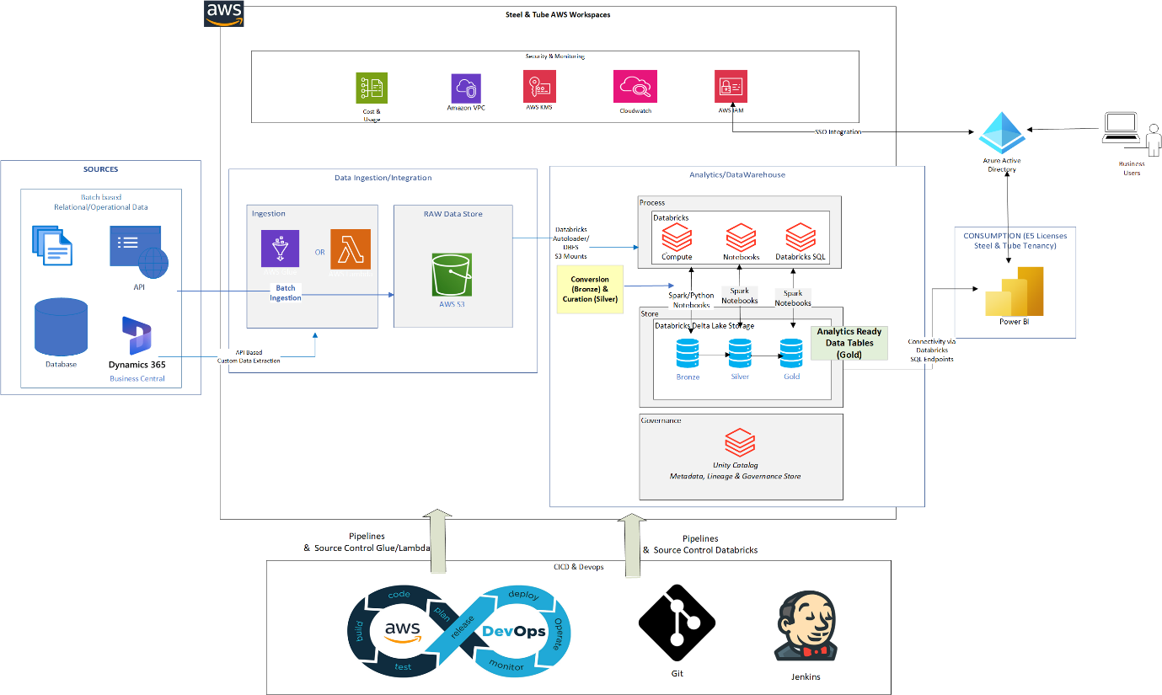
Target AWS Analytics Architecture
High-Level Components
- Data Ingestion: Batch-based ingestion from sources like Business Central via APIs
- Landing Zone: Data stored in Amazon S3
- Processing Layer: AWS Glue / Lambda for ingestion; Databricks for transformation
- Storage Format: Delta Lake with Bronze, Silver, Gold medallion architecture
- Governance: Unity Catalog for data cataloging, lineage, and access control
- Consumption: Power BI as reporting layer
- CI/CD & DevOps: Git + Jenkins or AWS DevOps Pipelines
- Security & Access: Azure AD (Entra ID) integration for SSO
- Ops & Governance: AWS services for logging, cost management, and monitoring

Notes:
Data Ingestion
We'll use a batch-based architecture initially. The core source is Business Central, which offers robust APIs. AWS Glue or Lambda functions can be scheduled to fetch data from these APIs and land it into S3.

Landing Zone (S3)
S3 is our central data lake storage. All raw and processed data will be stored here in a structured format that is scalable and cost-effective.

Processing with Databricks
Databricks will serve as our unified data engineering and analytics platform. It will either mount S3 buckets directly or use Autoloader for scalable file ingestion.

Delta Lake & Medallion Architecture
We’ll adopt a Bronze–Silver–Gold Delta Lake architecture:
- Bronze: Raw data as ingested
- Silver: Cleaned and joined data
- Gold: Business-ready dimensional models for reporting
This provides modularity, auditability, and reusability.

Unity Catalog for Governance
Unity Catalog will allow us to manage metadata, access control, and lineage centrally — supporting data discovery, audits, and future compliance needs.

Power BI for Reporting
End users will continue to use Power BI as the reporting tool, which will connect to curated datasets in the gold layer, either via Databricks SQL or through ODBC/Direct Lake.

CI/CD & DevOps
We'll manage code and pipelines through Git repositories and Jenkins for CI/CD. AWS-native DevOps services can also be explored depending on maturity.

SSO with Azure AD
Azure Active Directory (Entra ID) will provide secure and unified user authentication across Databricks, Power BI, and supporting tools using SAML/OIDC.

Monitoring, Cost & Security
AWS-native tools like CloudWatch, CloudTrail, and Cost Explorer will be set up to manage monitoring, audit logs, and cost visibility across the platform.

High-Level Tasks for AWS Analytics Platform Implementation
1. Infrastructure Setup
- Provision S3 buckets for raw, cleaned, and curated data zones
- Provision Databricks workspace and set up S3 access (IAM roles)
- Set up AWS Glue and/or Lambda functions
- Configure Unity Catalog and associated metastore
- Configure networking, IAM, security groups, and VPCs

2. Data Ingestion
- Design API ingestion framework for Business Central
- Implement Glue/Lambda jobs to pull data into S3 (Bronze layer)
- Schedule jobs for periodic refresh based on source system behavior
- Log metadata for ingestion auditing and traceability

3. Data Transformation & Modeling
- Mount S3 or configure Autoloader in Databricks
- Define Delta Lake schema for Bronze, Silver, and Gold layers
- Build transformation notebooks or pipelines (raw → curated → dimensional)
- Implement data quality checks and validation in Silver layer
- Create Gold layer dimensional models for consumption

4. Governance & Security
- Define Unity Catalog schemas, tables, and lineage policies
- Assign access control roles via Unity Catalog (entitlements)
- Integrate Azure Active Directory with Databricks for SSO
- Implement audit logging and data access tracking

5. Reporting Integration
- Set up Databricks SQL endpoints or data gateway if required
- Rebuild or migrate Power BI datasets to point to new data models
- Validate visuals, filters, DAX measures against the new source
- Coordinate workspace and dataset publishing

6. CI/CD & DevOps
- Set up Git repositories for notebooks, ingestion code, and configurations
- Design Jenkins pipelines (or use AWS CodePipeline) for deployment
- Automate promotion from Dev → Test → Prod environments
- Parameterize environments for dynamic deployment

7. Monitoring, Cost & Operations
- Configure CloudWatch and CloudTrail for job and access logging
- Set up alerts for failed jobs or data anomalies
- Enable AWS Budgets and Cost Explorer for spend tracking
- Document runbooks and support procedures

8. UAT, Cutover & Rollout
- Perform functional UAT on curated datasets and reports
- Align with business users for validation and feedback
- Plan cutover from old reporting stack to new Power BI datasets
- Communicate access instructions and training, if needed
- Monitor post-launch performance and user adoption

Tactical Option 1 – Azure to Azure Migration
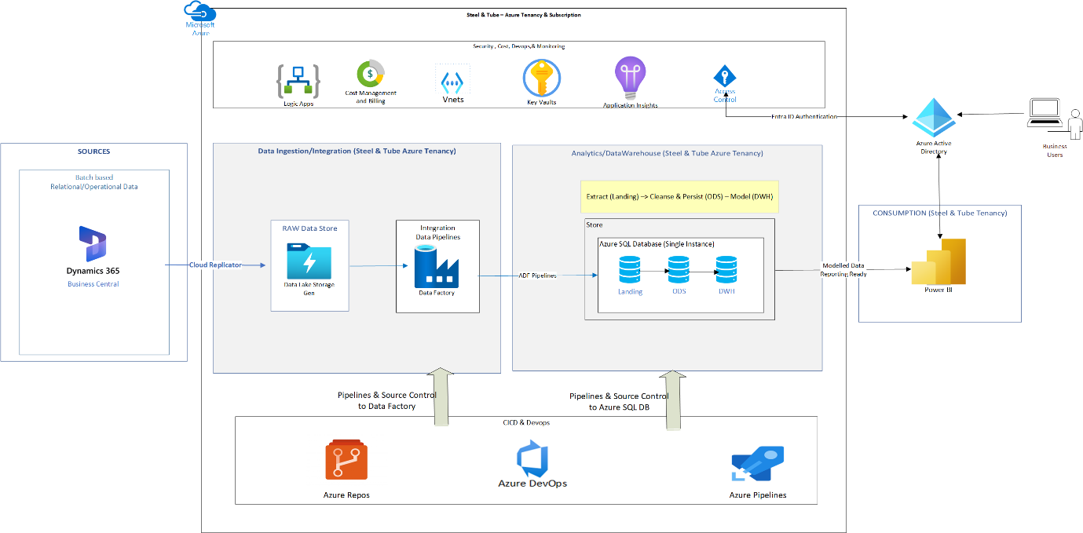

Use Case: Tactical Migration of Perry’s Azure Business Analytics Stack to Azure under Parent Tenancy of Steel & Tube
Background
As part of a recent acquisition, the PMP business currently operates an analytics solution in its own Azure tenancy, comprising:
- Data sourced from Business Central via Dataverse
- Landed in Azure Storage
- Processed via Azure Data Factory into an Azure SQL Database
- Visualized using Power BI reports hosted in their Power BI service
The client’s long-term strategic direction is to migrate all capabilities to AWS. However, to ensure a quick and minimally disruptive transition post-acquisition, the tactical approach is to rehost the solution in the client’s Azure tenancy using existing Azure components.

Scope of Migration
This tactical migration includes:
- Recreating infrastructure (ADF, SQL DB, Logic Apps, Storage, Power BI) in the client’s Azure tenancy
- Migrating existing Azure Data Factory pipelines
- Migrating database objects and data from the source Azure SQL Database
- Repointing Power BI reports to the new Azure SQL database
- Automating deployment via Azure DevOps CI/CD pipelines
- Ensuring operational continuity with alerting, testing, and minimal disruption
This approach enables the client to take control of the analytics stack quickly, without waiting for a full AWS re-architecture.

Business Disruption Considerations
Power BI Tenancy Change:
- Users will move from Acquired Entity's Power BI environment to the Client’s Power BI service/tenant.
- This means:
  - New access provisioning will be needed — users may lose access to existing workspaces temporarily.
  - Users will no longer see reports in the original tenant unless both tenants are linked or interim access is provided.
  - Power BI personal bookmarks or custom views will not carry over.
  - Power BI email subscriptions and scheduled alerts will need to be recreated.
  - User training or communication may be required to direct users to the new location of the reports.
  - Gateways or Data Source credentials may need updates depending on whether on-prem sources are involved (unlikely here).
To minimize disruption, a dual-running phase or pre-switch user testing can be included, and communications should be sent in advance about the changes.

High Level stories and tasks:
Epic 1: Infrastructure Provisioning (Dev & Prod)
- Provision Azure Resource Groups
- Provision Azure Data Factory
- Provision Azure SQL Database
- Provision Azure Storage Account
- Provision Azure Logic Apps (for alerts)
- Provision Power BI Workspaces
- Setup Azure DevOps Project and Repositories

Epic 2: Data Integration Setup
- Export Azure Data Factory pipelines from acquired tenant
- Import and configure ADF pipelines in target environment
- Update linked services with new connection strings
- Configure pipeline triggers and schedules
- Setup managed identity between ADF and SQL Database
- Test connectivity and pipeline execution

Epic 3: Data Storage and Access Configuration
- Repoint Dataverse export to new Azure Storage
- Validate file and schema compatibility
- Setup RBAC roles for storage and ADF access
- Validate data landing in staging area

Epic 4: SQL Database Migration
- Extract schema and objects from existing Azure SQL Database
- Deploy schema and initial data to target Azure SQL Database
- Update stored procedures, views, and functions
- Validate referential integrity and row counts
- Create required indexes and statistics

Epic 5: Power BI Migration
- Repoint Power BI reports to new Azure SQL DB
- Update dataset credentials and gateway settings (if any)
- Test and validate visuals and filters
- Publish reports to appropriate workspace
- Validate dataset refresh schedule

Epic 6: Azure DevOps CI/CD Setup
- Setup build and release pipelines for ADF
- Setup build and release pipelines for Azure SQL
- Create service connection or SPN for deployment
- Parameterize infrastructure and code for environments
- Validate end-to-end automated deployment

Epic 7: Monitoring and Alerts
- Configure Logic App alerts for pipeline failures
- Setup monitoring dashboard in Azure Monitor or Log Analytics
- Configure email/SMS alerts for key failures
- Validate test alerts and escalation flow

Epic 8: Cutover and Validation
- Perform final data sync or delta load
- Run end-to-end test of entire pipeline
- Validate data accuracy in reports
- Capture stakeholder sign-off
- Document rollback plan if needed

