PHARMACY MANAGEMENT SYSTEM

**SYNOPSIS REPORT**

SUBMITTED IN PARTIAL FULFILLMENT OF THE REQUIREMENT FOR

Semester Industrial Training

at

**Solitaire Infosys Pvt. limited**

SUBMITTED BY:

Varinder Kumar(1414744)

Kajal (1510568)

Branch: CSE



**Department of Computer Science& Technology**

**KHALSA COLLEGE OF ENGINEERING & TECHNOLOGY,**

AMRITSAR, INDIA

**table of CONTENTS**

## Contents Page No.

## 1. Introduction 3

2. Existing System 3

3. Proposed System 3

4. Objectives 4

5. Methodology 4

5.1 Modules 4

5.2 Process 4

6. Requirements specification 5

6.1 Functional Requirement 5

6.2 Non Functional Requirement 6

7. System Requirement 7

7.1 Hardware Requirement 7

7.2 Software Requirement 8

8. System Analysis and Design 8

8.1 DFD Diagram 8

8.2 ER Diagram 9

8.3 Use Case Diagram 10

9. Conclusion 11

10. Future Scope 11

11. Appendix 11

1. **Introduction:**

Pharmacy management system is a management system that is designed to improve accuracy and to enhance safety and efficiency in the pharmaceutical store. It is a computer based system which helps the Pharmacist to improve inventory management, cost, medical safety etc. The system allows the user to enter a manufacturing and expiry date for a particular product or drug during opening stock and sales transaction.

The system will also give report showing the list of products expiry after a specified date before the product eventually expires. It also involves manual entry upon arrival of new batches of drugs and upon drug movement out of the pharmacy for a certain period, e.g. every month, the pharmacist may want to generate report for the movement of drugs in and out of the pharmacy, getting information about the drugs e.g. expiry date, date purchased, number of drug type left, location of a drug in the pharmacy. At present, manual system is being utilized in the pharmacy. It requires the pharmacist to manually monitor each drug that is available in the pharmacy. This usually leads to mistakes as the workload of the pharmacist increases.

1. **Existing System:**

The existing system is paper-based involving high amount of paper work and manpower requirement. Even though computerized systems are used in some places, they are also web-based system and are improperly managed. But in our project we are enhancing some features of existing pharmacy system. This system includes the out-of-date stock or confirmation about out-stock medicine validation.

1. **Proposed System:**

The proposed system, being web-based, is very efficient and effective from the point of view of work productivity and time. It is less tedious to manage operations in a [medical store](http://www.codewithc.com/mini-project-in-c-medical-store-management-system/) or pharmacy with such a system. It has all the required modules and is developed with the aim of schedule, inventories, and relevant things in the medical store.

With this system, the entire operations in medical store is fully automated. Unlike the traditional system where records were maintained manually, this system maintains records in a database. Typical example of these records include purchases, counter sales, recorder levels, suppliers, customers, monetary transactions, etc.

1. **Objectives:**

* It is the user friendly application for Pharmacist which reduces the burden and helps to manage all sections of Pharmacy like Medicine management and Billing etc.
* It deals with the automating tasks of maintaining of Bills.
* In Pharmacy, Billing management is the key process. Including safe data store about medicine as well as fast searching, delete and update of medicines.
* The pharmacy management system is easy for use so the user can do pharmacy actions without ambiguities.
* This refers the pharmacy management system project highly minimize time and resource by which, searching the medicine data you can get the data in quickest time.
* The pharmacy management system is built for the sake of ensuring effective and clear data saving and manipulating as well as neat work on the pharmacy medical products.

1. **Methodology:**

**5.1. Modules-**

* **Admin:**Admin should have prior knowledge of the system. Admin is able to control the whole system. He/she can add, delete, update and modify the system.
* **Cashier:** Pharmacy Cashiers handle customer transactions and operate the cash register in a pharmacy and give a bill to the customer.
* **Manager:** Performs management activities like inventory management, salary of the employees.
* **Pharmacists:** The pharmacist will be able to see the list of newly ordered drug prescriptions by the doctors for each patient. They will select the order which they want to dispense. The pharmacist can manually select the batch or the system will automatically get the batch as first-in, first-out process.
* **User:**To buy medicines.
  1. **Process-**

Step-1: - Start

Step-2: - Login Process

Step-3: - Check user name and password.

Step-4: - If No, then Back the Login process. If Yes, then enter the main process.

Step-5: -Check for the Item availability. If No, then add dealer/Item entry. If Yes, then sale and receive payment.

Step-6: - Check for the dealer/Item identify. If No any dealer, then add dealer entry and go to step-5;

Step-7: - If return Item Yes then check bill no and return Item or payment. If No, then Exit.

Step-8: - Generate bill.

Step-9: - Exit.

**5.3 Implementation:**

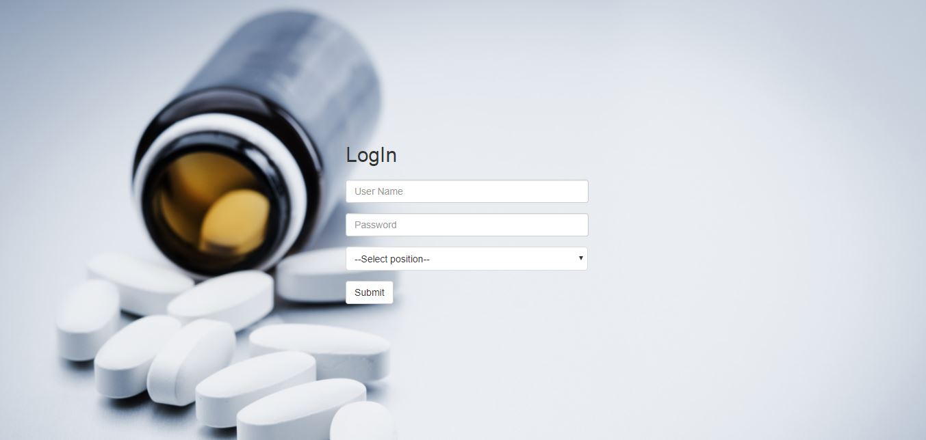

Fig. 1 (Login Admin, Pharmacist Or Cashier)

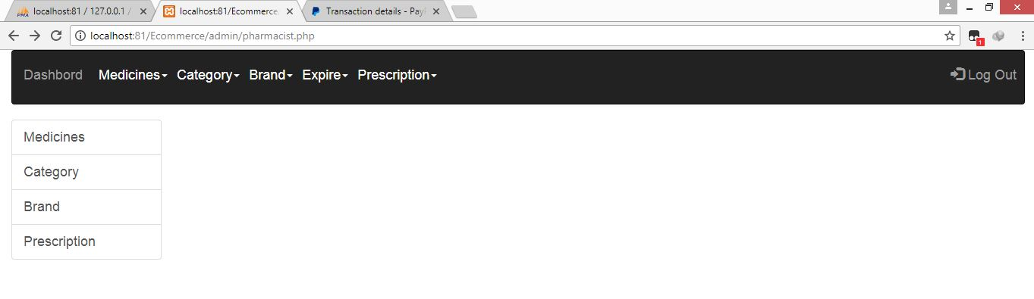

Fig 2. (Medicine, category, brand, etc)

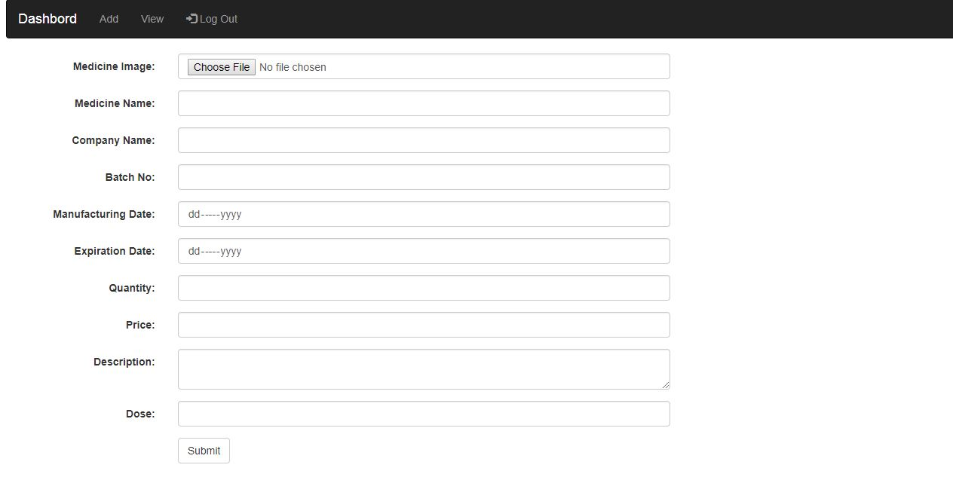

Fig 3(Add or View Medicine)

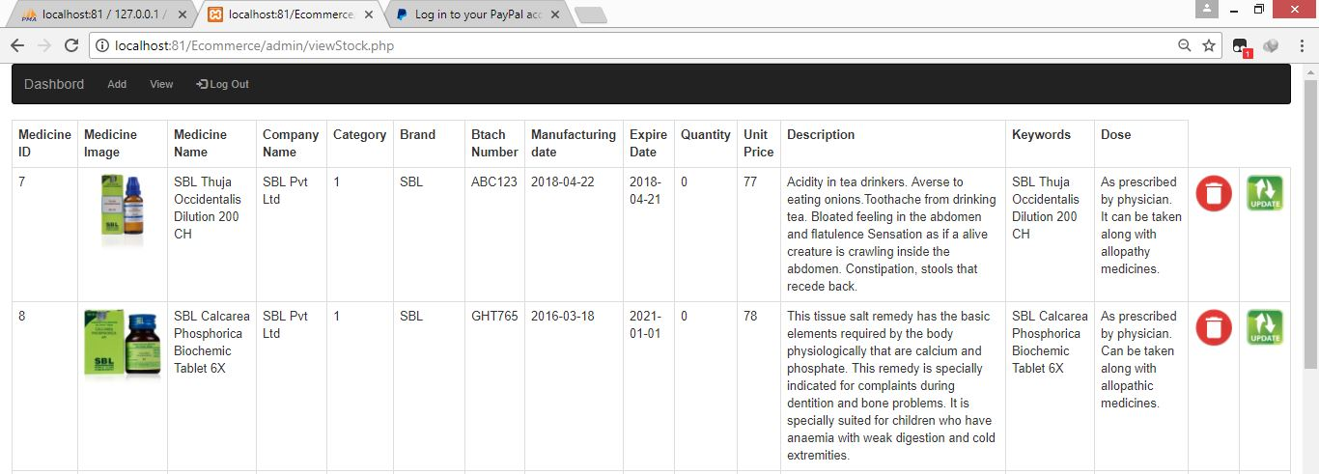

Fig 4(Update or Delete Medicine)

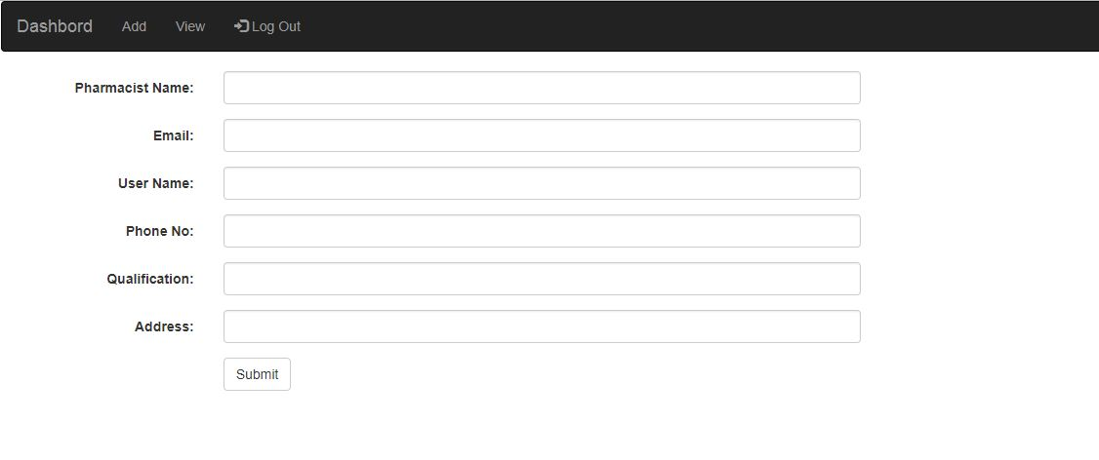

Fig 5(Add Pharmacist)

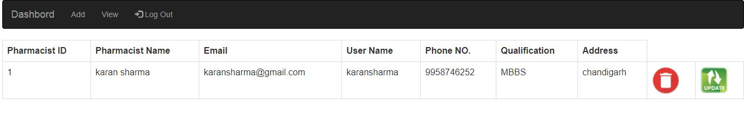

Fig 6(Add, update, delete Pharmacist)

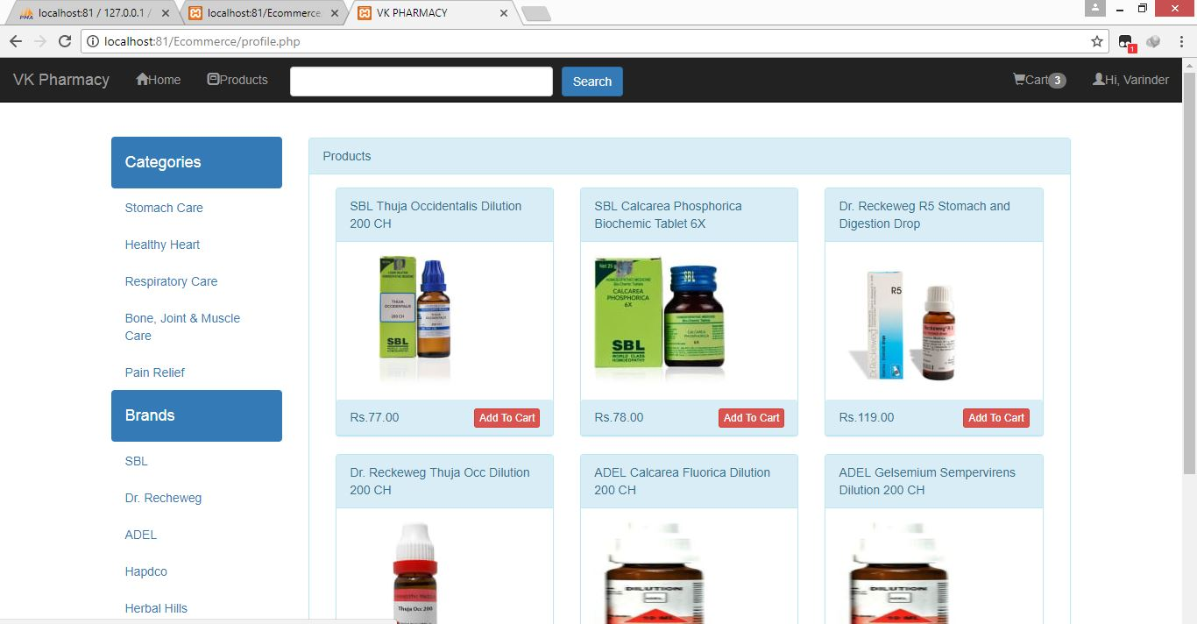

Fig 7(User Panel Add to cart)

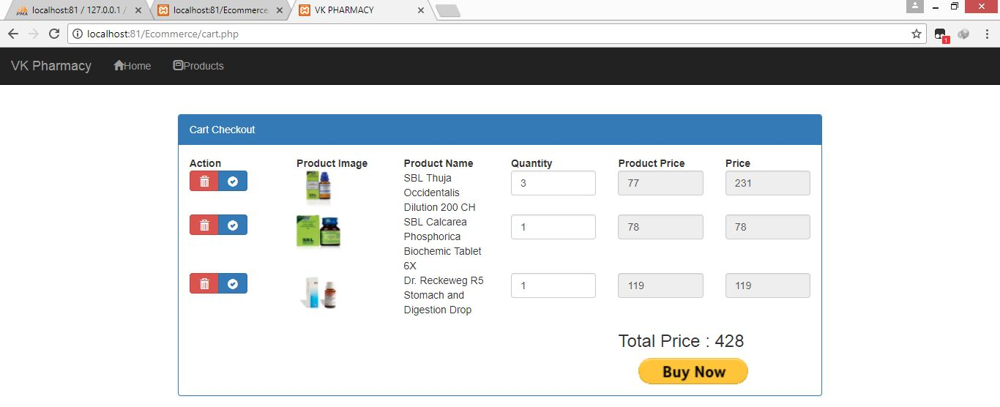

Fig 8(Buy Medicine)

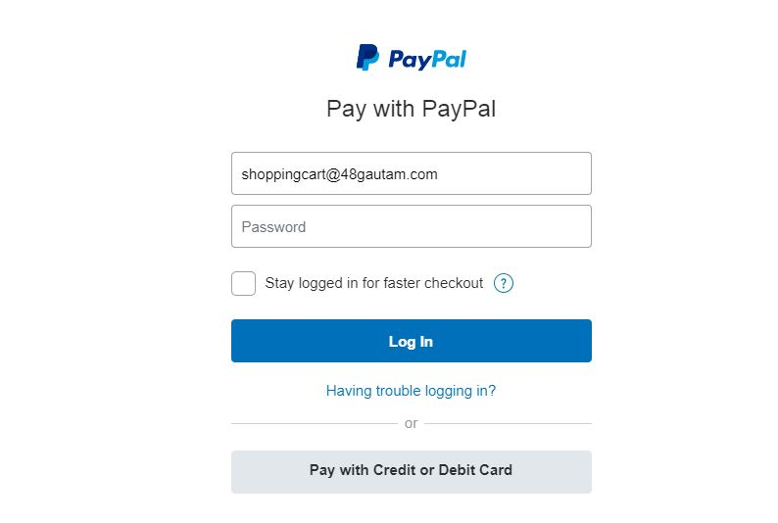

Fig 9 (Payment Through Paypal)

1. **Requirements specification:**

The pharmacy management system provides functions on identify medication usages instruction, minimize human errors in medication safety, facilitate accessibility of drugs’ information and information management among employees, providing optimal drugs movement in pharmacy unit, enable reports with in significantly short period of time, despite simultaneous usage of database for the purpose stated above.

The system will solve the problem of the current system by minimizing time wastage and reduce resources which simply change manual based system to computerized system.

### **6.1. Functional Requirements: -**

There are functions done by the system such as: store the necessary information of drugs, prepare bill for the medicine, give week reports, easily searching of medicine, working in two languages, Update, delete and save data’s of medicine.

* **Generate report:** the pharmacy management system generates report weakly on information about the drugs and it exports the information as output document.
* **Store the necessary information of the drugs**: The PS (pharmacy system) stores the detail information about each medicine including Actual name, formula ofmedicine and how it is importance and forwhich diseases isrequired. Since the information for each drug were required in some cases like the use of drugs, when use drugs and for whom is given.
* **Searching Medicine and other Data’s**: The PS has easily searching of medicine which shows in which shelf is put and the behavior of the medicine. The searching process is based on the name of the give data or the identification of the item. Here when the user searches the item on search bar the related things were displayed in the screen and can select the actual item that the user needs.
* **Alerting pharmacy Data’s in the system**: Changing medicines to another because of medicine outdated, modifying the saved medicine data for incorrect data, deleting of data’s of the pharmacy can be done on the system.
* **Support**: The function what the system do is:
* Store Medicine data’s
* Search Medicine data effectively
* Update, delete, and Edit medicine information
* Generate report on medicine
* Prepare bill for the medicine
* Gives navigation or information for pharmacy organization
* Give alert for expiry date to the user when medicine item is low
* Changing login password
* Have the system document how to use the system?

### **Non-functionalRequirements**: -

This pharmacy management system is able to operate in the following characteristics.

* **Usability:** Any familiar in using windows operation can operate the system since it has user friendly user interface. Which have the instruction menu’s how to use it which self-directive application then can be used the system without ambiguity.
* **Reliability:** The pharmacy system is available based on the user needs, can work properly, and do transactions efficiently including safe data management of the pharmacy. For invalid and malfunctioned operation, the system will restart in order to prevent data loose as well as safe operation within 5 seconds. The pharmacy system is password protected to change things on the system. Here the pharmacist manager control over the system by login to the pharmacy system. Any user can’t use the system but the guest user can see on general properties of the pharmacy and medicines without password. As result data is protected and controlled by only the administrator.
* **Performance:** The pharmacy management system operates its function in small amount of time which is less than two seconds and can be accessed by one user at a time or concurrently. To access the user must first login to the system which must have the pharmacy system privileged and also the system can store data up to 40 GB data. When the system may be busy due to malfunction operation it may wait up to one minute other ways the pharmacy system restarts.
* **User interface:** the user interface is friendly which is easy to use. And having attractive frame structure which is prepared in assumption with other related systems. Also the user can change him/her user favorite interfaces that Is available in the system.
* **Operation:** the pharmacy management system is operated and controlled by the pharmacy manager for safe work.
* **Supportability:** This pharmacy management system operates in any version of windows operating system. Such as windows 7, windows 8 and other related versions. The system can be easily maintained by the manager of the pharmacy system by using the prepared documents of the system for easy maintenance. Other ways it is maintained by the system developers for corrective and other heavy problems.
* **Implementation:**The system is implemented in Intel(R) Core(TM) i3 processor with 2 GB RAM,32-bit computer. And it is implemented through testing on both Black and White testing. The language we use implement the system is PHP, MYSQL database.

1. **System Requirements:**

The system services and goals are established by consultation with system user. They are then defined in details and serve as a system specification. System requirement are those on which the system runs.

**7.1. Hardware Requirement: -**

|  |  |
| --- | --- |
| Name of component | Specification |
| Processor | Pentium iv 2.4 GHz |
| RAM | 4GB |
| Hard Disk | 40GB |
| Floppy Drive | 1.25GB |
| Monitor | 15VGA color |
| Mouse | Logitech |

* 1. **Software Requirement: -**

|  |  |
| --- | --- |
| Name of Component | Specification |
| Operating system | Window7, window8, window10 |
| Database | MySQL server |
| Tools | * Adobe Dreamweaver * PHP |
| Host Server | XAMPP Server |

1. **System Analysis and Design**

**8.1. DFD Diagram:**

**DFD level 0:**

Stock management

Medicine management

System user management

Sales management

Login management

**DFD level 1:**

Generate inventory report

Check sell details

Generate company report

Generate stock report

Generate medicine report

inventory management

sell management

company management

stocks management

Medicines management

* 1. **ER Diagram:**

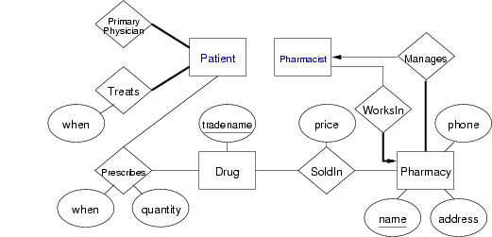

* 1. **Use Case:**

staff

user

1. **Conclusion**

The primary aim of is to improve accuracy and enhance safety and efficiency in the pharmaceutical store. In this project we can also include BAR CODE facility using the bar code reader, which will detect the expiry date and the other information about the related medicines.

The application was designed to track record of the stock of the pharmacy inventory.

1. **Future Scope**

* Developing an application for android devices that works on the same database which is the mini of (MySQL).
* The android application will be useful for controlling the system like remote app.
* This project can be modified in future according to the organization need.
* They can now purchase medicines by just a single click and from sitting at home wasting no time and energy.

1. **Appendix**

**11.1 Appendix 1**

The tools and technology in the development of the system are:

**PHP:** PHPis a server-side scripting language designed for web development but also used as a general-purpose programming language. Originally created by RasmusLerdorf in 1994. PHP originally stood for Personal Home Page, but it now stands for the periodic acronym PHP Hypertext Preprocessor. PHP code may be embedded into HTML code, or it can be used in combination with various web template systems, web content management systems, and web frameworks.

During 2014 and 2015, a new major PHP version was developed, which was numbered **PHP 7**. As with any piece of software, PHP has a release life cycle in which has to adhere to in order to keep pushing things forward and making improvements. Each major release of PHP is typically fully supported for two years after its release. During that time, bugs and security issues are fixed and patched on a regular basis.

**PHP 7** is a major release of PHP programming language and is touted to be a revolution in the way web applications and their features are:

* **Improved performance** − Having PHPNG code merged in PHP7, it is twice as fast as PHP 5.
* **Lower Memory Consumption** − Optimized PHP 7 utilizes lesser resource.
* **Scalar type declarations** − Now parameter and return types can be enforced.
* **Many fatal errors converted to Exceptions** − Range of exceptions is increased covering many fatal errors converted as exceptions.
* **Secure random number generator** − Addition of new secure random number generator API.
* **Return and Scalar Type Declarations** − Support for return type and parameter type added.

**XAMPP** stands for Cross Platform, Apache, MariaDB (MySQL), PHP, Perl. XAMPP is a free and open source cross-platform web server solution stack package developed by Apache Friends, consisting mainly of the Apache HTTP Server, MariaDB database, and interpreters for scripts written in the PHP and Perl programming languages.

**DATABASE: MySQL** is a fast, easy-to-use RDBMS being used for many small and big businesses. MySQL is developed, marketed and supported by MySQL AB, which is a Swedish company. MySQL is becoming so popular because of many good reasons −

* MySQL is released under an open-source license. So you have nothing to pay to use it.
* MySQL is a very powerful program in its own right. It handles a large subset of the functionality of the most expensive and powerful database packages.
* MySQL uses a standard form of the well-known SQL data language.
* MySQL works on many operating systems and with many languages including PHP, PERL, C, C++, JAVA, etc.
* MySQL works very quickly and works well even with large data sets.
* MySQL is very friendly to PHP, the most appreciated language for web development.
* MySQL is customizable. The open-source GPL license allows programmers to modify the MySQL software to fit their own specific environments.

**CMS: WordPress** is an Open Source software system used by millions of people around the world to create beautiful websites and blogs. It is completely customizable by the use of themes and plugins. “WordPress is web software you can use to create a beautiful website or blog. We like to say that WordPress is both free and priceless at the same time.”

Themes can be easily downloaded from the official WordPress site or from hundreds of other places around the web. The same goes with plugins, which are used to extend the functionality of your WordPress site.

As well as being a fantastic blogging and content management system, one of the huge benefits is the wealth of information out there. There’s a great community of people behind the design & development of the WordPress system itself. People from all over the world contribute their time, knowledge and skill to keeping WordPress updated and secure. There’s also a huge number of designers, developers & bloggers who share their knowledge through blog posts, tutorials, reviews, videos and the creation of thousands of themes & plugins.

**Framework: Code Igniter** is a powerful open-source PHP framework with a very small footprint, created by Rick Ellis in 2006. CodeIgniter was born from ExpressionEngine, essentially a collection of refactored classes originally written for EllisLab's flagship CMS. CodeIgniter does all the heavy lifting for you while maintaining high performance. It will simplify PHP syntax, streamline the code underlying your web pages, and—best of all—have you churning out dynamic, interactive, professional websites in no time.

Here are some of the principal benefits of coding your next project in CodeIgniter:

• It makes coding in PHP simple, quick and user-friendly.

• It’s an excellent framework for learning more about how PHP works as you code.

• It underpins the Model/View/Controller (MVC) approach to web development—a best practice philosophy all developers should adhere to.

• It’s built on a linear, easy-to-use folder structure.

• It’s open source and simple to configure and customize for your own needs.

You can construct your own cleaner URI lines in CodeIgniter.

**Notepad++** is a simple text editor for Microsoft Windows. It has been included in all versions of Microsoft Windows since Windows 1.0 in 1985. It is a common text-only (plain text) editor. The resulting files—typically saved with the .txt extension— have no format tags or styles, making the program suitable for editing system files that are to be used in a DOS environment.

* Notepad++ can edit files of almost any format like txt, html, PHP etc.
* Notepad++ offers only the most basic functions, such as finding text.
* Easy to use implementation of Shortcut Keys for Basic Editing Functions.