* Here’s the data of the E-Commerce Dataset.

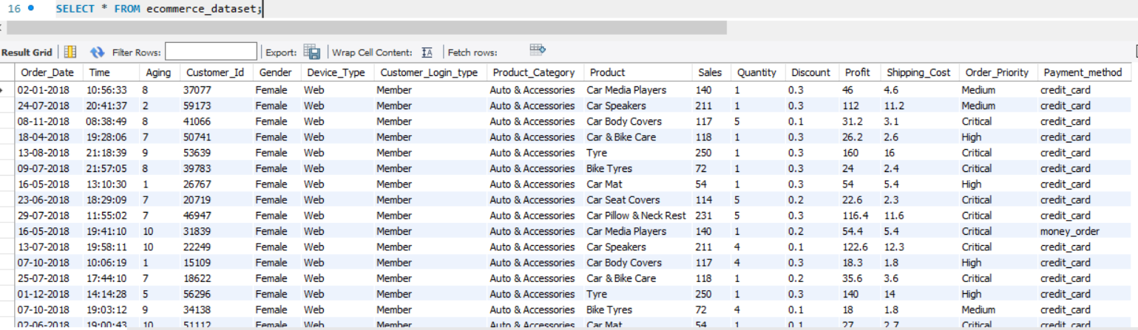

1. Count the total number of records in the dataset.

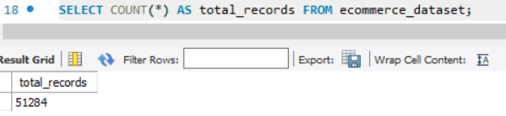

1. Find the sum or average of a numerical column (e.g., sales, prices, scores).

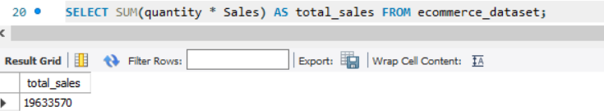

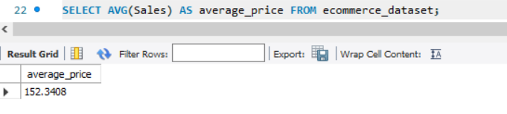

1. Filter the dataset based on a condition (e.g., find all records where a column meets a specific threshold or value).

