**G09_UTC_to_MTC**

This module basically takes in the earth time and date (UTC time on the prime meridian; coordinated universal time) as input which is expressed in the format Y:M:D:H:M:S and eventually calculates and generates the Mars time of day for the Mars clock (MTC time on the prime meridian) which is expressed in the format H:M:S.

Below is a symbol diagram for this circuit:

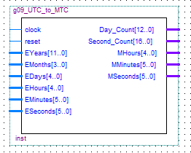

The following are the input/output pins along with their VHDL description:

clock : in std_logic

reset : in std_logic

EYears : in std_logic_vector(11 downto 0)

EMonths: in std_logic_vector(3 downto 0)

EDays : in std_logic_vector(4 downto 0)

EHours : in std_logic_vector(4 downto 0)

EMinutes: in std_logic_vector(5 downto 0)

ESeconds: in std_logic_vector(5 downto 0)

Day_Count: out std_logic_vector(12 downto 0)

Second_Count: out std_logic_vector(16 downto 0)

MHours : out std_logic_vector(4 downto 0)

MMinutes: out std_logic_vector(5 downto 0)

MSeconds: out std_logic_vector(5 downto 0)

In the architecture of VHDL code, we described components HMS_Counter, YMD_Counter and Seconds_to_Days.

To test the UTC_to_MTC circuit, we conducted a simulation and achieved the following results as seen in the figure below.

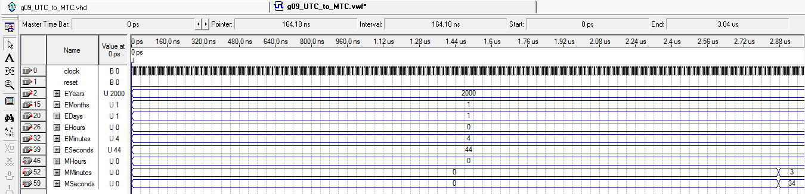

After comparing these values with an online Mars time calculator, we verified these results in the above simulation too.

A summary of the FPGA resource utilization is given below:

