**g09_YMD_Counter**

This circuit designs a counter circuit that counts years (ranging from 0 to 4000), months (ranging from 1 to 12) and days (ranging from 1 to 31 days) on Earth which also includes leap years in the determination of maximum day count.

The following image is the symbol diagram for the circuit:

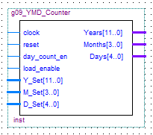

The following are the input/output pins along with their VHDL descriptions:

clock: in std_logic;

reset: in std_logic;

day_count_en: in std_logic;

load_enable: in std_logic;

Y_Set : in std_logic_vector(11 downto 0);

M_Set : in std_logic_vector(3 downto 0);

D_Set : in std_logic_vector(4 downto 0);

Years : out std_logic_vector(11 downto 0);

Months : out std_logic_vector(3 downto 0);

Days : out std_logic_vector(4 downto 0);

The circuit was tested by running a functional simulation and expected results were achieved. We then created a testbed VHDL file to implement the circuit on the altera board. We connected one push button to the counter reset and the other one to the counter load enable input. In the end, we successfully achieved results on the four 7-segment LEDs which displayed years, months and days values one at a time. The functional simulation in given below:

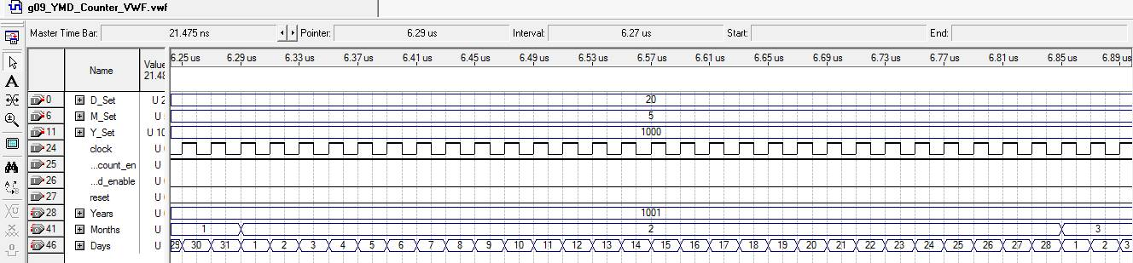

Below is the summary of FPGA resource utilization:

