NATIONAL PHYSICAL LABORATORY
INDENT FORM NO.: 03
FOR USE BY PURCHASE
Sr. No. of Indent Monitoring Register
NEW DELHI-110012

INDENT FOR PURCHASE
(Regular Indent Form)
FOR USE BY PME GROUP: 1. verified that the indented item is in the list of items sanctioned by competent authority for Project No. __________________ under ____________________(Consumable/equipment) category & the same has been noted in PME Group as per details given below. 2. Necessary funds are available to process this item (This should commensurate with the delivery schedule.
Indent No. | Date | S. No. of Priority List | Budget allocated under the project  (Rs in Lakhs) | Total amount of indents (duly revised) including the present, in the project | Balance available | Signatures of  Verifying officer
ONLY TYPED INDENT (WITHOUT CUTTINGS/ OVERWRITINGS) WILL BE ACCEPTED
TO BE FILLED BY INDENTOR: Dated:
Name of Indentor & Designation: |  |  |  |  |  |  |  |  | Name of alternative Person:
Email id |  |  |  |  |  |  |  | Phone No(s). :
Name of Project Leader: |  |  |  |  |  |  |  | Designation of Project Leader:
Name of Division: |  |  |  |  |  |  |  |  |  |  |  | DU No.:
Project No: |  |  |  |  | Project Starting date: |  |  |  |  |  | Ending date:
# Total estimated Cost Rs. : |  |  |  |  |  | Budget Head: |  |  |  | Indigenous or imported :
1.0 The following items may kindly be procured. (Separate items to be indented for each class).
Sl. No. | Required items with detailed specification *  (Please use separate sheet, if necessary)  (While framing specifications please see Annexure-I) | Quantity | Estimated cost of each item in Rupee
* No specific make/brand of a specific manufacturer/firm should be mentioned in the indent.
* As far as possible specifications may be given in two parts: 1. Critical/essential 2. Desirable
* Spitting of indents in order to bring it outside the ambit of open tender method is strictly prohibited.
# In case of imported items, freight, insurance & custom duty components (i.e. 15% of indented cost) must be added in the estimated cost of the item.
Contd……page 2

Page 2:

- In case of procurement of items under PAC/ Single Tender/ PUC, certificate is required to the filled up by I/O and duly signed by PL as per annexure D, E, and G.

- Category of the indented item (please tick whichever is applicable) :
1. Capital item 2. Consumable item 3. Spares 4. Accessories 5. Components

3.1 Whether the requirement is (i) New (ii) additional (iii) replacement (iv) maintenance (Please tick whichever is applicable) along with a certificate that the specifications are complete and correct to meet the requirement fully ………………… … . . . . . . . . . . . . . . . . . . . . . . . . . . . . . …………………………… ……………………………………… . . . . . . . . . . . . .

- The installation/commissioning of the item shall be done by:- a. Indentor ( ) b. Not required ( ) c. Supplier/Manufacturer ( ) d. Indian representative or authorized agent/dealer ( )

- The brief purpose/end use /summery of the functions of the indented equipment/items (should be given in a paragraph separately) _________________________________________________

- Certify that the indented items are not available in India (applicable for imported items)

- The details about the life of the equipment, availability of spares, ease of maintenance etc.:-

____________________________________________________________________________

- Date of delivery by which the material is required _________________________.

- The installation requirements like area, power, civil works etc. are ready- Yes/ No.
If No, expected time by which requirements will be completed _____________________

- The list of available vendors, their complete addresses and websites wherever available. (please give the vendors of comparable reputation only) :
1. _________________________________________________________________________
2. _________________________________________________________________________
3. _________________________________________________________________________
4. _________________________________________________________________________

- The tentative inspection schedule for the item is as under: _________________________________

- The approximate period required for the equipment to become operational from the date of its arrival ……………… ……………………………………………………. ……………………… ……….

Signature of the Indentor with Date Signature of Project Leader with Date

Contd….. page 3.
Page 3:

TO BE USED BY CENTRAL STORES:

Certificate of availability of indented items in Central Stores for indent No. __________________________

1. The above items are : Available / Not available in Stores
2. Whether the item has been procured earlier as per Stores records : YES / NO
3. Details of the previous purchase are given below:

S.No. of Indent | Date of previous purchase | Name of supplier | Brief details with Brand/model of the item last purchased | Name of the Indentor/user | Rate/  Cost  in Rs.

Stores In-Charge S.O. (Stores)

ANNEXURE-I
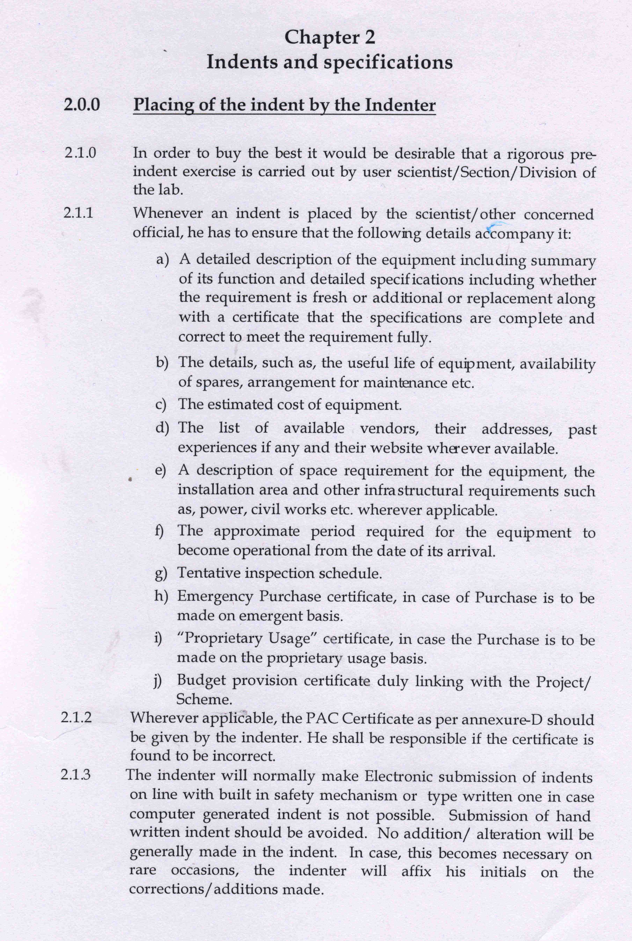

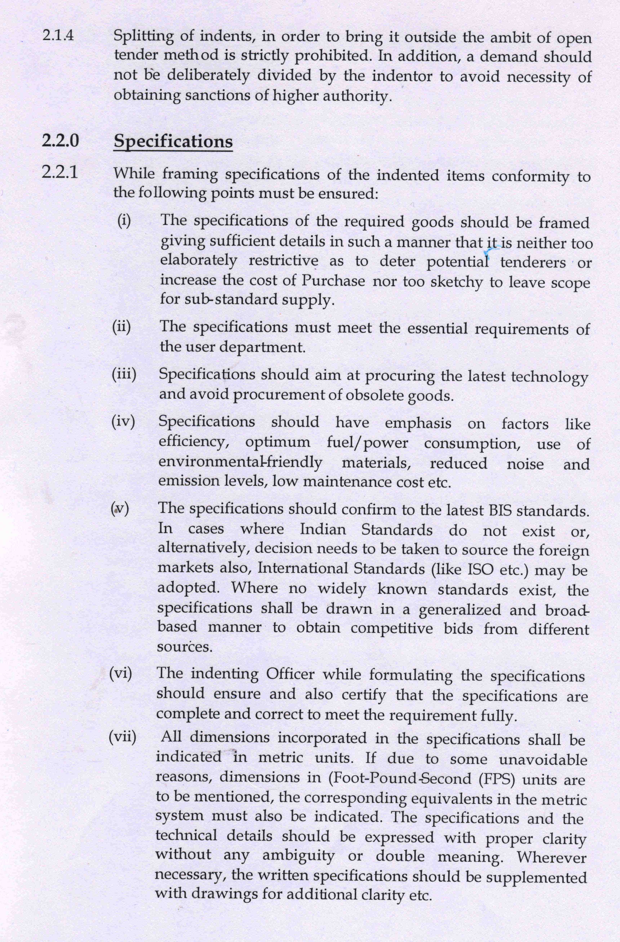

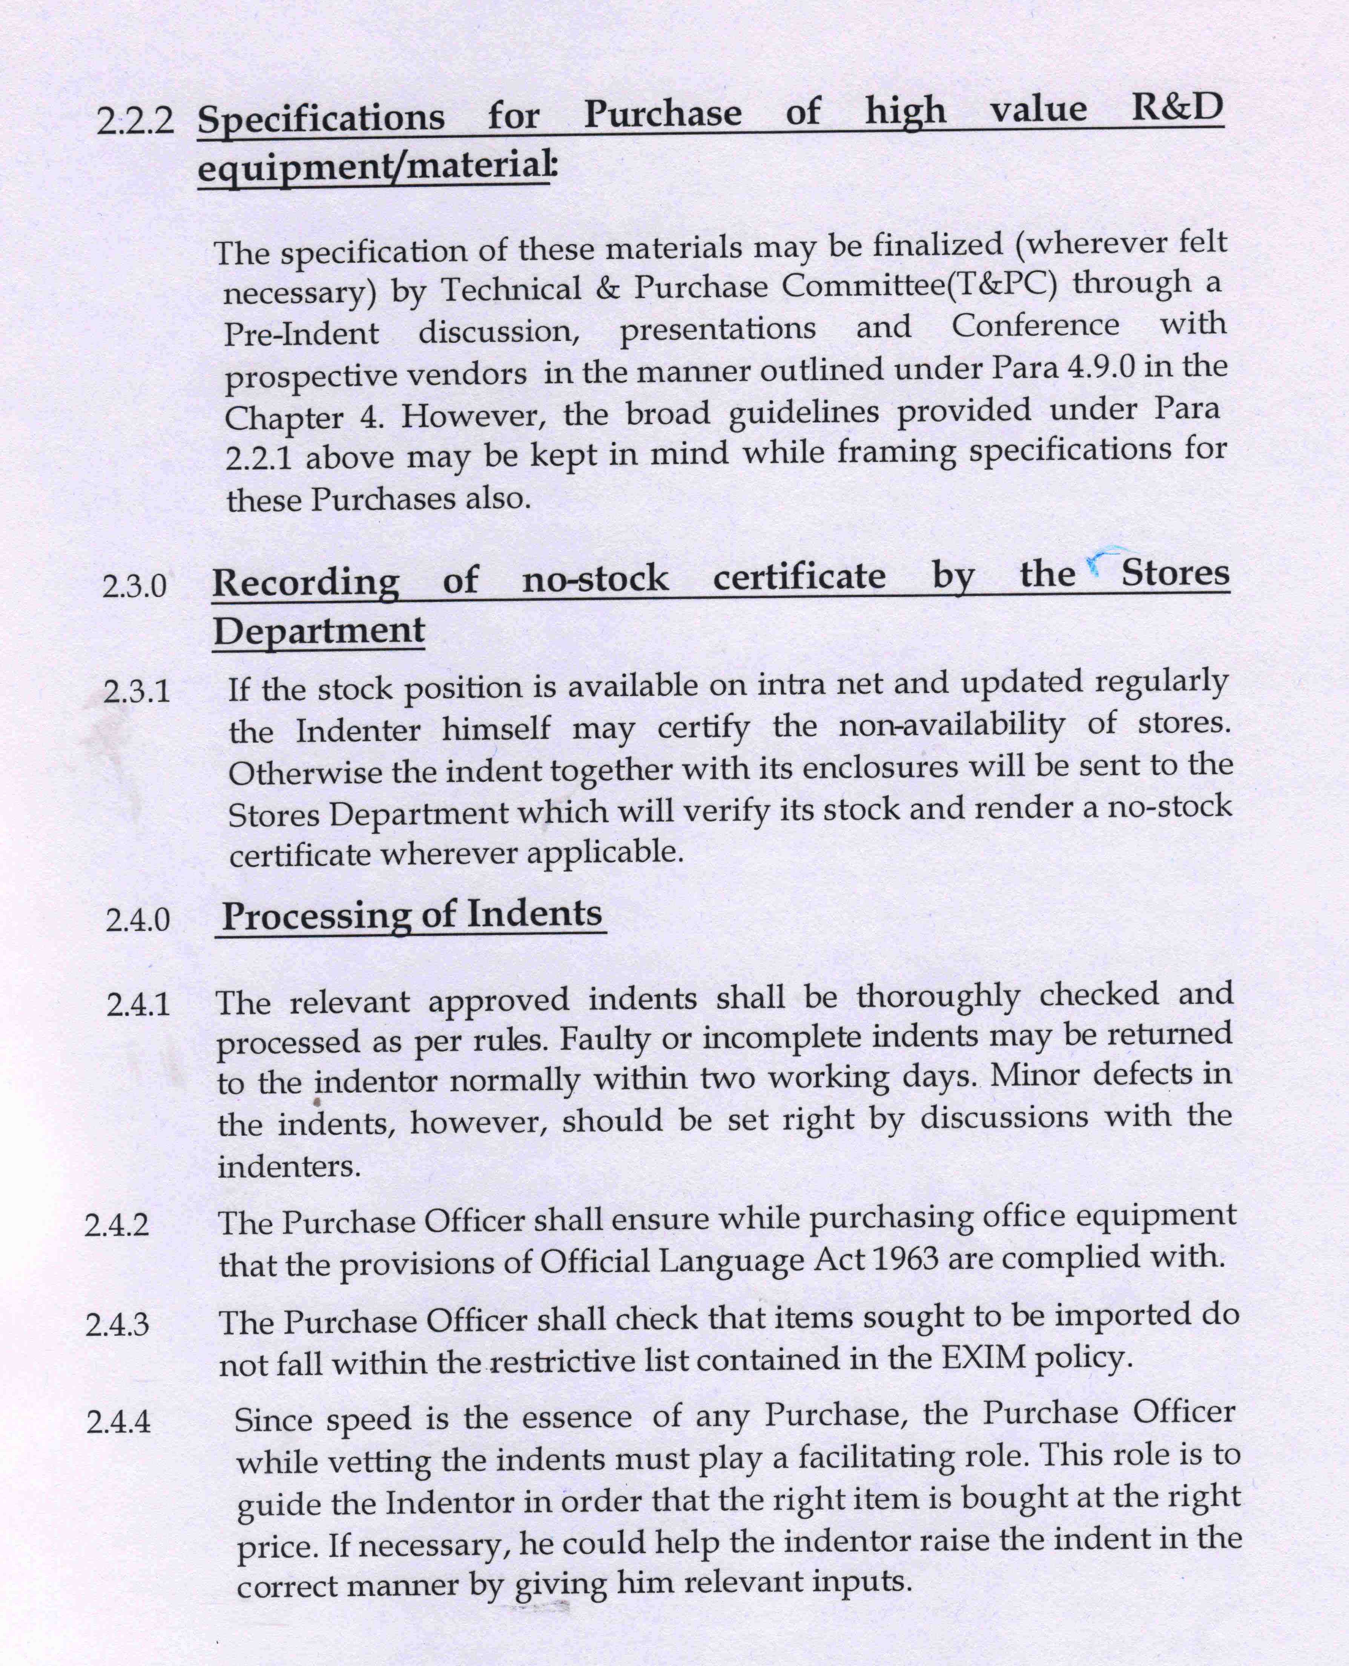

ANNEXURE –‘D’

PROPRIETARY ARTICLE CERTIFICATE (PAC)

Certified that to the best of our knowledge, the items indented vide indent no. …………………… dated ………………. are manufactured by M/S ……………………………………………………….……………………….………… only.

There is no other option for the Laboratory except to Purchase this item(s) as it is having unique feature which is essential for R&D job and which is not available in any other similar equipment. I/We shall be held responsible in case the certificate is found to be incorrect.

Signature of Indenting Officer
Designation:…………………

Signature of Project Leader

Date:…………………

ANNEXURE –‘E’

SINGLE TENDER CERTIFICATE
(For procurement from a single source basis only during emergency)

The items indented are necessarily to be purchased from M/S ………….………………………………………………… . for the following reasons : …………………………………………………………………………………………………..

Signature of Indenting Officer
Designation:…………………

Signature of Project Leader

Date:…………………

ANNEXURE –‘G’

PROPRIETARY USAGE CERTIFICATE (PUC)

For requirement of this project/section/ Division, the item/s …………..………………………………. ……. … is /are required to be purchased from manufacturers/dealers ……………..……………………………………… only in order to maintain consistency, continuity, of established/ standardized methods protocols and SOPs.

It is further declared that any deviation in respect of material inputs at this stage will affect the integrity, authenticity and validity of analysis/ result.

Signature of Indenting Officer
Name ……………………………….
Designation …………………………
Date………………………………....

Signature of PL
Name ……………………………….
Designation …………………………
Date………………………………....

