PURCHASE FORMAT – PU4
Revolving Reimbursement/Adjustment

PURCHASE OF GOODS WITHOUT CALLING QUOTATIONS
(For purchase of goods up to the value of Rs 15,000/- for Non- R&D Items / Rs. 1,00,000/- for R&D Items)
(Strike out whichever is not applicable)

REIMBURSEMENT AGAINST REVOLVING ADVANCE
(To be filled by the Indentor / Project Leader)

  - Revolving Advance drawn vide Purchase OM No……………………..….……. dt. …..…..…….…. in the name of Sh./Smt/ Dr. …………………………………………………...………………..…….…. for Rs. ………………………………………
- Certified that the amount of total purchases already made without calling quotations during this financial year under the above Revolving fund are for Rs_____________________________. The funds are available under the project to make the proposed purchase.
- It is certified that the procurement/repair was very urgent and immediate nature which necessitated such purchase/ repair and expenditure made out of advance drawn from Revolving Fund.

Signature of the Indentor
Name & Designation:

Sanctioned a sum of Rs. ..………………….….. (Rs. …………………..…………………………………… under Project No : ………………….…… Budget Head: ……….………… Cash Code: P99102/ P99103 for the purchase/ repair of ………….…………………………………………………………….
Cashier, NPL may kindly arrange to draw the amount for reimbursement purposes.

Signature of Reporting Officer/ Supervisor Signature of the Sanctioning Authority/Project Leader
(As Applicable) Name & Designation: ………………………………..

ANNEXURE –‘A’

PURCHASE OF GOODS WITHOUT CALLING QUOTATIONS*
(For purchase of goods up to the value of Rs 15,000/- for Non- R&D Items / Rs. 1,00,000/- for R&D Items)
(Strike out whichever is not applicable)

- “I Shri/Ms. /Dr. …………………….……..……………………………, am personally satisfied that these goods purchased are of the requisite quality and specification and have been purchased from a reliable supplier at a reasonable price”.
- “It is further certified that the required item is for specific use of the R&D and will be utilized for the project titled…………………………………………………..…… (Project No.)”.
(Strike out whichever is not applicable)
- “It is also certified that the item(s)is/are not available in the Stores.”
- It is certified that the procurement/ repair was very urgent and immediate nature which necessitated such purchase/ repair and expenditure made out of Advance Drawn from Revolving Fund”.
Cash Memo/Paid bill(s) is/are attached as under:
Sr. No. | Bill No. & Dt.: | Name of firms | Bill Amount
(1)
(2)
(3)
(4)
(5)
Total Amount (Rs.)

The amount of Rs. …………………………………………………………………………….. may kindly be reimbursed to (Name of IO) …………………………………………. ID No.: ……………..

Sanctioned a sum of Rs. ____________________(Rs. _________________________________________)

Signature of Indenting Officer Signature of Reporting Officer/ Supervisor# Date:…………………. (#As Applicable) Date:…….……………..

Signature of the Sanctioning Authority/ Project Leader
Date: ………………..
Name & Designation: ………………………

*To be submitted along with Revolving Advance Reimbursement bill(s) to Purchase Section.
FVC BILL 2 – FOR REVOLVING ADV. REIMBURSEMENT
[To be submitted only at the time of reimbursement for revolving advance along with Bills/ Cash Memos]

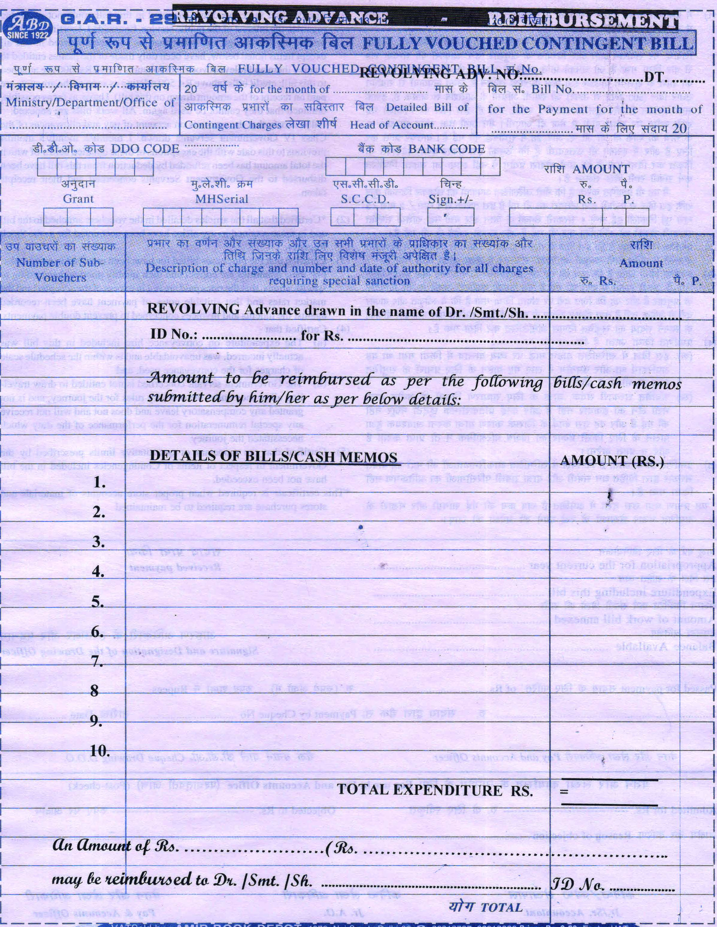

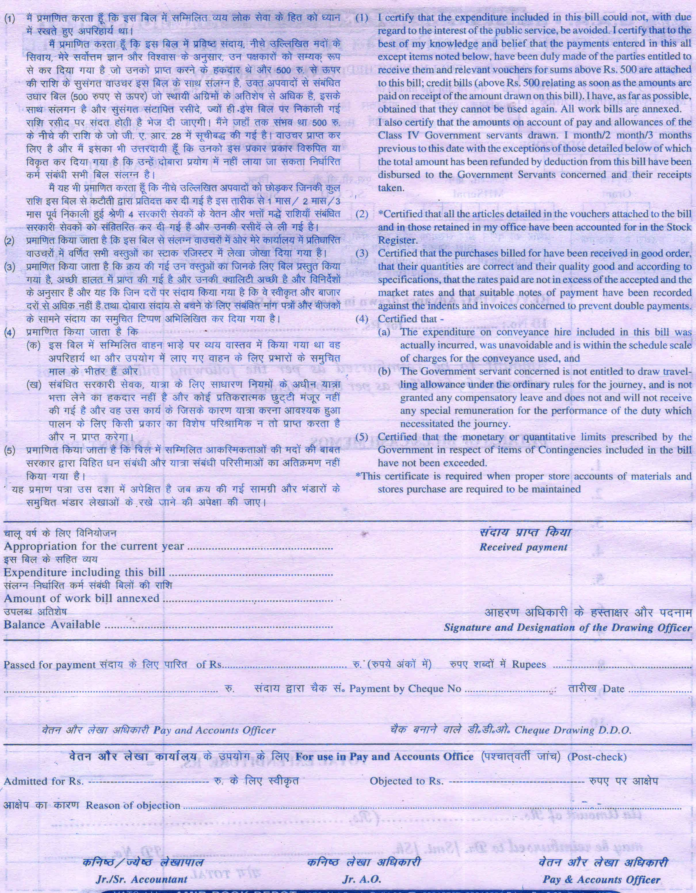

FVC BILL 3 – FOR REVOLVING ADV. ADJUSTMENT
[To be submitted only at the time of Adjustment/ OB Removal against revolving advance along with Bills/ Cash Memos]
