**NAME :** M.Naga Ravi Chandra

**ROLL NUMBER :** CB.EN.U4CYS21044

# About AUMS :

AUMS ( Amrita University Management System ) is a web-based application that is used by students, faculty, and staff at Amrita University to access a variety of online resources and services related to their academic and administrative needs.

The AUMS is actually based on the opensource Sakai Project. The patches applied to AUMS gives the AUMS the look and feel are not open sourced , but the core that is based on it.

**User Interface Evaluation**

**ID :** AUMS-UIE-21044-001

# Issue :

When the user truly means to log in, the logged out notification may occasionally be displayed.

# Principle Violated :

Support internal locus of control.

# Suggestion :

Make sure that sessions are managed properly , and show the relevant message that answers to user requests.

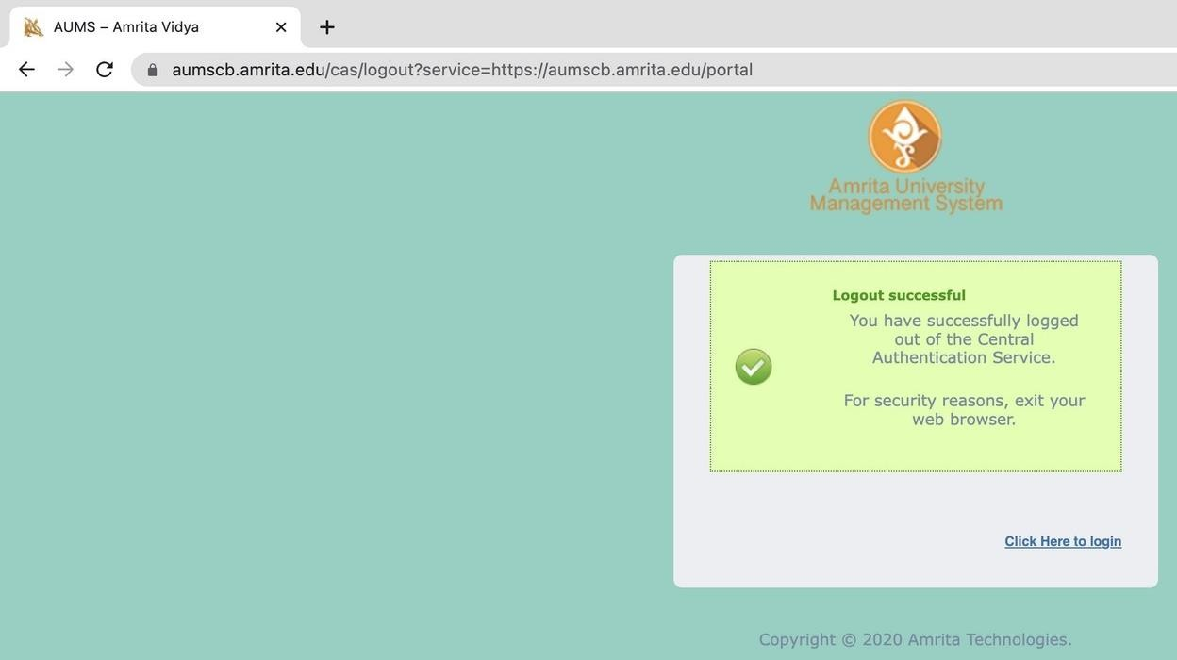

**ID :** AUMS-UIE-21044-002

# Issue :

The course names are not shown on the tabs for each course, forcing the user to either browse through all tabs or keep track of where each tab is. This is a really taxing activity for the user because there are so many topics to choose from.

# Principles Violated :

* Offer informative feedback
* Reduce short term memory load

# Suggestion :

It would be easier and faster for users to get to the required subject if the tabs for each subject just displayed the subject code.

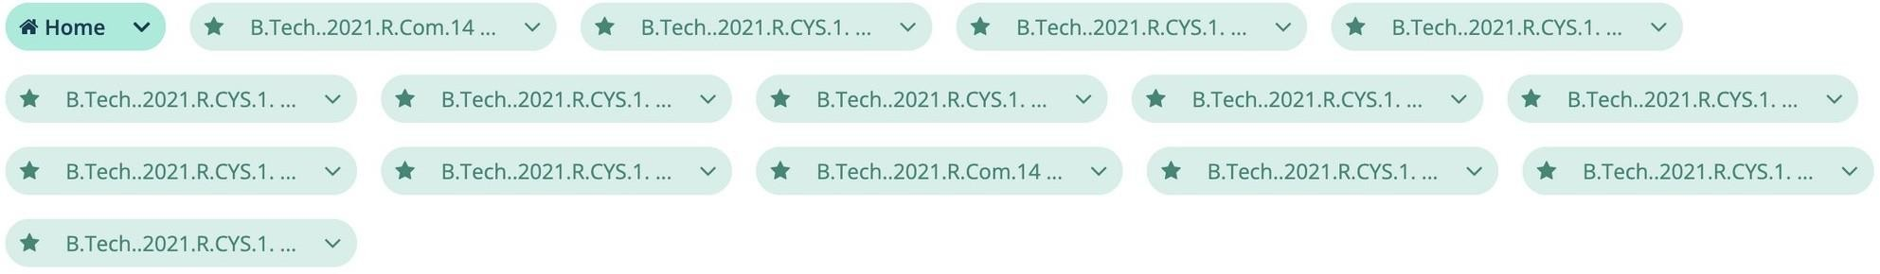

**ID :** AUMS-UIE-21044-003

# Issue :

The course name cannot be easily seen; instead, the user must move the pointer over the tab before the topic can be seen.

# Principle Violated :

Reduce short term memory load.

# Suggestion :

Instead, the topic codes might be shown on their own in the tabs for each subject, making it easier and faster for users to find the required subject.

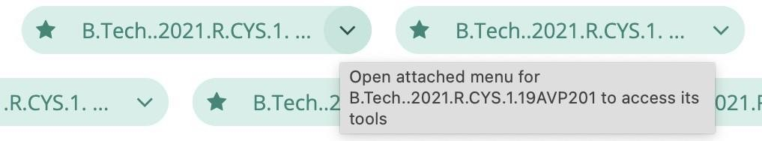

**ID :** AUMS-UIE-21044-004

# Issue :

It becomes hard to scroll past and display the next row in the marks table if the number of rows exceeds a certain limit.

# Principle Violated :

Strive for consistency.

# Suggestion :

The table's alignment needs to be changed dynamically using CSS.

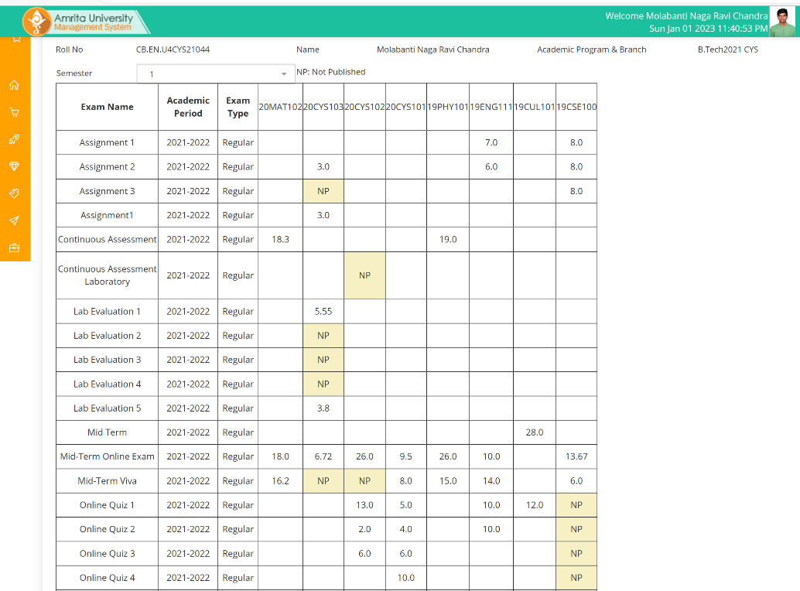

**ID :** AUMS-UIE-21044-005

# Issue :

It is difficult for the user to read the text since it is cut off multiple times.

# Principle Violated :

Strive for consistency.

# Suggestion :

CSS must be used to dynamically modify the text's alignment.

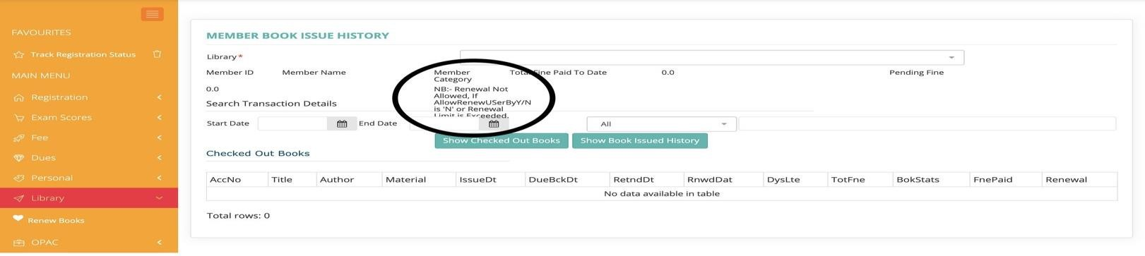

**ID :** AUMS-UIE-21044-006

# Issue :

The user must browse the whole list of time zones to make their selection in order to change the time zone.

# Principle violated :

Permit easy reversal of actions.

# Suggestion :

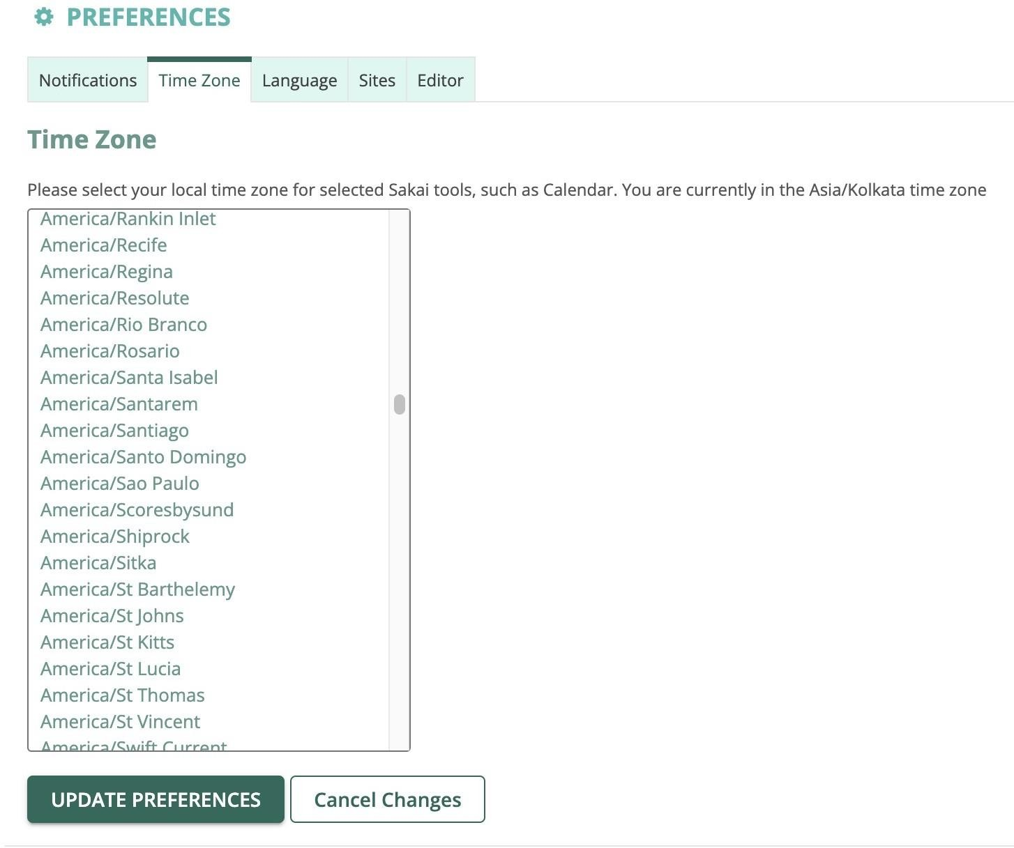The user can utilize a search feature to rapidly identify the right time zone.

**ID :** AUMS-UIE-21044-007

# Issue :

# Here the content is not relevant to the selected option.

# 

**Suggestion:**

Rectify the selection sort algorithm.