Crop Yield Prediction using RNN, Feed forward and LSTM Neural Network

To implement this project we are using agriculture production dataset and then training above 3 neural networks algorithms on that dataset and building neural network model, we can apply new test data on that model to predict crop yield will be HIGH or LESS. In test data we will have values of location, current year, and agriculture land area and then neural model will predict production. To test neural model we are using below test dataset.

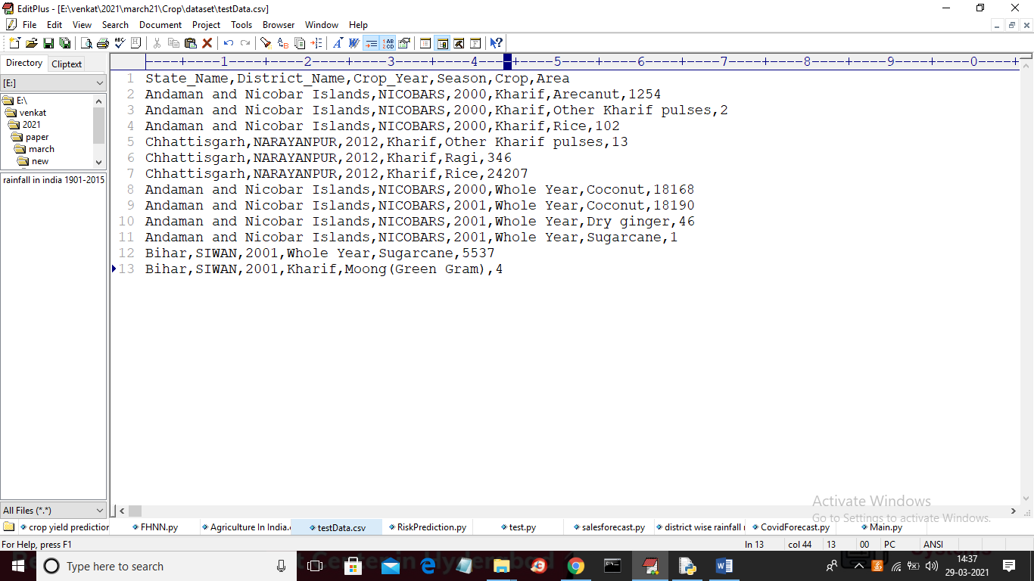

In above test data in last column there is no production values and neural network will predict production will be high or less. In above dataset we have area name, crop name, year and area size.

SCREEN SHOTS

To run project double click on ‘CropYield.py’ file to get below screen

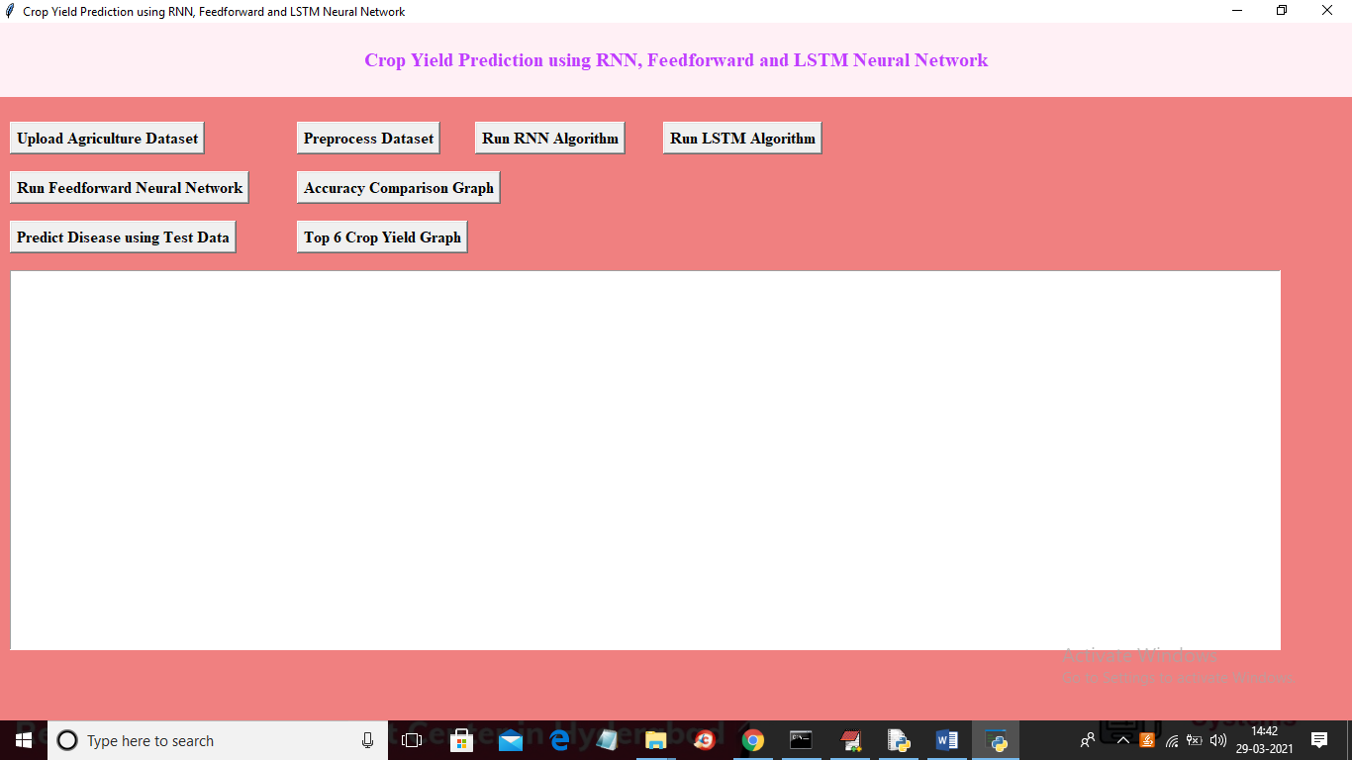

In above screen click on ‘Upload Agriculture Dataset’ button to upload dataset

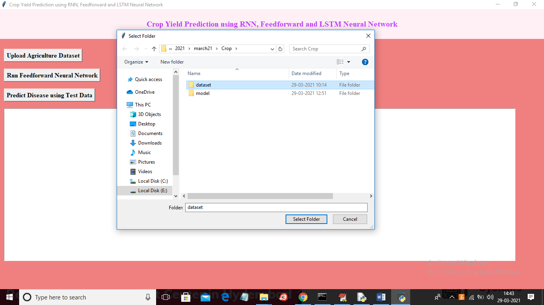

In above screen selecting and uploading ‘dataset’ folder which contains agriculture and rainfall dataset and then click on ‘Select Folder’ button to load dataset and to get below screen

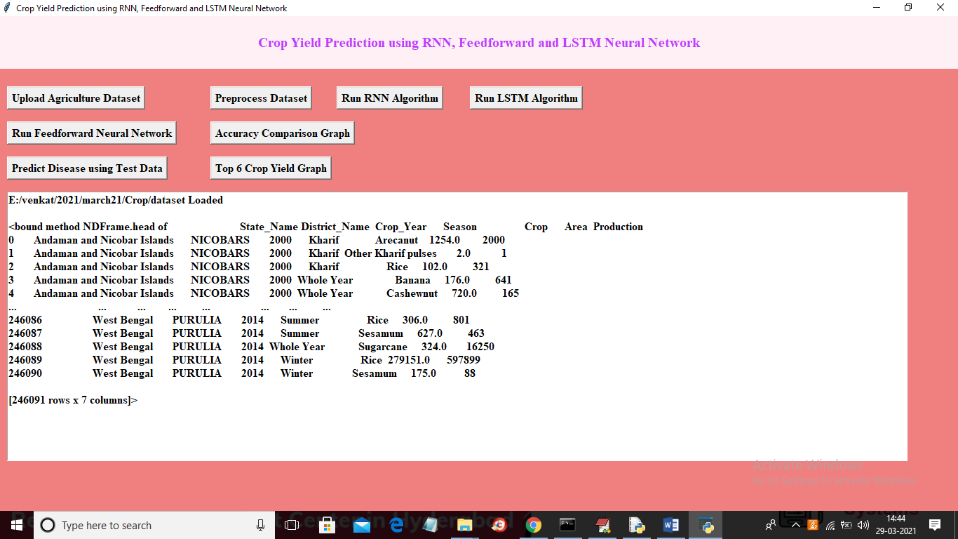

In above screen dataset loaded and above dataset contains missing values and string values and neural network will not accept missing or string values so we need to preprocess above dataset to replace missing and string values with numeric data. So click on ‘Preprocess Dataset’ button to get below screen

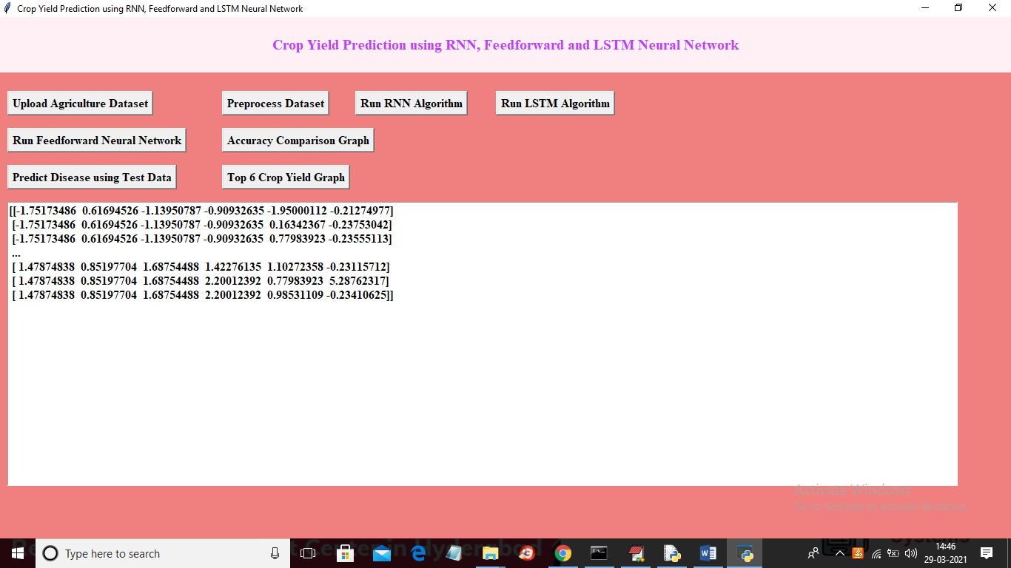

In above screen all dataset converted to numeric values and now dataset is ready and now click on ‘Run RNN Algorithm’ button to build RNN model on loaded dataset

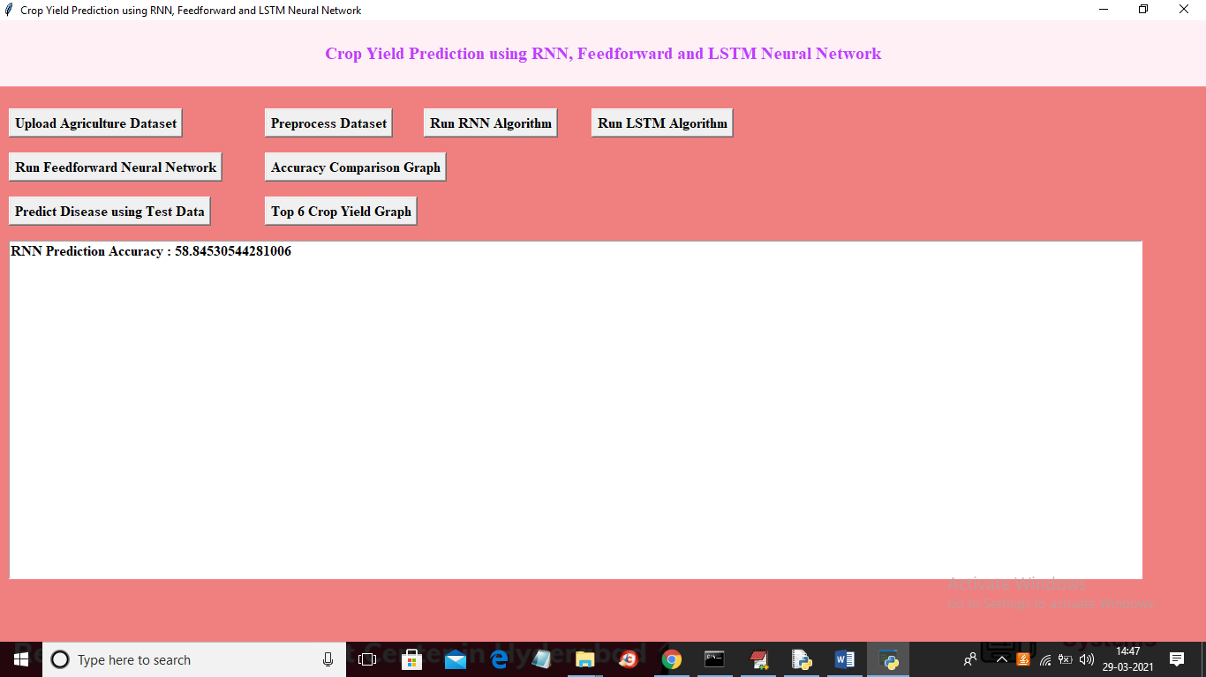

In above screen RNN model generate with accuracy as 58% and now click on ‘Run LSTM Algorithm’ button to build LSTM model

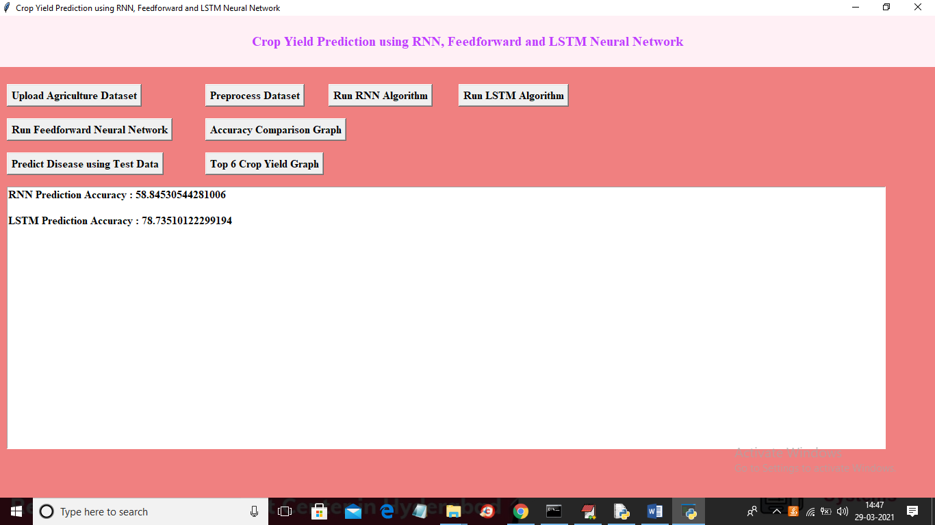

In above screen LSTM model generated with accuracy 78% and now click on ‘Run FeedForward Neural Network’ button to build feed forward model

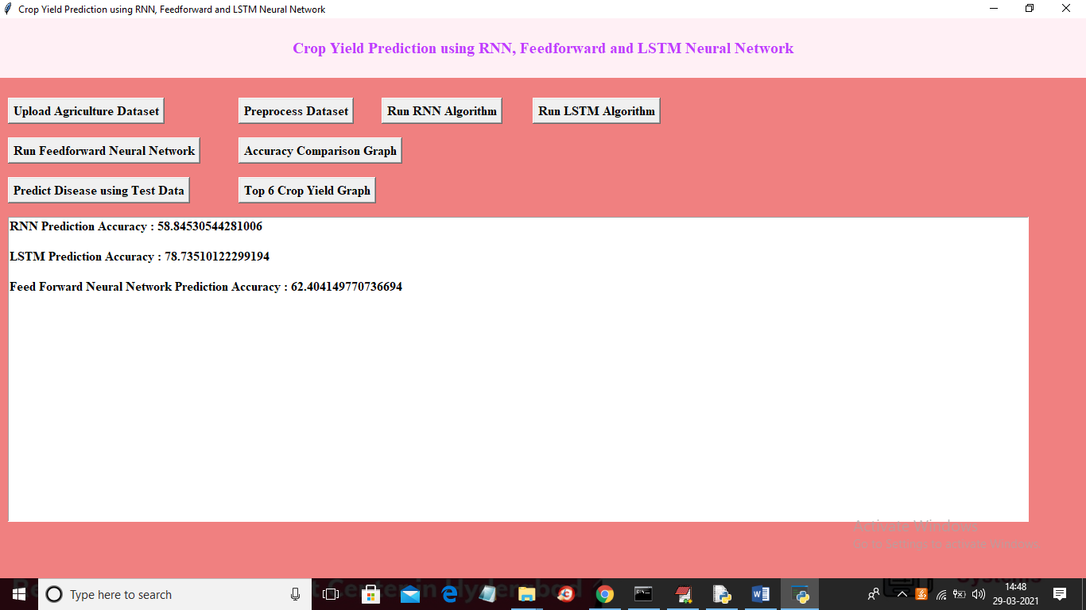

In above screen feed forward model generated with accuracy 62% and now click ‘Accuracy Comparison Graph’ button to get below graph

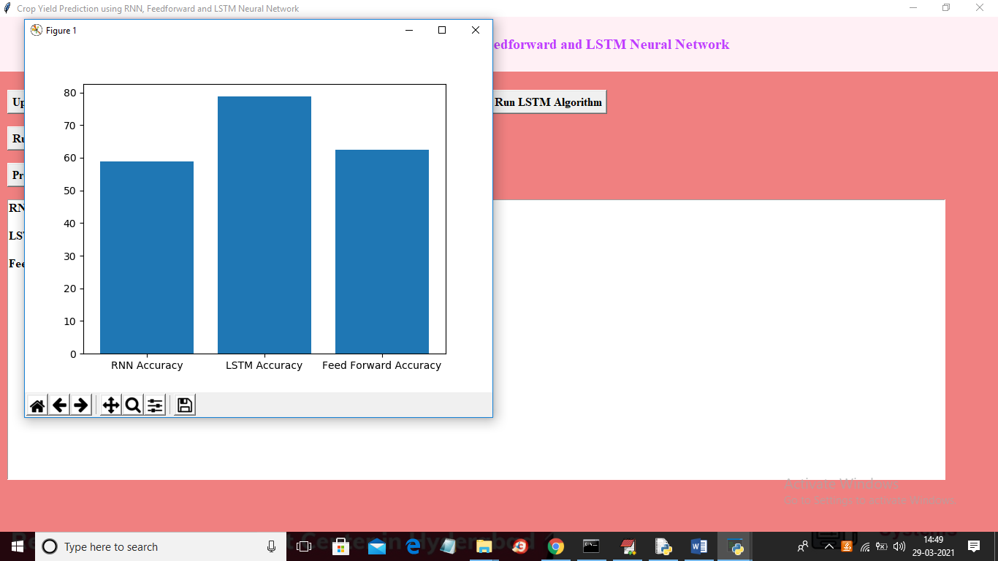

In above graph x-axis represents algorithm name and y-axis represents accuracy of those algorithms and in all algorithms LSTM giving better prediction accuracy and now click on ‘Predict Disease using Test Data’ button to upload test data and then neural network will give below prediction result

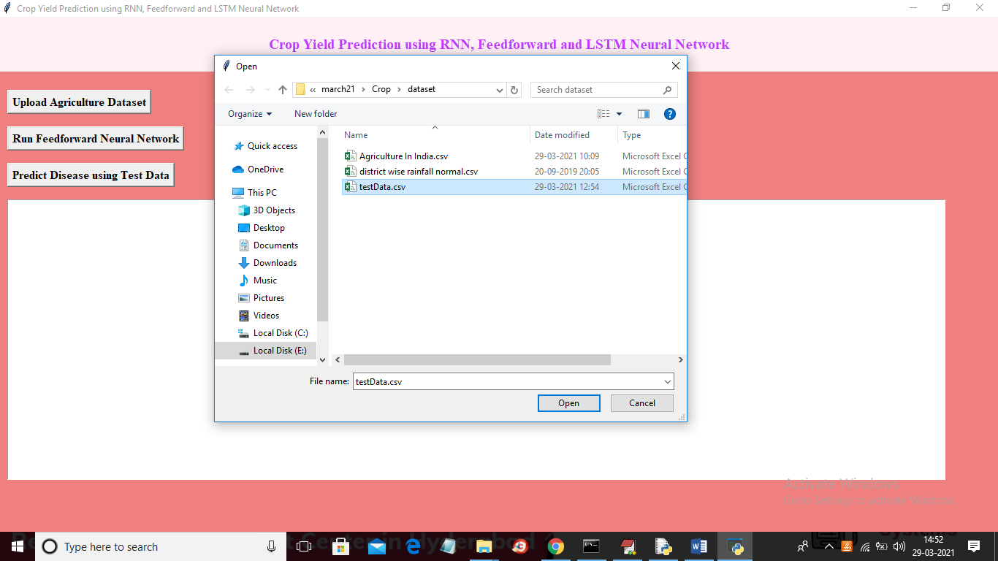

In above screen selecting and uploading ‘testData.csv’ and then click on ‘Open’ button to get below result

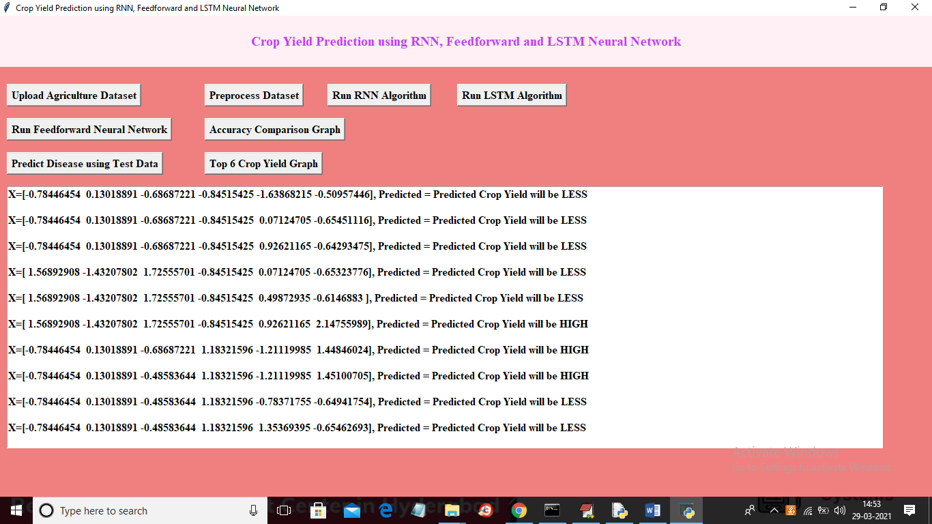

In above screen in square brackets we have test values from dataset which converted to numeric format and after square bracket we can see prediction result as HIGH or LESS. Based on given agriculture input neural network will give prediction result. Now click on ‘Top 6 Crop Yield Graph’ button to get below graph

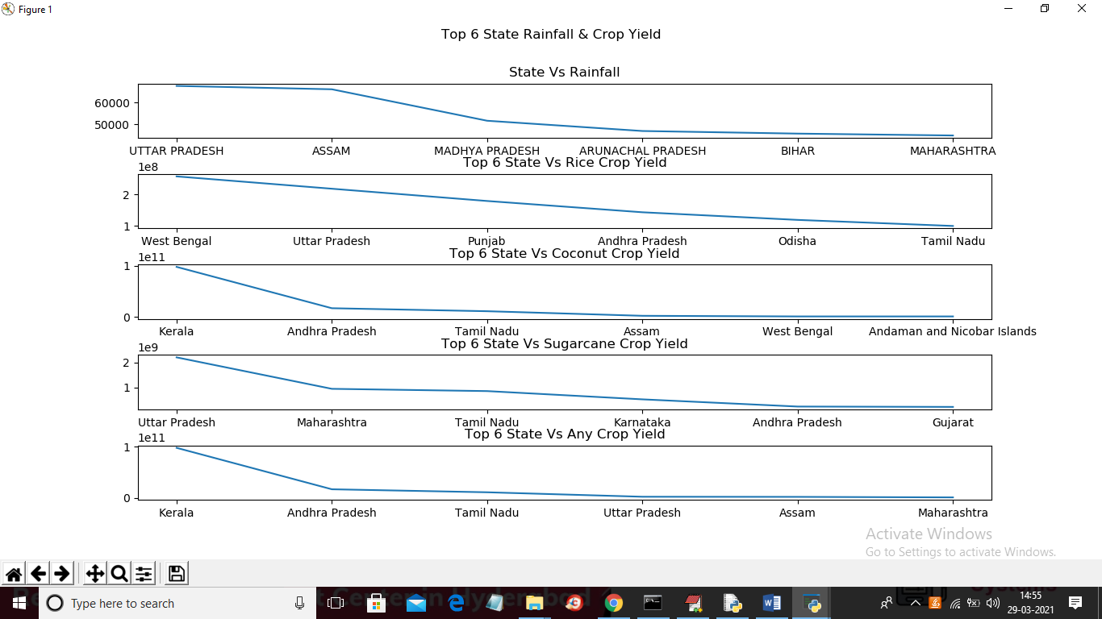

In above graph x-axis represents state names and y-axis represents rainfall, rice, coconut, sugarcane and various top6 crops in other states. First graph is for state vs rainfalls, state vs rice, state vs coconut, state vs sugarcane and top6 various crops in different states.