Software Architecture
Implementation
Student ID: -24155160
Name: - Ravichandran Mahinthan
Healthcare Management System - Report
This report reflects on how the designs produced in Part 1 of the Healthcare Management System have been realised in the Part 2 Java implementation, and how the Model-View-Controller (MVC) architectural pattern has been applied to structure the application.
In Part 1, UML use case and class diagrams were created to model the functional and structural requirements of the system. These designs directly informed the implementation in Part 2. Core domain classes such as Patient, Appointment, Prescription, Referral, Staff, and Clinician were implemented in Java, closely matching the attributes and responsibilities defined in the class diagram. Inheritance relationships were preserved. Associations between classes were also maintained, such as the relationship between Patient and Appointment, and Patient and Prescription, ensuring consistency between design and code.
The use case diagram guided the implementation of key system functionalities. Actions such as booking appointments, creating prescriptions, and generating referrals were implemented through controller logic and user interface interactions. The referral functionality, in particular, was enhanced using the Singleton design pattern, as required. The ReferralManager class was implemented as a Singleton to ensure that only one instance manages referral queues, referral file generation, and simulated email communications. This design prevents duplicate referrals, maintains consistent referral processing, and supports auditability, directly aligning with the architectural intent described in Part 1.
The system was implemented using a three-tier architectural approach. The data tier is represented by repository classes responsible for loading and saving CSV files using plain Java file I/O. This includes repositories for patients, staff, appointments, prescriptions, clinicians and referrals. The business logic tier is represented by service and controller classes that apply validation rules, coordinate workflows, and manage application logic such as appointment handling and referral processing. The presentation tier is implemented using Java Swing, providing a graphical user interface through panels, tables, and forms.
The MVC pattern was used to clearly separate concerns within the application. Model classes represent the core data and domain logic. View classes, implemented using Swing components such as JTable and JPanel, are responsible only for displaying information and capturing user input. Controller classes act as intermediaries, responding to user actions, updating models, and refreshing views accordingly. This separation improves maintainability, readability, and scalability of the codebase. Changes to the user interface do not directly impact the data logic, and vice versa, demonstrating effective use of MVC principles.
Overall, the Part 2 implementation closely reflects the architectural and design models developed in Part 1. The use of MVC, combined with a three-tier structure and appropriate design patterns, resulted in a well-organised, modular, and functional healthcare management application that satisfies the assignment requirements.

Application Screenshots and Demonstration of Functionality
- Main Screen
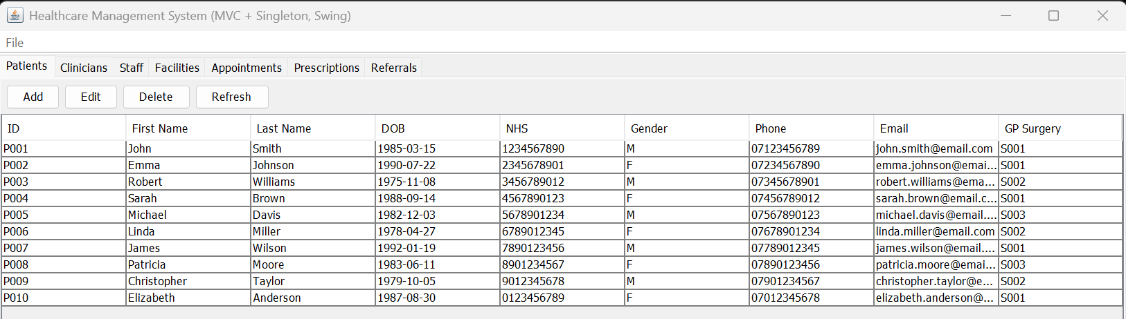
- Add Functionality

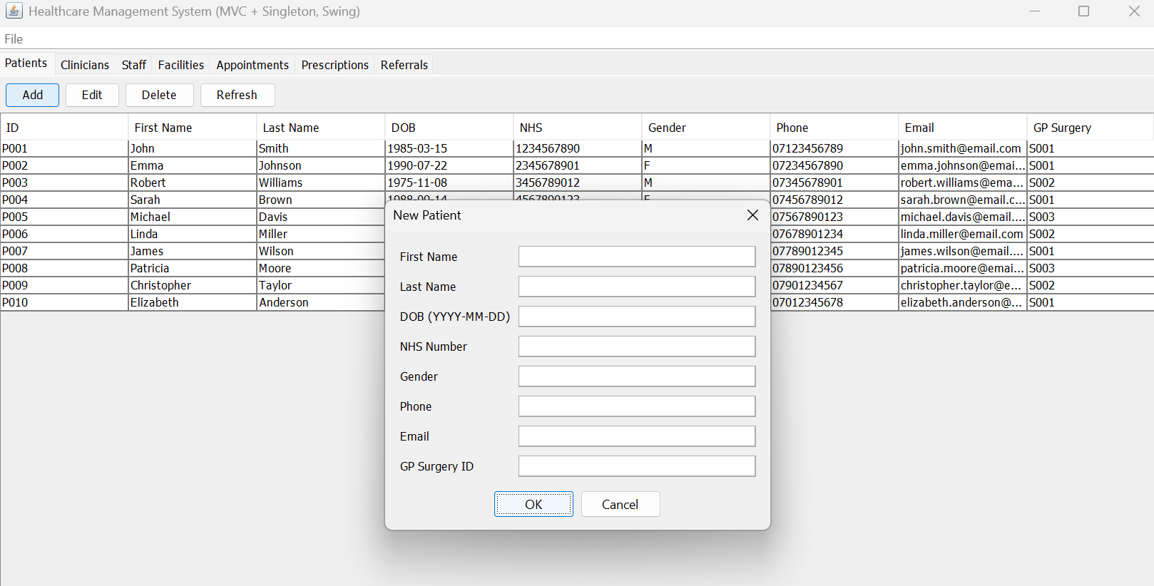

- Edit Functionality

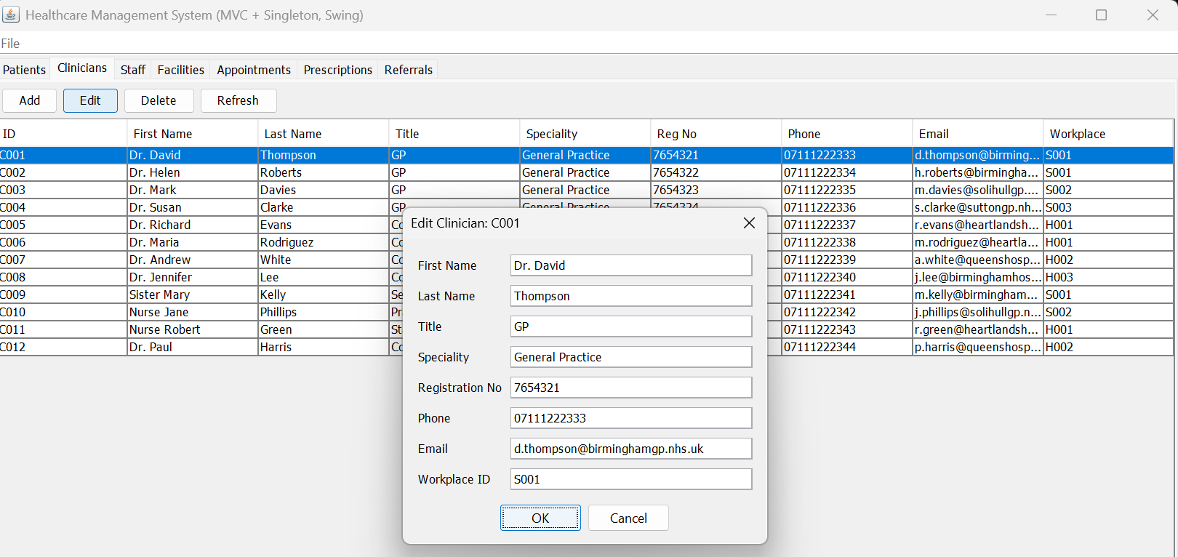
- Delete Functionality
