Sales Analytics Dashboard Project (Step-by-Step)
Prepared by: Ravi Chaudhary
Tools: Excel, MySQL Workbench, SQL, Power BI, DAX

Step 1: Dataset Preparation
The dataset was stored in multiple sheets in a single Excel workbook: SalesOrder, Customers, Products, Regions, and Product Budgets (2017). Each sheet was separated into individual files for easier import into MySQL.

Step 2: Database Creation in MySQL
A new database named salesanalyticsdb was created in MySQL Workbench. Tables were created for Customers, Products, Regions, SalesOrder, and ProductBudgets.

Step 3: Creating Primary and Foreign Keys
Primary keys were defined for dimension tables and foreign keys were created in the SalesOrder table to connect Customers, Products, and Regions.

Step 4: Importing Data into Tables
Data from Excel files was imported into MySQL tables. Errors such as incorrect integer values and decimal formats were resolved during import.

Step 5: Connecting MySQL to Power BI
Power BI Desktop was used to connect directly to the MySQL database using the MySQL connector.

Step 6: Data Transformation using Power Query
Data types were verified, unnecessary columns were checked, and data was prepared for modeling.

Step 7: Data Modeling (Star Schema)
Relationships were created between tables where SalesOrder acts as the fact table and Customers, Products, Regions, and ProductBudgets act as dimension tables.

Step 8: Creating DAX Measures
Important measures were created such as Total Sales, Total Orders, Total Quantity, Total Cost, Profit, Total Budget, and Sales vs Budget.

Step 9: Building Dashboard Visualizations
Various visuals were created including KPI cards, bar charts, pie chart, line chart for monthly sales trend, and comparison charts.

Step 10: Final Dashboard and Insights
The dashboard allows analysis of sales performance by country, product, channel, and month. Filters were added for interactive analysis.

Data Model (Relationships View)
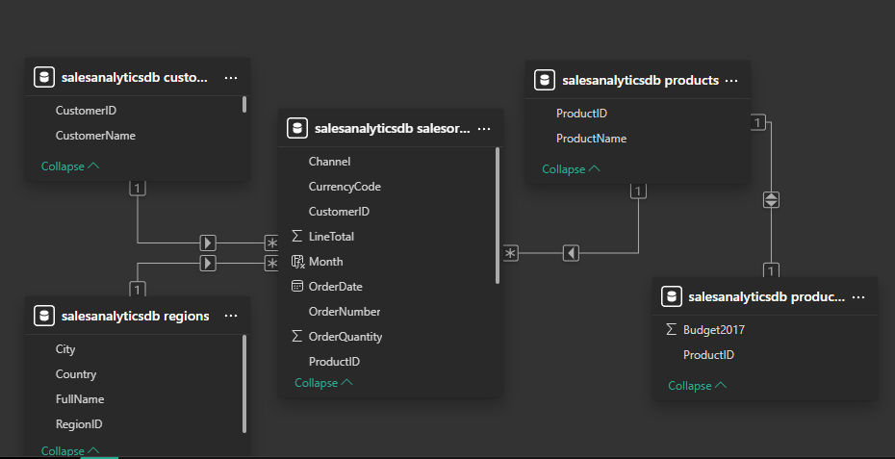

Final Power BI Dashboard
