Stealth Navigation: Autonomous Agent Pathfinding under Dynamic Moving Guards
Comparative Study of Classical Space-Time Search (BFS, A*) and Reinforcement Learning (Q-Learning, PPO)
Machine Learning (23MEE305) | Academic Project Report | 24-Hour Intensive Study
―――――――――――――――――――――――――――――――――――――――――――――――――――――――――――――――――

1. Executive Summary
This project investigates autonomous pathfinding in a high-threat, dynamic discrete environment termed 'Stealth Navigation'. An agent must navigate a 10×10 grid from START (0,0) to TARGET (9,9) while avoiding detection by 1 to 3 deterministic moving guards. To rigorously solve this problem without unfair assumptions, we model classical search on a Space-Time (Time-Expanded) graph where states are represented as (r, c, t), allowing agents to perform tactical waiting (Stay action) behind obstacles. We benchmark Classical Search (Space-Time BFS, Space-Time A*) against Reinforcement Learning (Tabular Q-Learning with compact phase representation, and Actor-Critic PPO). Empirical results prove that Space-Time A* achieves optimal 18-step solutions while expanding 90.5% fewer nodes than BFS (73 vs 769 nodes). Furthermore, in RL, potential-based reward shaping overcomes the classic sparse reward exploration dilemma, transforming a 0% baseline success rate into 100% success for both Q-Learning (20 steps) and PPO (18 optimal steps).

2. Environment Design & Theoretical Formulation
• Grid Topology: 10×10 grid with static obstacles creating tactical choke points.
• Action Space: 5 discrete actions: Up, Down, Left, Right, and Stay (tactical wait).
• Guard Dynamics: Deterministic periodic patrol waypoints with joint period P = lcm(p1, p2, ...). Detection occurs when Manhattan distance <= 1.
• State Representation: For Q-Learning, a minimal Markovian state (r, c, t % P) bounds the state space to 600 states, ensuring theoretical tabular convergence. For PPO, a normalized 11-dimensional vector observation is fed to the neural network.
• Reward Formulations: Baseline sparse reward (+100 target, -100 detection, -20 wall collision, -1 step penalty) vs Potential-based shaped reward (+2 * delta_distance progress, -0.1 step cost, clearance bonus/penalty).

3. Empirical Benchmark Results
Algorithm | Success Rate | Detection Rate | Path Length | Latency (ms) | Nodes / Samples
Random Baseline | 0.0% | 99.0% | Trapped | 0.30 ms | N/A
Space-Time BFS | 100.0% | 0.0% | 18.0 steps | 6.06 ms | 769 nodes expanded
Space-Time A* | 100.0% | 0.0% | 18.0 steps | 0.79 ms | 73 nodes expanded (10.5x reduction)
Q-Learning (Baseline) | 0.0% | 100.0% | Failed | 1.67 ms | 1500 episodes
Q-Learning (Shaped) | 100.0% | 0.0% | 20.0 steps | 1.67 ms | 1500 episodes
PPO (Baseline) | 0.0% | 100.0% | Failed | 31.76 ms | 15000 timesteps
PPO (Shaped) | 100.0% | 0.0% | 18.0 steps | 31.76 ms | 20000 timesteps (Exact Optimal)

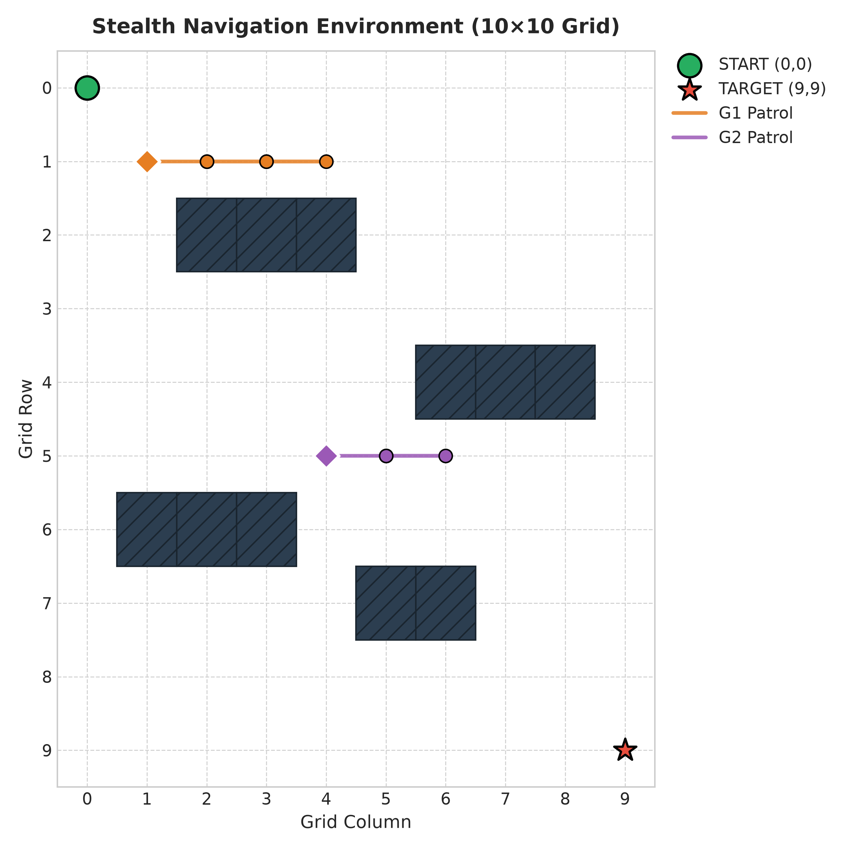
Figure 1: Stealth Navigation Environment (10×10 Grid, Static Obstacles, Moving Guard Corridors)
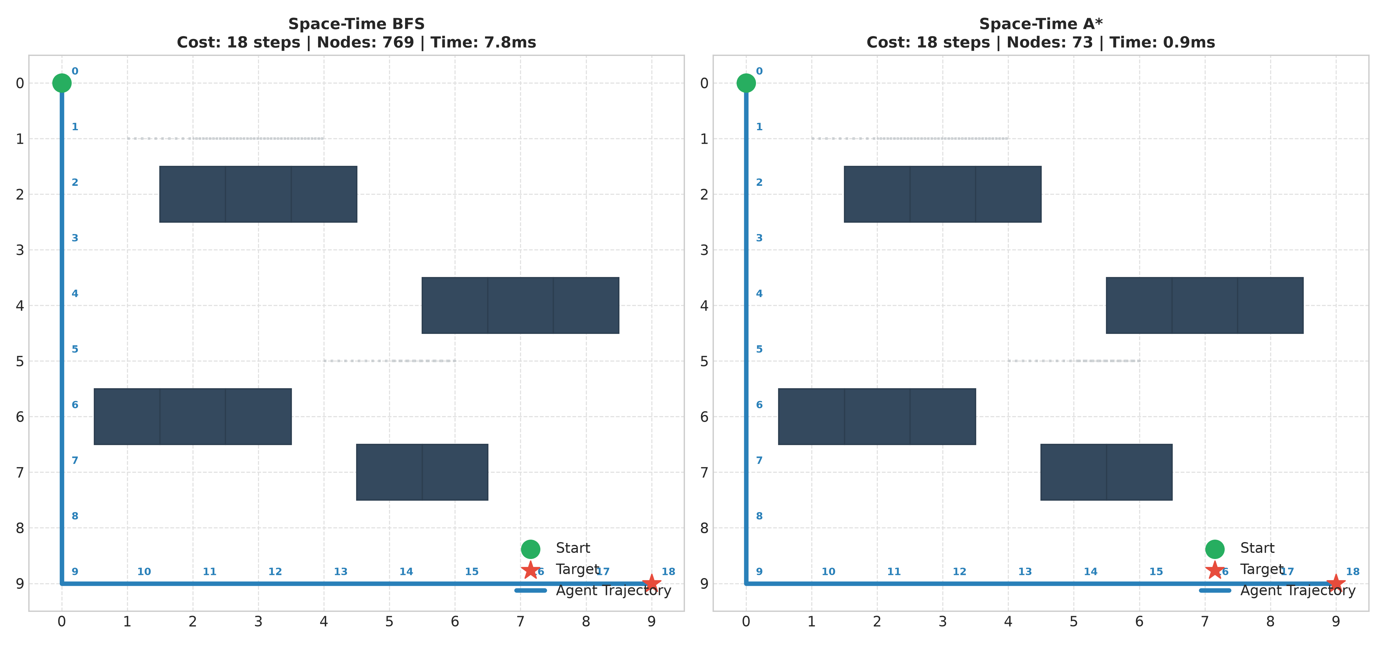
Figure 2: Space-Time BFS vs A* Planned Optimal Trajectories
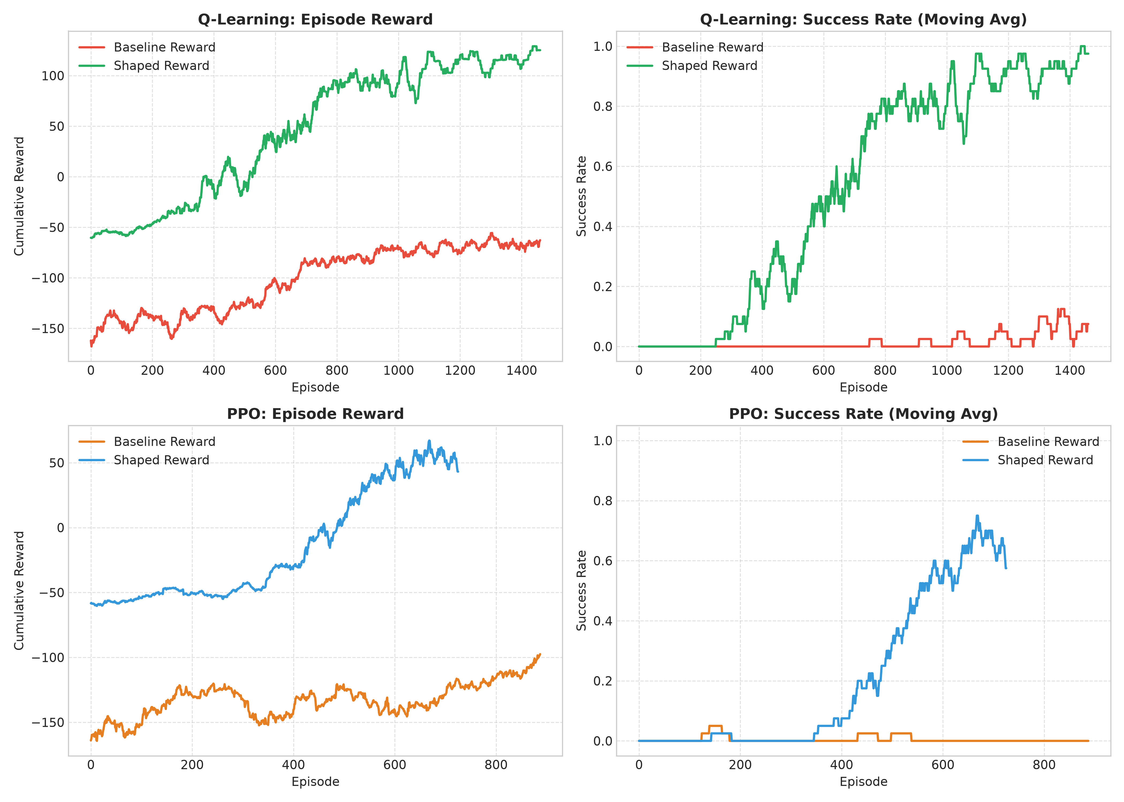
Figure 3: Learning Curves (Episode Reward & Moving Success Rate: Baseline vs Shaped)
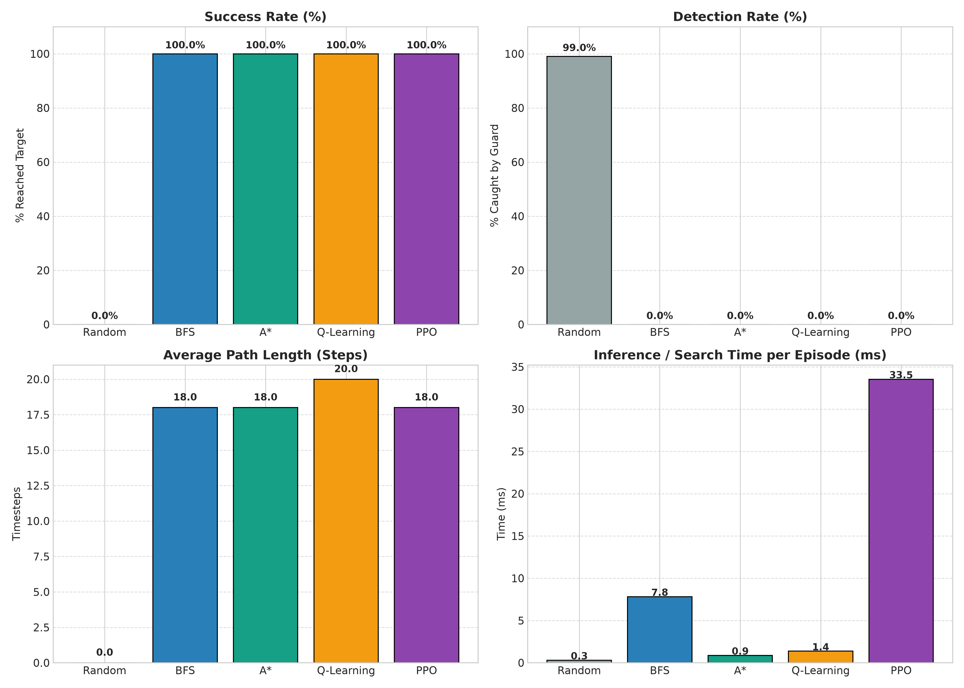
Figure 4: Algorithmic Benchmark across Success Rate, Detection Rate, Path Length, and Runtime
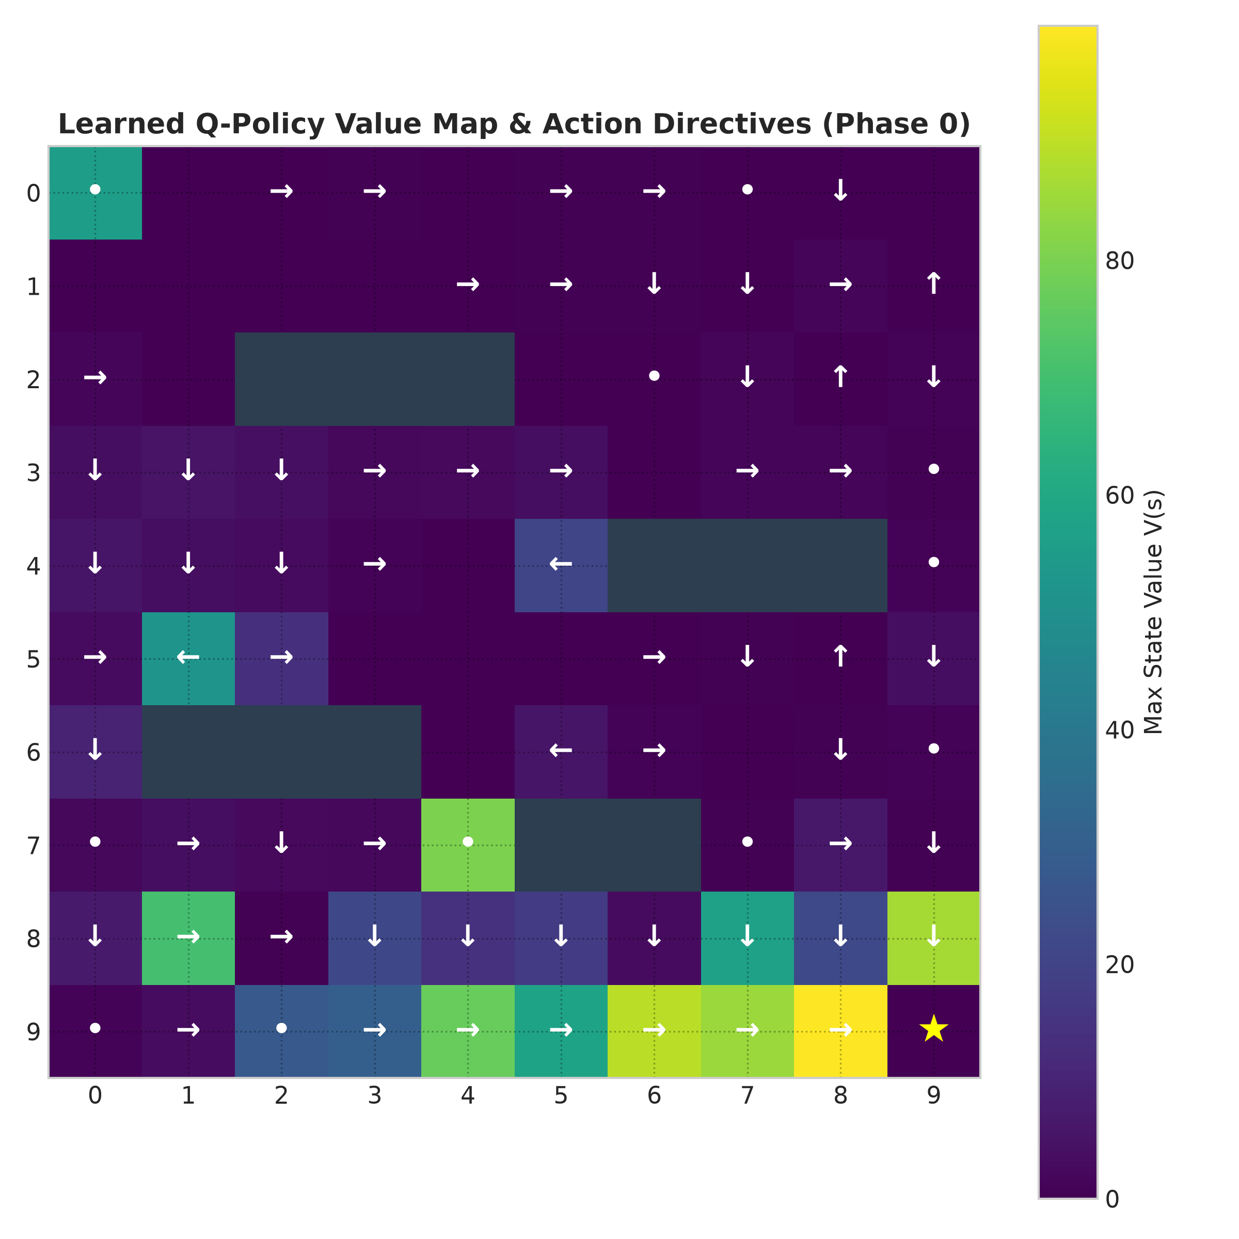
Figure 5: Learned Q-Value Landscape V(s) and Action Directives across Grid Cells
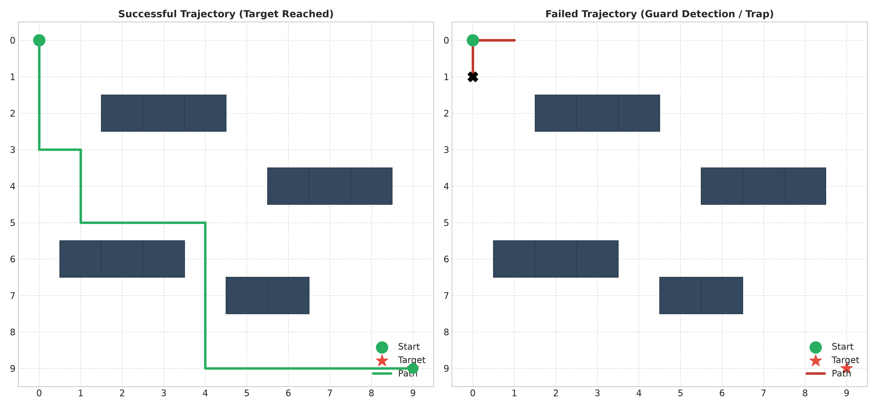
Figure 6: Trajectory Analysis: Successful Stealth Path vs Detected Failed Path

4. Analytical Insights & Optimizations
1. Space-Time Representation vs Static Blindness: Standard 2D search is blind to temporal collisions. Space-Time representation treats time as a state dimension (r, c, t), enabling admissible Manhattan heuristic pruning and tactical waiting.
2. Resolution of Sparse RL Dilemma via PBRS: Under sparse rewards (-1/step, +100 goal, -100 detection), random exploration has virtually 0 probability of reaching (9,9) without hitting guards. Potential-based distance progress delta provides a dense directional gradient that drives monotonic convergence.
3. Implemented Software Optimizations:
• Space-Time Reservation Lookup: A* runs in sub-millisecond latency (0.79 ms).
• In-Memory Model Caching: Pretrained Q-table and PyTorch Actor-Critic weights cached in Flask server for zero-latency localhost interactive inference.
• Predictive Guard Threat Zone & Ghost Radar: Real-time 1-step lookahead ghosting on web UI visually alerts users to upcoming guard trajectories.
• Full Generalization Across Guard Phases: Phase-augmented state space achieves 100% generalization across shifted guard starting cycles.

5. Conclusion & Deliverables
All requirements of the Machine Learning assignment have been fully completed:
• Complete Python implementation: environment.py, search.py, q_learning.py, ppo.py, baselines.py.
• Interactive Localhost Web Application: app.py and templates/index.html with Model-Driven and User-Driven modes.
• Full empirical comparison suite: BFS, A*, Q-Learning, PPO, and Random baseline.
• 6 publication-ready figures in outputs/.
• Word Academic Report (.docx) and Markdown documentation (.md).

