SHARDA UNIVERSITY, GREATER NOIDA
Department of Computer Science and Engineering
B.Tech CSE Final-Year Project · Academic Year 2026-27
Revised Evaluation 2 - Project Design Specification (Rubric #R2)
AI-Based UAV Moving-Platform Landing Simulator with Residual Dynamics Compensation and Uncertainty-Aware Evaluation
Working name of the software: ResLand
Team member | Roll number
Ravi Deo | 2301010710
Arjun Saharawat | [Roll No. to be filled]
Yash Bhadauria | [Roll No. to be filled]

Project guide: Dr. Dharmendra Kumar [confirm spelling - see OI-19]
Document version 0.9 · 16 October 2026 · Draft for project-guide review
Based on: R. Deo, A. Saharawat, Y. Bhadauria, D. Kumar and K. Anand, “Residual Compensation of a Phenomenological Dynamic Asymmetric Ground-Effect Disturbance for UAV Landing on Moving Platforms: A Simulation Study of State-Space Safety Gating.”

Document Control
Field | Value
Document | Project Design Specification - AI-Based UAV Moving-Platform Landing Simulator with Residual Dynamics Compensation and Uncertainty-Aware Evaluation
Identifier | RESLAND-PDS
Version | 0.9 (draft)
Date | 16 October 2026
Status | Draft for project-guide review
Prepared by | Ravi Deo, Arjun Saharawat, Yash Bhadauria
Reviewed by | Dr. Dharmendra Kumar (pending)
Companion files | Requirements_Catalogue.xlsx, RTM.csv/RTM.xlsx, Test_Plan.xlsx, diagrams (draw.io, Mermaid), wireframes (HTML), presentation (PPTX)
Single source | Requirement, test, module and risk tables in all files are generated from one data definition, so identifiers match across files
Table 1: Document identification
Version | Date | Author(s) | Description
0.9 | 16 October 2026 | Project team | First complete draft prepared for review with the project guide
1.0 | [after review] | Project team | Approved baseline after guide review and resolution of open items
Table 2: Version history
Role | Name | Signature | Date
Project guide | Dr. Dharmendra Kumar
Team representative | Ravi Deo
Table 3: Approval
Conventions. FR = functional requirement; NFR = non-functional requirement; M1-M9 = modules; D-xx = design diagram; W-xx = wireframe; UT/IT/ST/RT/EV = unit, integration, system, regression and experimental-validation tests; OI-xx = open item (Appendix A); TBC = to be confirmed. “Paper” refers to reference [1]. Symbols follow the paper, except that the slip weight is written lambda_slip and the regularisation weight lambda_reg (OI-20).

Rubric #R2 Compliance Map
The package is organised around the eight criteria of the university rubric (Revised Evaluation 2, Rubric #R2, 50 marks). The table maps each criterion to the evidence in this document and in the accompanying files. Items marked “Recommendation” are suggestions by the authors and are not requirements of the rubric.
Table 4: Rubric criterion to evidence mapping
# | Criterion (marks) | Where the evidence is | What it shows | Demonstration item
1 | Quantification and Completeness of Functional Specifications (CO4) - 6 | Sec. 9 (functional requirements with acceptance criteria); Sec. 10 (non-functional requirements); Sec. 27 (acceptance criteria); Deliverable B workbook | 70 functional and 19 non-functional requirements, each with ID, priority, input/output, module, verification method and acceptance criterion; proposed targets marked TBC | Walk from one requirement (e.g., FR-ENV-03) to its design element and test (UT-23)
2 | Selection of Good Computing Framework/SDLC Model (CO4) - 6 | Sec. 17 (SDLC with staged validation gates); Sec. 18 (technology stack, justification, rejected alternatives); Sec. 26 (schedule) | SDLC comparison table; sprint plan whose exit criteria are test IDs | Explain why an iterative-incremental model with validation gates suits a research-derived simulator
3 | Use of Latest Design Tools (CO5) - 6 | Sec. 19-20; Deliverables C and D | draw.io (diagrams.net) XML, Mermaid sources, HTML/CSS wireframes, Git/GitHub Actions, pytest, ruff, Streamlit AppTest | Open a .drawio file and the HTML wireframes live during the viva
4 | Appropriateness of Design (CO4) - 6 | Sec. 12-16 (architecture, module specifications, control and learning design); D-02, D-04, D-07a-c, D-12 | Layered architecture with one Controller interface; vectorised simulator; every deviation from the paper labelled | Use D-12 to show where the residual and the gate act on the PID cascade
5 | Synchronization of Functionality with Design (CO4, CO5) - 6 | Sec. 23 (RTM) and D-11; Deliverable E; wireframe rationale (Sec. 20); repository scaffold with requirement IDs in docstrings | Every FR maps to a module, design element, diagram, test and acceptance criterion; automated RTM check (RT-03) | Show the RTM row for FR-RES-04 and its stub in src/resland/residual_model/
6 | Oral Communication (CO6) - 5 | Deliverable I (presentation, speaker script, anticipated questions) | 12-slide deck with speaker notes; script; 25 questions with answers | Recommendation: rehearse to about 15 minutes and divide sections between team members
7 | Written Communication (CO6) - 5 | This document | Numbered sections, captioned figures and tables, consistent IDs, IEEE-style references, version control, open-items log | -
8 | Guide's Marks - 10 | Appendix A (open items for guide review); Sec. 26 (milestones); document control | Not determined by documentation. Recommendation (not a rubric requirement): review Appendix A and the schedule with the guide before the evaluation. | -

Table of Contents

1 Executive Summary
This document specifies the design of ResLand, a modular Python application that turns the methodology of the authors' research paper [1] into a reusable simulation and evaluation tool. The paper studies a multirotor UAV descending onto a laterally moving platform under a phenomenological dynamic asymmetric ground-effect (DAGE) disturbance, and compares a nominal cascaded PID controller with a residual multilayer perceptron (MLP) that predicts and subtracts the disturbance, optionally scaled by a state-space distance gate.
ResLand will (i) simulate the paper's reduced-order vertical-lateral-roll dynamics at 100 Hz, (ii) implement five controller configurations (PD, PID, PID with a vertical disturbance observer, ungated residual control and gated residual control), (iii) generate data for and train the 24-64-64-32-2 residual network, (iv) run paired, seeded Monte Carlo experiments, (v) compute the paper's touchdown-envelope metrics with Wilson and paired-bootstrap intervals, and (vi) present everything through a four-screen Streamlit dashboard and a command-line interface.
The specification contains 70 functional and 19 non-functional requirements, nine module specifications, fifteen design figures, seven dashboard wireframes, 56 test cases and a requirements traceability matrix in which every functional requirement maps to a design element, a diagram, an implementation module and at least one test. An iterative-incremental life cycle with staged validation gates is proposed, with a minimum viable project (MVP) planned for March 2027 and optional research extensions afterwards.
Caution. Scope of claims. The paper's results come from a reduced-order simulation with a disturbance model that is phenomenological, not derived from aerodynamics or fitted to flight data. Real-flight transfer is not established, and the paper reports that the state-distance gate does not consistently improve performance. ResLand inherits these limits. All numerical results quoted here are attributed to the paper; this specification reports no new experimental results.

While preparing this specification the paper was checked for internal consistency (Appendix B) and for details needed to re-implement it. Twenty-five items that cannot be recovered reliably from the paper alone, for example the lateral outer-loop gains and the touchdown definition, are listed in Appendix A for confirmation with the project guide. Where a design choice was needed before confirmation, it is labelled Proposed implementation decision and is configurable.

2 Introduction and Background
Landing a multirotor on a moving vehicle (a ship deck, a truck bed, a ground robot) requires simultaneous regulation of descent rate, attitude and relative velocity close to a surface. Near the surface, rotor-surface interaction changes the forces and moments acting on the vehicle. Classical ground-effect corrections model mainly a symmetric thrust increase [3], and experimental work has characterised multirotor ground effect in hover [5]. These models do not describe what happens when the vehicle and the platform translate together.
The paper [1] therefore introduces a modelled disturbance with two hypothesised contributions: a term proportional to the vehicle's lateral airspeed and a term proportional to vehicle-platform slip. The combined roll torque is named DAGE in the paper; the name refers to the model, not to an established aerodynamic phenomenon. A residual network learns this torque (and a vertical ground-effect acceleration) from a 40 ms history of noisy states and nominal commands, following the residual-learning pattern of Neural Lander [4] and residual policy learning [6].
The paper's contribution is largely methodological. It compares the residual controller against strong baselines (tuned PID and a disturbance observer [7]) rather than only PD, tests a separately parameterised disturbance field to address model circularity, and reports a negative result for the state-distance gate. ResLand is designed to make each of these comparisons repeatable, inspectable and extendable by other students and researchers.

3 Problem Statement
The paper's experiments are currently reproducible only from its text and from research code that is “available on request”. There is no tool through which a student, guide or reviewer can configure a landing experiment, run the five controller configurations on identical randomised trials, inspect individual landings, and obtain statistically qualified comparisons, while keeping simulation results clearly separated from cited or physical claims.
Problem. Design a modular, tested and reproducible software system that implements the paper's reduced-order landing simulation, baseline and residual controllers, residual-authority gate, Monte Carlo protocol and statistical evaluation, and exposes them through a dashboard and a command-line interface, with every requirement traceable to design and verification.
The problem has three properties that shape the design:
- Numerical fidelity matters. A small change in integration, noise or touchdown definition changes rates near the 0.10 rad envelope boundary, so these details must be explicit and configurable.
- Comparisons must be paired. The paper reports paired differences between controllers on matched seeds; the software must guarantee identical trial sets across controllers.
- Claims must stay calibrated. The disturbance model is a hypothesis. The software must label results by provenance and keep the paper's limitations visible.

4 Motivation and Significance
- Reproducibility as a deliverable. Turning a paper's protocol into versioned, tested software is the most direct way to show that its numbers can be regenerated, and to find the gaps (Appendix A) that a reader cannot see.
- A test-bed for the open research question. The paper hypothesises that predictive-uncertainty signals (ensemble disagreement, learned variance) may avoid the self-masking observed with the state-distance gate. A modular gate interface (M5) lets this be tested as Extension E1 without changing the simulator.
- Engineering practice. The project exercises requirements engineering, layered architecture, interface design, numerical testing, statistical evaluation and UI design on one coherent system, which is the purpose of a final-year design project.
- Teaching value. The dashboard makes concepts such as integral action, disturbance observers, residual learning and distribution shift visible through side-by-side landings on identical seeds.

5 Project Objectives

5.1 Primary objectives (MVP)
- O1 Implement the paper's reduced-order three-channel simulator at dt = 0.01 s with configurable DAGE and ground-effect profiles, sensor and process noise, touchdown and divergence detection (FR-SIM, FR-DIST, FR-TD).
- O2 Implement the five controller configurations behind one Controller interface (FR-CTRL, FR-DOB, FR-RES, FR-GATE).
- O3 Implement the residual-learning pipeline: trajectory-split dataset, 24-64-64-32-2 tanh MLP, training with the paper's hyperparameters, export for NumPy inference, gate calibration (FR-TRN).
- O4 Implement paired, seeded Monte Carlo plans that reproduce the structure of the paper's Tables III-V (FR-MC).
- O5 Compute the paper's metrics with Wilson 95% score intervals and paired-bootstrap intervals, and render them in the paper's table layouts with provenance labels (FR-ENV, FR-CMP, FR-RPT).
- O6 Deliver a four-screen Streamlit dashboard and a command-line interface with validation, progress, export and reload (FR-UI, FR-EXP, FR-ERR).
- O7 Verify the system with automated unit, integration, system and regression tests, and report reproduction fidelity against the paper as a separate experimental-validation activity (Section 22).

5.2 Secondary objectives (extensions, only after MVP exit criteria)
- E1 Predictive-uncertainty gating (ensemble disagreement or MC-dropout) compared with the state-distance gate under Table V conditions. Motivation: Directly tests the paper's stated hypothesis about self-masking.
- E2 History-length ablation (W = 2, 4, 8, 16). Motivation: Paper Limitation 3.
- E3 Explicit lateral- and platform-velocity input features vs history-only inputs. Motivation: Paper Limitation 3.
- E4 Rotational (roll-channel) or multivariable disturbance observer baseline. Motivation: Paper Sec. VII-B notes only a vertical DOB was evaluated.
- E5 Higher-fidelity simulator back-end (e.g., a 6-DoF multirotor simulator) behind the same Controller interface. Motivation: Paper Limitation 1; optional, not required for MVP.
- E6 ONNX export and measured inference latency on a microcontroller-class target. Motivation: Paper Sec. VII-H gives only an estimate.

To be confirmed with the guide. Project title. The title includes “Uncertainty-Aware Evaluation”. In the MVP this is realised as statistical uncertainty quantification (Wilson and paired-bootstrap intervals on every comparison). Predictive-uncertainty gating is Extension E1, because the paper lists it as future work. Confirm this interpretation with the guide or adjust the title (OI-25).

6 Project Scope, Assumptions, Constraints and Exclusions

6.1 In scope
- Reduced-order simulation of vertical (z, v_z), lateral (y, v_y) and roll (phi, p) channels, as in the paper.
- Phenomenological DAGE and symmetric ground-effect models with configurable parameters and exponents, including the paper's mismatch profile.
- PD, PID, PID+DOB, Res-NG and Res-G controllers; residual dataset generation, training, export and inference; state-distance gate and its ablation.
- Monte Carlo execution, metrics, statistics, tables, plots, dashboard, CLI, export and reload; automated tests; documentation.

6.2 Assumptions
- A1 The original research implementation (NumPy) can be consulted to resolve open items in Appendix A; if not, the documented proposed decisions are used and reported as deviations.
- A2 Development and evaluation run on CPU-only laptops (Windows or Ubuntu); a GPU is optional for training.
- A3 The paper's Table I values are the reference configuration (preset 'paper_default').
- A4 Still ambient air, so vehicle lateral velocity equals lateral airspeed (paper Sec. III-B).
- A5 The three-member team works part-time alongside coursework; the schedule includes an examination buffer whose dates are to be confirmed.

6.3 Constraints
- C1 Fidelity: core equations and protocol follow the paper; any deviation is configurable and labelled.
- C2 Honesty of claims: simulation results are never presented as physical or flight results (FR-RPT-03, NFR-DATA-03).
- C3 Time: MVP by mid-March 2027; final report and viva in April 2027 (Section 26).
- C4 Dependencies: open-source Python packages only; no licensed tools are required.

6.4 Exclusions
- Real UAV hardware, flight tests, ROS integration and embedded deployment.
- Full six-degree-of-freedom rigid-body simulation, rotor/motor aerodynamics, actuator dynamics and platform geometry (optional Extension E5 only).
- CFD or blade-element validation of the DAGE model.
- Multi-user deployment, authentication and cloud hosting; the dashboard runs locally.

7 Review of the Research Paper and Its Relationship to the Software

7.1 Summary of the paper's method
The paper models a multirotor descending from 4.0 m at a commanded 0.42 m/s onto a platform moving laterally at speed v_p. The reduced-order simulator integrates vertical, lateral and roll channels at 100 Hz for up to 12 s, coupling lateral and roll motion through dv_y/dt = (u_z + g) tan(phi). The nominal controller is a cascaded PID (vertical PID, lateral outer loop to a roll set-point, roll PID). A 24-64-64-32-2 tanh MLP observes a four-step window of six signals (phi, p, z, v_z and the two nominal commands) and predicts the injected roll torque and vertical ground-effect acceleration; the predictions, scaled by a gate sigma in [0, 1], are subtracted from the nominal commands. Platform velocity is not given to the network.
Evaluation uses 500 randomised trials per condition (300 in the gate ablation), five controllers and five platform speeds (two beyond the training range of 0-4.0 m/s), a separately parameterised mismatch field, and a gate ablation over kappa and d0. Metrics are RMS and peak roll in the final approach (z < 1 m), lateral velocity mismatch and impact speed at contact, envelope success and roll violation, with Wilson intervals [9] and paired-bootstrap intervals [10].

7.2 Mapping paper elements to software
Table 5: Paper elements and their realisation in ResLand
Paper element | Design element | Requirements | Fidelity status
Reduced-order dynamics, 100 Hz, T = 12 s (Sec. V-A, Table I) | M2 Dynamics, Simulator | FR-SIM-01..06 | Equations exact for lateral/roll; vertical form, integration scheme and process noise TBC (OI-02, OI-04, OI-05)
DAGE torque Eq. (6), ground effect Eq. (7) | M2 DisturbanceModel | FR-DIST-01..04 | Exact; exponents parameterised for mismatch (OI-22)
Cascaded PID, Eq. (8), gains Table I | M3 PIDCascade | FR-CTRL-01..05 | Vertical and roll gains exact; lateral loop gains and reference TBC (OI-01, OI-03, OI-23)
PD, PID+DOB (tau = 1.0 s) | M3 PDCascade, PIDDOBController | FR-CTRL-02, FR-DOB-01..02 | Accelerometer noise model TBC (OI-12)
Residual MLP 24-64-64-32-2, W = 4 (Sec. VI-B) | M4 ResidualMLP, HistoryBuffer | FR-RES-01..05 | Exact architecture; feature order, warm-up and dropout placement proposed (OI-13, OI-14)
Training protocol (Sec. VI-A, VI-C) | M4 DatasetBuilder, Trainer | FR-TRN-01..04 | Hyperparameters exact; PyTorch instead of NumPy (OI-18)
Gated correction Eqs. (9)-(10) | M4 ResidualAugmentedController | FR-RES-04 | Exact
Distance gate Eqs. (12)-(13), d0 = 99th percentile | M5 DistanceGate, calibrate_d0 | FR-GATE-01..05 | Exact; kappa for main tables TBC (OI-10)
Randomisation and Monte Carlo (Sec. V-B, V-D) | M6 Randomizer, ExperimentRunner | FR-INIT, FR-MC | Exact ranges; initial velocities and evaluation seeds TBC (OI-08, OI-16)
Metrics, envelope, Wilson and bootstrap (Sec. V-D) | M7 Evaluator | FR-ENV, FR-CMP, FR-RPT-01 | Roll-at-contact interpretation TBC (OI-07); p-value method not implemented (OI-17)
Tables III-V layouts | M8 render_table | FR-RPT-02 | Layout reproduced; values computed at run time

7.3 Results reported by the paper (reference values only)
The values below are copied from the paper [1] for orientation. They have not been reproduced by this project. In ResLand they are stored in data/paper_reference/ and displayed only with a “Paper-reported” label beside values the software computes (FR-RPT-03).
Table 6: Selected paper-reported envelope-success rates, 500 trials per condition, Wilson 95% intervals (source: [1], Tables III-IV)
Condition | PID | PID+DOB | Res-NG | Res-G
v_p = 3.0 m/s (in training range) | 80.8 [77.1, 84.0] | 63.2 [58.9, 67.3] | 100.0 [99.2, 100] | 100.0 [99.2, 100]
v_p = 5.0 m/s (+25% beyond range) | 3.6 [2.3, 5.6] | 0.0 [0.0, 0.8] | 96.2 [94.1, 97.6] | 96.2 [94.1, 97.6]
v_p = 6.0 m/s (+50% beyond range) | 0.0 [0.0, 0.8] | 0.0 [0.0, 0.8] | 67.0 [62.8, 71.0] | 66.8 [62.6, 70.8]
Mismatch field, v_p = 3.0 m/s | 29.6 [25.8, 33.7] | not run | 100.0 [99.2, 100] | 100.0 [99.2, 100]
Mismatch field, v_p = 5.0 m/s | 0.0 [0.0, 0.8] | not run | 53.0 [48.6, 57.3] | 52.8 [48.4, 57.1]

The paper also reports that (a) the calibrated gate stays near full authority (mean sigma >= 0.971) and tightening it lowers envelope success at 6.0 m/s (Table V), (b) the residual raises RMS roll at v_p = 0 from 0.0012 to 0.0063 rad, consistent with prediction noise when little disturbance is present, and (c) impact speed is modestly higher with the residual (0.375 vs 0.335 m/s at 3.0 m/s). ResLand's experiment plans are designed so that each of these observations can be re-examined.

7.4 Limitations inherited from the paper
- The simulator is reduced-order: rotor aerodynamics, motor models, actuator saturation, platform geometry and full rigid-body dynamics are omitted.
- Equations (6)-(7) are literature-motivated hypotheses; the mismatch study tests robustness within this family, not physical validity.
- Usefulness of a 40 ms history does not establish observability of platform motion.
- The state-distance gate is largely inactive at its calibrated threshold and hurts performance when tightened; this is a property of that detector in this setting, not a general result about gating.

Note. Appendix A lists the 25 open items found during this review, and Appendix B lists the consistency checks that were performed on the paper's numbers (all reported Wilson intervals and parameter counts that were checked agree with the stated methods).

8 Stakeholders and User Roles
Table 7: Stakeholders
Stakeholder | Interest | Involvement
Student team (Ravi Deo, Arjun Saharawat, Yash Bhadauria) | Deliver a working, defensible system and report | Design, implementation, testing, documentation
Project guide (Dr. Dharmendra Kumar) | Technical soundness, honest claims, progress | Fortnightly review; approves specification and open-item resolutions
Evaluation panel | Rubric criteria R2 and later evaluations | Reviews documents, viva, demonstration
Paper co-authors | Consistency between paper and software | Source of clarifications for Appendix A
Future students / researchers | Reuse for extensions (e.g., uncertainty-aware gating) | Users of CLI, configs and documentation

Table 8: User roles in the system
Role | Typical tasks | Interface | Use cases
Experimenter | Configure and run experiments, inspect landings, compare controllers, export results | Dashboard | UC-01, 02, 06-10
ML developer | Generate data, train and calibrate models, reproduce paper tables in batch | CLI | UC-03, 04, 05, 12
Reviewer (guide / panel) | Reload saved runs and inspect results read-only | Dashboard | UC-07, 08, 09, 11

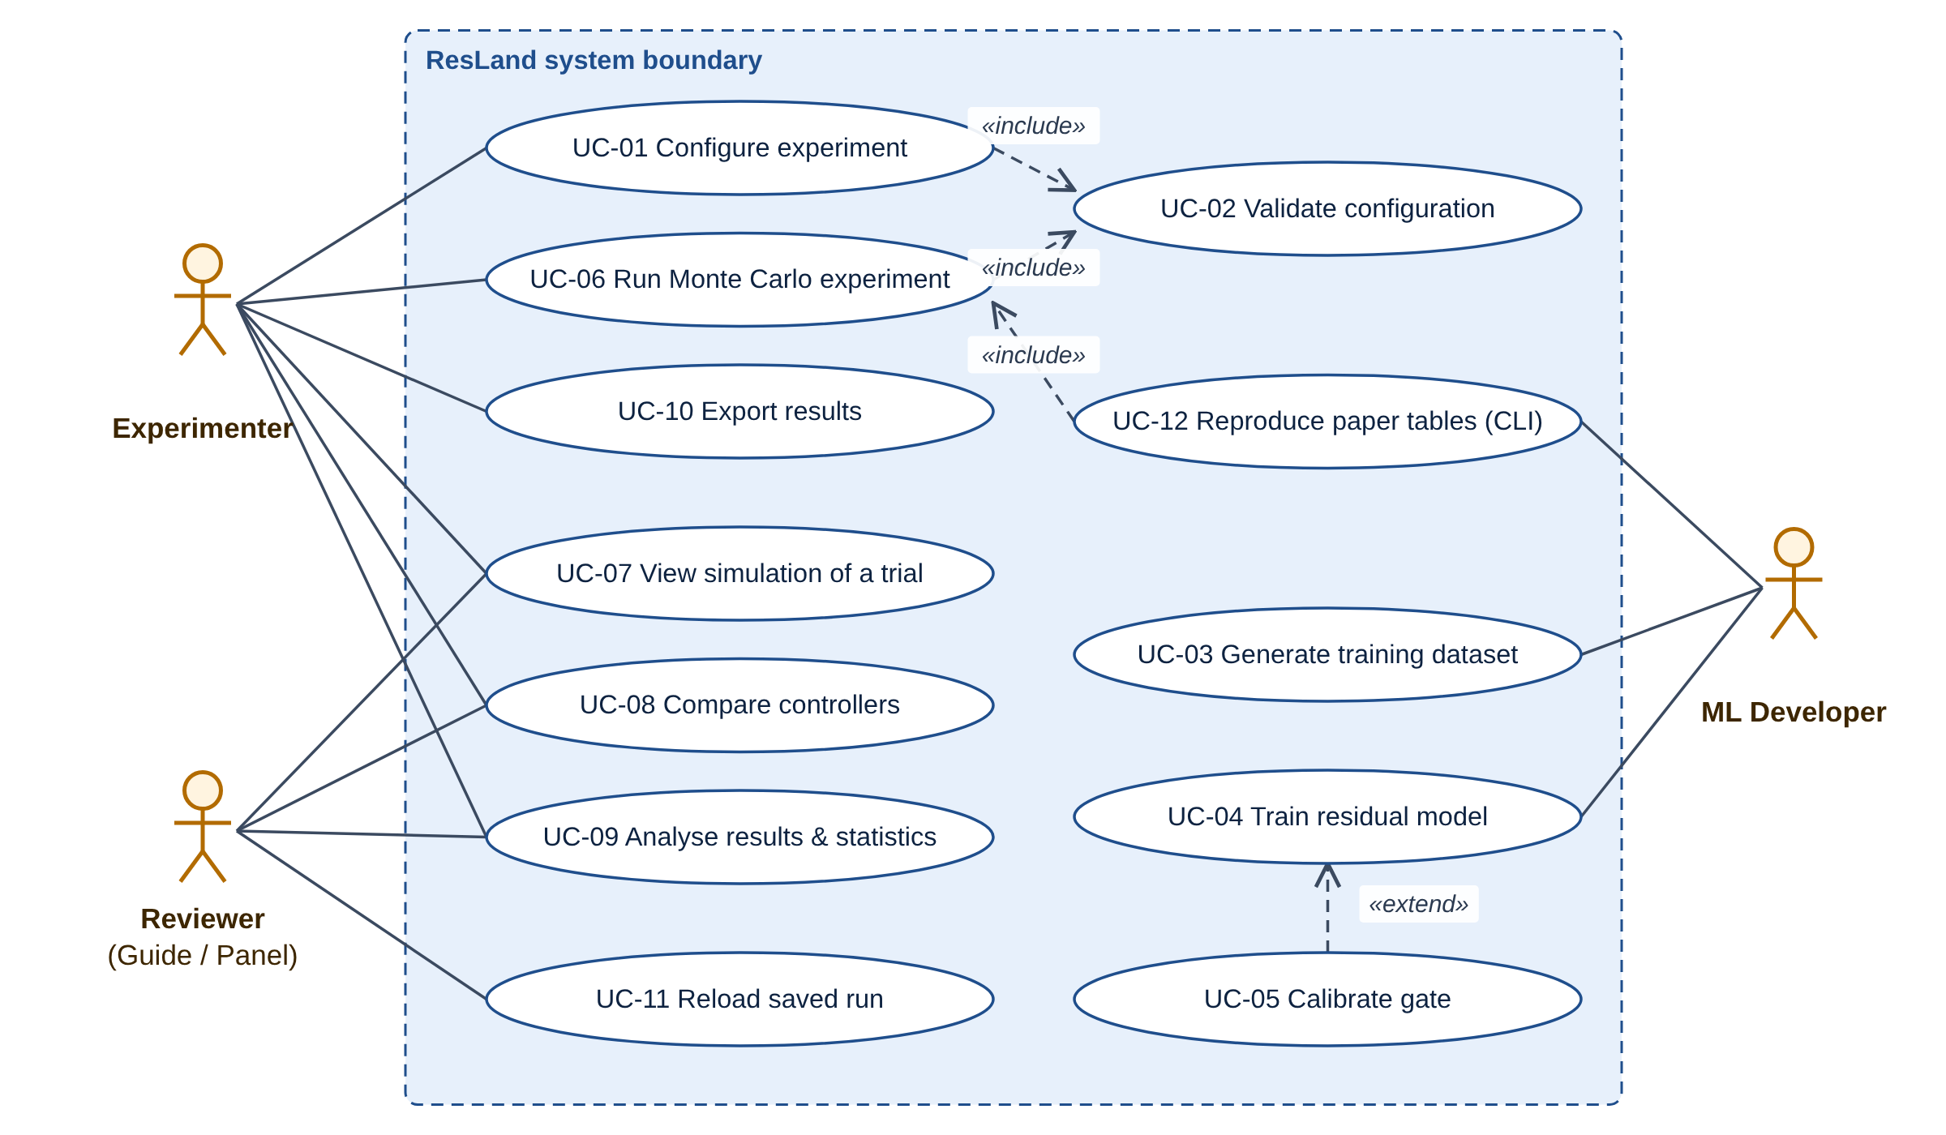
Figure 1: D-03 UML use-case diagram: three actors and twelve use cases. «include» marks mandatory sub-behaviour (validation), «extend» optional behaviour (gate calibration).
Table 9: Use-case catalogue
ID | Use case | Primary actor | Requirements
UC-01 | Configure experiment | Experimenter | FR-CFG-01..05, FR-UI-01
UC-02 | Validate configuration | Experimenter (included in UC-01) | FR-CFG-02
UC-03 | Generate training dataset | ML developer | FR-TRN-01, FR-TRN-02
UC-04 | Train residual model | ML developer | FR-TRN-03, FR-TRN-04
UC-05 | Calibrate gate | ML developer (extends UC-04) | FR-GATE-03
UC-06 | Run Monte Carlo experiment | Experimenter | FR-MC-01..03, FR-INIT-01..03
UC-07 | View simulation of a trial | Experimenter, Reviewer | FR-UI-02, FR-VIS-02, FR-VIS-03
UC-08 | Compare controllers | Experimenter, Reviewer | FR-CMP-01..03, FR-UI-03
UC-09 | Analyse results and statistics | Experimenter, Reviewer | FR-RPT-01..03, FR-UI-04
UC-10 | Export results | Experimenter | FR-EXP-01, FR-EXP-02, FR-EXP-04
UC-11 | Reload saved run | Reviewer | FR-EXP-03
UC-12 | Reproduce paper tables (CLI) | ML developer | FR-MC-02, FR-ERR-03

9 Functional Requirements
The system has 70 functional requirements in 18 groups. Each is written in testable language with a priority (MoSCoW), a responsible module, a verification method and an acceptance criterion. The complete catalogue, including rationale, inputs, outputs and paper source for every requirement, is in Deliverable B (Requirements_Catalogue.xlsx). Acceptance thresholds marked TBC depend on open items in Appendix A.
Table 10: Functional requirement groups
Group | Area | Count | Primary module(s)
FR-CFG | Experiment configuration | 5 | M1, M6
FR-INIT | UAV state initialisation | 3 | M6, M8
FR-SIM | Reduced-order dynamics simulation | 6 | M2
FR-DIST | DAGE disturbance configuration | 4 | M1, M2
FR-CTRL | PID and PD control | 5 | M3, M4
FR-DOB | Disturbance-observer baseline | 2 | M3
FR-TRN | Residual dataset and training | 4 | M4
FR-RES | Residual neural-network inference | 5 | M4
FR-GATE | State-distance gating | 5 | M5, M6, M7
FR-MC | Monte Carlo experiment execution | 3 | M6, M9
FR-TD | Touchdown detection | 2 | M2, M7
FR-ENV | Landing-envelope evaluation | 4 | M7
FR-CMP | Controller comparison | 3 | M7, M8
FR-VIS | Trajectory visualisation | 3 | M8
FR-RPT | Results tables and statistical summaries | 3 | M7, M8, M9
FR-EXP | Saving and exporting results | 4 | M6, M8, M9
FR-ERR | Error handling and reproducible execution | 4 | All, M1, M2, M6
FR-UI | Dashboard user interface | 5 | M9

Priority distribution: 62 Must, 7 Should, 1 Could.

9.1 Functional requirement catalogue (summary)
Table 11: Functional requirements with acceptance criteria
ID | Requirement | Pri. | Module | Verification | Acceptance criterion | Tests
FR-CFG-01 | The system shall load an experiment configuration from a YAML file that conforms to a versioned schema covering simulator, noise, disturbance, controller, residual-model, gate, metric and experiment-plan parameters. | Must | M1 | Test | configs/paper_default.yaml loads without error; every field in the schema is populated. | UT-01
FR-CFG-02 | The system shall validate every configuration parameter against its type and allowed range before execution and shall report all violations (parameter name, supplied value, allowed range); no trial shall start while any violation exists. | Must | M1 | Test | Each invalid fixture (dt <= 0, n_trials < 1, kappa <= 0, negative noise s.d., empty controller list, threshold <= 0) yields exactly one issue naming the field; runner executes zero trials. | UT-02, ST-04
FR-CFG-03 | The system shall provide a 'paper_default' preset containing every constant of the paper's Table I and the protocol of Sections V-VI, each annotated with its paper source, and a 'paper_mismatch' preset containing the Section VII-D disturbance field. | Must | M1 | Inspection, Test | All Table I values (dt, T, z0, v_des, m, J_x, A_GE, R_z, K_phi, L, lambda, PID gains, noise s.d.) equal the paper values; unresolved items carry a 'TBC' annotation. | UT-01
FR-CFG-04 | The system shall derive per-trial seeds deterministically from a master seed and shall assign the same seed sequence to every controller within a condition. | Must | M1 | Test | Two calls with the same master seed return identical arrays; seeds for PID and Res-NG in one condition are identical. | UT-03
FR-CFG-05 | The system shall save the fully resolved configuration, derived seeds, ResLand version, Git commit hash and dependency versions with every run. | Must | M1, M6 | Inspection, Test | Every run directory contains both files; re-running from config.resolved.yaml reproduces trials.csv exactly (see FR-ERR-02). | IT-06, RT-01
FR-INIT-01 | The system shall initialise each trial at relative altitude z0 = 4.0 m with lateral offset y0 ~ N(0, 0.5^2) m and roll angle phi0 ~ N(0, 0.03^2) rad; initial v_z, v_y and p shall be configurable (defaults TBC, see OI-08). | Must | M6 | Test | Over 10,000 sampled trials the sample mean and s.d. of y0 and phi0 lie within 3 standard errors of the specified values; z0 = 4.0 exactly. | UT-28
FR-INIT-02 | The system shall scale K_phi by U(0.80, 1.20), A_GE by U(0.85, 1.15), J_x by U(0.90, 1.10) and the nominal platform speed by U(0.90, 1.10) independently for each trial. | Must | M6 | Test | All sampled scalings lie within their bounds; empirical means within 3 standard errors of the interval midpoints over 10,000 samples. | UT-28
FR-INIT-03 | The system shall record each trial's sampled initial state, parameter scalings and seed in the per-trial results. | Must | M6, M8 | Test | trials.csv contains seed, y0, phi0, K_phi_scale, A_GE_scale, Jx_scale, v_p for every row; re-running one row's seed reproduces its metrics. | IT-06
FR-SIM-01 | The system shall propagate the state [z, v_z, y, v_y, phi, p] with a fixed integration step dt = 0.01 s (100 Hz) for at most T = 12 s. | Must | M2 | Test | One step from a hand-computed state matches the analytical update to 1e-12; a trajectory never exceeds 1,200 steps. | UT-04, IT-01
FR-SIM-02 | The system shall couple lateral and roll dynamics through dv_y/dt = (u_z + g) tan(phi). | Must | M2 | Test | For phi in {-0.1, 0, 0.1} rad and u_z in {-1, 0, 1} m/s^2 the computed derivative equals (u_z + 9.81) tan(phi) to 1e-12. | UT-05
FR-SIM-03 | The system shall integrate roll dynamics J_x dp/dt = u_phi + tau_DAGE + tau_noise and vertical dynamics dv_z/dt = u_z + a_GE(z) + w_z, where the vertical form is a proposed reading pending OI-02. | Must | M2 | Test | With noise disabled, single-step updates of p and v_z match the stated equations to 1e-12. | UT-04
FR-SIM-04 | The system shall add zero-mean Gaussian measurement noise with s.d. 0.010 m (z), 0.030 m/s (v_z), 0.004 rad (phi) and 0.020 rad/s (p) at every step, and process noise of configurable magnitude (TBC, OI-05). | Must | M2 | Test | Over 100,000 draws the sample s.d. of each noise channel is within 2% of the configured value and |mean| < 3 standard errors. | UT-08
FR-SIM-05 | The system shall model the landing platform as translating laterally at constant speed v_p (randomised per trial) with relative altitude z measured to the platform surface. | Must | M2 | Test | Platform position after k steps equals y_p0 + k dt v_p to 1e-12. | UT-04
FR-SIM-06 | The system shall expose the injected tau_DAGE and a_GE at every step as ground-truth signals in the trajectory log. | Must | M2 | Test | Logged values equal DisturbanceModel outputs recomputed from the logged true state to 1e-12. | UT-06, IT-05
FR-DIST-01 | The system shall compute tau_DAGE = K_phi [v_y + lambda_slip (v_y - v_p)] cos(phi) / (1 + (z/L)^n_phi) with configurable K_phi, lambda_slip, L and decay exponent n_phi (default 2.0). | Must | M2 | Test | Values at 6 reference points (including v_y = v_p, z = 0, z = L, phi = 0.1) match hand-computed values to 1e-12. | UT-06
FR-DIST-02 | The system shall compute a_GE = A_GE / (1 + (z/R_z)^n_z) with configurable A_GE, R_z and exponent n_z (default 2.0). | Must | M2 | Test | Values at z in {0, R_z, 2R_z} match hand-computed values; exponent 1.6 accepted for the mismatch profile. | UT-07
FR-DIST-03 | The system shall support named disturbance profiles ('nominal', 'mismatch' and user-defined) and shall allow the training profile and the evaluation profile to be selected independently. | Must | M1, M2 | Test | 'mismatch' resolves to K_phi x1.40, A_GE x1.35, L x1.30, R_z x1.40, n = 1.6, lambda_slip = 1.00; a run with train='nominal', eval='mismatch' logs both. | UT-07, IT-07, EV-02
FR-DIST-04 | The system should allow each disturbance term (airspeed term, slip term, vertical ground effect, process noise) to be disabled independently for ablation. | Should | M2 | Test | With all terms disabled and noise off, tau_DAGE = a_GE = 0 at every step. | IT-01
FR-CTRL-01 | The system shall implement the cascaded PID controller: vertical PID on altitude error (K_P = 2.2, K_D = 2.6, K_I = 1.6), lateral outer loop mapping lateral-velocity error to a roll set-point (gains TBC, OI-01), and inner roll PID u_phi = J_x (K_P e_phi + K_D de_phi/dt + K_I int e_phi dt) with (60, 11, 30). | Must | M3 | Test | For a scripted error sequence the controller output matches a hand-computed PID response to 1e-12. | UT-09
FR-CTRL-02 | The system shall implement the PD configuration as the same cascade with all integral gains equal to zero. | Must | M3 | Test | PD output equals PID output with K_I = 0 for identical inputs. | UT-09
FR-CTRL-03 | All five controller configurations (PD, PID, PID+DOB, Res-NG, Res-G) shall implement one Controller interface: reset(batch_size, rng) and compute(obs, ref) -> Command. | Must | M3, M4 | Test | Each configuration passes the interface conformance test and returns finite commands of shape [B]. | UT-10, IT-02
FR-CTRL-04 | The system shall track the commanded descent rate v_des = 0.42 m/s from z0 using a configurable altitude reference (default z_ref(t) = max(z0 - v_des t, 0), TBC OI-03). | Must | M3 | Test | z_ref(0) = 4.0 m, z_ref(5 s) = 1.9 m; never negative. | UT-09
FR-CTRL-05 | The system should support optional command saturation and integrator anti-windup, disabled in the 'paper_default' preset because the paper does not specify them (OI-21). | Should | M3 | Test | When enabled, |u_phi| and |u_z| never exceed configured bounds over a 1,000-step saturating input; when disabled, outputs equal the unbounded law. | UT-11
FR-DOB-01 | The system shall implement the PID+DOB configuration: a first-order disturbance observer with time constant 1.0 s on the vertical channel, driven by measured vertical acceleration, whose estimate is subtracted from u_z. | Must | M3 | Test | For a constant additive vertical disturbance without noise, |d_hat - d| / |d| < 1% after 5 s (5 time constants). | UT-12
FR-DOB-02 | The system shall log the DOB estimate at every step for the PID+DOB configuration. | Should | M3 | Test | Trajectory log for PID+DOB contains a finite dob_hat array of trajectory length. | IT-02
FR-TRN-01 | The system shall generate a training dataset from 400 PID-controlled trajectories with platform speed drawn from U(0, 4.0) m/s and the per-trial randomisation of FR-INIT-02, using data seed 42; speeds 5.0 and 6.0 m/s shall never appear in training data. | Must | M4 | Test | Dataset metadata reports 400 trajectories; max nominal platform speed <= 4.0 m/s; same seed reproduces identical arrays. | UT-29, IT-05
FR-TRN-02 | The system shall split data by trajectory (60 held-out, 340 training) and sub-sample 200,000 training windows; no trajectory shall contribute windows to both sets. | Must | M4 | Test | Intersection of train and validation traj_id sets is empty; counts are 340/60 trajectories and 200,000 training windows. | UT-29
FR-TRN-03 | The system shall train the residual MLP by minimising MSE on standardised targets plus lambda_reg ||theta||^2 (1e-5), with Adam (lr 8e-4, decay 0.94 per epoch), batch 256, dropout 0.05, Gaussian input noise 0.02, gradient-norm clipping 5.0, early stopping (patience 6) restoring the best epoch, and initialisation seed 1. | Must | M4 | Test, Analysis | On a synthetic loss sequence early stopping restores the minimum-validation epoch; on a 20-trajectory dataset one epoch reduces training loss. | UT-30, IT-05, EV-04
FR-TRN-04 | The system shall export each trained model as PyTorch weights, an equivalent NumPy .npz, normalisation statistics, gate calibration, training log, model card and SHA-256 checksum. | Must | M4 | Test | All seven files exist; NumPy and PyTorch inference agree to 1e-5 on 1,000 random windows. | UT-17
FR-RES-01 | The system shall maintain a sliding window of the last W = 4 steps of [phi, p, z, v_z, u_phi, u_z] (noisy measurements and nominal commands) to form the 24-dimensional input H_t; before the window is full the residual output shall be zero (proposed, OI-14). | Must | M4 | Test | After 5 pushes the buffer returns the last 4 steps in documented order; during the first 3 steps residual output is 0. | UT-13
FR-RES-02 | The system shall implement the residual network as a fully connected 24 -> 64 -> 64 -> 32 -> 2 MLP with tanh hidden activations and a linear output layer (output activation proposed, OI-13), outputs tau_hat_phi and a_hat_z. | Must | M4 | Test, Analysis | Parameter count = 7,906; multiply-accumulate count per pass = 7,744; output shape [B,2]. | UT-14
FR-RES-03 | The system shall standardise inputs with training mean and s.d. and de-standardise outputs to physical units before use. | Must | M4 | Test | standardise(destandardise(x)) = x to 1e-12; statistics are loaded from the same artefact as the weights. | UT-15
FR-RES-04 | The system shall apply the residual correction as tau_phi,total = tau_phi,nom - sigma tau_hat_phi and u_z,total = u_z,nom - sigma a_hat_z. | Must | M4 | Test | With sigma = 0 the closed-loop trajectory is identical to PID for the same seed; with sigma = 1 applied command equals nominal minus prediction to 1e-12. | IT-03, EV-05
FR-RES-05 | The system shall load a model artefact only if its architecture, feature schema version and SHA-256 checksum match, and shall reject it otherwise with a descriptive error. | Must | M4 | Test | Valid artefact loads; artefacts with altered shape, schema version or one flipped byte are rejected. | UT-16, RT-02
FR-GATE-01 | The system shall compute d(H_t) = max_i |H_t,i - mu_i| / s_i over the 24 features using training statistics. | Must | M5 | Test | On crafted vectors d equals the maximum (not the mean) standardised deviation. | UT-18
FR-GATE-02 | The system shall compute sigma = clip(exp(-max(0, d - d0)/kappa), 0, 1) with configurable d0 and kappa > 0. | Must | M5 | Test | sigma = 1 for d <= d0; sigma = exp(-1) at d = d0 + kappa; sigma -> 0 as d -> infinity; kappa <= 0 rejected; non-finite H_t gives sigma = 0. | UT-19
FR-GATE-03 | The system shall calibrate d0 as a configurable percentile (default 0.99) of d over held-out in-distribution windows and store it with the model artefact. | Must | M5 | Test, Analysis | On synthetic data with known distribution the computed percentile equals numpy.quantile to 1e-12. | UT-20
FR-GATE-04 | The system shall support ungated residual control (sigma = 1) and gate-ablation sweeps over kappa and a d0 scale factor. | Must | M5, M6 | Test | Res-G with d0 = infinity produces trajectories identical to Res-NG; ablation plan expands to 12 cells plus the ungated reference. | IT-04, ST-03, EV-03
FR-GATE-05 | The system shall log sigma, d and the magnitudes of the gated and ungated corrections at every step for gated controllers, and report the condition mean sigma_bar. | Must | M5, M7 | Test | Logged sigma lies in [0, 1]; sigma_bar equals the mean of logged sigma over all steps and trials of the condition (averaging basis TBC). | UT-19, IT-06
FR-MC-01 | The system shall execute N randomised trials (1 <= N <= 10,000; default 500) for each condition defined by controller, nominal platform speed and disturbance profile. | Must | M6 | Test | A run with 3 controllers x 2 speeds x N = 20 produces exactly 120 trial rows. | IT-06
FR-MC-02 | The system shall provide experiment plans reproducing the paper's speed sweep (5 controllers x {0, 1.5, 3.0, 5.0, 6.0} m/s), mismatch study ({1.5, 3.0, 5.0} m/s; PD, PID, Res-NG, Res-G) and gate ablation (6.0 m/s, 300 trials per cell). | Must | M6 | Test | Plans expand to 25, 12 and 13 conditions respectively. | ST-01, ST-02, ST-03, EV-01, EV-02
FR-MC-03 | The system shall report progress (completed and total trials) at least once per completed batch and shall allow cancellation, leaving completed batches readable on disk. | Must | M6, M9 | Test | Cancelling a 2,500-trial run after the first batch leaves a readable trials.csv with a whole number of batches and status CANCELLED. | ST-05
FR-TD-01 | The system shall detect touchdown at the first step at which true relative altitude z <= 0 (proposed, OI-06), record the contact state and terminate that trial. | Must | M2 | Test | A scripted descent crossing z = 0 between steps k and k+1 is detected at k+1; the contact state equals the state at k+1. | UT-21
FR-TD-02 | The system shall mark trials that do not touch down within T = 12 s as NO_TOUCHDOWN and count them as envelope failures. | Must | M2, M7 | Test | A hover-only command yields NO_TOUCHDOWN and envelope_success = False. | UT-21
FR-ENV-01 | The system shall compute RMS(phi) and peak |phi| over the final approach, defined as steps with z < 1.0 m. | Must | M7 | Test | On a synthetic trajectory the metrics equal hand-computed values to 1e-12; steps with z >= 1.0 m are excluded. | UT-22
FR-ENV-02 | The system shall compute lateral velocity mismatch |v_y - v_p| and impact speed |v_z| at contact. | Must | M7 | Test | Values equal those of the logged contact state. | UT-22
FR-ENV-03 | The system shall classify a trial as envelope success when |phi| <= 0.10 rad, |v_z| <= 0.75 m/s and |v_y - v_p| <= 0.75 m/s (thresholds configurable; time at which |phi| is evaluated TBC, OI-07). | Must | M7 | Test | Boundary cases exactly at each threshold are classified as success (inclusive); any value 1e-9 above is failure. | UT-23
FR-ENV-04 | The system shall classify a roll violation when peak final-approach |phi| exceeds 0.10 rad. | Must | M7 | Test | peak_phi = 0.10 gives False; 0.1000001 gives True. | UT-23
FR-CMP-01 | The system shall compare any subset of the five controller configurations within the same condition and seed set. | Must | M7, M8 | Test | Comparison table has one row per selected controller per condition; all rows share the same seed set. | IT-06
FR-CMP-02 | The system shall compute paired differences of scalar metrics against a reference controller (default PID) with 95% paired-bootstrap intervals over 20,000 resamples using a recorded seed. | Must | M7 | Test | For a constant difference c the interval is [c, c]; identical seeds give identical intervals; unpaired inputs raise PairingError. | UT-25
FR-CMP-03 | The system shall report the mean gate value sigma_bar per condition for gated controllers. | Must | M7 | Test | sigma_bar present for Res-NG (1.000) and Res-G; absent (NaN) for non-residual controllers. | IT-06
FR-VIS-01 | The system shall plot time histories of altitude, vertical velocity, roll angle and lateral velocity mismatch for one or more controllers run on the same seed. | Must | M8 | Demonstration, Test | Figure contains one trace per controller per selected signal; final-approach region (z < 1 m) is shaded. | ST-06
FR-VIS-02 | The system shall show a schematic side view of the UAV and moving platform, animated over the trajectory with a time slider. | Should | M8 | Demonstration | Slider spans 0 to t_touchdown; UAV icon tilts by phi; platform moves at v_p. | ST-05
FR-VIS-03 | The system shall plot the gate value sigma and the residual corrections over time for residual controllers. | Should | M8 | Demonstration | Plot shows sigma in [0, 1] and both correction channels for Res-G. | ST-05
FR-RPT-01 | The system shall aggregate each condition into means of scalar metrics and envelope-success and roll-violation rates with Wilson 95% score intervals. | Must | M7 | Test | wilson_interval(404, 500) = [77.1, 84.0]%, (500, 500) = [99.2, 100]%, (0, 500) = [0.0, 0.8]% after rounding to one decimal. | UT-24
FR-RPT-02 | The system shall render aggregate results in the column layout of the paper's Tables III, IV and V. | Must | M8 | Test | Rendered Table III has columns v_p, Controller, RMS phi, Peak phi, |dv_y|, |v_z|, Envelope success [CI], Roll viol., sigma_bar. | ST-01
FR-RPT-03 | The system shall label every displayed or exported value as 'Reproduced' (computed by this software) or 'Paper-reported' and shall never mix them in one column without a label. | Must | M8, M9 | Inspection, Test | Every exported CSV has a 'source' column; dashboard comparison tables show a provenance badge. | ST-06
FR-EXP-01 | The system shall save every run to results/<run_id>/ containing config.resolved.yaml, manifest.json, trials.csv, aggregate.csv, paired_diffs.csv and run.log. | Must | M6, M8 | Test | All six files exist after a completed run; CSV headers match the documented schema. | UT-27, IT-06
FR-EXP-02 | The system shall export figures as PNG (>= 150 dpi) and SVG and tables as CSV from the dashboard and the CLI. | Must | M8 | Test | Exported PNG opens with width >= 1200 px; SVG parses as XML; CSV re-reads to an identical DataFrame. | ST-06
FR-EXP-03 | The system shall reload a saved run into the dashboard without re-running any simulation. | Should | M8, M9 | Test | Aggregates displayed after reload are identical to those displayed at run completion. | IT-09
FR-EXP-04 | The system could export a Markdown run summary with the resolved configuration, aggregate tables and key figures. | Could | M8 | Inspection | summary.md lists run_id, plan, controllers, speeds and embeds aggregate tables. | ST-06
FR-ERR-01 | The system shall detect non-finite state values or |phi| above a configurable divergence limit (default pi/2 rad, proposed), terminate that trial with outcome DIVERGED, and continue the experiment. | Must | M2, M6 | Test | Injecting NaN into one trial of a 50-trial batch yields 1 DIVERGED and 49 completed trials. | UT-26
FR-ERR-02 | The system shall produce identical per-trial results when the same resolved configuration, seeds and model artefact are re-run on the same platform and dependency versions. | Must | M1, M2, M6 | Test | Two runs of the regression configuration produce byte-identical trials.csv. | RT-01
FR-ERR-03 | The system shall provide command-line entry points to generate data, train, calibrate the gate, run any plan and reproduce paper tables, returning a non-zero exit code on failure. | Must | M6 | Test | Each sub-command runs on the 'smoke' configuration and exits 0; an invalid config exits 2 with the validation report. | ST-01
FR-ERR-04 | The system shall write structured log records (timestamp, level, module, run_id, message) to run.log for every run. | Should | All | Inspection | run.log contains start, per-batch progress, completion or error records for a test run. | IT-06
FR-UI-01 | The dashboard shall provide an Experiment Setup screen with controller selection, platform speed(s), disturbance profile and parameters, random seed, number of trials and live configuration validation. | Must | M9 | Test, Demonstration | All fields of the wireframe W-01 are present; invalid input disables Run and shows the M1 message beside the field. | ST-04, IT-08
FR-UI-02 | The dashboard shall provide a Simulation View showing the side-view animation and live signals for a selected trial. | Must | M9 | Demonstration | Selecting any trial of a finished run displays its animation and four signal plots. | ST-05
FR-UI-03 | The dashboard shall provide a Controller Comparison screen with overlaid roll angle, lateral velocity mismatch, altitude and vertical velocity for selected controllers on a common seed. | Must | M9 | Demonstration | Four synchronised plots render for any 2-5 selected controllers. | ST-05
FR-UI-04 | The dashboard shall provide a Results and Analysis screen with envelope-success rates and Wilson intervals, roll error, impact speed, paired differences, provenance labels and export controls. | Must | M9 | Test, Demonstration | Table and bar chart with CI whiskers render; CSV/PNG downloads work (ST-06). | ST-06
FR-UI-05 | Each screen shall implement empty, loading/progress, validation-error, run-error and completion states as specified in the wireframes. | Must | M9 | Test | Each state is reachable in Streamlit AppTest and shows the specified message text. | ST-05

10 Non-Functional Requirements
Non-functional requirements cover performance, usability, maintainability, reliability, reproducibility, portability, testability and data integrity. Performance figures are proposed targets to be confirmed after the first measurements (ST-08); none is a guarantee.
Table 12: Non-functional requirements
ID | Category | Requirement | Acceptance criterion | Verification | Target status
NFR-PERF-01 | Performance | A single 500-trial condition for any controller shall complete within 60 s on the reference machine (to be fixed: the team's development laptop, CPU only). | Measured wall-clock time for PID and Res-G at 500 trials <= 60 s, median of 3 runs. | Test (measurement) | Proposed target - requires confirmation after first measurement
NFR-PERF-02 | Performance | Regenerating the full Table III plan (25 conditions x 500 trials) shall complete within 30 minutes on the reference machine. | Measured wall-clock time <= 30 min. | Test (measurement) | Proposed target - requires confirmation
NFR-PERF-03 | Performance | During a run the dashboard shall update progress at least every 2 s and shall respond to a cancel request within one batch. | Progress timestamps show gaps <= 2 s; cancel honoured before the next batch starts. | Test | Proposed target - requires confirmation
NFR-PERF-04 | Performance | The residual network shall require exactly 7,744 multiply-accumulate operations per forward pass; per-step inference time shall be measured and reported, not asserted against an embedded-hardware figure. | Analytical MAC count = 7,744; measured per-batch inference time recorded in the test report. | Analysis, Test | Fixed by architecture
NFR-USE-01 | Usability | Every numeric input on the dashboard shall show its unit and allowed range, and every validation message shall name the field and the allowed range. | Inspection of all Setup fields; ST-04 messages contain field name and range. | Inspection, Test | Fixed
NFR-USE-02 | Usability | A first-time user shall be able to run a 50-trial PID vs Res-NG comparison from the default preset in at most 5 interactions. | Scripted walkthrough counts <= 5 clicks/inputs. | Demonstration | Proposed target - requires confirmation
NFR-MAINT-01 | Maintainability | Module dependencies shall follow the layered architecture (UI -> Runner -> Simulator/Controllers/Model/Gate -> Config) with no import cycles. | import-linter contract passes in CI. | Inspection (automated) | Fixed
NFR-MAINT-02 | Maintainability | All public functions and classes shall have type hints and docstrings citing the requirement IDs they implement; code shall pass ruff lint and format checks. | ruff check and ruff format --check exit 0; script lists public symbols without requirement IDs = 0. | Inspection (automated) | Fixed
NFR-MAINT-03 | Maintainability | Adding a new controller shall require only a new class implementing Controller and a registry entry, with no change to M6, M7 or M8. | Demonstrated by adding a dummy controller in a test without modifying runner/evaluation code. | Demonstration, Test | Fixed
NFR-REL-01 | Reliability | A failure in one trial (exception or divergence) shall not abort the experiment; it shall be recorded with an outcome code. | UT-26 and fault-injection test pass. | Test | Fixed
NFR-REL-02 | Reliability | Results shall be written per completed batch using write-to-temporary-then-rename so that an interruption never leaves a truncated CSV. | Killing the process mid-run leaves trials.csv parseable with whole batches. | Test | Fixed
NFR-REPRO-01 | Reproducibility | Same configuration, seeds and model artefact on the same platform shall yield byte-identical trials.csv; model training shall be repeatable within a documented tolerance using fixed seeds and deterministic PyTorch settings. | RT-01 byte-identical; two training runs give validation MSE within 1% relative (tolerance TBC). | Test | Tolerance for training TBC
NFR-REPRO-02 | Reproducibility | Dependency versions shall be pinned in a lock file and recorded in each run's manifest. | manifest.json lists Python and all package versions. | Inspection | Fixed
NFR-PORT-01 | Portability | The system shall run on Windows 10/11 and Ubuntu 22.04 or later with Python 3.10-3.12, CPU only; a GPU shall be optional for training. | Smoke test passes on Windows and Linux (CI matrix). | Test | Fixed (macOS best effort)
NFR-TEST-01 | Testability | Automated pytest suite with statement coverage >= 80% for M1-M7. | pytest --cov report >= 80% for src/resland excluding ui/. | Test | Proposed target - requires confirmation
NFR-TEST-02 | Testability | Every functional requirement shall map to at least one test case in the traceability matrix. | RTM check script reports zero unmapped requirements. | Inspection (automated) | Fixed
NFR-DATA-01 | Data integrity | Every results file shall carry a schema version, and each trial row shall be uniquely keyed by (run_id, condition_id, controller, trial_idx). | Uniqueness check passes; schema_version present. | Test | Fixed
NFR-DATA-02 | Data integrity | Model artefacts shall be verified by SHA-256 before loading, and loading shall use non-executable formats (NumPy .npz, or torch.load with weights_only=True). | UT-16 rejects altered artefacts; code inspection shows no unsafe pickle loading. | Test, Inspection | Fixed
NFR-DATA-03 | Data integrity | Paper-reported reference values shall be stored separately (data/paper_reference/) and labelled; they shall never be written into a run's results files. | Inspection of writers; ST-06 provenance check. | Inspection, Test | Fixed

11 System Context and External Interfaces
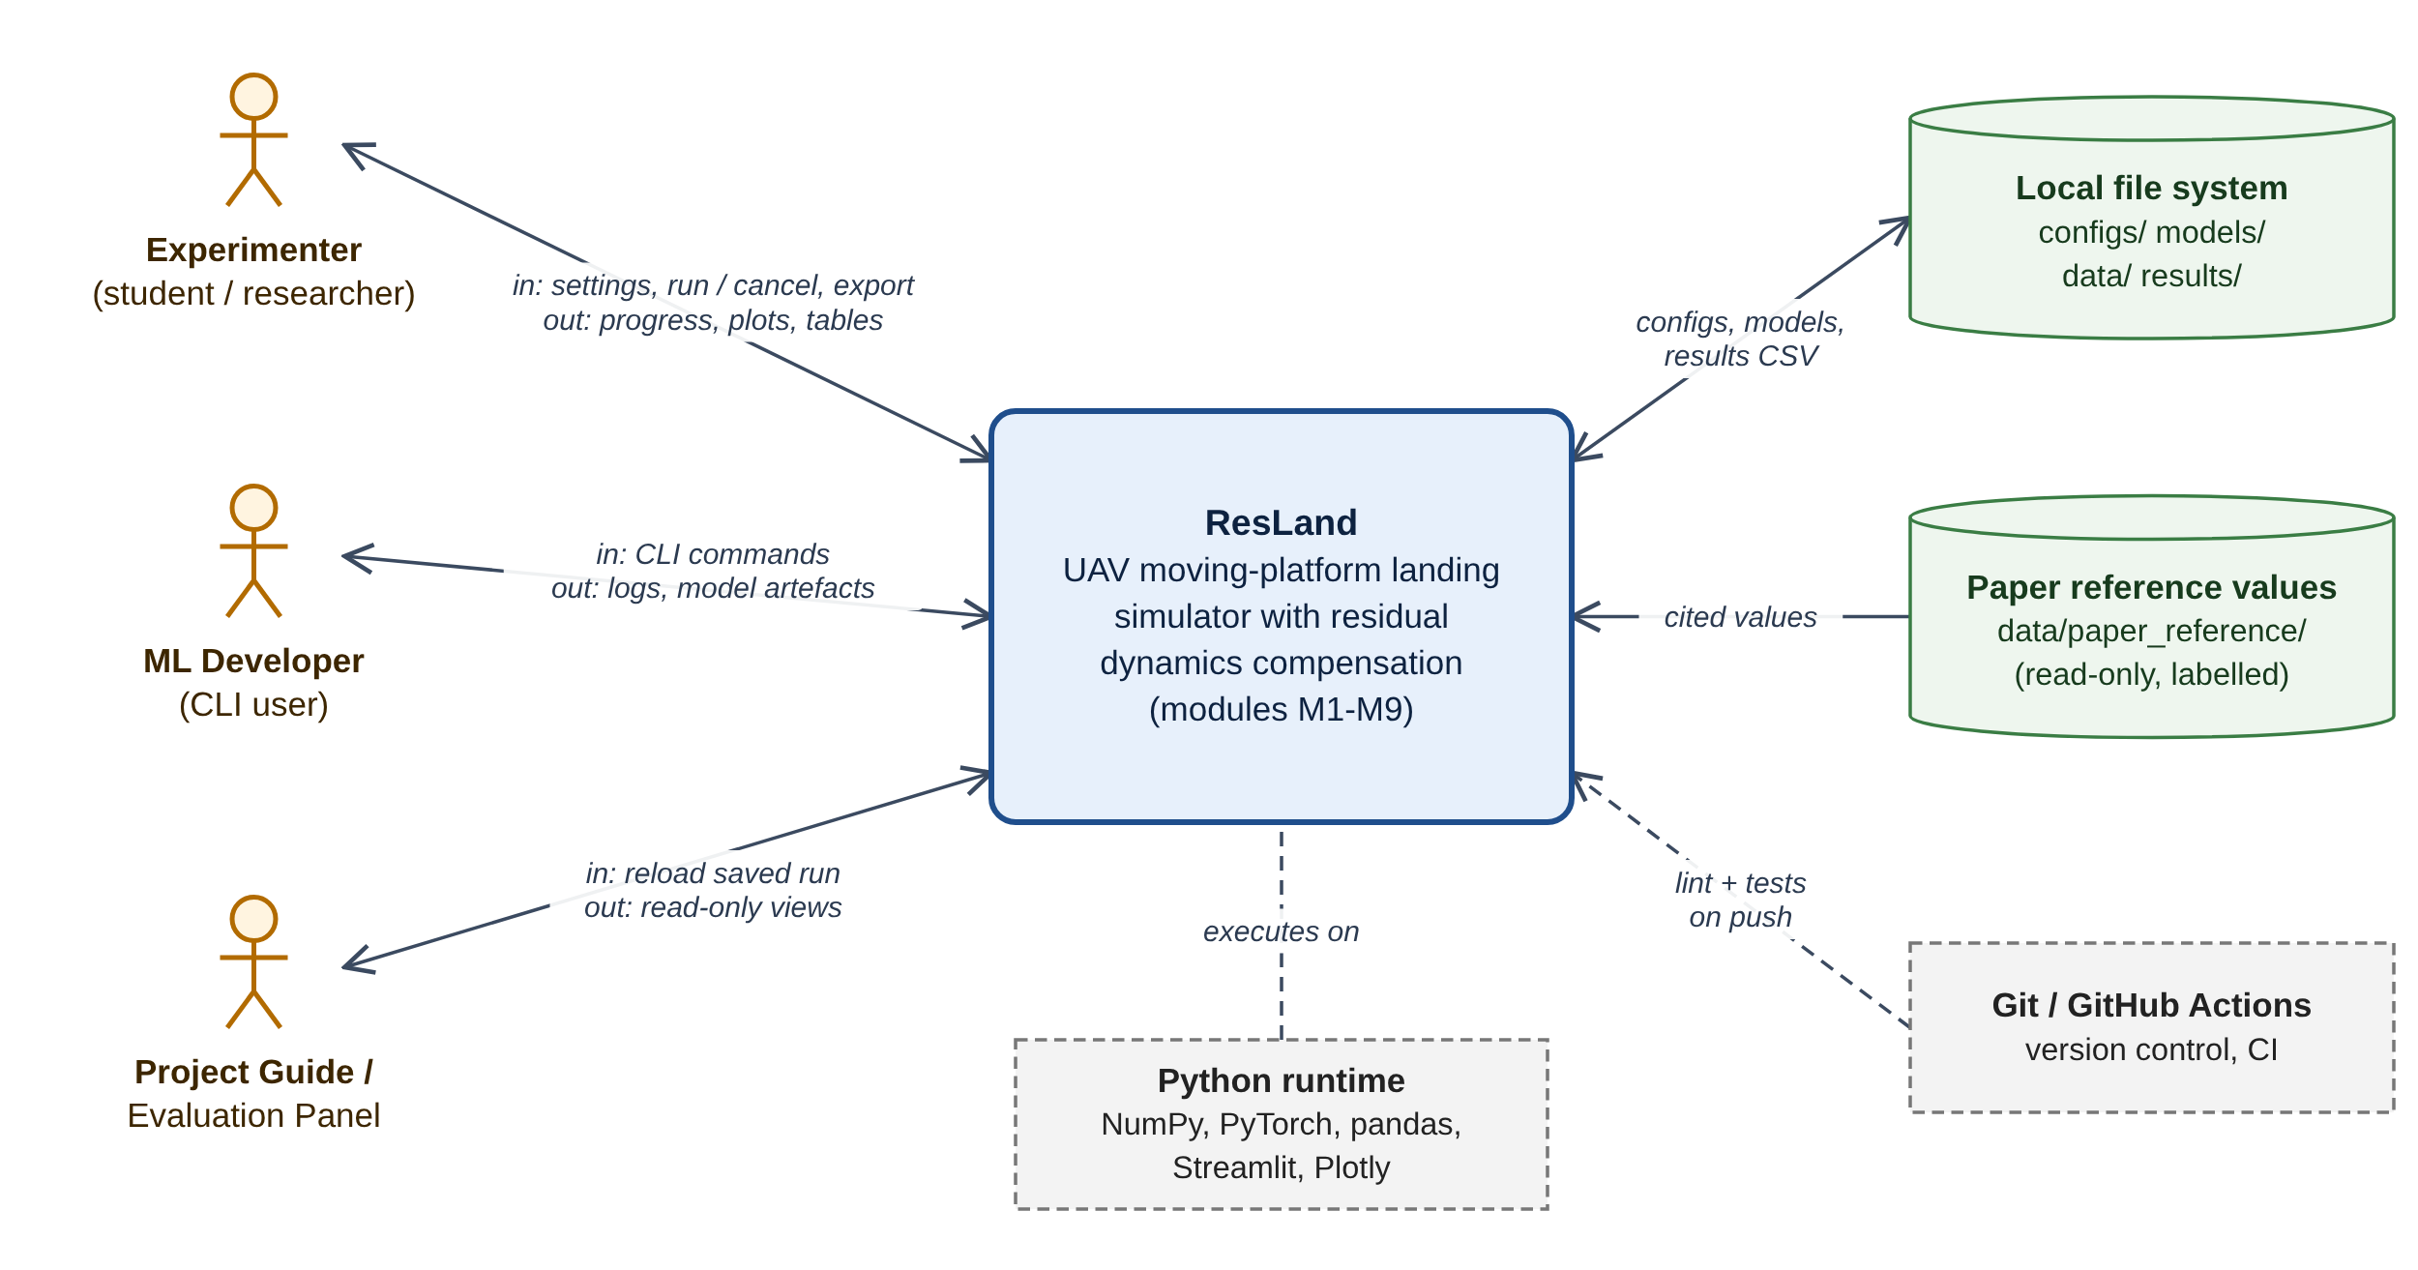
Figure 2: D-01 System context: ResLand, its three human actors, the local file system, read-only paper reference data, CI and the Python runtime.
Table 13: External interfaces
Interface | Direction | Format / protocol | Specification
Dashboard | User ↔ system | HTTP on localhost (Streamlit) | Four pages (Section 20); inputs validated by M1 before any run
Command line | User → system | resland <subcommand> [options] | generate, train, calibrate, run --plan, reproduce --table {3,4,5}; exit 0 on success, 2 on invalid config, 1 on runtime error
Configuration files | In / out | YAML, schema-versioned | configs/*.yaml; resolved copy saved per run (FR-CFG-05)
Model artefacts | In / out | PyTorch .pt, NumPy .npz, JSON, CSV, Markdown | models/<model_id>/ with SHA-256 (FR-TRN-04, NFR-DATA-02)
Results | Out | CSV (UTF-8), PNG, SVG, Markdown, JSON | results/<run_id>/ (Section 21)
Paper reference data | In (read-only) | CSV | data/paper_reference/table3.csv, table4.csv, table5.csv; displayed only with provenance labels
Continuous integration | Repo → CI | GitHub Actions workflow | Lint, import contracts, tests, coverage, RTM check on push (RT-03)

12 Proposed System Architecture
ResLand uses a layered architecture with four layers. Dependencies point downwards only (NFR-MAINT-01), so the numerical core (domain layer) can be tested without the dashboard, and the dashboard can be replaced without touching the core.
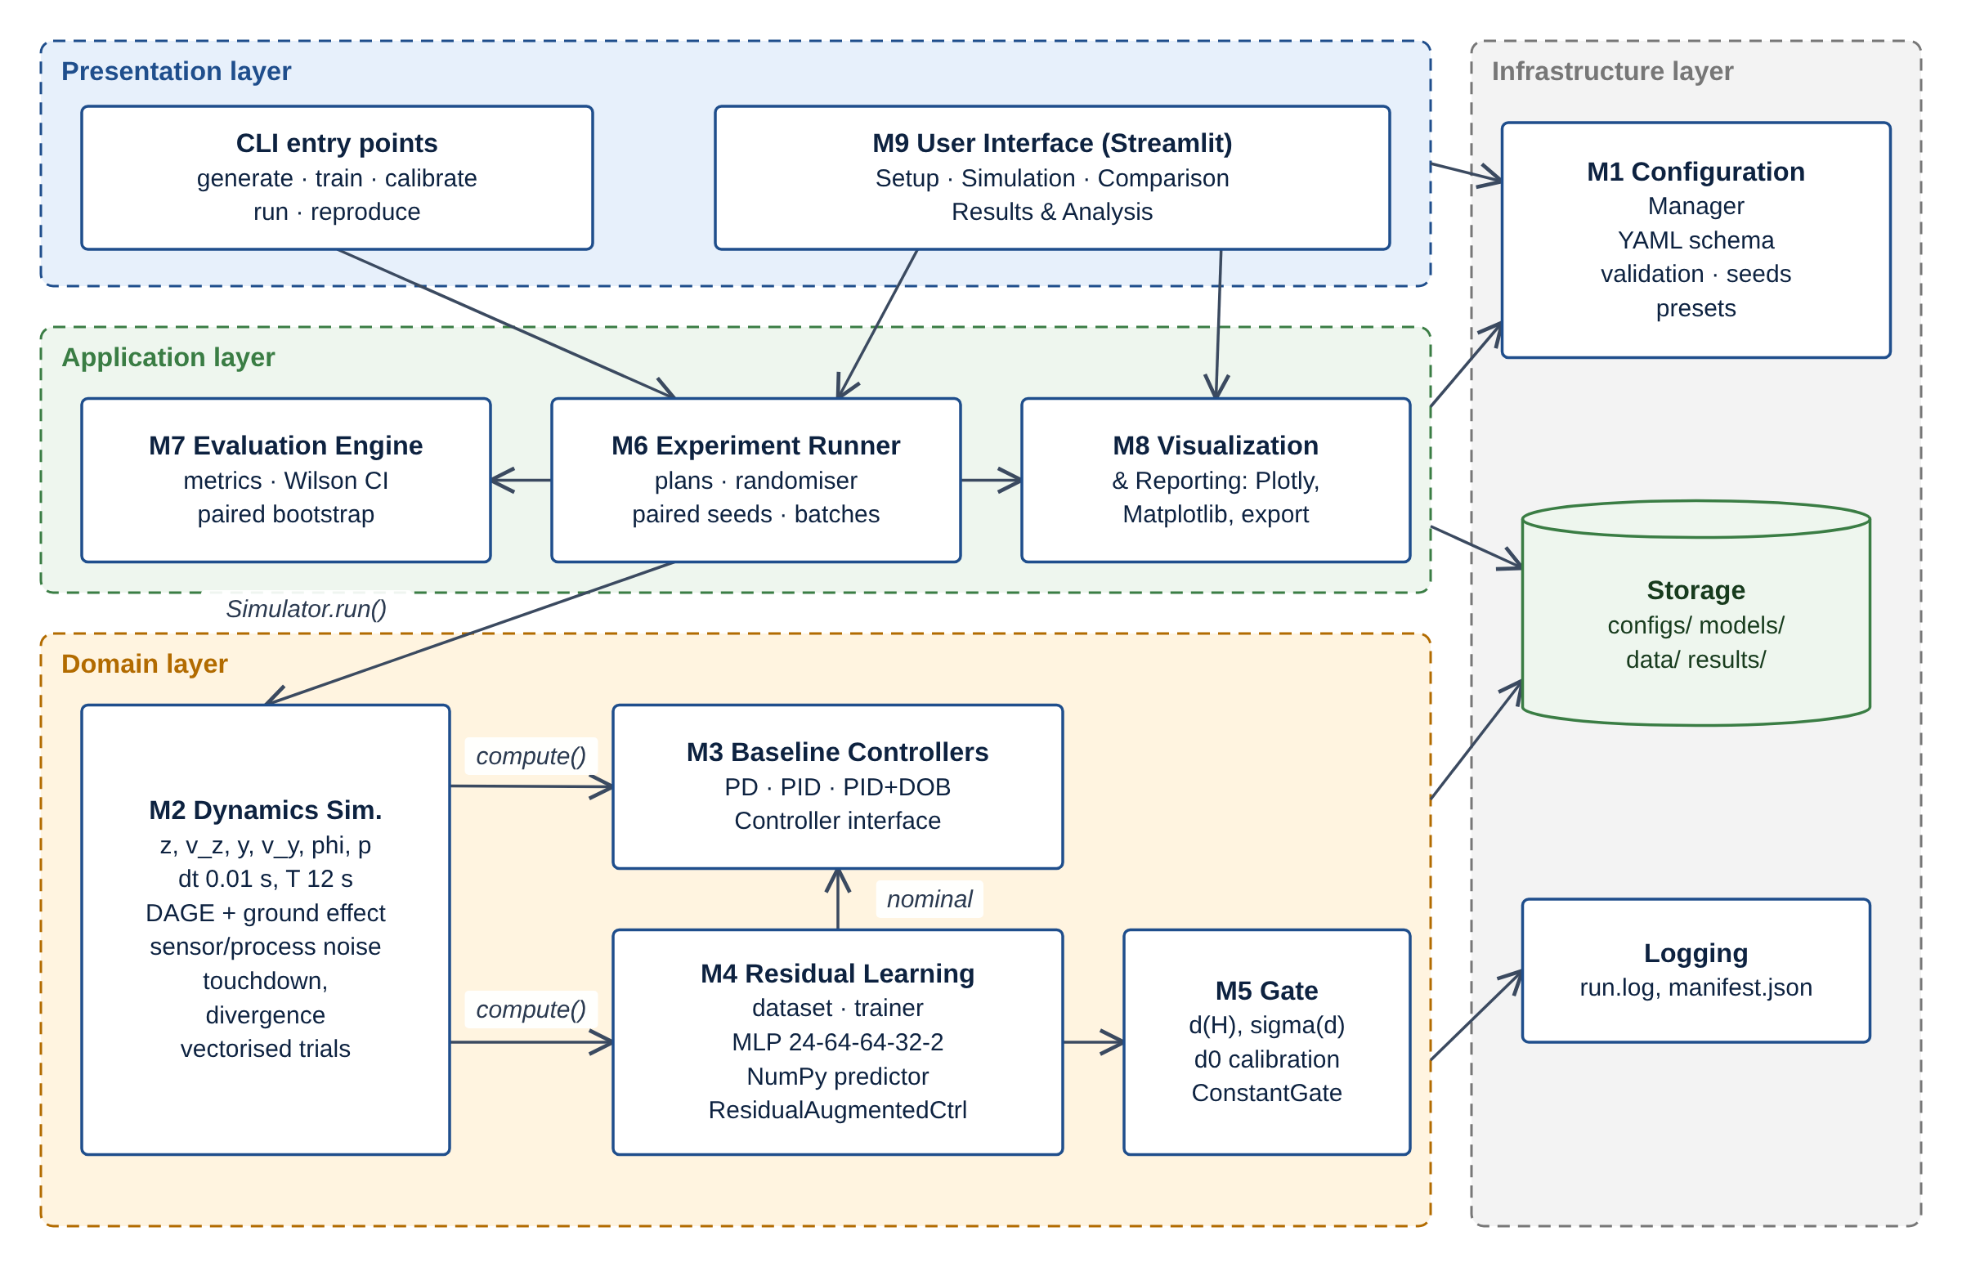
Figure 3: D-02 High-level architecture. Arrows show calls or data dependencies; arrows into the infrastructure column denote use of configuration (M1), storage and logging.
- Presentation layer. The Streamlit dashboard (M9) and the CLI. Neither contains numerical logic; both build an ExperimentConfig and hand it to the runner.
- Application layer. The Experiment Runner (M6) expands plans into conditions and paired trial batches; the Evaluation Engine (M7) computes metrics and statistics; Visualization and Reporting (M8) renders figures, tables and exports.
- Domain layer. The simulator (M2), baseline controllers (M3), residual learning (M4) and gate (M5). The simulator calls any controller only through Controller.compute(); the residual controller wraps a nominal controller, a predictor and a gate.
- Infrastructure layer. Configuration (M1), storage under configs/, models/, data/ and results/, and structured logging.

12.1 Key architectural decisions
Table 14: Architectural decisions
ID | Decision | Rationale | Status
AD-1 | One abstract Controller interface for all five configurations | Runner, simulator and evaluation stay controller-agnostic; Res-NG and Res-G differ only in the injected Gate object; new controllers (E1, E4) plug in without changes (NFR-MAINT-03) | Proposed
AD-2 | Vectorise trials along a batch axis in NumPy | A 500-trial condition advances as one array operation per step instead of 500 Python loops; finished trials are frozen with a mask | Proposed implementation decision
AD-3 | Train in PyTorch, infer in NumPy | Autograd, Adam and early stopping are standard in PyTorch; per-step NumPy inference avoids framework overhead in the 100 Hz loop and matches the paper's NumPy implementation; equivalence enforced by UT-17 | Proposed (OI-18)
AD-4 | Declarative, validated configuration (pydantic + YAML) with presets | Every run is reproducible from one file; invalid physics never reaches the simulator (FR-CFG-02) | Proposed
AD-5 | Paired seeds derived from a master seed per condition | Enables paired-bootstrap comparisons exactly as in the paper (FR-CFG-04) | Required by paper protocol
AD-6 | Provenance field on every displayed value | Prevents mixing reproduced and paper-reported numbers (FR-RPT-03) | Proposed
AD-7 | Batch-wise atomic result writing | Interrupted or cancelled runs never leave corrupted files (NFR-REL-02) | Proposed

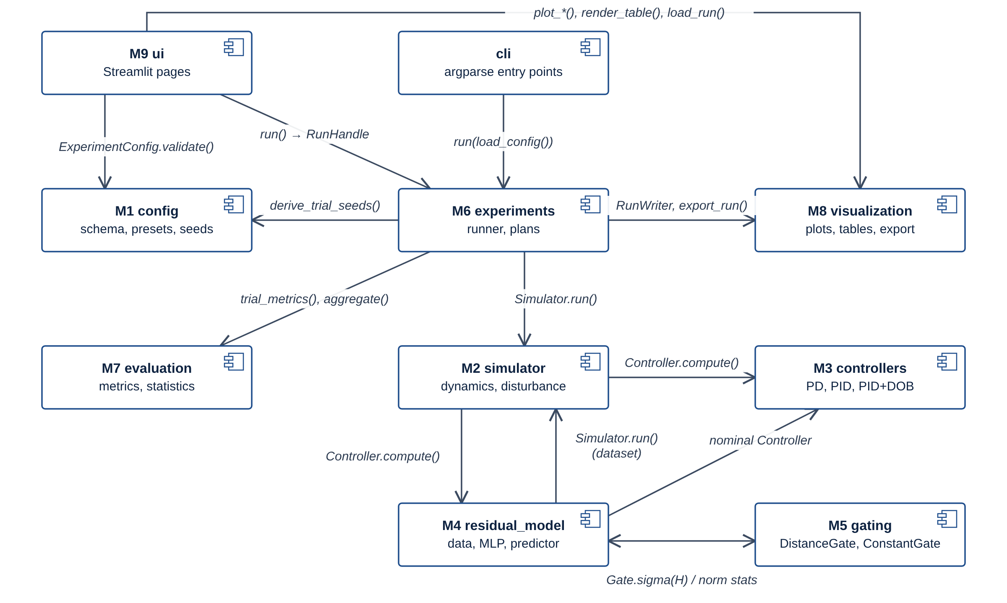
Figure 4: D-04 UML component diagram. Edge labels name the interface used between components.

13 Detailed Module Specifications
Each module is specified by its responsibilities, public interface, inputs, outputs, dependencies, error conditions and tests. Interface signatures are Python type-hinted pseudocode and are reproduced as stubs in the repository scaffold (Appendix C).

13.1 M1 Experiment Configuration Manager (resland.config)
Responsibilities
- Load experiment configurations from versioned YAML files and presets.
- Validate types and ranges of every parameter before execution.
- Derive deterministic per-trial seeds from a master seed (paired across controllers).
- Resolve and persist the full configuration, software version and commit hash with every run.

Public interface
load_config(path: Path) -> ExperimentConfig
ExperimentConfig.validate() -> list[ValidationIssue]
load_preset(name: str) -> ExperimentConfig # 'paper_default', 'paper_mismatch'
derive_trial_seeds(master_seed: int, n_trials: int) -> np.ndarray[int64]
save_resolved(cfg: ExperimentConfig, run_dir: Path) -> Path

Table 15: M1 Experiment Configuration Manager: inputs, outputs, dependencies, errors and tests
Aspect | Specification
Inputs | YAML file or UI form values; preset name; master seed.
Outputs | Validated, immutable ExperimentConfig; ValidationIssue list; config.resolved.yaml.
Dependencies | pydantic, PyYAML. No dependency on other ResLand modules.
Error conditions | ConfigValidationError listing every out-of-range or missing field (name, value, allowed range). • UnknownPresetError for an unknown preset name. • Schema-version mismatch between file and code raises ConfigVersionError.
Tests | UT-01, UT-02, UT-03, IT-07
Requirements | FR-CFG-01, FR-CFG-02, FR-CFG-03, FR-CFG-04, FR-CFG-05, FR-DIST-03, FR-ERR-02

13.2 M2 UAV Dynamics Simulator (resland.simulator)
Responsibilities
- Represent the reduced-order vertical (z, v_z), lateral (y, v_y) and roll (phi, p) channels.
- Advance the state with a fixed step dt = 0.01 s up to the horizon T = 12 s.
- Evaluate the DAGE roll torque (Eq. 6) and the symmetric ground-effect acceleration (Eq. 7) from a named disturbance profile.
- Inject sensor and process noise at every step.
- Detect touchdown and numerical divergence and terminate the trajectory with an outcome code.
- Vectorise across trials so a batch of N trials advances as one array operation (proposed implementation decision).

Public interface
DisturbanceModel.tau_dage(z, v_y, v_p, phi) -> np.ndarray
DisturbanceModel.a_ge(z) -> np.ndarray
NoiseModel.measure(state, rng) -> Observation
Dynamics.step(state, cmd, dist, rng) -> SimState
Simulator.run(trials: TrialBatch, controller: Controller) -> TrajectoryBatch
TouchdownDetector.check(state) -> np.ndarray[bool]

Table 16: M2 UAV Dynamics Simulator: inputs, outputs, dependencies, errors and tests
Aspect | Specification
Inputs | SimConfig, DisturbanceProfile, TrialBatch (initial states, randomised parameters, seeds), Controller instance.
Outputs | TrajectoryBatch: per-step true and measured states, nominal and applied commands, injected disturbances, gate values, outcome codes.
Dependencies | NumPy; M1 (config types); M3/M4 through the Controller interface only.
Error conditions | NaN/Inf in state or |phi| above the divergence limit sets outcome DIVERGED for that trial only. • No touchdown within T sets outcome NO_TOUCHDOWN. • dt <= 0, T <= 0 or inconsistent array shapes raise SimulationSetupError before stepping.
Tests | UT-04, UT-05, UT-06, UT-07, UT-08, UT-21, UT-26, IT-01
Requirements | FR-SIM-01, FR-SIM-02, FR-SIM-03, FR-SIM-04, FR-SIM-05, FR-SIM-06, FR-DIST-01, FR-DIST-02, FR-DIST-03, FR-DIST-04, FR-TD-01, FR-TD-02, FR-ERR-01, FR-ERR-02

13.3 M3 Baseline Controllers (resland.controllers)
Responsibilities
- Implement the cascaded PID controller of Section IV-A (vertical PID, lateral outer loop, roll PID per Eq. 8).
- Implement the PD variant (integral gains set to zero).
- Implement the PID+DOB reference configuration: first-order vertical-channel disturbance observer, time constant 1.0 s.
- Expose one Controller interface shared by all five configurations.

Public interface
class Controller(ABC): reset(batch_size, rng) -> None; compute(obs: Observation, ref: Reference) -> Command
Command(u_z, u_phi, diag: dict[str, np.ndarray])
PIDCascade(gains: PIDGains, lateral: LateralGains, limits: Limits | None)
PDCascade(PIDCascade) # integral gains fixed to 0
PIDDOBController(pid: PIDCascade, dob: VerticalDOB)
VerticalDOB(tau: float = 1.0).update(a_meas, u_z) -> d_hat

Table 17: M3 Baseline Controllers: inputs, outputs, dependencies, errors and tests
Aspect | Specification
Inputs | Observation (noisy z, v_z, phi, p plus lateral tracking signal), Reference (altitude/descent reference, platform-velocity reference for the lateral loop).
Outputs | Command (u_z as vertical acceleration command, u_phi as roll torque command) and diagnostics (integrator states, DOB estimate).
Dependencies | NumPy; M1 for gain configuration.
Error conditions | Non-finite observation raises ControllerInputError (caught by M2, trial marked DIVERGED). • Negative gains or missing lateral gains rejected at configuration time (M1).
Tests | UT-09, UT-10, UT-11, UT-12, IT-02
Requirements | FR-CTRL-01, FR-CTRL-02, FR-CTRL-03, FR-CTRL-04, FR-CTRL-05, FR-DOB-01, FR-DOB-02

13.4 M4 Residual Learning (resland.residual_model)
Responsibilities
- Generate training windows from PID-controlled trajectories with ground-truth disturbance targets.
- Split data by trajectory (60 held out, 340 training) and sub-sample 200,000 training windows.
- Define the 24 -> 64 -> 64 -> 32 -> 2 tanh MLP (7,906 parameters) and train it with the Section VI-C hyperparameters.
- Export weights and normalisation statistics for NumPy inference inside the simulation loop.
- Combine the residual prediction with the nominal command (Eqs. 9-10) in ResidualAugmentedController.

Public interface
DatasetBuilder.build(cfg) -> WindowDataset (X: [N,24], Y: [N,2], traj_id: [N])
ResidualMLP(nn.Module).forward(x: Tensor[B,24]) -> Tensor[B,2]
Trainer.fit(train, val) -> TrainingReport
export_checkpoint(model, stats, path) -> ModelArtifact
ResidualPredictor.load(path) / .predict(H: np.ndarray[B,24]) -> (tau_hat, a_hat)
HistoryBuffer(W=4).push(obs, cmd_nom) -> np.ndarray[B,24]
ResidualAugmentedController(nominal: Controller, predictor, gate: Gate)

Table 18: M4 Residual Learning: inputs, outputs, dependencies, errors and tests
Aspect | Specification
Inputs | Training configuration; PID trajectories from M2; for inference, the 24-dimensional window H_t.
Outputs | ModelArtifact (weights.pt, weights.npz, norm_stats.json, training_log.csv, model_card.md, SHA-256); per-step tau_hat, a_hat.
Dependencies | PyTorch (training only), NumPy (inference), M2, M3, M5.
Error conditions | Checkpoint with wrong layer shapes, feature schema or checksum raises ModelLoadError. • Empty or overlapping train/validation trajectory sets raise DatasetSplitError. • Non-finite training loss stops training and keeps the last good checkpoint.
Tests | UT-13, UT-14, UT-15, UT-16, UT-17, UT-29, UT-30, IT-03, IT-05, RT-02
Requirements | FR-CTRL-03, FR-TRN-01, FR-TRN-02, FR-TRN-03, FR-TRN-04, FR-RES-01, FR-RES-02, FR-RES-03, FR-RES-04, FR-RES-05

13.5 M5 Residual-Authority Gate (resland.gating)
Responsibilities
- Compute the standardised max-feature distance d(H_t) of Eq. 12.
- Map distance to authority sigma in [0, 1] with Eq. 13 using configurable d0 and kappa.
- Calibrate d0 as a configurable percentile (default 99th) of d on held-out in-distribution windows.
- Provide ConstantGate (sigma = 1, Res-NG) and support kappa/d0 sweeps.
- Log sigma, d and the gated versus ungated correction for every step.

Public interface
class Gate(ABC): sigma(H) -> np.ndarray[B]
DistanceGate(mu, std, d0, kappa).distance(H) -> np.ndarray[B]
DistanceGate.sigma(H) -> np.ndarray[B]
ConstantGate(value=1.0)
calibrate_d0(H_val, mu, std, q=0.99) -> float

Table 19: M5 Residual-Authority Gate: inputs, outputs, dependencies, errors and tests
Aspect | Specification
Inputs | Window H_t (24-dim), training mean/std, d0, kappa.
Outputs | sigma per trial per step; d per step; gate_calibration.json.
Dependencies | NumPy; normalisation statistics from M4.
Error conditions | kappa <= 0 or q outside (0, 1) rejected at configuration time. • Non-finite H_t yields sigma = 0 (fall back to nominal control) and a logged warning (proposed safe default).
Tests | UT-18, UT-19, UT-20, IT-04
Requirements | FR-GATE-01, FR-GATE-02, FR-GATE-03, FR-GATE-04, FR-GATE-05

13.6 M6 Experiment Runner (resland.experiments)
Responsibilities
- Expand an experiment plan (speed sweep, mismatch, gate ablation, single trial) into conditions.
- Sample randomised initial conditions and parameter scalings per trial.
- Run each condition for every selected controller with identical per-trial seeds (paired design).
- Report progress, support cancellation, and write per-trial records incrementally.

Public interface
ExperimentPlan.from_config(cfg) -> list[Condition]
Randomizer.sample(cfg, seeds) -> TrialBatch
ExperimentRunner.run(plan, on_progress: Callable | None, cancel: Event | None) -> RunHandle
RunHandle.run_dir: Path; RunHandle.status: RunStatus

Table 20: M6 Experiment Runner: inputs, outputs, dependencies, errors and tests
Aspect | Specification
Inputs | Validated ExperimentConfig, model artifact (for residual controllers), progress callback.
Outputs | results/<run_id>/trials.csv (one row per trial), trajectories (optional .npz), run.log, manifest.json.
Dependencies | M1, M2, M3, M4, M5, M7 (per-trial metrics), M8 (writers).
Error conditions | Residual controller selected without a valid model artifact raises MissingModelError before any trial runs. • A failing trial is recorded with outcome ERROR and the run continues (NFR-REL-01). • Cancellation stops after the current batch; completed batches stay on disk.
Tests | UT-03, UT-28, IT-06, IT-07, ST-01, ST-02, ST-03
Requirements | FR-CFG-05, FR-INIT-01, FR-INIT-02, FR-INIT-03, FR-GATE-04, FR-MC-01, FR-MC-02, FR-MC-03, FR-EXP-01, FR-ERR-01, FR-ERR-02, FR-ERR-03

13.7 M7 Evaluation Engine (resland.evaluation)
Responsibilities
- Compute per-trial touchdown metrics: RMS and peak |phi| for z < 1.0 m, |dv_y| and |v_z| at contact.
- Classify envelope success and roll violation using configurable thresholds.
- Aggregate per condition: means, rates, Wilson 95% score intervals.
- Compute paired differences against a reference controller with 95% paired-bootstrap intervals (20,000 resamples).
- Compute mean gate value per condition.

Public interface
Evaluator.trial_metrics(traj: TrajectoryBatch, thr: EnvelopeThresholds) -> pd.DataFrame
Evaluator.aggregate(trials: pd.DataFrame, by=[...]) -> pd.DataFrame
wilson_interval(k: int, n: int, z: float = 1.959964) -> tuple[float, float]
paired_bootstrap(a, b, n_resamples=20000, seed) -> BootstrapResult
Evaluator.compare(trials, reference='PID') -> pd.DataFrame

Table 21: M7 Evaluation Engine: inputs, outputs, dependencies, errors and tests
Aspect | Specification
Inputs | TrajectoryBatch or trials.csv; thresholds; reference controller name.
Outputs | trials.csv metric columns, aggregate.csv, paired_diffs.csv.
Dependencies | NumPy, pandas.
Error conditions | n = 0 in a condition yields NaN interval with a warning, never a division error. • Unpaired seeds between compared controllers raise PairingError.
Tests | UT-22, UT-23, UT-24, UT-25, IT-06
Requirements | FR-GATE-05, FR-TD-02, FR-ENV-01, FR-ENV-02, FR-ENV-03, FR-ENV-04, FR-CMP-01, FR-CMP-02, FR-CMP-03, FR-RPT-01

13.8 M8 Visualization and Reporting (resland.visualization)
Responsibilities
- Produce interactive Plotly figures for the dashboard and Matplotlib figures for static export.
- Render paper-style tables (Tables III-V layout) from aggregate results.
- Export results (CSV), figures (PNG, SVG) and a run summary; reload saved runs.
- Label every displayed number as Reproduced (computed by this software) or Paper-reported.

Public interface
plot_time_histories(trajs, signals, controllers) -> go.Figure
plot_side_view(traj, t) -> go.Figure
plot_gate(traj) -> go.Figure
render_table(aggregate, layout='table3') -> pd.DataFrame
export_run(run_dir, formats) -> list[Path]; load_run(run_dir) -> RunResult

Table 22: M8 Visualization and Reporting: inputs, outputs, dependencies, errors and tests
Aspect | Specification
Inputs | TrajectoryBatch, aggregate.csv, paired_diffs.csv, paper reference values (data/paper_reference/*.csv).
Outputs | Figures, tables, export files, summary.md.
Dependencies | Matplotlib, Plotly, pandas; M7 data schemas.
Error conditions | Missing or schema-incompatible run directory raises RunLoadError with the missing file named. • Write failures (permissions, disk) surface to the UI as an error message; partial files are removed.
Tests | UT-27, IT-09, ST-06
Requirements | FR-INIT-03, FR-CMP-01, FR-VIS-01, FR-VIS-02, FR-VIS-03, FR-RPT-02, FR-RPT-03, FR-EXP-01, FR-EXP-02, FR-EXP-03, FR-EXP-04

13.9 M9 User Interface (resland.ui)
Responsibilities
- Provide the Streamlit dashboard: Experiment Setup, Simulation View, Controller Comparison, Results and Analysis.
- Translate form inputs into an ExperimentConfig and show validation messages inline.
- Start runs through M6, show progress, and handle loading, empty, error and completion states.
- Offer exports and reloading of saved runs.

Public interface
app.py (st.navigation with four pages)
pages/1_setup.py, 2_simulation.py, 3_comparison.py, 4_results.py
state.py: SessionState(config, run_handle, selected_run)

Table 23: M9 User Interface: inputs, outputs, dependencies, errors and tests
Aspect | Specification
Inputs | User actions; saved runs under results/.
Outputs | Rendered views; ExperimentConfig passed to M6; downloads.
Dependencies | Streamlit; M1, M6, M7, M8.
Error conditions | Validation errors block the Run button and are shown next to the offending field. • Runner exceptions are caught and shown as an error panel with the log path.
Tests | IT-08, ST-04, ST-05, ST-06
Requirements | FR-MC-03, FR-RPT-03, FR-EXP-03, FR-UI-01, FR-UI-02, FR-UI-03, FR-UI-04, FR-UI-05

13.10 Class design
The class design is split into three diagrams for legibility. D-07a shows the configuration model, D-07b the simulation and experiment classes, and D-07c the controller hierarchy with the residual model and gate. The same classes appear in the module interfaces above and in the repository stubs.
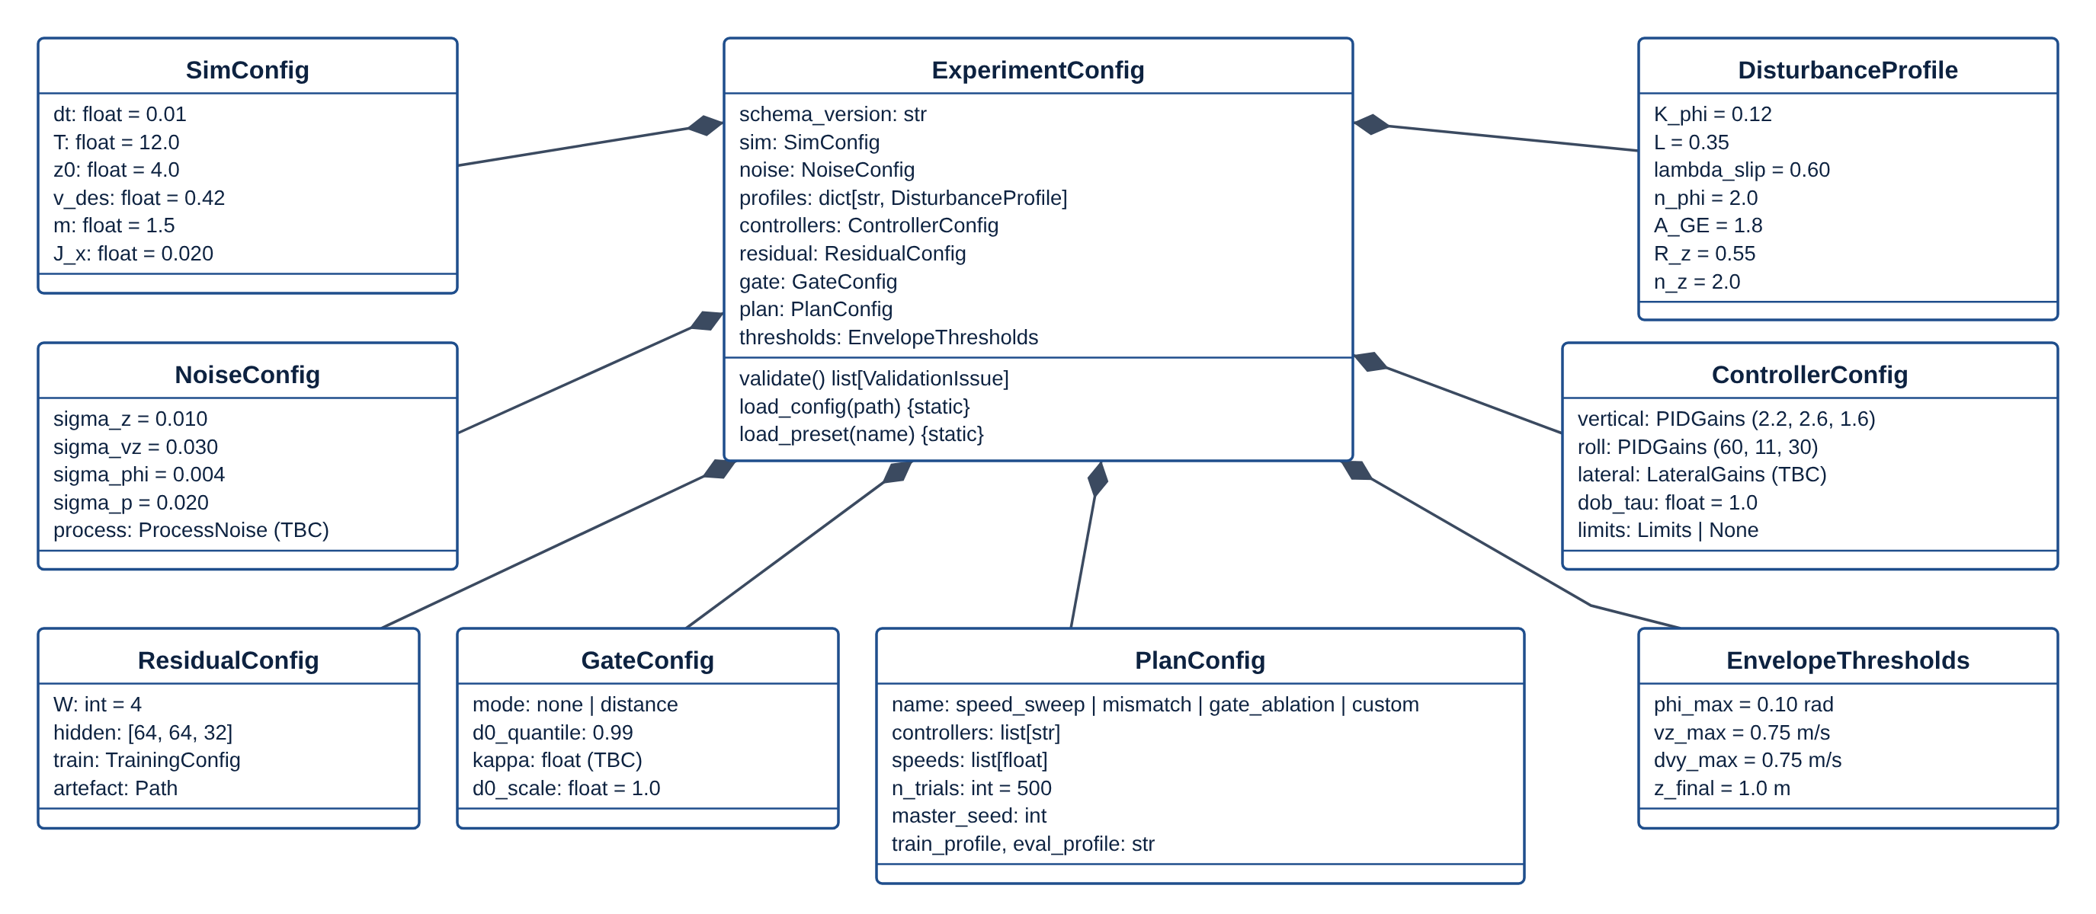
Figure 5: D-07a UML class diagram: configuration model (values shown are the paper_default preset; TBC items are open in Appendix A).
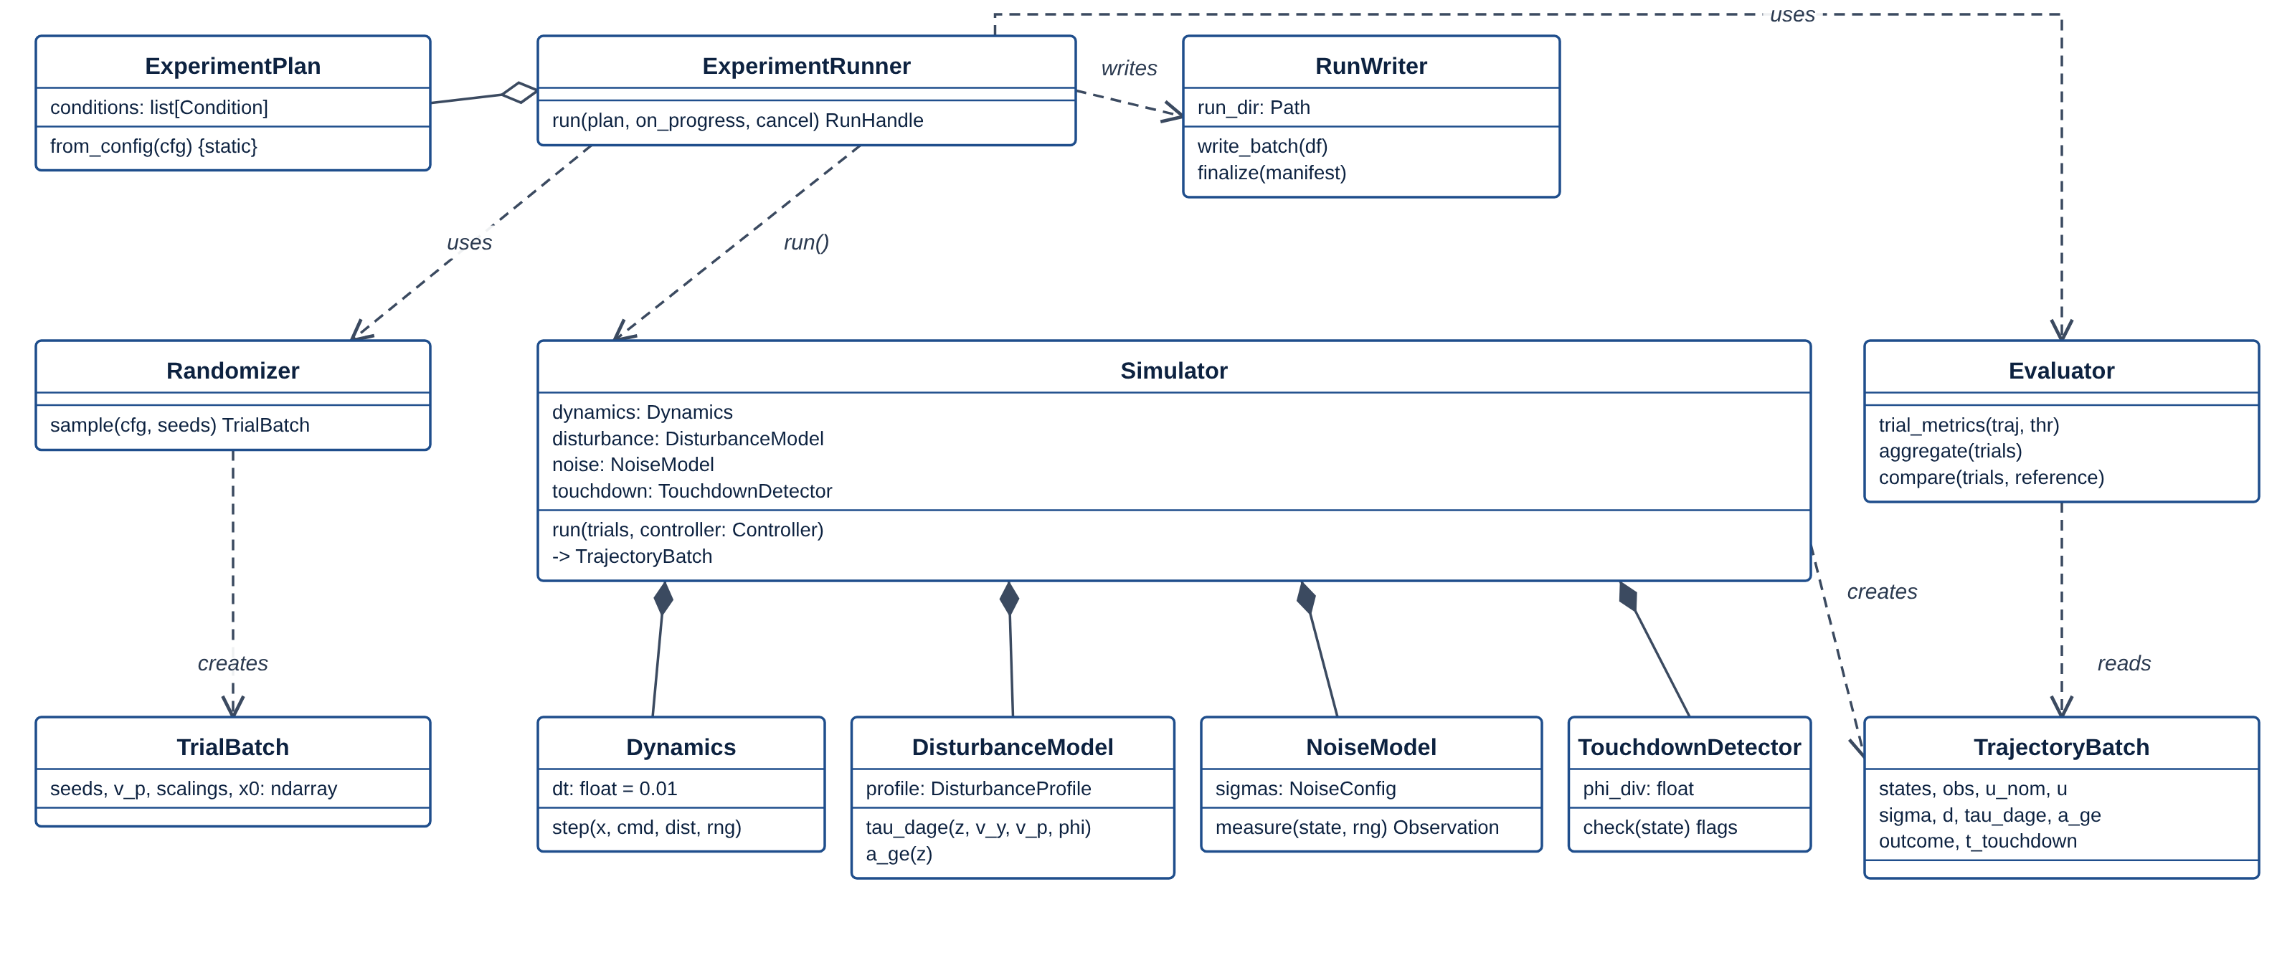
Figure 6: D-07b UML class diagram: experiment runner, simulator and its composed parts, trial and trajectory batches, evaluation and writing.
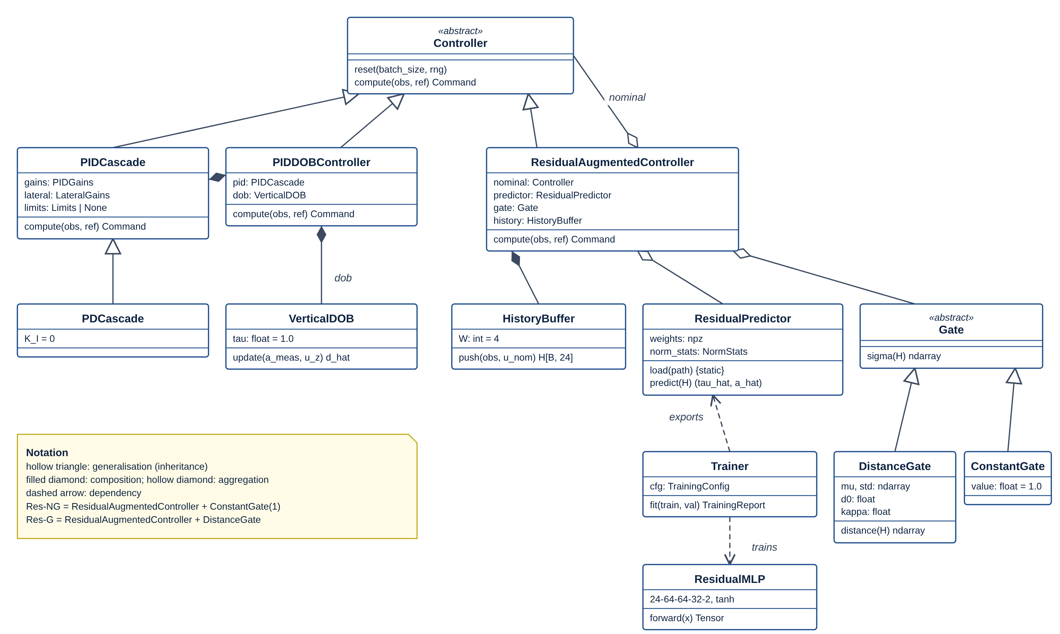
Figure 7: D-07c UML class diagram: Controller hierarchy, PID+DOB composition, residual-augmented controller with predictor, history buffer and gate.

14 Data Flow and Control Flow
Figure D-08 shows how data moves between the processes and stores; D-05 shows the control flow of a complete experiment; D-06 shows the per-step interaction inside the simulation loop; D-10 shows how each experiment plan expands into conditions.
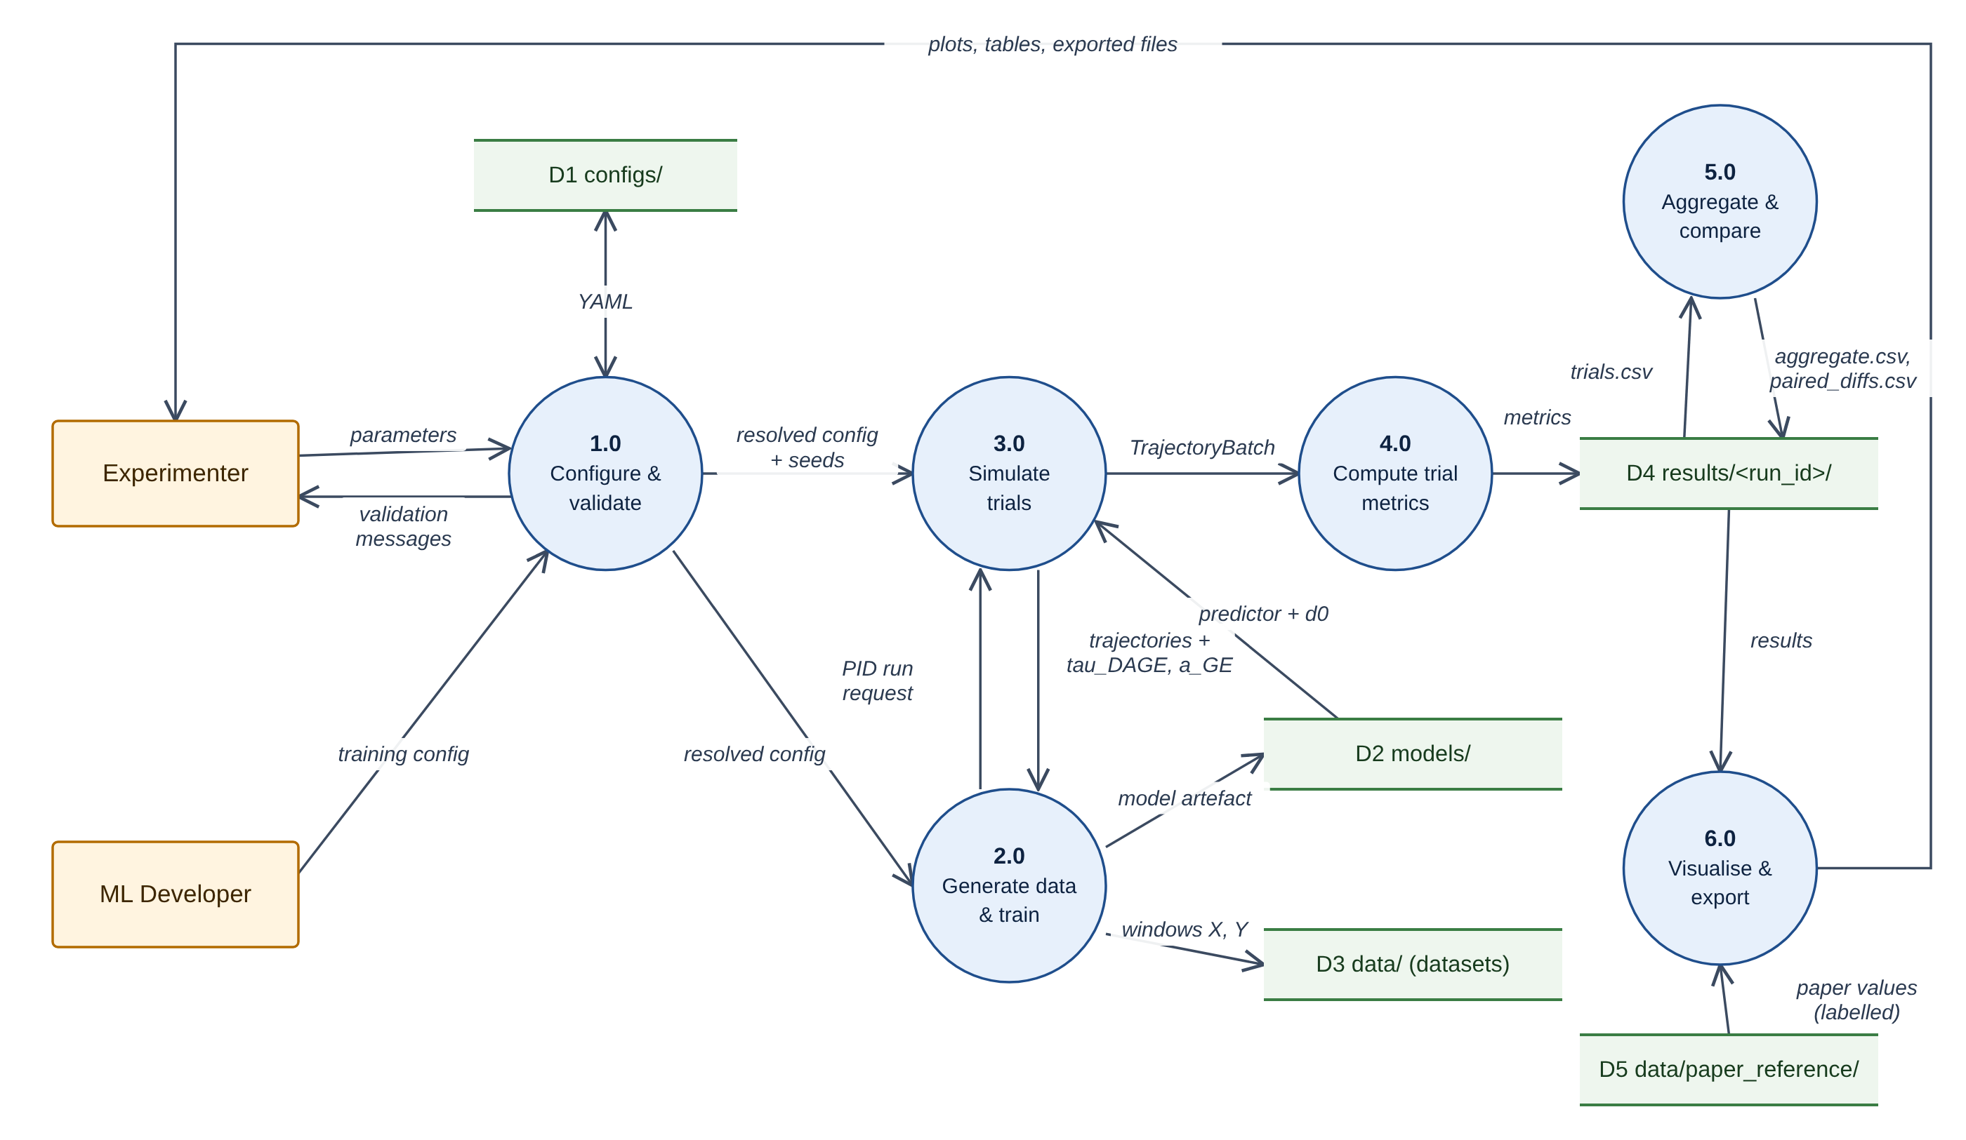
Figure 8: D-08 Level-1 data-flow diagram: six processes, five data stores (D1-D5) and two external entities. Paper-reported values (D5) flow only to visualisation, never into results.
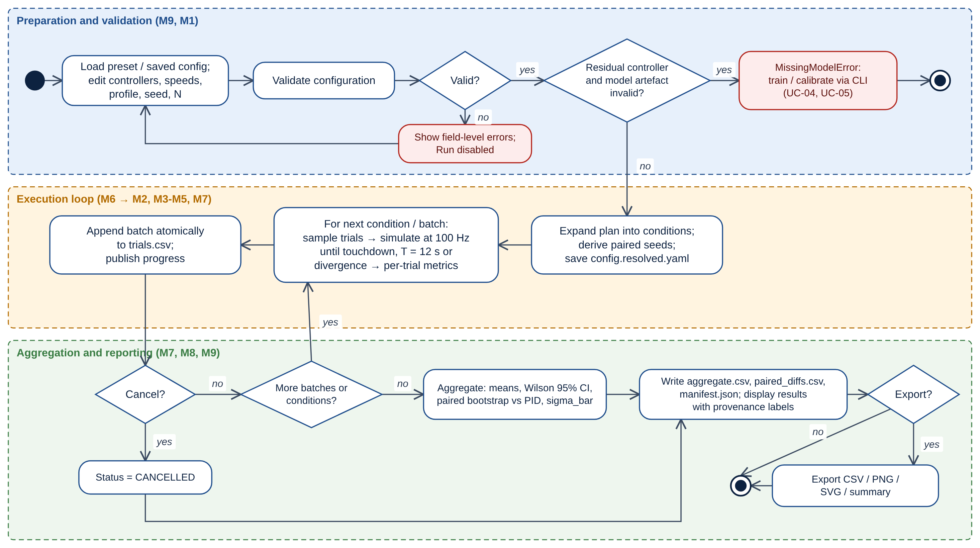
Figure 9: D-05 UML activity diagram of a complete experiment, in three swim-lanes: preparation and validation, the batched execution loop, and aggregation and reporting.
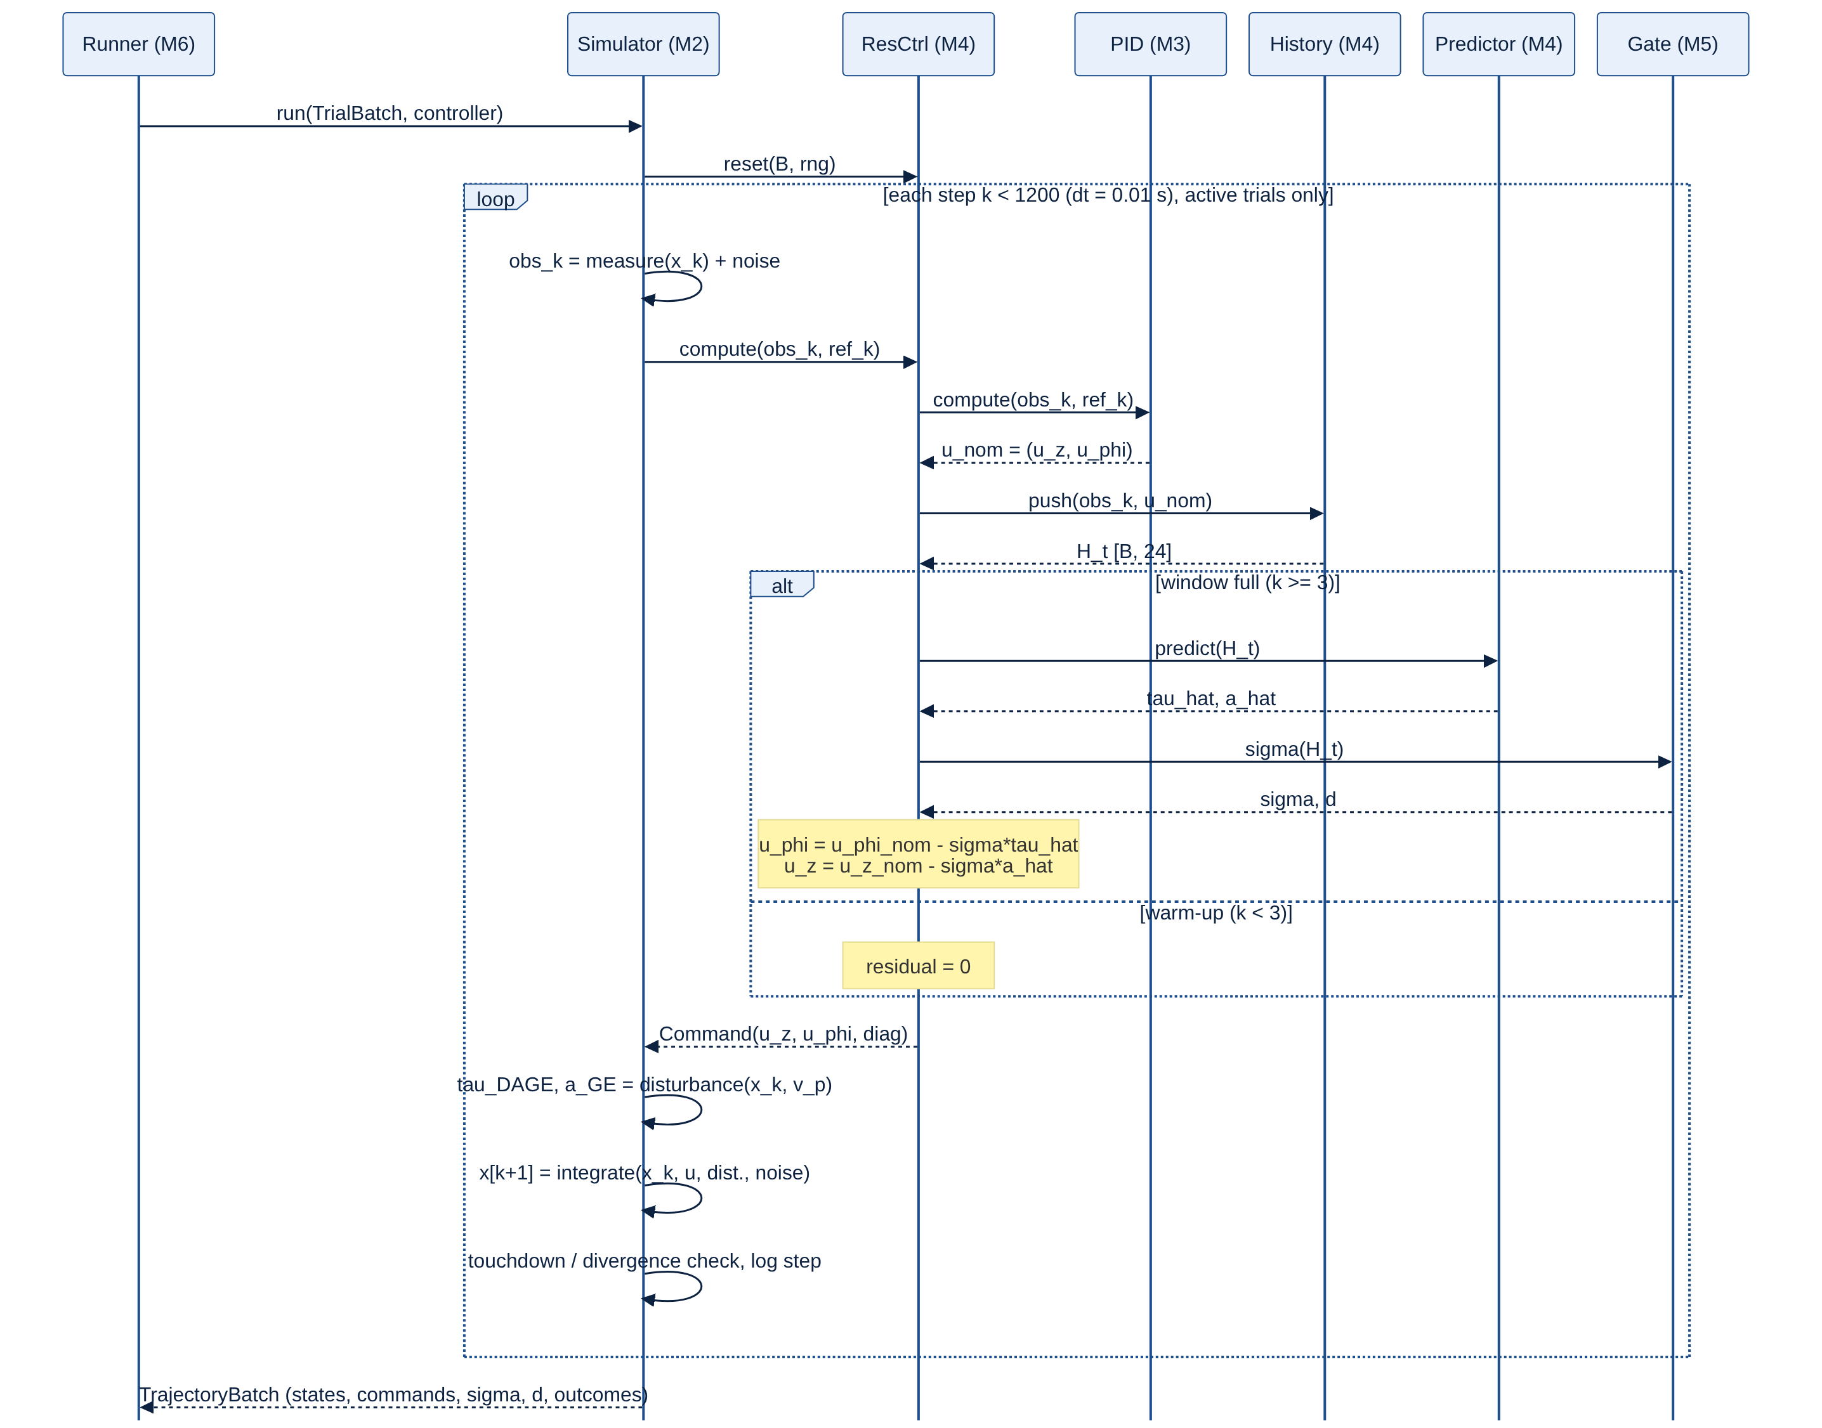
Figure 10: D-06 UML sequence diagram of one simulation step for a residual controller. Res-NG uses ConstantGate(1); with sigma = 0 the command reduces to the PID command (IT-03).

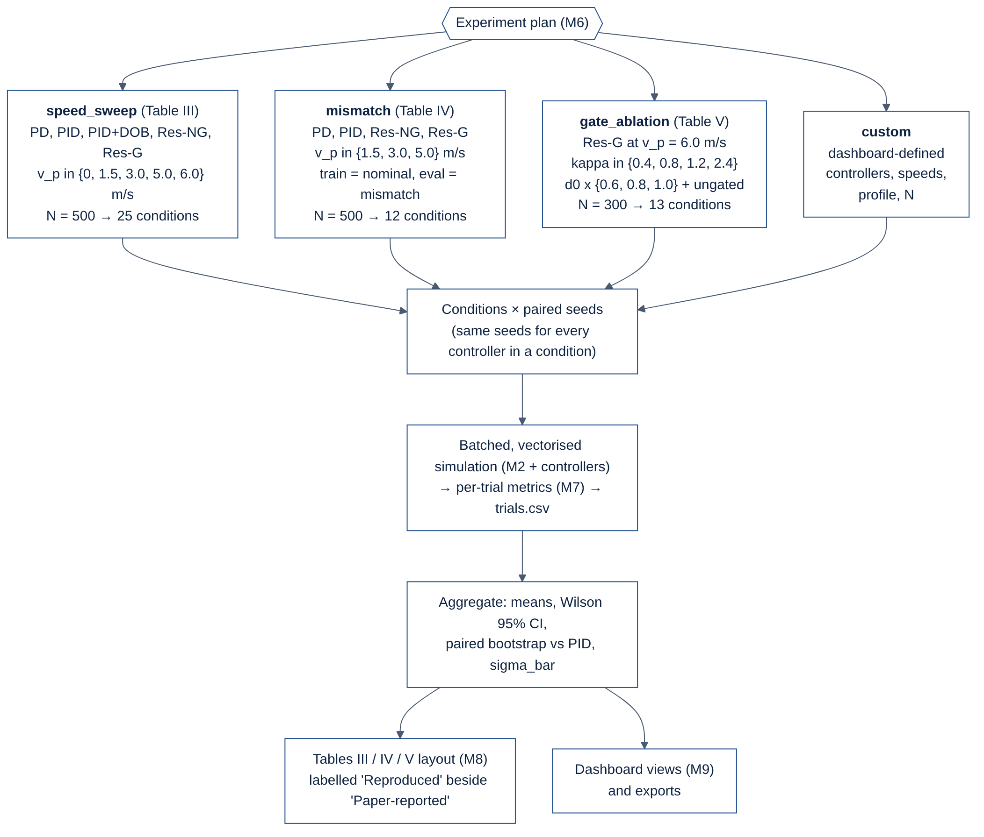
Figure 11: D-10 Experiment plans and their expansion into conditions with paired seeds. Condition counts follow the paper's Tables III-V.

15 Algorithm and Controller Design

15.1 Reduced-order dynamics
The simulator advances the state x = [z, v_z, y, v_y, phi, p] for a batch of B trials. The lateral-roll coupling and the roll equation are taken from the paper (Sec. V-A, Eq. 4 reduced to roll); the vertical form is the proposed reading of Sec. V-A pending OI-02.
(15.1)
(15.2)
The disturbance terms are the paper's Eqs. (6)-(7), generalised with altitude-decay exponents n_phi and n_z (default 2.0) so that the mismatch profile (n = 1.6) can be expressed:
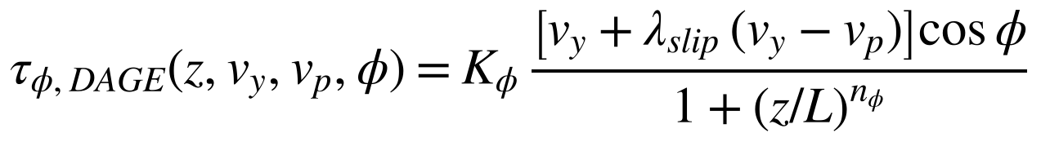 (15.3)
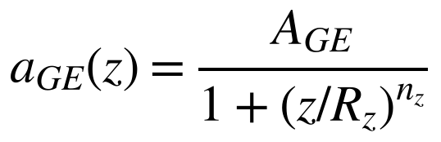 (15.4)
Proposed implementation decision. (OI-04) Semi-implicit Euler integration at dt = 0.01 s, i.e. velocities are updated first and positions use the updated velocities. The scheme is a configuration option (euler | semi_implicit | rk4) so that it can be matched to the original code.

15.2 Controllers
(15.5)
Table 24: Controller configurations
Name | Composition | Purpose in the comparison (paper Sec. V-C) | Gains / parameters
PD | PDCascade (K_I = 0) | Shows the effect of integral action under a sustained disturbance | Vertical (2.2, 2.6, 0); roll (60, 11, 0)
PID | PIDCascade | Reference baseline throughout | Vertical (2.2, 2.6, 1.6); roll (60, 11, 30); lateral TBC
PID+DOB | PIDDOBController = PIDCascade + VerticalDOB | Classical disturbance-rejection reference (vertical channel only) | First-order DOB, tau = 1.0 s
Res-NG | ResidualAugmentedController(PID, predictor, ConstantGate(1)) | Isolates the learned correction (vs PID) | MLP 24-64-64-32-2
Res-G | ResidualAugmentedController(PID, predictor, DistanceGate) | Isolates the gate (vs Res-NG) | d0 = 99th percentile; kappa TBC

15.3 Gated residual correction and gate
(15.6)
(15.7)
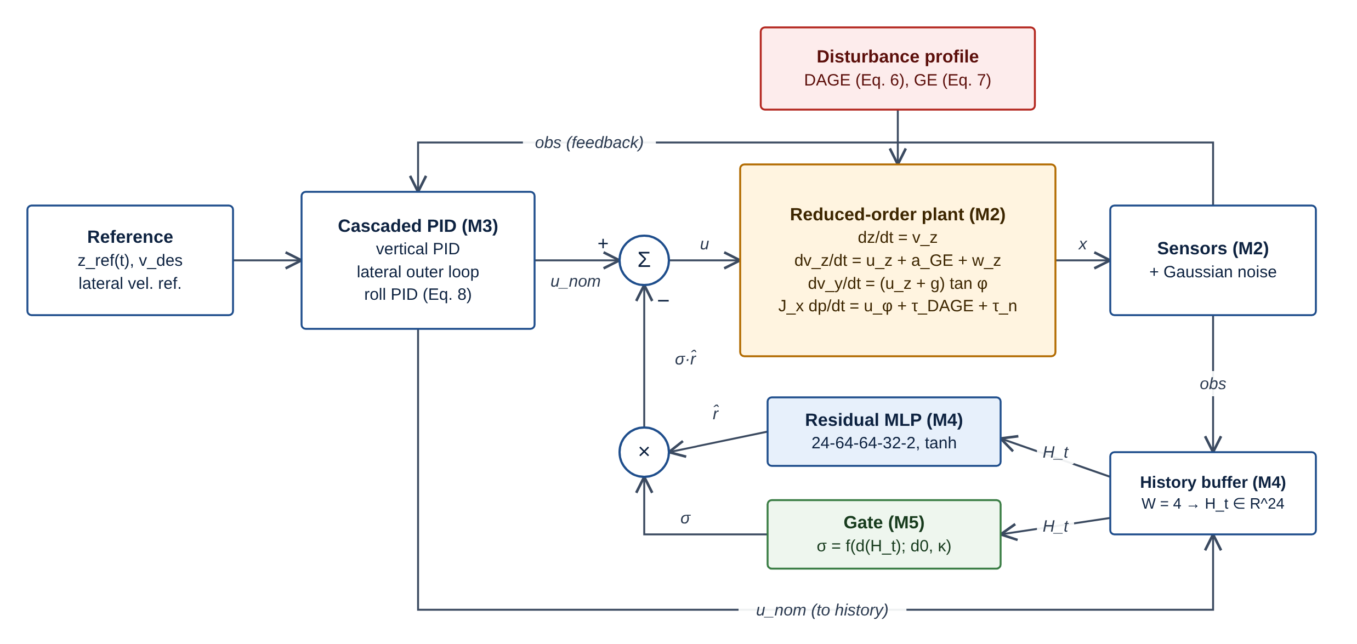
Figure 12: D-12 Gated residual control loop. The residual corrects rather than replaces the PID command; at sigma = 0 the loop is exactly the PID cascade.

15.4 Per-step algorithm (vectorised over trials)
for k in range(K_max): # K_max = T/dt = 1200
obs = noise.measure(x, rng) # FR-SIM-04
u_nom = pid.compute(obs, ref(k)) # FR-CTRL-01
H = history.push(obs, u_nom) # FR-RES-01, zero residual while k < 3
r_hat = predictor.predict(H) if residual # (tau_hat, a_hat), FR-RES-02/03
sigma = gate.sigma(H) if residual # FR-GATE-02, ConstantGate for Res-NG
u = u_nom - sigma * r_hat # FR-RES-04
tau_d, a_ge = disturbance(x, v_p) # FR-DIST-01/02, logged as ground truth
x[active] = integrate(x, u, tau_d, a_ge, w) # FR-SIM-01..03
done = touchdown(x) | diverged(x) # FR-TD-01, FR-ERR-01
log(k, ...); active &= ~done; if not active.any(): break

15.5 Metrics and statistics
For each trial M7 computes RMS(phi) and peak |phi| over steps with z < 1.0 m, and |v_y - v_p| and |v_z| at contact. Envelope success and roll violation follow the paper (Sec. V-D):
(15.8)
Rates are reported with the Wilson score interval [9], which behaves better than the normal approximation near 0 and 1:
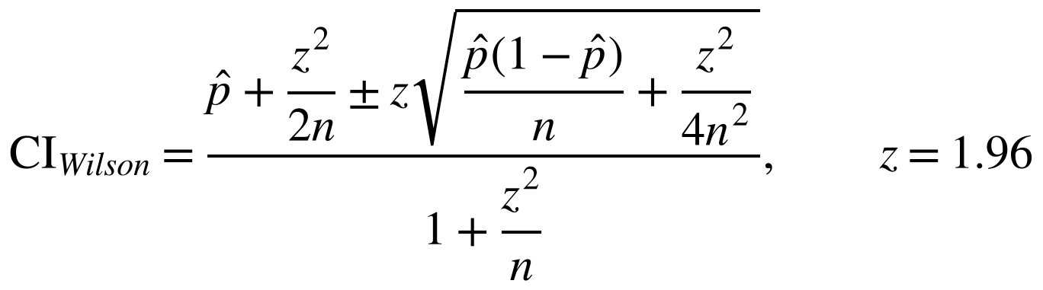 (15.9)
Paired differences against a reference controller (default PID) use trials matched by seed and 20,000 bootstrap resamples of the per-trial differences [10], with the resampling seed recorded. The implementation is checked against the paper's own intervals (UT-24): for example k = 404 of n = 500 gives [77.1, 84.0]%.

16 Neural-Network Training and Inference Workflow
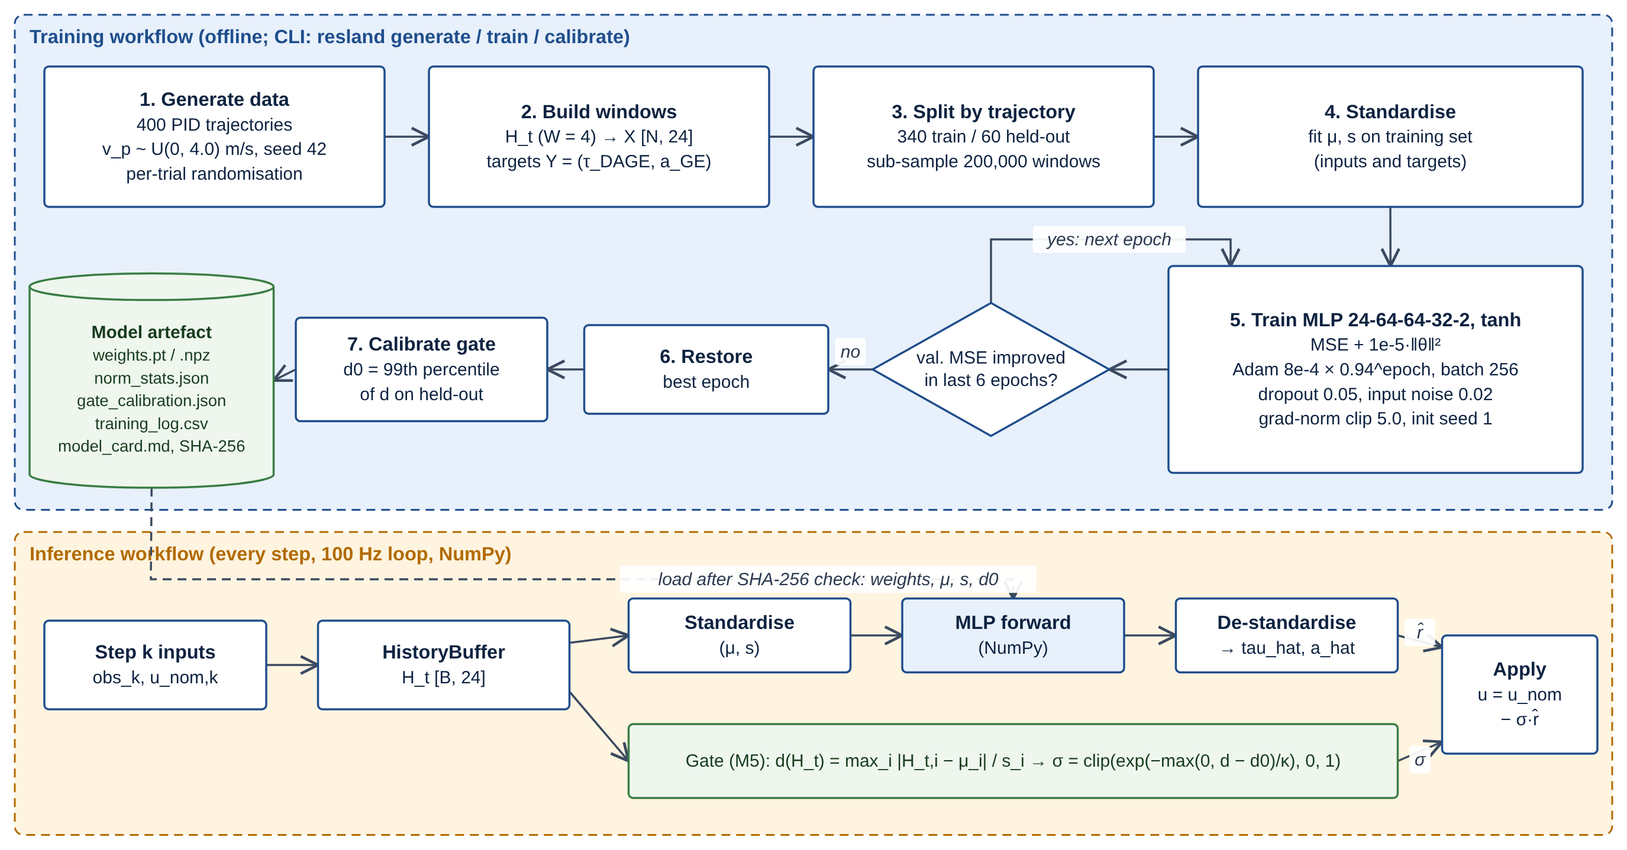
Figure 13: D-09 Training workflow (offline) and inference workflow (inside the control loop). The artefact is verified by SHA-256 before loading.

16.1 Network
Table 25: Residual MLP layers (paper Sec. VI-B; parameter count verified in Appendix B)
Layer | Shape | Activation | Parameters | MACs
Input | 24 = 4 steps × 6 signals | - | - | -
Dense 1 | 24 → 64 | tanh | 1,600 | 1,536
Dense 2 | 64 → 64 | tanh | 4,160 | 4,096
Dense 3 | 64 → 32 | tanh | 2,080 | 2,048
Output | 32 → 2 (tau_hat_phi, a_hat_z) | linear (proposed, OI-13) | 66 | 64
Total |  |  | 7,906 | 7,744

16.2 Training protocol
Table 26: Training configuration (paper Sec. VI-A and VI-C)
Item | Value | Source
Data | 400 PID trajectories, v_p ~ U(0, 4.0) m/s, per-trial randomisation, seed 42 | Paper
Split | By trajectory: 60 held-out (validation), 340 training; 200,000 training windows sub-sampled | Paper
Inputs / targets | 24-dim window of (phi, p, z, v_z, u_phi, u_z); targets (tau_DAGE, a_GE), standardised | Paper
Loss | MSE on standardised targets + 1e-5 ||theta||^2 (Eq. 16.1) | Paper
Optimiser | Adam, lr 8e-4 × 0.94^epoch, batch 256 | Paper
Regularisation | Dropout 0.05, Gaussian input noise 0.02 (standardised), gradient-norm clip 5.0 | Paper; dropout placement proposed
Stopping | Early stopping on validation MSE, patience 6, restore best epoch | Paper
Initialisation seed | 1 | Paper
Framework | PyTorch (CPU, deterministic algorithms) | Proposed (OI-18)
Paper-reported outcome (reference) | Stopped at epoch 43; best epoch 37; validation MSE 0.00723 (standardised) | Paper; compared in EV-04

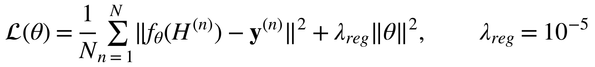 (16.1)

16.3 Inference and export
After training, weights and normalisation statistics are exported to weights.npz and the gate threshold d0 is calibrated on held-out windows. In the loop, ResidualPredictor performs the forward pass with NumPy matrix products on a [B, 24] batch. UT-17 requires NumPy and PyTorch outputs to agree within 1e-5. Model loading uses non-executable formats only (NumPy .npz, or torch.load with weights_only=True) and verifies the SHA-256 checksum (NFR-DATA-02).
Proposed implementation decision. (OI-14) The residual output is zero for the first three steps of each trial, until the four-step window is full (OI-14). Feature order inside the window follows the paper's notation H_t = [x_(t-3..t); u_(t-3..t)].

17 Software Development Life-Cycle Model
Selected model: iterative-incremental development (Scrum-style two-week sprints) with staged validation gates. Each increment delivers a vertical slice that is verified before the next layer is built on it: dynamics before controllers, controllers before the runner, baselines before the residual network, and the numerical core before the dashboard.
Table 27: SDLC models considered
Model | Fit for this project | Assessment
Waterfall | Requires complete requirements up front; 25 open items will be resolved during implementation | Rejected
V-model | Strong verification mapping, but sequential; late integration of the residual network with the simulator is risky | Verification idea adopted (test level per design level)
Spiral | Risk-driven iterations suit research uncertainty, but heavy for a three-person student team | Risk review adopted at each sprint boundary
Pure Scrum | Iterative and flexible, but weak on fixed documentation and validation milestones required by the university | Adapted
Iterative-incremental with staged validation gates | Small increments, each closed by named tests; fortnightly guide review; documentation kept current | Selected

17.1 Phases, deliverables and exit criteria
Table 28: Life-cycle phases
Phase | Main activities | Deliverables | Exit criterion (validation gate)
Requirements gathering | Paper analysis, open-item log, requirement catalogue | This specification v1.0 | Guide approval; open items assigned
Architecture and design | Layering, interfaces, UML, wireframes, RTM | Diagrams, wireframes, scaffold | Design review at Evaluation 2
Dynamics implementation | M1, M2, CI pipeline | Simulator core | UT-01..UT-08 pass
Controller implementation | M3, touchdown, basic metrics | PD, PID, PID+DOB | UT-09..UT-12, UT-21..23, IT-01, IT-02 pass
Runner and evaluation | M6 vectorised runner, M7 statistics | Baseline rows of Table III | UT-24..28, IT-06 pass; baseline fidelity recorded
Dataset generation | DatasetBuilder, trajectory split | Training data (regenerable) | UT-29 pass
Neural-network training | Trainer, export, calibration | Model artefact v1 | UT-13..17, UT-30, IT-05 pass; EV-04 recorded
Integration | Residual controller, gate, all plans | Tables III-V plans | IT-03, IT-04, ST-01..03, RT-01, RT-02 pass
UI development | M8, M9 four screens, export, reload | Dashboard | IT-08, IT-09, ST-04..06 pass
Testing and validation | System tests, performance, cross-platform, fidelity report | Test report, fidelity report | All MVP tests executed; ST-07 pass
Documentation and demonstration | Report, README, demo video, viva | Final package | Guide sign-off

17.2 Working practices
- Two-week sprints with a planning note and a review with the guide (proposed fortnightly).
- Definition of Done for a backlog item: code with type hints and requirement IDs in docstrings, unit tests passing in CI, RTM updated, no ruff violations.
- Git feature branches with pull-request review by a second team member; main branch protected by CI.
- Proposed role allocation (to be agreed by the team): Ravi Deo - residual learning, gate, integration lead; Arjun Saharawat - simulator, controllers, runner; Yash Bhadauria - visualisation, dashboard, test automation. All members share documentation and testing.

The minimum viable project comprises modules M1-M9, the five controllers, the three paper plans and the four dashboard screens. Extensions E1-E6 start only after the MVP exit criterion (S9) is met.

18 Technology Stack and Justification
Table 29: Technology stack
Concern | Choice | Justification | Alternatives considered
Language | Python ≥ 3.10 | Team expertise; scientific ecosystem; matches paper code base | MATLAB (licence; not a CSE software stack)
Simulation | NumPy | Vectorised array maths for batched trials; paper's code is NumPy | Numba/JAX (added complexity; consider only if ST-08 fails)
Neural network | PyTorch (training) | Autograd, Adam, dropout, deterministic CPU mode; widely taught | TensorFlow (no benefit here); hand-written NumPy training (more code to verify)
Data handling | pandas | Per-trial tables, group-by aggregation, CSV I/O | Polars (unnecessary for this data size)
Plots | Plotly (interactive) + Matplotlib (static export) | Plotly integrates with Streamlit for zoom/hover; Matplotlib gives publication figures and SVG | Only one library would compromise either interactivity or print quality
Dashboard | Streamlit | Python-only UI, fast to build, built-in testing (AppTest) | Dash, React (more front-end effort, little benefit)
Configuration | pydantic + PyYAML | Typed schema with range validation and field-level error messages (FR-CFG-02) | dataclasses + manual checks (more code)
Testing | pytest, pytest-cov, Streamlit AppTest | Parametrised numerical tests, coverage, UI tests without a browser | unittest (more boilerplate)
Code quality | ruff, import-linter | Fast lint/format; enforce layer contracts (NFR-MAINT-01) | flake8 + black (two tools)
Versioning and CI | Git, GitHub, GitHub Actions | Branching, review, CI on Windows and Linux runners | GitLab CI (equivalent)
Environment | pyproject.toml + lock file (pip-tools or uv) | Pinned versions recorded per run (NFR-REPRO-02) | conda (heavier)
Design tools | diagrams.net, Mermaid, HTML/CSS wireframes | Editable, version-controllable sources; Mermaid renders on GitHub; wireframes open in any browser and can be imported into Figma | Visio (licence); screenshots only (not editable)

Not used: ROS, Gazebo, PX4 or a 6-DoF simulator (outside scope, Section 6.4); GPU requirement; databases (file-based results suffice); web hosting.

19 UML and Other Design Diagrams
All diagrams have editable sources. The draw.io files open in diagrams.net (desktop or web); Mermaid sources render in GitHub, VS Code and mermaid.live. For diagrams laid out by hand (D-01 to D-05, D-07a-c, D-08, D-09, D-12) the Mermaid file is generated from the same definition as the draw.io file, so the content is identical but the automatic layout differs.
Table 30: Diagram index
ID | Diagram | Section | Editable sources (03_Diagrams/)
D-01 | System context diagram | Section 11 | drawio/D-01_system_context.drawio, mermaid/D-01_system_context.mmd
D-02 | High-level software architecture (layered) | Section 12 | drawio/D-02_architecture.drawio, mermaid/D-02_architecture.mmd
D-03 | UML use-case diagram | Section 8 | drawio/D-03_use_case.drawio, mermaid/D-03_use_case.mmd
D-04 | UML component diagram | Section 12 | drawio/D-04_component.drawio, mermaid/D-04_component.mmd
D-05 | UML activity diagram - complete experiment | Section 14 | drawio/D-05_activity_experiment.drawio, mermaid/D-05_activity_experiment.mmd
D-06 | UML sequence diagram - simulation and control loop | Section 14 | mermaid/D-06_sequence_control_loop.mmd
D-07a | UML class diagram - configuration | Section 13 | drawio/D-07a_class_configuration.drawio, mermaid/D-07a_class_configuration.mmd
D-07b | UML class diagram - simulation and experiments | Section 13 | drawio/D-07b_class_simulation_experiments.drawio, mermaid/D-07b_class_simulation_experiments.mmd
D-07c | UML class diagram - controllers, residual model and gate | Section 13 | drawio/D-07c_class_controllers_residual_gate.drawio, mermaid/D-07c_class_controllers_residual_gate.mmd
D-08 | Data-flow diagram (level 1) | Section 14 | drawio/D-08_dataflow.drawio, mermaid/D-08_dataflow.mmd
D-09 | Neural-network training and inference workflow | Section 16 | drawio/D-09_nn_workflow.drawio, mermaid/D-09_nn_workflow.mmd
D-10 | Experiment execution workflow (plans) | Section 14 | mermaid/D-10_experiment_workflow.mmd
D-11 | Requirements traceability matrix diagram | Section 23 | mermaid/D-11_traceability.mmd (network view); matrix generated from spec
D-12 | Gated residual control-loop block diagram | Section 15 | drawio/D-12_control_block.drawio, mermaid/D-12_control_block.mmd
D-13 | Implementation schedule (Gantt) | Section 26 | mermaid/D-13_gantt.mmd; PNG/SVG from schedule data

20 User-Interface Design and Wireframes
The dashboard follows Streamlit's layout conventions: a sidebar for navigation, saved runs and model status, and a main area per page. The wireframes are editable HTML/CSS (04_Wireframes/ResLand_Dashboard_Wireframes.html). All result values in them are placeholders (##) or illustrative curve shapes; the single paper-reported row demonstrates provenance labelling.
Table 31: Screen design rationale
Screen | Purpose | Requirements | Key design decisions | States shown
W-01 Experiment Setup | Define a valid experiment without code | FR-UI-01, FR-CFG-01..04, FR-MC-01/02, FR-DIST-03, NFR-USE-01 | Grouped cards; unit and range on every field; Run disabled until valid; extrapolation speeds marked †; TBC badges on unresolved parameters | Valid (W-01a), validation error (W-01b)
W-02 Simulation View | Understand one landing | FR-UI-02, FR-VIS-02/03, FR-MC-03 | Schematic side view with time slider; four signals with final-approach shading; gate trace for Res-G; progress banner with cancel | Loading (W-02a), empty (W-02b)
W-03 Controller Comparison | Compare controllers on one paired trial | FR-UI-03, FR-VIS-01, FR-CMP-01 | Four synchronised plots (roll, lateral mismatch, altitude, vertical velocity); controller toggles with fixed colours; trial index picker | Populated (W-03)
W-04 Results & Analysis | Read the quantitative outcome | FR-UI-04, FR-RPT-01..03, FR-CMP-02/03, FR-EXP-02 | KPI cards with Wilson CI; bar chart with CI whiskers; Table III layout with provenance badges; paired differences; export panel; simulation-only notice | Completion (W-04a), run error (W-04b)

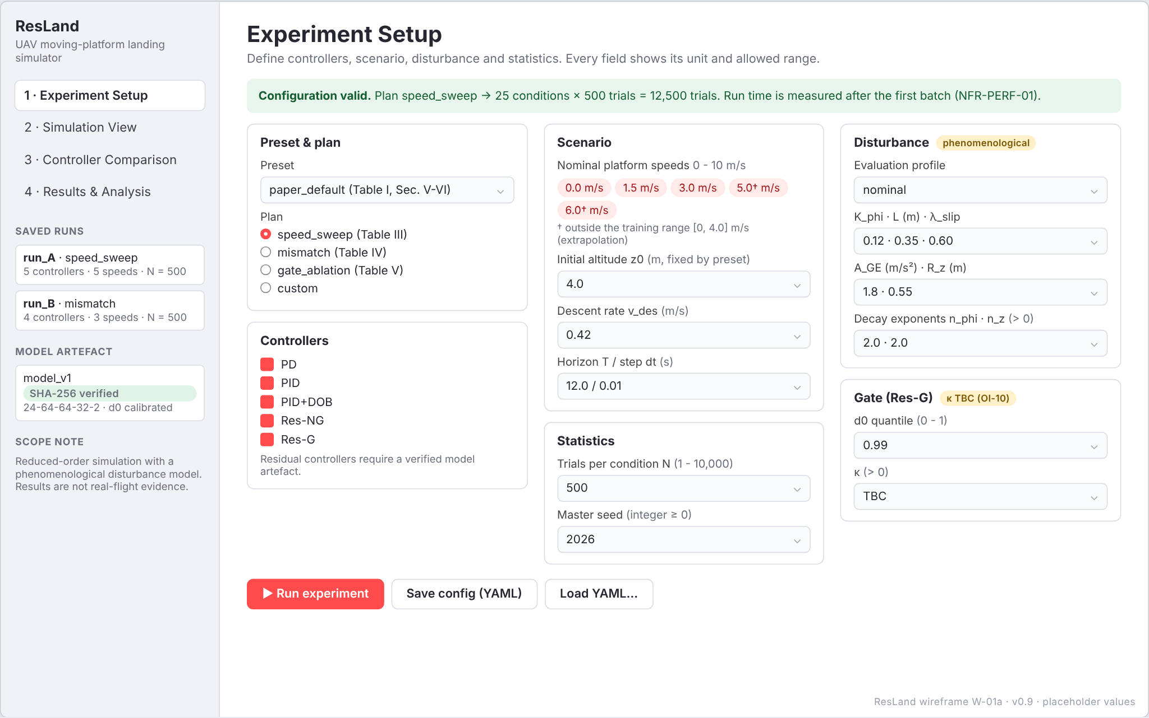
Figure 14: W-01a Experiment Setup, valid configuration (wireframe; placeholder values).
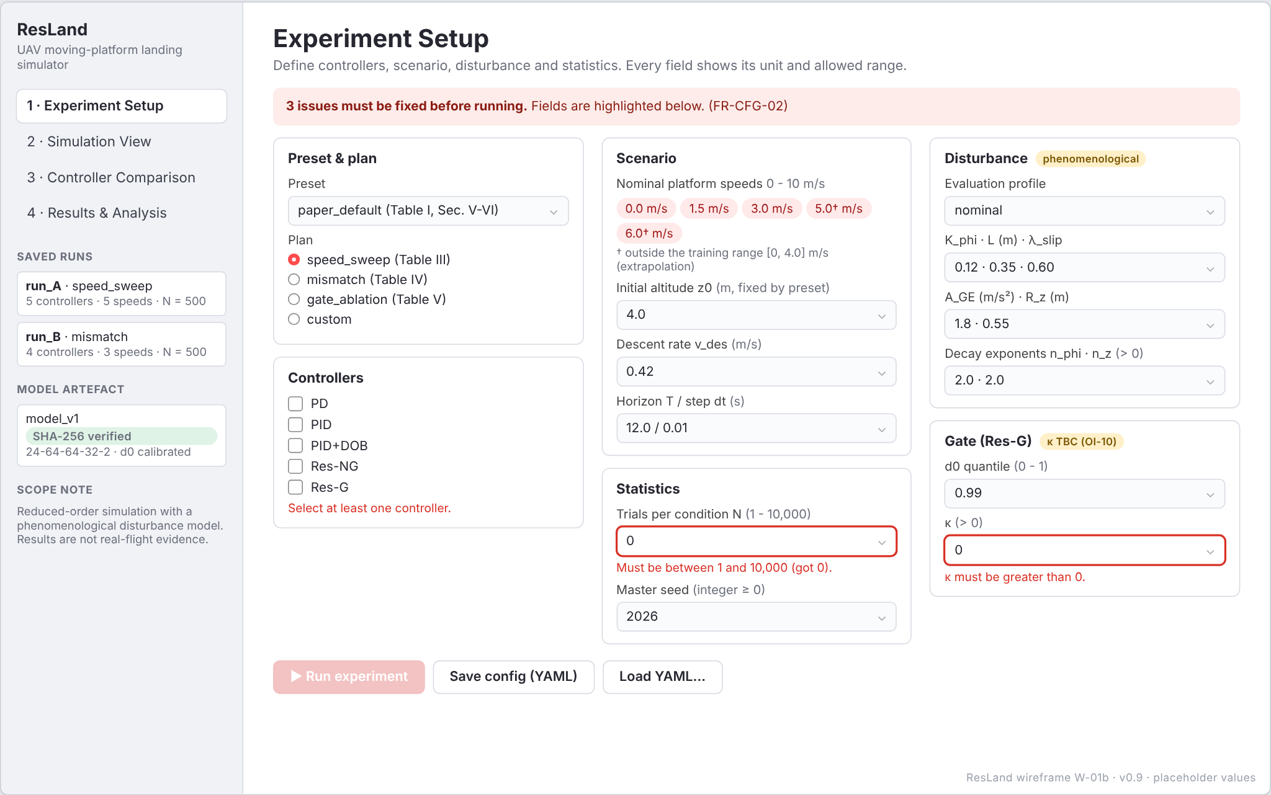
Figure 15: W-01b Experiment Setup, validation-error state (wireframe; placeholder values).
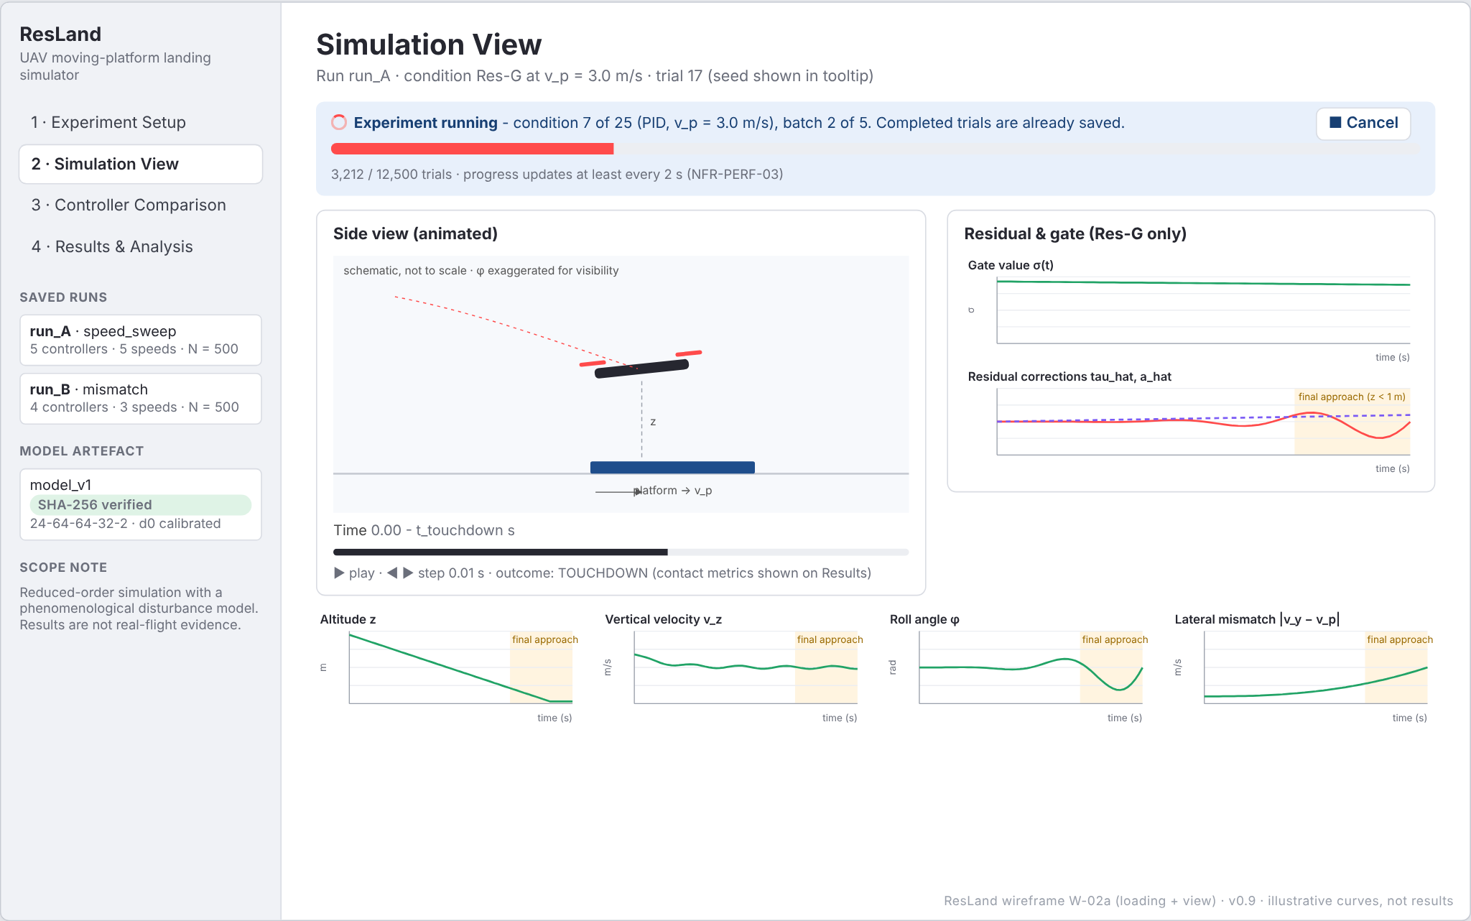
Figure 16: W-02a Simulation View, run in progress with trial animation (wireframe; placeholder values).
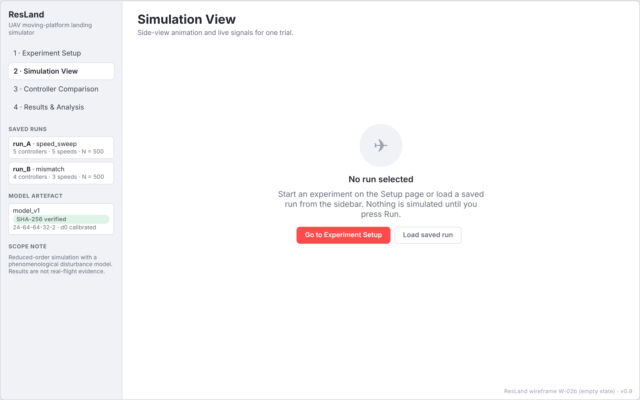
Figure 17: W-02b Simulation View, empty state (wireframe; placeholder values).
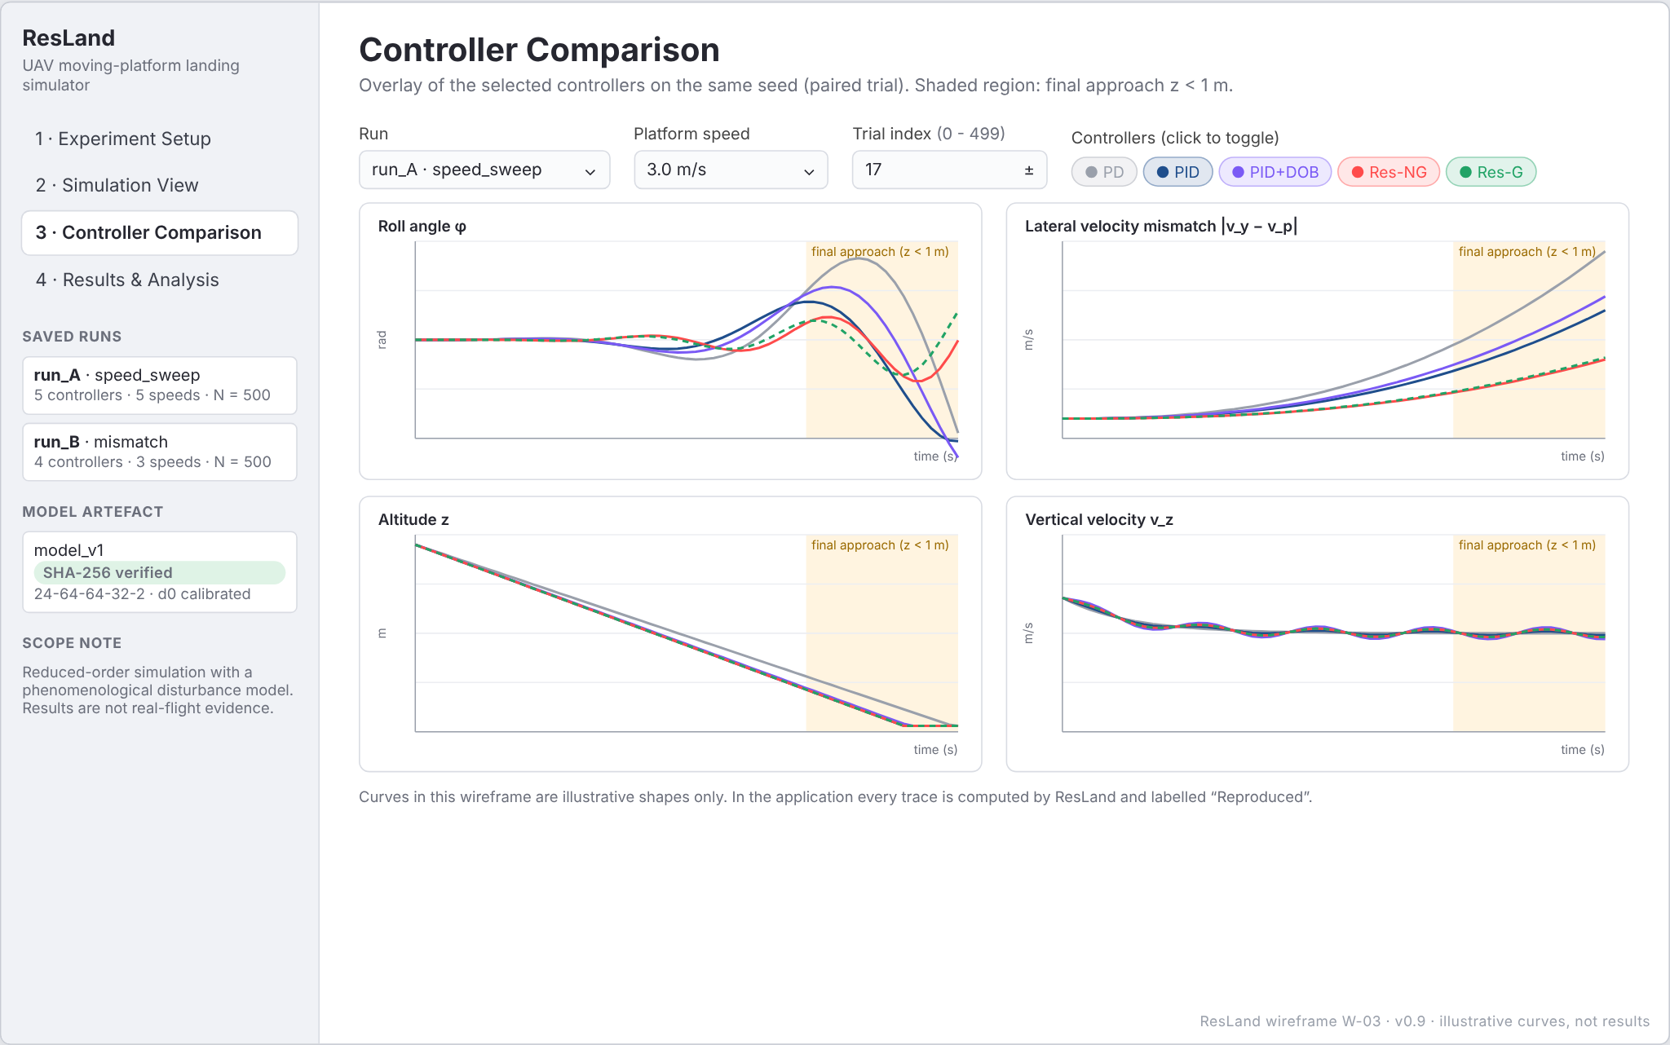
Figure 18: W-03 Controller Comparison (wireframe; placeholder values).
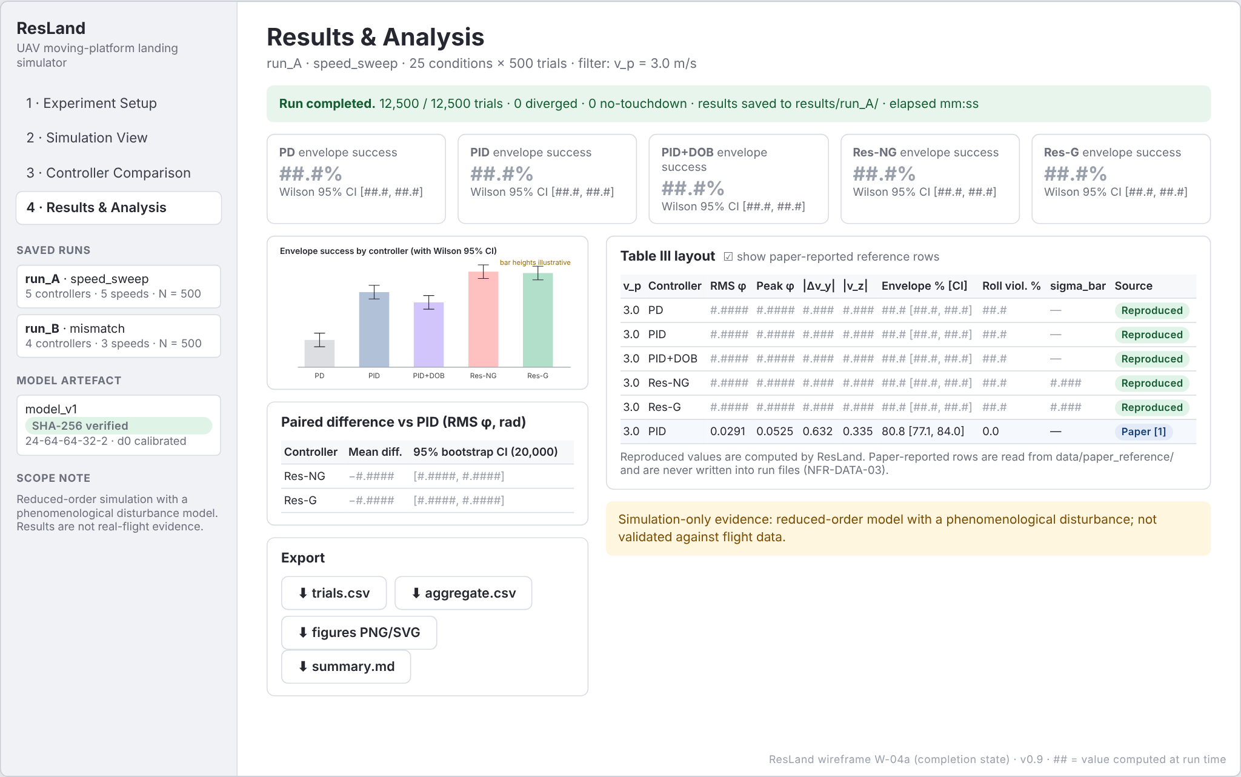
Figure 19: W-04a Results and Analysis, completion state (wireframe; placeholder values).
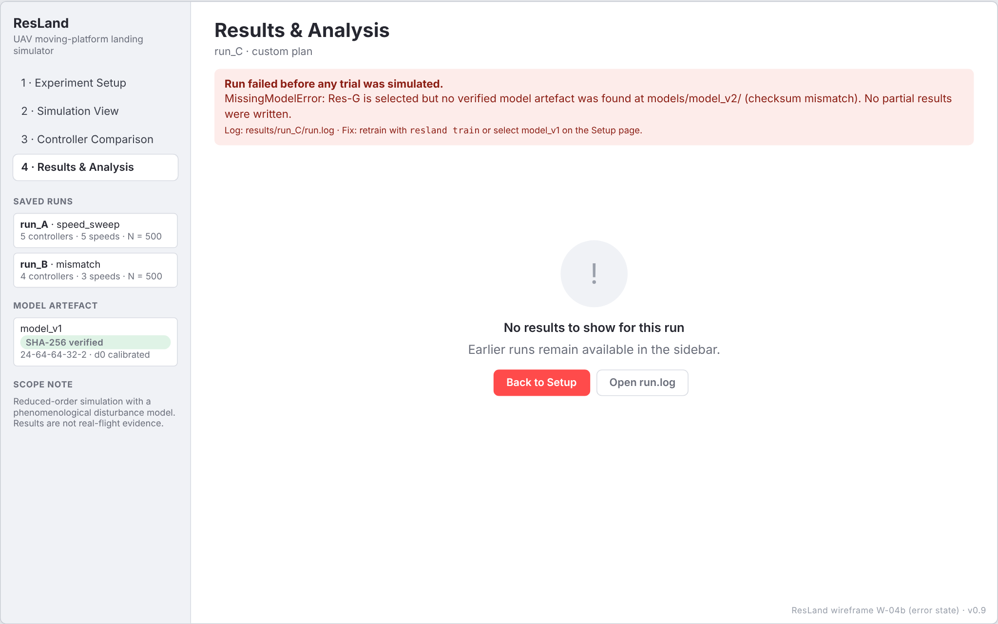
Figure 20: W-04b Results and Analysis, run-error state (wireframe; placeholder values).

21 Data Structures, Configuration Management and Experiment Logging

21.1 Core in-memory structures
Table 32: Core data structures (arrays have a leading batch dimension B)
Structure | Fields | Producer → consumer
SimState | z, v_z, y, v_y, phi, p (true state, float64 [B]) | M2 → M2
Observation | z, v_z, phi, p with sensor noise; lateral tracking signal; a_meas for DOB | M2 → M3/M4
Command | u_z (vertical acceleration command), u_phi (roll torque), diag dict | M3/M4 → M2
TrialBatch | trial_idx, seed, v_p, K_phi_scale, A_GE_scale, Jx_scale, y0, phi0, initial velocities | M6 → M2
TrajectoryBatch | t, true and measured states, u_nom, u, tau_hat, a_hat, sigma, d, tau_DAGE, a_GE, dob_hat, outcome, t_touchdown, contact state | M2 → M7/M8
WindowDataset | X [N, 24], Y [N, 2], traj_id [N], normalisation statistics | M4 → M4

21.2 Result files
Table 33: trials.csv schema (one row per trial; key = run_id, condition_id, controller, trial_idx)
Column | Type / unit | Description
schema_version | str | Results schema version
run_id, condition_id | str | Run and condition identifiers
controller | str | PD | PID | PID+DOB | Res-NG | Res-G
v_p_nominal, v_p | m/s | Nominal and sampled platform speed
profile_train, profile_eval | str | Disturbance profiles
trial_idx, seed | int | Trial index and per-trial seed (paired across controllers)
y0, phi0, K_phi_scale, A_GE_scale, Jx_scale | m, rad, - | Sampled initial conditions and scalings
rms_phi, peak_phi | rad | Final-approach roll metrics (z < 1 m)
dvy_contact, vz_contact, phi_contact | m/s, m/s, rad | Contact metrics
envelope_success, roll_violation | bool | Classification (FR-ENV-03/04)
sigma_mean | - | Mean gate value (residual controllers only)
outcome, t_touchdown | str, s | TOUCHDOWN | NO_TOUCHDOWN | DIVERGED | ERROR
source | str | Always 'Reproduced' in run files

aggregate.csv holds one row per (condition, controller) with n, metric means, success and violation counts and rates, Wilson bounds and sigma_bar; paired_diffs.csv holds mean paired differences and bootstrap bounds against the reference controller.

21.3 Directory layout of a run and a model
results/<run_id>/ # run_id = UTC timestamp + short config hash
config.resolved.yaml # every parameter after presets and overrides
manifest.json # versions, git commit, seeds, model SHA-256, status
trials.csv aggregate.csv paired_diffs.csv
trajectories/ (optional .npz) figures/ summary.md run.log
models/<model_id>/
weights.pt weights.npz norm_stats.json gate_calibration.json
training_log.csv model_card.md SHA256SUMS

21.4 Configuration management
- Configurations are YAML files under configs/ with a schema_version; presets (paper_default, paper_mismatch, smoke) are read-only and versioned in Git.
- Every parameter carries its source in a comment (paper table/section or 'proposed'); unresolved items are marked TBC and listed in Appendix A.
- The CLI and dashboard never modify a preset; overrides produce a new resolved file saved with the run.
- Generated datasets, model checkpoints and results are excluded from Git (.gitignore) and regenerated from configs; small golden files for regression tests are committed.

# configs/paper_default.yaml (excerpt)
schema_version: '1.0'
sim: {dt: 0.01, T: 12.0, z0: 4.0, v_des: 0.42, m: 1.5, J_x: 0.020, integrator: semi_implicit} # integrator TBC (OI-04)
noise: {sigma_z: 0.010, sigma_vz: 0.030, sigma_phi: 0.004, sigma_p: 0.020, process: TBC} # Table I; OI-05
profiles:
nominal: {K_phi: 0.12, L: 0.35, lambda_slip: 0.60, n_phi: 2.0, A_GE: 1.8, R_z: 0.55, n_z: 2.0}
mismatch: {K_phi: 0.168, L: 0.455, lambda_slip: 1.00, n_phi: 1.6, A_GE: 2.43, R_z: 0.77, n_z: 1.6} # Sec. VII-D
controllers: {vertical: [2.2, 2.6, 1.6], roll: [60, 11, 30], lateral: TBC, dob_tau: 1.0}
randomisation: {K_phi: [0.80, 1.20], A_GE: [0.85, 1.15], J_x: [0.90, 1.10], v_p: [0.90, 1.10], y0_sd: 0.5, phi0_sd: 0.03}
thresholds: {phi_max: 0.10, vz_max: 0.75, dvy_max: 0.75, z_final: 1.0}

Note. Mismatch values are the paper's scalings applied to Table I: K_phi 0.12 × 1.40 = 0.168, A_GE 1.8 × 1.35 = 2.43, L 0.35 × 1.30 = 0.455, R_z 0.55 × 1.40 = 0.77.

21.5 Experiment logging
manifest.json records: run_id, start and end time, status (COMPLETED | CANCELLED | FAILED), plan, conditions, master seed and derived seed ranges, ResLand version, Git commit and dirty flag, Python and package versions, platform, model_id and SHA-256, counts of each outcome, and wall-clock time per condition. run.log contains structured records (timestamp, level, module, run_id, message) for start, each batch, warnings (e.g., NaN windows forcing sigma = 0) and completion or error.

22 Testing Strategy and Test Cases
Testing separates two different questions:
- Software correctness (UT, IT, ST, RT): does the code implement the specified equations, interfaces and behaviours? These tests have deterministic pass/fail criteria and run in CI.
- Experimental validation (EV): how closely do ResLand's control-performance results reproduce the paper? These are measurements, not pass/fail tests; a deviation triggers investigation of open items rather than counting as a defect.

Table 34: Test levels
Level | Count | Scope | Tooling | When run
Unit (UT) | 30 | Equations, controllers, network shapes, gate, metrics, statistics, I/O | pytest (parametrised) | Every push
Integration (IT) | 9 | Simulator + controllers, training pipeline, runner + evaluation, UI hand-off | pytest, Streamlit AppTest | Every push
System (ST) | 8 | CLI plans, dashboard states and validation, export, cross-platform, performance | pytest, AppTest, CI matrix, manual checklist | Sprint end
Regression (RT) | 3 | Golden-file results, model inference, CI quality gates | pytest, GitHub Actions | Every push
Experimental validation (EV) | 6 | Reproduction of Tables III-V, training, VII-F effect, extension E1 | CLI plans, fidelity report | After S5, S6, S9

Caution. Status of every test case: Not executed. This is a design-stage specification; no test has been run and no pass is claimed.

Golden values from the paper are used where the paper defines them unambiguously, for example the Wilson intervals in UT-24 and the parameter and MAC counts in UT-14. Invariants that follow from the design give strong integration tests without needing reference data: with sigma = 0 the residual controller must reproduce the PID trajectory exactly (IT-03), and Res-G with an infinite threshold must equal Res-NG (IT-04).

22.1 Test case catalogue
Table 35: Test cases (full preconditions and steps in Test_Plan.xlsx)
ID | Level | Title | Requirements | Preconditions / steps | Expected result | Pass criterion
UT-01 | Unit | Load paper_default preset | FR-CFG-01, FR-CFG-03 | configs/paper_default.yaml present | Load preset; compare each field with the Table I reference dictionary. | All Table I values equal; schema version matches. | All assertions pass.
UT-02 | Unit | Configuration validation rejects invalid values | FR-CFG-02 | Invalid-config fixtures | For each fixture call validate(). | Exactly one ValidationIssue naming the faulty field and its allowed range. | Issue count and field names match for every fixture.
UT-03 | Unit | Seed derivation and pairing | FR-CFG-04 | - | derive_trial_seeds(42, 500) twice; expand a 2-controller condition. | Identical arrays; both controllers receive the same seeds. | Arrays equal element-wise.
UT-04 | Unit | Dynamics single-step correctness | FR-SIM-01, FR-SIM-03, FR-SIM-05 | Noise disabled | Step from a known state with known command and disturbance; compare with hand-computed Euler update. | State difference < 1e-12; step count never exceeds 1,200. | Max abs error < 1e-12.
UT-05 | Unit | Lateral-roll coupling | FR-SIM-02 | Noise disabled | Evaluate dv_y/dt over a grid of phi and u_z. | Equals (u_z + g) tan(phi). | Max abs error < 1e-12.
UT-06 | Unit | DAGE torque equation | FR-DIST-01, FR-SIM-06 | - | Evaluate tau_DAGE at 6 reference points. | Matches hand-computed Eq. 6 values; zero slip contribution when v_y = v_p. | Max abs error < 1e-12.
UT-07 | Unit | Ground-effect equation and mismatch profile | FR-DIST-02, FR-DIST-03 | - | Evaluate a_GE at z in {0, R_z, 2R_z}; resolve 'mismatch' profile. | Correct values; mismatch scalings and exponent 1.6 applied. | All values match.
UT-08 | Unit | Noise statistics | FR-SIM-04 | Fixed seed | Draw 100,000 samples per channel. | Sample s.d. within 2% of configured; mean within 3 standard errors of 0. | Both bounds hold for all channels.
UT-09 | Unit | PID/PD law and descent reference | FR-CTRL-01, FR-CTRL-02, FR-CTRL-04 | Lateral gains set in fixture | Feed a scripted error sequence; compare with hand-computed PID; check PD = PID with K_I = 0; check z_ref values. | Outputs match to 1e-12; z_ref(0) = 4.0, z_ref(5) = 1.9. | All assertions pass.
UT-10 | Unit | Controller interface conformance | FR-CTRL-03, NFR-MAINT-03 | All 5 configurations plus a dummy controller registered | Instantiate, reset(B=8), compute on a random observation. | Finite Command with arrays of shape [8]. | No exception; shapes and finiteness correct.
UT-11 | Unit | Saturation and anti-windup | FR-CTRL-05 | Limits enabled in fixture | Apply a saturating error for 1,000 steps. | Commands within bounds; integrator bounded. With limits disabled, output equals unbounded law. | Bounds never exceeded.
UT-12 | Unit | Vertical DOB convergence | FR-DOB-01 | Noise off; constant disturbance d | Run DOB for 5 s at 100 Hz. | Relative estimation error < 1% (first-order response after 5 time constants). | |d_hat - d|/|d| < 0.01.
UT-13 | Unit | History buffer ordering and warm-up | FR-RES-01 | - | Push 5 known steps; inspect window; check outputs during warm-up. | Window holds steps 2-5 in documented order (24 values); residual = 0 for first 3 steps. | Exact equality.
UT-14 | Unit | MLP dimensions and cost | FR-RES-02, NFR-PERF-04 | - | Build ResidualMLP; count parameters; forward a [B,24] batch; compute MACs from layer shapes. | 7,906 parameters; 7,744 MACs; output [B,2]. | Counts equal; shape correct.
UT-15 | Unit | Standardisation round trip | FR-RES-03 | Synthetic statistics | standardise then destandardise random inputs and outputs. | Round trip exact to 1e-12. | Max abs error < 1e-12.
UT-16 | Unit | Model artefact loading and rejection | FR-RES-05, NFR-DATA-02 | Valid artefact fixture plus 3 corrupted variants | Load each. | Valid loads; altered shape, schema version or checksum raise ModelLoadError. | Outcomes as expected for all 4.
UT-17 | Unit | NumPy vs PyTorch inference equivalence | FR-TRN-04 | Trained or random-initialised model exported | Run both paths on 1,000 random windows. | Max abs difference < 1e-5 (float32). | Bound holds.
UT-18 | Unit | Gate distance definition | FR-GATE-01 | mu = 0, s = 1 | Evaluate d on vectors with one large feature vs many moderate features. | d equals the maximum standardised deviation, not the mean. | Exact equality.
UT-19 | Unit | Gate authority edge cases | FR-GATE-02, FR-GATE-05 | - | Evaluate sigma at d < d0, d = d0, d = d0 + kappa, very large d, NaN input; construct with kappa = 0. | 1, 1, exp(-1), ~0, 0; kappa = 0 rejected. | All values within 1e-12; error raised.
UT-20 | Unit | Gate calibration percentile | FR-GATE-03 | Synthetic validation windows | calibrate_d0(q = 0.99). | Equals numpy.quantile of computed distances. | Difference < 1e-12.
UT-21 | Unit | Touchdown detection | FR-TD-01, FR-TD-02 | Scripted trajectories | Descent crossing z = 0 between steps; hover-only trajectory. | Touchdown at first step with z <= 0; hover yields NO_TOUCHDOWN. | Indices and outcome codes match.
UT-22 | Unit | Touchdown metric calculation | FR-ENV-01, FR-ENV-02 | Synthetic trajectory with known phi(t) | Compute metrics. | RMS and peak over z < 1 m and contact values match hand calculation. | Abs error < 1e-12.
UT-23 | Unit | Envelope and roll-violation boundaries | FR-ENV-03, FR-ENV-04 | - | Classify values exactly at and 1e-9 above each threshold. | At threshold: success / no violation; above: failure / violation. | All classifications correct.
UT-24 | Unit | Wilson score interval | FR-RPT-01 | - | Compute intervals for (404, 500), (500, 500), (0, 500), (316, 500), (335, 500). | [77.1, 84.0], [99.2, 100.0], [0.0, 0.8], [58.9, 67.3], [62.8, 71.0] % (paper values, rounded). | All five match to one decimal.
UT-25 | Unit | Paired bootstrap | FR-CMP-02 | Fixed seed | Constant difference c; repeated call; unpaired input. | CI = [c, c]; identical results on repeat; PairingError on unpaired. | All assertions pass.
UT-26 | Unit | Divergence handling | FR-ERR-01, NFR-REL-01 | 50-trial batch | Inject NaN into trial 7. | Trial 7 DIVERGED; 49 trials complete normally. | Outcome counts 1/49.
UT-27 | Unit | Results writer schema and atomicity | FR-EXP-01, NFR-REL-02, NFR-DATA-01 | Temp directory | Write two batches; simulate crash during third. | CSV has documented header, schema_version, unique keys, whole batches only. | File parses; 2 batches present; keys unique.
UT-28 | Unit | Randomiser distributions | FR-INIT-01, FR-INIT-02 | Fixed seed | Sample 10,000 trials. | All scalings within bounds; moments within 3 standard errors. | All checks pass.
UT-29 | Unit | Dataset builder split | FR-TRN-01, FR-TRN-02 | Small config (40 trajectories, 6 held out) | Build and split. | No traj_id overlap; counts as configured; same seed reproduces arrays. | All checks pass.
UT-30 | Unit | Trainer early stopping | FR-TRN-03 | Mock validation-loss sequence | Run trainer loop with patience 6. | Stops 6 epochs after minimum; restores minimum epoch weights. | Restored epoch index correct.
IT-01 | Integration | Undisturbed closed-loop landing | FR-SIM-01, FR-DIST-04 | Disturbances and noise disabled; y0 = phi0 = 0; v_p = 0 | Run PID trial. | Touchdown occurs; |phi| < 1e-9 throughout. | Both conditions hold.
IT-02 | Integration | All controllers in the loop | FR-CTRL-03, FR-DOB-02 | Model artefact available | Run one trial at v_p = 3.0 for each of the 5 configurations. | Every trial ends TOUCHDOWN or NO_TOUCHDOWN without exception; logs complete. | No exceptions; required log fields present.
IT-03 | Integration | Residual with sigma = 0 equals PID | FR-RES-04 | Same seed | Run PID and Res-G with ConstantGate(0). | Trajectories identical. | Max abs difference = 0.
IT-04 | Integration | Res-G with infinite threshold equals Res-NG | FR-GATE-04 | Same seed | Run Res-NG and Res-G with d0 = inf. | Trajectories identical. | Max abs difference = 0.
IT-05 | Integration | Training pipeline end to end | FR-TRN-01, FR-TRN-03, FR-SIM-06 | Smoke config (20 trajectories, 3 epochs) | Generate data, train, export, load predictor, run one Res-NG trial. | Artefact files present and loadable; trial completes. | All steps succeed.
IT-06 | Integration | Runner plus evaluation | FR-MC-01, FR-CMP-01, FR-CMP-03, FR-EXP-01, FR-INIT-03, FR-ERR-04 | Smoke config: 3 controllers x 2 speeds x 20 trials | Run plan; inspect outputs. | 120 trial rows; 6 aggregate rows; seeds paired; sigma_bar populated for residual controllers; all run files present. | All checks pass.
IT-07 | Integration | Training and evaluation profile separation | FR-DIST-03 | Mismatch plan | Run with train = nominal, eval = mismatch. | Manifest records both; evaluation trajectories use mismatch parameters. | Logged parameters match profile.
IT-08 | Integration | Dashboard to runner hand-off | FR-UI-01 | Streamlit AppTest | Fill Setup form with valid values; press Run. | Runner receives a config equal to the form values. | Config equality holds.
IT-09 | Integration | Export and reload round trip | FR-EXP-03 | Completed smoke run | Export, then load_run(). | Reloaded aggregate equals original. | DataFrames equal.
ST-01 | System | Speed-sweep plan from CLI | FR-MC-02, FR-RPT-02, FR-ERR-03 | Trained model artefact | resland run --plan speed_sweep --trials 50 | 25 conditions run; Table III-format output written; exit code 0. | Output complete; exit 0.
ST-02 | System | Mismatch plan | FR-MC-02 | Trained model artefact | resland run --plan mismatch --trials 50 | 12 conditions; Table IV-format output. | Output complete.
ST-03 | System | Gate-ablation plan | FR-GATE-04, FR-MC-02 | Trained model artefact | resland run --plan gate_ablation --trials 30 | 13 conditions; Table V-format output. | Output complete.
ST-04 | System | Dashboard input validation | FR-UI-01, FR-CFG-02, NFR-USE-01 | Dashboard running | Enter trials = 0, speed = -1, kappa = 0, no controller selected. | Inline message per field naming allowed range; Run disabled. | All four messages shown; Run disabled.
ST-05 | System | Dashboard states | FR-UI-02, FR-UI-03, FR-UI-05, FR-MC-03, FR-VIS-02, FR-VIS-03, NFR-PERF-03, NFR-USE-02 | Dashboard running | Open with no runs; start run; cancel; start and complete run; force runner error. | Empty, progress, cancelled, complete and error states shown as specified. | Each state appears with specified text.
ST-06 | System | Export functionality | FR-EXP-02, FR-RPT-03, FR-UI-04, FR-VIS-01, FR-EXP-04, NFR-DATA-03 | Completed run | Download CSV, PNG, SVG and summary from Results screen. | Files open; CSV has 'source' column; PNG >= 1200 px wide. | All files valid.
ST-07 | System | Cross-platform smoke test | NFR-PORT-01 | CI runners: windows-latest, ubuntu-latest | Install from lock file; run pytest -m smoke. | All smoke tests pass on both. | Both jobs green.
ST-08 | System | Performance measurement | NFR-PERF-01, NFR-PERF-02, NFR-PERF-04 | Reference machine documented | Time 500-trial PID and Res-G conditions and the full Table III plan (3 repeats). | Times recorded and compared with proposed targets. | Pass if within targets; otherwise targets revisited with guide.
RT-01 | Regression | Golden-file regression | FR-ERR-02, FR-CFG-05, NFR-REPRO-01 | Golden CSV committed (20 trials, 2 speeds, 3 controllers) | Re-run regression config; diff with golden file. | Byte-identical trials.csv. | Diff empty.
RT-02 | Regression | Model inference regression | FR-RES-05 | Fixed checkpoint and stored input batch | Predict and compare with stored outputs. | Max abs difference < 1e-7. | Bound holds.
RT-03 | Regression | Continuous integration suite | NFR-MAINT-01, NFR-MAINT-02, NFR-TEST-01, NFR-TEST-02 | GitHub Actions configured | On each push: ruff, import-linter, pytest with coverage, RTM check script. | All jobs succeed; coverage >= target; zero unmapped requirements. | Workflow green.
EV-01 | Experimental validation | Reproduce Table III (speed sweep) | FR-MC-02 | Open items OI-01..OI-10 resolved | Run speed sweep with 500 trials; compare with paper values. | Reproduced envelope-success rates fall inside the paper's Wilson intervals, or deviations are explained by documented open items. | Fidelity assessment, not a software pass/fail; deviations logged.
EV-02 | Experimental validation | Reproduce Table IV (model mismatch) | FR-MC-02, FR-DIST-03 | As EV-01 | Run mismatch plan with 500 trials. | Qualitative ordering PD < PID < Res-NG holds; rates compared with paper intervals. | Fidelity assessment.
EV-03 | Experimental validation | Reproduce Table V (gate ablation) | FR-GATE-04 | As EV-01; OI-10, OI-11 resolved | Run ablation with 300 trials per cell. | Tightening the gate does not improve envelope success (paper's finding) - or a documented difference. | Fidelity assessment.
EV-04 | Experimental validation | Residual training reproduction | FR-TRN-03, NFR-REPRO-01 | Training config from paper | Train with seeds 42/1; record validation MSE and stopping epoch. | Compared against paper: val MSE 0.00723 (standardised), best epoch 37. | Fidelity assessment; difference reported.
EV-05 | Experimental validation | Residual effect at negligible disturbance | FR-RES-04 | Trained model | Run PID vs Res-NG at v_p = 0, 500 trials. | Paired RMS-roll difference sign and magnitude compared with paper Sec. VII-F (+0.0051 rad). | Fidelity assessment.
EV-06 | Experimental validation | Extension: ensemble-disagreement gate | (Extension E1) | MVP complete | Train K = 5 networks; gate on disagreement; compare with state-distance gate under Table V conditions. | Exploratory; no acceptance criterion. | Research extension - not part of MVP acceptance.

23 Requirements Traceability Matrix
Every one of the 70 functional requirements maps to a design component, at least one diagram, an implementation module and at least one test case. The matrix below is generated from the same data as RTM.csv and RTM.xlsx; the consistency check (no unmapped requirement, no test referencing an unknown requirement, every back-reference present) reports zero issues.
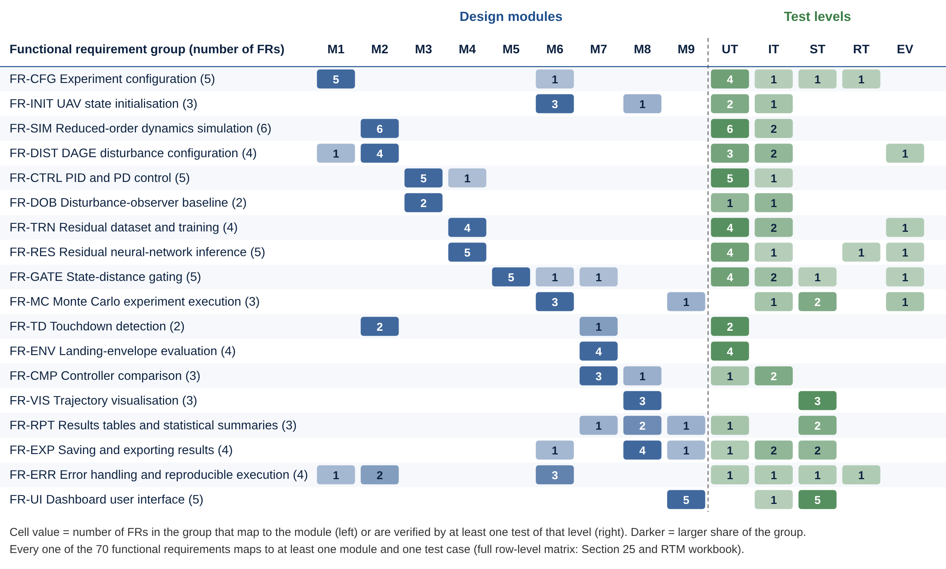
Figure 21: D-11 Traceability summary: FR groups against modules and test levels. Cell values are numbers of requirements.
Table 36: Requirements traceability matrix (functional requirements)
Req. ID | Design component | Diagram(s) | Implementation module | Test case IDs | Status
FR-CFG-01 | ExperimentConfig, load_config() | D-04, D-07a | src/resland/config/ | UT-01 | Proposed
FR-CFG-02 | ExperimentConfig.validate() | D-05 | src/resland/config/ | UT-02, ST-04 | Proposed
FR-CFG-03 | load_preset() | D-07a | src/resland/config/ | UT-01 | Proposed
FR-CFG-04 | derive_trial_seeds() | D-06 | src/resland/config/ | UT-03 | Proposed
FR-CFG-05 | save_resolved(), Manifest | D-08 | src/resland/config/, src/resland/experiments/ | IT-06, RT-01 | Proposed
FR-INIT-01 | Randomizer.sample() | D-05 | src/resland/experiments/ | UT-28 | Proposed
FR-INIT-02 | Randomizer.sample() | D-05 | src/resland/experiments/ | UT-28 | Proposed
FR-INIT-03 | TrialSpec | D-08 | src/resland/experiments/, src/resland/visualization/ | IT-06 | Proposed
FR-SIM-01 | Dynamics.step() | D-06, D-12 | src/resland/simulator/ | UT-04, IT-01 | Proposed
FR-SIM-02 | Dynamics.step() | D-12 | src/resland/simulator/ | UT-05 | Proposed
FR-SIM-03 | Dynamics.step() | D-12 | src/resland/simulator/ | UT-04 | Proposed
FR-SIM-04 | NoiseModel | D-06 | src/resland/simulator/ | UT-08 | Proposed
FR-SIM-05 | PlatformModel | D-06 | src/resland/simulator/ | UT-04 | Proposed
FR-SIM-06 | TrajectoryBatch | D-08, D-09 | src/resland/simulator/ | UT-06, IT-05 | Proposed
FR-DIST-01 | DisturbanceModel.tau_dage() | D-12 | src/resland/simulator/ | UT-06 | Proposed
FR-DIST-02 | DisturbanceModel.a_ge() | D-12 | src/resland/simulator/ | UT-07 | Proposed
FR-DIST-03 | DisturbanceProfile | D-10 | src/resland/config/, src/resland/simulator/ | UT-07, IT-07, EV-02 | Proposed
FR-DIST-04 | DisturbanceProfile flags | D-07b | src/resland/simulator/ | IT-01 | Proposed
FR-CTRL-01 | PIDCascade | D-06, D-07c, D-12 | src/resland/controllers/ | UT-09 | Proposed
FR-CTRL-02 | PDCascade | D-07c | src/resland/controllers/ | UT-09 | Proposed
FR-CTRL-03 | Controller ABC | D-07c | src/resland/controllers/, src/resland/residual_model/ | UT-10, IT-02 | Proposed
FR-CTRL-04 | Reference generator | D-06 | src/resland/controllers/ | UT-09 | Proposed
FR-CTRL-05 | Limits | D-07c | src/resland/controllers/ | UT-11 | Proposed
FR-DOB-01 | VerticalDOB | D-07c | src/resland/controllers/ | UT-12 | Proposed
FR-DOB-02 | Command.diag | D-08 | src/resland/controllers/ | IT-02 | Proposed
FR-TRN-01 | DatasetBuilder | D-09 | src/resland/residual_model/ | UT-29, IT-05 | Proposed
FR-TRN-02 | DatasetBuilder.split() | D-09 | src/resland/residual_model/ | UT-29 | Proposed
FR-TRN-03 | Trainer | D-09 | src/resland/residual_model/ | UT-30, IT-05, EV-04 | Proposed
FR-TRN-04 | export_checkpoint() | D-09 | src/resland/residual_model/ | UT-17 | Proposed
FR-RES-01 | HistoryBuffer | D-06, D-09 | src/resland/residual_model/ | UT-13 | Proposed
FR-RES-02 | ResidualMLP | D-07c, D-09 | src/resland/residual_model/ | UT-14 | Proposed
FR-RES-03 | ResidualPredictor | D-09 | src/resland/residual_model/ | UT-15 | Proposed
FR-RES-04 | ResidualAugmentedController | D-06, D-12 | src/resland/residual_model/ | IT-03, EV-05 | Proposed
FR-RES-05 | ResidualPredictor.load() | D-09 | src/resland/residual_model/ | UT-16, RT-02 | Proposed
FR-GATE-01 | DistanceGate.distance() | D-06 | src/resland/gating/ | UT-18 | Proposed
FR-GATE-02 | DistanceGate.sigma() | D-06 | src/resland/gating/ | UT-19 | Proposed
FR-GATE-03 | calibrate_d0() | D-09 | src/resland/gating/ | UT-20 | Proposed
FR-GATE-04 | ConstantGate, ablation plan | D-10 | src/resland/gating/, src/resland/experiments/ | IT-04, ST-03, EV-03 | Proposed
FR-GATE-05 | TrajectoryBatch fields | D-08 | src/resland/gating/, src/resland/evaluation/ | UT-19, IT-06 | Proposed
FR-MC-01 | ExperimentRunner | D-05, D-10 | src/resland/experiments/ | IT-06 | Proposed
FR-MC-02 | ExperimentPlan | D-10 | src/resland/experiments/ | ST-01, ST-02, ST-03, EV-01, EV-02 | Proposed
FR-MC-03 | on_progress callback, cancel Event | D-06 | src/resland/experiments/, src/resland/ui/ | ST-05 | Proposed
FR-TD-01 | TouchdownDetector | D-05, D-06 | src/resland/simulator/ | UT-21 | Proposed
FR-TD-02 | TouchdownDetector | D-05 | src/resland/simulator/, src/resland/evaluation/ | UT-21 | Proposed
FR-ENV-01 | trial_metrics() | D-08 | src/resland/evaluation/ | UT-22 | Proposed
FR-ENV-02 | trial_metrics() | D-08 | src/resland/evaluation/ | UT-22 | Proposed
FR-ENV-03 | EnvelopeThresholds | D-08 | src/resland/evaluation/ | UT-23 | Proposed
FR-ENV-04 | trial_metrics() | D-08 | src/resland/evaluation/ | UT-23 | Proposed
FR-CMP-01 | compare() | D-05 | src/resland/evaluation/, src/resland/visualization/ | IT-06 | Proposed
FR-CMP-02 | paired_bootstrap() | D-08 | src/resland/evaluation/ | UT-25 | Proposed
FR-CMP-03 | aggregate() | D-08 | src/resland/evaluation/ | IT-06 | Proposed
FR-VIS-01 | plot_time_histories() | D-06 | src/resland/visualization/ | ST-06 | Proposed
FR-VIS-02 | plot_side_view() | D-06 | src/resland/visualization/ | ST-05 | Proposed
FR-VIS-03 | plot_gate() | D-06 | src/resland/visualization/ | ST-05 | Proposed
FR-RPT-01 | aggregate(), wilson_interval() | D-08 | src/resland/evaluation/ | UT-24 | Proposed
FR-RPT-02 | render_table() | D-08 | src/resland/visualization/ | ST-01 | Proposed
FR-RPT-03 | Provenance field | D-08 | src/resland/visualization/, src/resland/ui/ | ST-06 | Proposed
FR-EXP-01 | RunWriter | D-08 | src/resland/experiments/, src/resland/visualization/ | UT-27, IT-06 | Proposed
FR-EXP-02 | export_run() | D-08 | src/resland/visualization/ | ST-06 | Proposed
FR-EXP-03 | load_run() | D-05 | src/resland/visualization/, src/resland/ui/ | IT-09 | Proposed
FR-EXP-04 | export_run() | D-08 | src/resland/visualization/ | ST-06 | Proposed
FR-ERR-01 | TouchdownDetector, runner error handling | D-05 | src/resland/simulator/, src/resland/experiments/ | UT-26 | Proposed
FR-ERR-02 | Seeded numpy.random.Generator per trial | D-08 | src/resland/config/, src/resland/simulator/, src/resland/experiments/ | RT-01 | Proposed
FR-ERR-03 | resland CLI (argparse) | D-10 | src/resland/experiments/ | ST-01 | Proposed
FR-ERR-04 | logging configuration | D-08 | all modules | IT-06 | Proposed
FR-UI-01 | pages/1_setup.py | D-03, W-01 | src/resland/ui/ | ST-04, IT-08 | Proposed
FR-UI-02 | pages/2_simulation.py | D-03, W-02 | src/resland/ui/ | ST-05 | Proposed
FR-UI-03 | pages/3_comparison.py | D-03, W-03 | src/resland/ui/ | ST-05 | Proposed
FR-UI-04 | pages/4_results.py | D-03, W-04 | src/resland/ui/ | ST-06 | Proposed
FR-UI-05 | state.py | W-01..W-04 | src/resland/ui/ | ST-05 | Proposed

24 Security, Reliability, Reproducibility and Error Handling

24.1 Security
- The application runs locally and needs no network access at run time; the Streamlit server binds to localhost by default.
- Model artefacts are loaded only from non-executable formats (NumPy .npz, or torch.load with weights_only=True) after SHA-256 verification, because unpickling untrusted checkpoints can execute code (NFR-DATA-02).
- YAML is parsed with yaml.safe_load; configuration values are validated before use.
- No personal data is processed. Dependencies are pinned; GitHub's dependency alerts are enabled (recommendation).

24.2 Reliability and error handling
Table 37: Error handling
Condition | Detection | Response | Requirement
Invalid configuration | M1 validation | Field-level messages; run blocked; CLI exit code 2 | FR-CFG-02
Missing or corrupted model | Shape/schema/checksum check | MissingModelError / ModelLoadError before any trial | FR-RES-05
Numerical divergence (NaN, |phi| > limit) | Per-step check | Trial marked DIVERGED; experiment continues | FR-ERR-01, NFR-REL-01
No touchdown within T | End-of-horizon check | Outcome NO_TOUCHDOWN; counted as envelope failure | FR-TD-02
Non-finite gate input | Gate | sigma = 0 (nominal control) and warning | FR-GATE-02
User cancellation | Cancel event | Stop after current batch; status CANCELLED; data readable | FR-MC-03
Crash or kill during write | Atomic rename | Previous batches intact; partial batch discarded | NFR-REL-02
Unpaired seeds in comparison | Evaluator | PairingError; comparison not shown | FR-CMP-02

24.3 Reproducibility
- Per-trial numpy.random.Generator seeded from the master seed and trial index; identical seeds across controllers (FR-CFG-04).
- Resolved configuration, versions, commit hash and model checksum in every run directory (FR-CFG-05, NFR-REPRO-02).
- Golden-file regression test on a small configuration (RT-01) guards against unintended numerical changes.
- Training on CPU with torch.use_deterministic_algorithms(True) and fixed seeds; tolerance for repeated training documented (NFR-REPRO-01).

25 Risk Assessment and Mitigation
Table 38: Risk register
ID | Risk | Likelihood | Impact | Mitigation | Owner
R-01 | Missing paper details (OI-01..OI-17) prevent exact reproduction of Tables III-V. | High | High | Obtain the original NumPy implementation; parameterise every unresolved item; report deviations explicitly (EV-01..EV-05). | Ravi Deo
R-02 | Monte Carlo runs too slow for interactive use. | Medium | Medium | Vectorise trials across a batch dimension; NumPy inference; cap dashboard N with CLI for full runs; measure early (ST-08 in Sprint 3). | Arjun Saharawat
R-03 | PyTorch-trained network behaves differently from the paper's NumPy-trained network. | Medium | Medium | UT-17 equivalence test; EV-04 comparison; document tolerance; optional NumPy trainer if gap is material. | Ravi Deo
R-04 | Streamlit re-run model complicates long-running jobs and state. | Medium | Medium | Run experiments in a background thread with a progress queue; keep state in st.session_state; integration test IT-08. | Yash Bhadauria
R-05 | Schedule slip due to end-semester examinations and placement activities. | High | Medium | Buffer weeks in December; MVP/extension split; fortnightly guide reviews; re-plan at each sprint boundary. | Team
R-06 | Simulation results misrepresented as physical or experimentally validated claims. | Low | High | Provenance labels (FR-RPT-03); limitations section in UI and report; review of all text by guide. | Team
R-07 | Non-deterministic training on GPU breaks reproducibility. | Medium | Low | Train on CPU by default; torch.use_deterministic_algorithms(True); record seeds and versions. | Ravi Deo
R-08 | Scope creep towards 6-DoF simulation, ROS or hardware. | Medium | High | Extensions only after MVP exit criteria; change control via guide approval. | Team
R-09 | Data or code loss. | Low | High | Git with remote (GitHub); results regenerable from configs; weekly backup of models/. | Team
R-10 | Gate behaves differently from the paper (e.g., fires more often). | Medium | Low | Treat as a finding; log d and sigma (FR-GATE-05); compare against Table V. | Ravi Deo

26 Implementation Schedule with Milestones
Dates are proposed and must be confirmed against the academic calendar, in particular the end-semester examination period (buffer B1). Each sprint ends with the validation gate given in the last column.

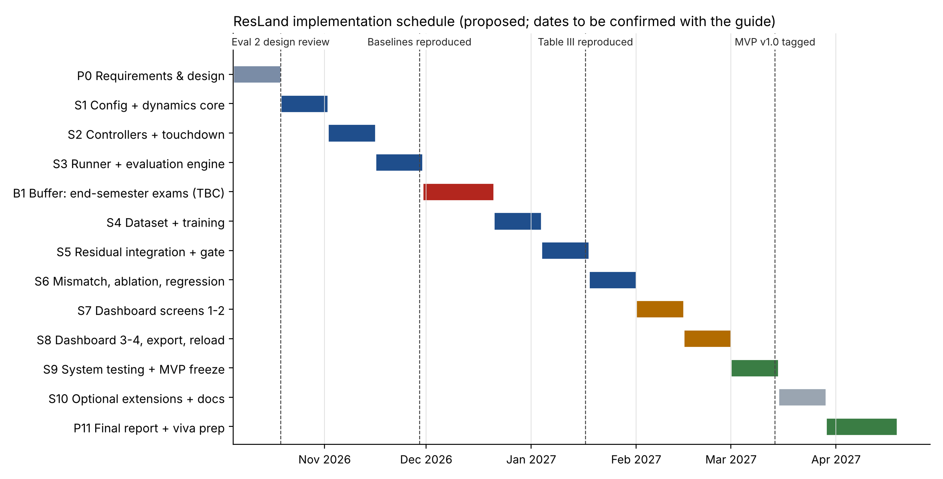
Figure 22: D-13 Proposed implementation schedule (October 2026 - April 2027).
Table 39: Milestone plan
Phase | Content | Weeks / dates | Depends on | Deliverables | Exit criterion
P0 | Requirements and design | W0 (to 18 Oct 2026) | - | This specification, diagrams, wireframes, RTM | Guide approves v1.0 of this specification; open items assigned owners
S1 | Repository, configuration, dynamics core | W1-W2 (19 Oct - 1 Nov) | P0 | M1, M2 (dynamics, disturbance, noise), CI pipeline | UT-01..UT-08 pass; CI green
S2 | Controllers and touchdown | W3-W4 (2 - 15 Nov) | S1 | M3 (PD, PID, PID+DOB), touchdown detection, basic metrics | UT-09..UT-12, UT-21..UT-23, IT-01, IT-02 (baselines) pass
S3 | Runner and evaluation engine | W5-W6 (16 - 29 Nov) | S2 | M6 vectorised runner, M7 Wilson/bootstrap, baseline rows of Table III | UT-24..UT-28, IT-06 pass; ST-08 first timing; baseline rows compared with paper
B1 | Buffer: end-semester examinations (dates TBC) | W7-W9 (30 Nov - 20 Dec) | - | Reduced capacity; open-item resolution | Open items OI-01..OI-10 resolved or formally parameterised
S4 | Dataset generation and training | W10-W11 (21 Dec - 3 Jan) | S3 | M4 DatasetBuilder, Trainer, export | UT-13..UT-17, UT-29, UT-30, IT-05 pass; EV-04 recorded
S5 | Residual integration and gate | W12-W13 (4 - 17 Jan) | S4 | ResidualAugmentedController, M5, full Table III plan | UT-18..UT-20, IT-03, IT-04, ST-01 pass; EV-01 recorded
S6 | Mismatch, ablation, regression baselines | W14-W15 (18 - 31 Jan) | S5 | Tables IV-V plans, golden files | ST-02, ST-03, RT-01, RT-02 pass; EV-02, EV-03 recorded
S7 | Visualisation and dashboard (screens 1-2) | W16-W17 (1 - 14 Feb) | S5 | M8 plots, Setup and Simulation screens | IT-08 pass; screens match W-01, W-02
S8 | Dashboard (screens 3-4), export and reload | W18-W19 (15 - 28 Feb) | S7 | Comparison and Results screens, exports | IT-09, ST-04..ST-06 pass
S9 | System testing and MVP freeze | W20-W21 (1 - 14 Mar) | S6, S8 | Test report, bug fixes, cross-platform runs | All MVP tests executed and reported; ST-07 pass; MVP tagged v1.0
S10 | Optional extensions and documentation | W22-W23 (15 - 28 Mar) | S9 | E1 (ensemble gate) or E2 (history ablation) if time permits; user guide | Extension results reported as exploratory; README complete
P11 | Final report, demonstration and viva preparation | W24-W26 (29 Mar - 18 Apr) | S9 | Final report, demo video, presentation | Guide sign-off

Minimum viable project (must be complete by S9): M1-M9; five controllers; speed-sweep, mismatch and gate-ablation plans; four dashboard screens; all UT, IT, ST and RT tests executed; fidelity report for EV-01..EV-05. Optional extensions (S10 onward, only if the MVP exit criterion is met): E1-E6 in Section 5.2.

27 Expected Outcomes and Measurable Acceptance Criteria
The outcomes below are expected, not achieved. They define how the finished project will be judged.
Table 40: Project acceptance criteria
ID | Criterion | Measure | Evidence
AC-01 | All Must requirements implemented | 62 of 62 Must FRs with status Implemented in the RTM | RTM, code review
AC-02 | Software correctness verified | All UT, IT, ST and RT cases executed; 100% of Must-linked tests pass | Test report, CI history
AC-03 | Paper plans executable end to end | speed_sweep, mismatch and gate_ablation complete from the CLI with full outputs | ST-01..ST-03, run directories
AC-04 | Reproduction fidelity reported | For every condition of Tables III-V: reproduced vs paper values, interval overlap, and explanation of deviations by open item (target: baseline rates inside the paper's Wilson intervals - proposed, TBC) | EV-01..EV-05 fidelity report
AC-05 | Reproducibility | Byte-identical trials.csv on re-run (RT-01) | RT-01
AC-06 | Dashboard usable | Four screens and five states demonstrated; ≤ 5 interactions to run a comparison (proposed) | ST-04, ST-05, NFR-USE-02
AC-07 | Performance measured | Measured times for NFR-PERF-01/02 reported against proposed targets | ST-08
AC-08 | Honest reporting | No exported or displayed value without provenance label; limitations shown in UI and report | ST-06, inspection

28 Limitations and Future Extensions

28.1 Limitations of the planned system
- Results are only as valid as the reduced-order model and the phenomenological disturbance; ResLand cannot provide evidence about real flight.
- Exact numerical reproduction of the paper depends on resolving the open items in Appendix A, or on access to the original code; otherwise reproduced values may differ within or beyond sampling error.
- Training in PyTorch rather than the paper's NumPy code means the trained network will not be bit-identical to the paper's.
- The dashboard is a single-user local tool; long runs (full Table III) are better executed from the CLI.
- Performance targets are proposals until measured.

28.2 Future extensions
Table 41: Extensions (not part of MVP acceptance)
ID | Extension | Motivation
E1 | Predictive-uncertainty gating (ensemble disagreement or MC-dropout) compared with the state-distance gate under Table V conditions. | Directly tests the paper's stated hypothesis about self-masking.
E2 | History-length ablation (W = 2, 4, 8, 16). | Paper Limitation 3.
E3 | Explicit lateral- and platform-velocity input features vs history-only inputs. | Paper Limitation 3.
E4 | Rotational (roll-channel) or multivariable disturbance observer baseline. | Paper Sec. VII-B notes only a vertical DOB was evaluated.
E5 | Higher-fidelity simulator back-end (e.g., a 6-DoF multirotor simulator) behind the same Controller interface. | Paper Limitation 1; optional, not required for MVP.
E6 | ONNX export and measured inference latency on a microcontroller-class target. | Paper Sec. VII-H gives only an estimate.

29 Conclusion
This specification defines a layered, testable system that converts the paper's simulation study into reusable software. The design keeps the paper's equations and protocol as its reference, isolates every deviation as a labelled, configurable decision, and connects 70 functional requirements to modules, diagrams and 56 test cases through a generated traceability matrix. The main technical risk, incomplete information for exact reproduction, is made explicit in 25 open items so that it can be resolved with the guide early in the project rather than discovered late. The proposed iterative life cycle builds and verifies the numerical core before the residual network and the dashboard, and separates software correctness from experimental fidelity, so the finished project can make clear, defensible claims about what it reproduces and what remains open.

30 References
[1] R. Deo, A. Saharawat, Y. Bhadauria, D. Kumar and K. Anand, "Residual Compensation of a Phenomenological Dynamic Asymmetric Ground-Effect Disturbance for UAV Landing on Moving Platforms: A Simulation Study of State-Space Safety Gating," manuscript, Dept. of CSE, Sharda University, 2026.
[2] R. Mahony, V. Kumar, and P. Corke, "Multirotor aerial vehicles: Modeling, estimation, and control of quadrotor," IEEE Robot. Autom. Mag., vol. 19, no. 3, pp. 20-32, Sep. 2012.
[3] I. C. Cheeseman and W. E. Bennett, "The effect of the ground on a helicopter rotor in forward flight," Aeronautical Research Council, London, U.K., R&M 3021, 1955.
[4] G. Shi, X. Shi, M. O'Connell, R. Yu, K. Azizzadenesheli, A. Anandkumar, Y. Yue, and S.-J. Chung, "Neural Lander: Stable drone landing control using learned dynamics," in Proc. IEEE ICRA, 2019, pp. 9784-9790.
[5] M. O'Connell et al., "Neural-Fly enables rapid learning for agile flight in strong winds," Sci. Robot., vol. 7, no. 66, art. eabm6597, 2022.
[6] T. Silver, K. Allen, J. Tenenbaum, and L. Kaelbling, "Residual policy learning," arXiv:1812.06298, 2018.
[7] W.-H. Chen, J. Yang, L. Guo, and S. Li, "Disturbance-observer-based control and related methods - An overview," IEEE Trans. Ind. Electron., vol. 63, no. 2, pp. 1083-1095, Feb. 2016.
[8] M. H. Danesh, M. Wabartha, S. Wu, J. Pineau, and H.-C. Lin, "Safe domain randomization via uncertainty-aware out-of-distribution detection and policy adaptation," arXiv:2507.06111, 2025.
[9] L. D. Brown, T. T. Cai, and A. DasGupta, "Interval estimation for a binomial proportion," Statist. Sci., vol. 16, no. 2, pp. 101-133, 2001.
[10] B. Efron and R. J. Tibshirani, An Introduction to the Bootstrap. New York, NY, USA: Chapman & Hall, 1993.
[11] H. K. Khalil, Nonlinear Systems, 3rd ed. Upper Saddle River, NJ, USA: Prentice Hall, 2002.
[12] A. Garofalo, M. Rusci, F. Conti, D. Rossi, and L. Benini, "PULP-NN: Accelerating quantized neural networks on parallel ultra-low-power RISC-V processors," Philos. Trans. Roy. Soc. A, vol. 378, no. 2164, art. 20190155, 2020.

Appendix A Open Items for Confirmation with the Project Guide
Each item is a detail that is missing, ambiguous or apparently inconsistent in the supplied paper. None is resolved by assumption in this document: the design either parameterises the item or adopts a labelled proposed decision.
Table 42: Open items
ID | Issue | Impact | Proposed handling
OI-01 | Lateral outer-loop gains, lateral reference signal and any roll set-point limit are not given (Table I lists only vertical and roll PID gains). | Exact lateral dynamics cannot be reproduced. | Read values from the original NumPy implementation; until then keep them as named configuration parameters marked TBC.
OI-02 | The vertical equation of motion is not written explicitly (how u_z, a_GE, gravity, mass and process noise combine). | Vertical channel may differ from the paper. | Proposed reading: dv_z/dt = u_z + a_GE(z) + w_z with u_z a gravity-compensated acceleration command. Confirm.
OI-03 | The descent reference is given only as a 'commanded descent rate' of 0.42 m/s; whether the vertical PID tracks a ramp z_ref(t) or a velocity set-point is not stated. | Affects impact speed and touchdown time. | Proposed: altitude ramp z_ref(t) = max(z0 - v_des t, 0). Confirm.
OI-04 | The numerical integration scheme (explicit Euler, semi-implicit Euler, RK4) is not stated. | Small numerical differences. | Proposed: semi-implicit Euler at dt = 0.01 s. Confirm from code.
OI-05 | Table I lists four noise standard deviations without stating whether they are sensor or process noise; the magnitude of tau_noise and of vertical process noise is not given, although Sec. V-A states both sensor and process noise are applied. | Noise level affects every metric. | Treat Table I values as sensor noise; add process-noise parameters marked TBC.
OI-06 | Touchdown is not formally defined. The held-out set of 60 trajectories has 71,760 samples (= 60 x 1,196), which implies fixed-length trajectories of about 1,200 steps (the full 12 s), yet Fig. 4 describes controllers landing at different times. It is unclear whether trajectories continue after contact. | Affects training data, metrics and the window count. | Confirm contact condition (proposed: first step with z <= 0) and post-contact handling for data generation.
OI-07 | Envelope success uses '|phi| <= 0.10 rad' without stating whether this is roll at contact or peak roll over the final approach (roll violation explicitly uses the final-approach peak). | Changes success rates. | Proposed: roll at contact. Confirm.
OI-08 | Initial v_z, v_y and roll rate p are not stated. | Early transient and possibly metrics. | Configurable; proposed defaults v_z0 = 0, p0 = 0, v_y0 to be confirmed (0 or v_p).
OI-09 | It is not stated whether the x U(0.90, 1.10) platform-speed scaling also applies to training draws v_p ~ U(0, 4.0); if so the effective maximum training speed is 4.4 m/s, which changes the '25% beyond the training range' statement. | Interpretation of extrapolation claims. | Confirm and state explicitly in the specification and dashboard.
OI-10 | The kappa value used for Res-G in Tables III and IV is not stated (Table V sweeps 0.4-2.4). | Res-G cannot be reproduced exactly. | Confirm kappa; until then the preset marks it TBC.
OI-11 | In Table V the gated rows use 300 trials per cell while the 'No gate' row (67.0%) matches the 500-trial Table III value; the x1.0 rows (63.7-64.0%) differ from Table III Res-G (66.8%). | Rows in Table V may not be paired comparisons. | Confirm the trial sets and seeds used per row.
OI-12 | PID+DOB is 'driven by the measured noisy vertical acceleration', but no accelerometer noise model is listed. | DOB baseline may differ. | Add accelerometer noise parameter marked TBC.
OI-13 | Dropout placement, output-layer activation (assumed linear) and whether input noise is added before or after standardisation are not specified. | Training reproduction. | Proposed: dropout after each hidden activation; linear output; noise on standardised inputs (as stated).
OI-14 | Feature ordering inside the 24-dimensional window and network behaviour during the first W-1 steps are not specified. | Reproducing a trained checkpoint requires exact ordering. | Proposed ordering [states block; controls block] per Sec. VI-B; zero residual during warm-up.
OI-15 | It is not stated whether normalisation statistics are computed from all 340 training trajectories or the 200,000-window subsample. | Minor numerical effect. | Proposed: from the training subsample.
OI-16 | Seeds are given for data generation (42) and initialisation (1) but not for evaluation trials or the bootstrap. | Exact numerical reproduction of Tables III-V. | Define evaluation master seed and bootstrap seed in the preset.
OI-17 | The method behind the reported p-values (p < 1e-4) is not stated. | Statistical reporting. | Confirm method; the specification implements bootstrap intervals only unless confirmed.
OI-18 | The paper states 'All code uses NumPy only', whereas the proposed stack trains the network in PyTorch. | Trained weights will not be bit-identical to the paper's. | Train in PyTorch; validate NumPy/PyTorch inference equivalence; treat paper metrics as reference values, not regression oracles.
OI-19 | Name spellings differ between the paper and other records ('Yash Bhadauria' vs 'Yash Bhaduria'; 'Dharmendar Kumar' vs 'Dharmendra Kumar'); co-author Ketan Anand's role in this project is not stated. | Cover page correctness. | Confirm official spellings and team composition before submission.
OI-20 | The symbol lambda denotes both the slip weight (Eq. 6) and the regularisation weight (lambda_reg, Eq. 14). | Notation ambiguity. | This specification uses lambda_slip and lambda_reg.
OI-21 | Command saturation and integrator anti-windup are not specified. | Behaviour at large speeds. | Disabled in paper_default; optional (FR-CTRL-05).
OI-22 | The mismatch study changes 'altitude decay exponents' from 2.0 to 1.6; Eqs. 6-7 show the exponent fixed at 2. | Model form. | Parameterise the exponent as n_phi and n_z (FR-DIST-01/02). Confirm form (z/L)^n.
OI-23 | An initial lateral offset y0 is randomised, but the lateral loop is described as velocity-only; it is unclear whether lateral position error is corrected. | Lateral behaviour and touchdown position. | Confirm whether a lateral position loop exists.
OI-24 | The averaging basis of the mean gate value sigma_bar (all steps, final approach only, or per-trial means) is not stated. | Gate statistics. | Proposed: mean over all steps of all trials. Confirm.
OI-25 | The project title includes 'Uncertainty-Aware Evaluation', but uncertainty-aware gating is future work in the paper. | Scope expectations of evaluators. | This specification interprets the MVP as statistical uncertainty quantification (Wilson and bootstrap intervals) and treats predictive-uncertainty gating as Extension E1. Confirm with the guide or adjust the title.

Appendix B Consistency Checks Performed on the Paper
Table 43: Checks of the paper's stated numbers
Item | Check | Result
MLP parameter count 7,906 | 24x64+64 + 64x64+64 + 64x32+32 + 32x2+2 = 1,600 + 4,160 + 2,080 + 66 = 7,906 | Consistent
7,744 MACs per pass | 1,536 + 4,096 + 2,048 + 64 = 7,744 | Consistent
54 us inference estimate | 1.066 GMAC/s / 7.45 = 0.143 GMAC/s; 7,744 / 0.143e9 = 54 us | Consistent (estimate, not a measurement)
Wilson intervals, Table III/IV | Recomputed for k = 404, 500, 0, 316, 12, 18, 481, 335, 148, 265 of 500: all match the reported intervals | Consistent
DOB RMS roll +25% at 3.0 m/s | 0.0364 / 0.0291 = 1.251 | Consistent
Residual RMS roll reduction at 3.0 m/s | 0.0291 - 0.0134 = 0.0157 rad | Consistent with paired -0.0157
Mismatch RMS roll 64% lower at 3.0 m/s | (0.0515 - 0.0185) / 0.0515 = 64.1% | Consistent
Negligible-disturbance effect | 0.0063 - 0.0012 = 0.0051 rad | Consistent with paired +0.0051
Held-out window count | 71,760 / 60 = 1,196 windows per trajectory | Implies fixed-length trajectories; see OI-06

Appendix C Repository Structure
uav-residual-control/
├── README.md setup, commands, reproduction guide
├── pyproject.toml package metadata and dependencies
├── requirements.lock pinned versions (generated)
├── configs/ paper_default.yaml, paper_mismatch.yaml, smoke.yaml
├── src/resland/
│ ├── config/ M1 schema, presets, seeds
│ ├── simulator/ M2 dynamics, disturbance, noise, touchdown
│ ├── controllers/ M3 Controller ABC, PID, PD, DOB
│ ├── residual_model/ M4 dataset, MLP, trainer, predictor, augmented controller
│ ├── gating/ M5 DistanceGate, ConstantGate, calibration
│ ├── experiments/ M6 plans, randomiser, runner
│ ├── evaluation/ M7 metrics, Wilson, bootstrap, comparison
│ ├── visualization/ M8 plots, tables, export/reload
│ ├── ui/ M9 Streamlit app and pages
│ └── cli.py command-line entry points
├── tests/ unit/, integration/, system/, regression/ (golden files)
├── data/paper_reference/ paper-reported values (CSV, read-only, labelled)
├── models/ trained artefacts (git-ignored; regenerable)
├── results/ run directories (git-ignored)
├── docs/ specification, test report, fidelity report
├── diagrams/ draw.io and Mermaid sources
├── design/ wireframes
└── scripts/ rtm_check.py, reproduce_tables.sh

The scaffold with these folders, a README, pyproject.toml, the paper_default configuration and interface stubs carrying requirement IDs is supplied in 08_Repository_Scaffold/.

Appendix D Deliverable File Index
Table 44: Files in the design package
Folder | Content | Format
01_Project_Design_Specification | This document (Deliverables A, F, G and the in-document matrix) | DOCX, PDF
02_Requirements | Requirements catalogue: functional, non-functional, open items (Deliverable B) | XLSX
03_Diagrams | Rendered diagrams and editable sources (Deliverable C) | PNG, SVG, .drawio, .mmd
04_Wireframes | Dashboard wireframes (Deliverable D) | HTML/CSS, PNG
05_Traceability | Requirements traceability matrix (Deliverable E) | CSV, XLSX
06_Test_Plan | Detailed test plan (Deliverable H) | XLSX
07_Presentation | Slides with speaker notes, script, anticipated questions (Deliverable I) | PPTX, DOCX
08_Repository_Scaffold | Proposed repository with README and stubs | Folder / ZIP

