**Experiment - 11**

**Program:**

import numpy as np

import matplotlib.pyplot as plt

def sigmoid(x):

    return 1 / (1 + np.exp(-x))

def sigmoid_derivative(x):

    return x * (1 - x)

def mlp_xor(inputs, targets, learning_rate, epochs):

    input_neurons = 2

    hidden_neurons = 2

    output_neurons = 1

    # Initialize weights with random values

    hidden_weights = np.random.uniform(size=(input_neurons, hidden_neurons))

    hidden_bias = np.random.uniform(size=(1, hidden_neurons))

    output_weights = np.random.uniform(size=(hidden_neurons, output_neurons))

    output_bias = np.random.uniform(size=(1, output_neurons))

    errors = []

    for epoch in range(epochs):

        total_error = 0

        for i in range(len(inputs)):

            # Forward propagation

            hidden_layer_input = np.dot(inputs[i], hidden_weights) + hidden_bias

            hidden_layer_output = sigmoid(hidden_layer_input)

            output_layer_input = np.dot(hidden_layer_output, output_weights) + output_bias

            predicted_output = sigmoid(output_layer_input)

            # Calculate error

            error = targets[i] - predicted_output

            total_error += abs(error[0])

            # Backpropagation

            delta_output = error * sigmoid_derivative(predicted_output)

            error_hidden = delta_output.dot(output_weights.T)

            delta_hidden = error_hidden * sigmoid_derivative(hidden_layer_output)

            # Update weights and biases

            output_weights += hidden_layer_output.reshape(-1,1).dot(delta_output) * learning_rate

            output_bias += delta_output * learning_rate

            hidden_weights += inputs[i].reshape(-1,1).dot(delta_hidden) * learning_rate

            hidden_bias += delta_hidden * learning_rate

        errors.append(total_error / len(inputs))

    return hidden_weights, hidden_bias, output_weights, output_bias, errors

inputs = np.array([[0, 0], [0, 1], [1, 0], [1, 1]])

#Binary

targets_binary = np.array([[0], [1], [1], [0]])

#Bipolar

targets_bipolar = np.array([[-1], [1], [1], [-1]])

learning_rate = 0.1

epochs = 10000

hidden_weights_b, hidden_bias_b, output_weights_b, output_bias_b, errors_b = mlp_xor(inputs, targets_binary, learning_rate, epochs)

hidden_weights_bp, hidden_bias_bp, output_weights_bp, output_bias_bp, errors_bp = mlp_xor(inputs, targets_bipolar, learning_rate, epochs)

#Plot the error curve

plt.plot(errors_b, label='Binary')

plt.plot(errors_bp, label='Bipolar')

plt.xlabel('Epochs')

plt.ylabel('Error')

plt.title('Epochs vs Error Curve ')

plt.legend()

plt.show()

**OUTPUT:**

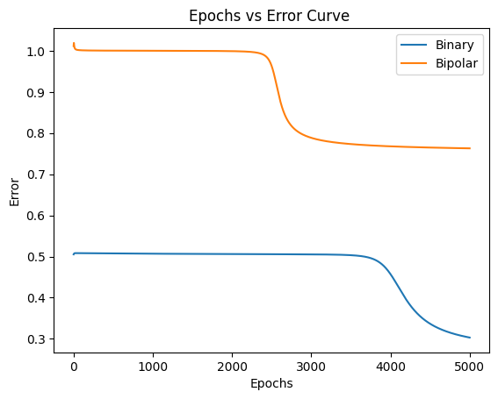

**Experiment - 10**

**Program:**

import numpy as np

def hebb_rule(inputs, targets, learning_rate, epochs):

    num_inputs = len(inputs[0])

    weights = np.zeros(num_inputs)

    bias = 0

    print("Initial weights:", weights)

    print("Initial bias:", bias)

    for epoch in range(epochs):

        print(f"\nEpoch {epoch + 1}:")

        for i in range(len(inputs)):

            weighted_sum = np.dot(inputs[i], weights) + bias

            #Hebb rule weight update

            weights = weights + learning_rate * targets[i] * inputs[i]

            bias = bias + learning_rate * targets[i]

            print(f"  Input: {inputs[i]}, Target: {targets[i]}, Weights: {weights}, Bias: {bias}")

    return weights, bias

# Example usage (AND gate)

inputs = np.array([[0, 0], [0, 1], [1, 0], [1, 1]])

targets = np.array([0, 0, 0, 1])

learning_rate = 0.2

epochs = 3  #for better output formatting

weights, bias = hebb_rule(inputs, targets, learning_rate, epochs)

print("\nFinal weights:", weights)

print("Final bias:", bias)

**OUTPUT:**

**AND GATE**

|  |  |
| --- | --- |
| **Epoch 1** | Input: [0 0], Target: 0, Weights: [0. 0.], Bias: 0.0  Input: [0 1], Target: 0, Weights: [0. 0.], Bias: 0.0  Input: [1 0], Target: 0, Weights: [0. 0.], Bias: 0.0  Input: [1 1], Target: 1, Weights: [0.2 0.2], Bias: 0.2 |
| **Epoch 2** | Input: [0 0], Target: 0, Weights: [0.2 0.2], Bias: 0.2  Input: [0 1], Target: 0, Weights: [0.2 0.2], Bias: 0.2  Input: [1 0], Target: 0, Weights: [0.2 0.2], Bias: 0.2  Input: [1 1], Target: 1, Weights: [0.4 0.4], Bias: 0.4 |
| **Epoch 3** | Input: [0 0], Target: 0, Weights: [0.4 0.4], Bias: 0.4  Input: [0 1], Target: 0, Weights: [0.4 0.4], Bias: 0.4  Input: [1 0], Target: 0, Weights: [0.4 0.4], Bias: 0.4  Input: [1 1], Target: 1, Weights: [0.6 0.6], Bias: 0.600000000000000 |

Final weights: [0.6 0.6]

Final bias: 0.6000000000000001

**Experiment - 13**

**Program:**

import os

import struct

import numpy as np

import pandas as pd

from zipfile import ZipFile

def extract_zip(zip_path, extract_to):

    with ZipFile(zip_path, 'r') as zip_ref:

        zip_ref.extractall(extract_to)

    print(f"Extracted files to: {extract_to}")

def read_idx_images(file_path):

    with open(file_path, 'rb') as file:

        # Read metadata

        magic_number, num_images, rows, cols = struct.unpack('>IIII', file.read(16))

        images = np.frombuffer(file.read(), dtype=np.uint8).reshape(num_images, rows, cols)

    return images

def read_idx_labels(file_path):

    with open(file_path, 'rb') as file:

        magic_number, num_labels = struct.unpack('>II', file.read(8))

        labels = np.frombuffer(file.read(), dtype=np.uint8)

    return labels

def create_dataframe(images, labels):

    # Flatten images into rows

    flattened_images = images.reshape(images.shape[0], -1)

    df = pd.DataFrame(flattened_images)

    df['label'] = labels

    return df

zip_path = "MNIST_ORG.zip"  # Path to the zip file

extract_to = "mnist_data"   # Extraction directory

extract_zip(zip_path, extract_to)

train_images_path = os.path.join(extract_to, "train-images.idx3-ubyte")

train_labels_path = os.path.join(extract_to, "train-labels.idx1-ubyte")

test_images_path = os.path.join(extract_to, "t10k-images.idx3-ubyte")

test_labels_path = os.path.join(extract_to, "t10k-labels.idx1-ubyte")

train_images = read_idx_images(train_images_path)

train_labels = read_idx_labels(train_labels_path)

test_images = read_idx_images(test_images_path)

test_labels = read_idx_labels(test_labels_path)

train_df = create_dataframe(train_images, train_labels)

test_df = create_dataframe(test_images, test_labels)

print("Training DataFrame:")

print(train_df.head())

print("Test DataFrame:")

print(test_df.head())

from sklearn.model_selection import train_test_split

X_train = train_df.drop(columns=['label']).values

y_train = train_df['label'].values

X_test = test_df.drop(columns=['label']).values

y_test = test_df['label'].values

X_train_images = X_train.reshape(-1, 28, 28)

X_test_images = X_test.reshape(-1, 28, 28)

import tensorflow as tf

from tensorflow.keras.models import Sequential

from tensorflow.keras.layers import Conv2D, MaxPooling2D, Flatten, Dense, Dropout

from sklearn.model_selection import train_test_split

from tensorflow.keras.utils import to_categorical

X_train_images = X_train_images / 255.0

X_test_images = X_test_images / 255.0

X_train_images = X_train_images.reshape(-1, 28, 28, 1)

X_test_images = X_test_images.reshape(-1, 28, 28, 1)

y_train = to_categorical(y_train, num_classes=10)

y_test = to_categorical(y_test, num_classes=10)

# Create a CNN model

model = Sequential()

model.add(Conv2D(32, (3, 3), activation='relu', input_shape=(28, 28, 1)))

model.add(MaxPooling2D(pool_size=(2, 2)))

model.add(Conv2D(64, (3, 3), activation='relu'))

model.add(MaxPooling2D(pool_size=(2, 2)))

model.add(Flatten())

model.add(Dense(128, activation='relu'))

model.add(Dropout(0.5))  # Dropout to prevent overfitting

model.add(Dense(10, activation='softmax'))  # Output layer for 10 classes

model.compile(optimizer='adam',

              loss='categorical_crossentropy',

              metrics=['accuracy'])

history = model.fit(X_train_images, y_train,

                    validation_data=(X_test_images, y_test),

                    epochs=10,

                    batch_size=64)

test_loss, test_acc = model.evaluate(X_test_images, y_test)

print(f"Test Accuracy: {test_acc:.2f}")

import matplotlib.pyplot as plt

# Plot training and validation accuracy

plt.plot(history.history['accuracy'], label='Train Accuracy')

plt.plot(history.history['val_accuracy'], label='Validation Accuracy')

plt.xlabel('Epochs')

plt.ylabel('Accuracy')

plt.legend()

plt.title('Model Accuracy')

plt.show()

# Plot training and validation loss

plt.plot(history.history['loss'], label='Train Loss')

plt.plot(history.history['val_loss'], label='Validation Loss')

plt.xlabel('Epochs')

plt.ylabel('Loss')

plt.legend()

plt.title('Model Loss')

plt.show()

**OUTPUT:**

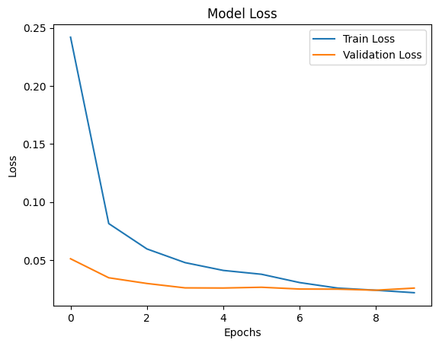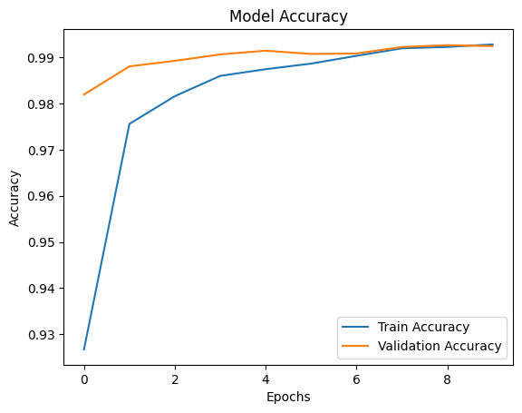

model.summary()

|  |  |  |
| --- | --- | --- |
| **Layer (type)** | **Output Shape** | **Param** |
| conv2d_2 (Conv2D) | (None, 26, 26, 32) | 320 |
| max_pooling2d (MaxPooling2D) | (None, 13, 13, 32) | 0 |
| conv2d_3 (Conv2D) | (None, 11, 11, 64) | 18,496 |
| max_pooling2d_1 (MaxPooling2D) | (None, 5, 5, 64) | 0 |
| flatten (Flatten) | (None, 1600) | 0 |
| dense (Dense) | (None, 128) | 204,928 |
| dropout (Dropout) | (None, 128) | 0 |
| dense_1 (Dense) | (None, 10) | 1290 |

**Experiment - 12**

**Program:**

import pandas as pd

import numpy as np

from sklearn.ensemble import RandomForestClassifier

from sklearn.model_selection import train_test_split, cross_val_score

from sklearn.metrics import accuracy_score

import scipy.io

import warnings

warnings.filterwarnings("ignore")

data=pd.read_csv("/content/lymphography.data")

print(data.head())

X=data.drop(["3"],axis=1)

y=data["3"]

X_train, X_test, y_train, y_test = train_test_split(X, y, test_size=0.3, random_state=42)

model = RandomForestClassifier(n_estimators=100, random_state=42)

model.fit(X_train, y_train)

y_pred_before = model.predict(X_test)

initial_score = accuracy_score(y_test, y_pred_before)

print(f"Initial model accuracy (before feature selection): {initial_score:.4f}")

def forward_selection(X, y, model, max_features=5, scoring='accuracy', cv=5, min_improvement=0.001):

    remaining_features = list(X.columns)

    selected_features = []

    best_score = 0

    iteration = 0

    while remaining_features and len(selected_features) < max_features:

        scores = []

        for feature in remaining_features:

            current_features = selected_features + [feature]

            X_selected = X[current_features]

            score = cross_val_score(model, X_selected, y, cv=cv, scoring=scoring).mean()

            scores.append((score, feature))

        best_score_feature = max(scores, key=lambda x: x[0])

        if best_score_feature[0] - best_score < min_improvement:

            print(f"No significant improvement; stopping at iteration {iteration}")

            break

        best_score = best_score_feature[0]

        selected_features.append(best_score_feature[1])

        remaining_features.remove(best_score_feature[1])

        iteration += 1

        print(f"Selected feature: {best_score_feature[1]}, Cross-validated score: {best_score:.4f}")

    return selected_features

def backward_selection(X, y, model, min_features=5, scoring='accuracy', cv=5, min_improvement=0.001):

    selected_features = list(X.columns)

    best_score = cross_val_score(model, X[selected_features], y, cv=cv, scoring=scoring).mean()

    iteration = 0

    while len(selected_features) > min_features:

        scores = []

        for feature in selected_features:

            current_features = [f for f in selected_features if f != feature]

            X_selected = X[current_features]

            score = cross_val_score(model, X_selected, y, cv=cv, scoring=scoring).mean()

            scores.append((score, feature))

        best_score_feature = max(scores, key=lambda x: x[0])

        if best_score - best_score_feature[0] > min_improvement:

            print(f"Performance drop detected; stopping at iteration {iteration}")

            break

        best_score = best_score_feature[0]

        selected_features.remove(best_score_feature[1])

        iteration += 1

        print(f"Removed feature: {best_score_feature[1]}, Cross-validated score: {best_score:.4f}")

    return selected_features

print("\nPerforming Sequential Forward Selection (SFS):")

sfs_selected_features = forward_selection(X_train, y_train, model, max_features=5)

X_train_sfs = X_train[sfs_selected_features]

X_test_sfs = X_test[sfs_selected_features]

model.fit(X_train_sfs, y_train)

y_pred_sfs = model.predict(X_test_sfs)

sfs_score = accuracy_score(y_test, y_pred_sfs)

print(f"\nModel accuracy after SFS: {sfs_score:.4f}")

print("\nPerforming Sequential Backward Selection (SBS):")

sbs_selected_features = backward_selection(X_train, y_train, model, min_features=5)

X_train_sbs = X_train[sbs_selected_features]

X_test_sbs = X_test[sbs_selected_features]

model.fit(X_train_sbs, y_train)

y_pred_sbs = model.predict(X_test_sbs)

sbs_score = accuracy_score(y_test, y_pred_sbs)

print(f"\nModel accuracy after SBS: {sbs_score:.4f}")

**OUTPUT:**

Initial model accuracy (before feature selection): 0.8444

Performing Sequential Forward Selection (SFS):

Selected feature: 4.1, Cross-validated score: 0.7552

Selected feature: 2.5, Cross-validated score: 0.8048

Selected feature: 1.1, Cross-validated score: 0.8248

Selected feature: 2.6, Cross-validated score: 0.8343

No significant improvement; stopping at iteration 4

Model accuracy after SFS: 0.7556

Performing Sequential Backward Selection (SBS):

Removed feature: 2.1, Cross-validated score: 0.8624

Performance drop detected; stopping at iteration 1

Model accuracy after SBS: 0.8667