Log File Input Reactor
The Log File Input Reactor can capture data from any structured text file so long as that file’s format is defined in a “Codec.” A Pion Codec defines an input or output format for things like logs. A Codec can also define notation such as JSON or XML. Codecs are used to 'break' data into chunks that can be recognized or manipulated.
Pion understands all of the normal log formats associated with web server logs such as Extended Log Format, Combined Log Format, and Common Log Format out of the box as well as numerous other log formats. If Pion doesn’t already contain a Codec for the log format you need, you can easily create a new Codec that describes the log format.
Sometimes, log files are stored in compressed format. If Pion is trying to read a log file, and the name of the log file ends in one of the following file extensions, Pion recognizes that the file is compressed, and will decompress the file as a part of the read process.
.gz (gzip or GNU zip)
.bz2 (bzip2)
When you first add a the Log File Reactor you will be prompted for the following fields:
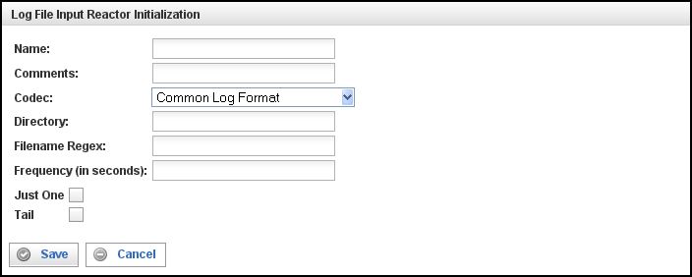
Field | Description
Name | Specify the name of this Log File Input Reactor. This can be any name you find descriptive, we recommend something which describes the log file(s) being read.
Comments | Enter some descriptive comments about this Log File Input Reactor. Any comment you feel will help you in the future, we recommend choosing something about the content or source of the log file(s), or the way in which the data in the files has been gathered or manipulated prior to being read.
Codec | Select the Codec to be used when reading the log file contents from this drop-down list. By default, the Log File Input reactor supports the following Codecs:  - Common Log Format  - Combined Log Format  - Extended Log Format  - Page View Log Format  - Visitor Session Log Format  - WebTrends Log  - Response Content Log  - RSS Channel Extraction Codec  - RSS Channel Log Format  - RSS Item Extraction Codec  - RSS Item Log Format  - Atom Feed  - Atom Feed  - Atom Entry  - Atom Entry  - Stock Price Log  - JSON Log Format  - XML Log Format
Directory | Specify the complete path to the directory containing the log file(s) to be read.
Filename Regex | Enter a regular expression or a file name to be used to determine the log file(s) to be read.  Note: A file name will be interpreted as a regular expression. If the file name contains a period, the period should be escaped.
Frequency | Define the amount of time (in seconds) for the interval between checking for new log files whose names match the Filename Regex.
Just One | Fill this check box to read only the first record of a log file, converts it to an event, and repeatedly duplicate and output that event until the reactor is stopped. (This is useful for testing.)
Tail | When this check box is filled, after reaching the end of a file, Pion keeps it open and periodically checks for newly appended data. (Based on the Unix 'tail -f' command.)

This creates the Log File Input Reactor in the workspace. Double-clicking on the reactor brings you to the configuration screen:
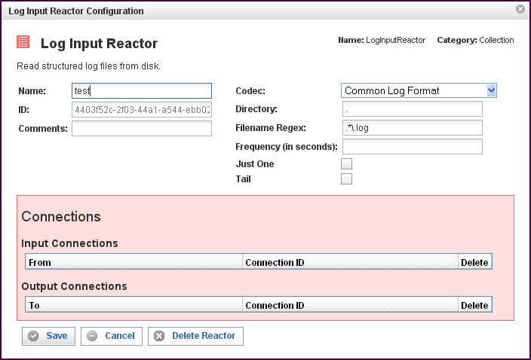

In addition to the fields you saw when adding the reactor initially (described above), you will see one additional field and the Connections section. The additional field is:
Field | Description
ID | The reactor ID, a unique ID generated by the Pion server. This ID identifies a particular reactor.

The Connections Section
The Connections section describes input and output connections for this Log Input Reactor. See “Error: Reference source not found“X on page XError: Reference source not foundX for more information.

