Aggregate Reactor
The Aggregate Reactor can distill critical pieces of information from large volumes of raw data. For example, the Aggregate Reactor could count all of the web users on the site in the last hour, calculate the average page size downloaded and tell you the total amount of traffic the site consumed in the last day. The Aggregate Reactor could even tell you each unique user name that accessed the site. Because it performs these calculations inside Pion, the Aggregate Reactor can do real-time reports, which reduces stress on your backend networks and systems, which are critical for high volume applications.
When you add an Aggregate Reactor you will be prompted for the following fields:
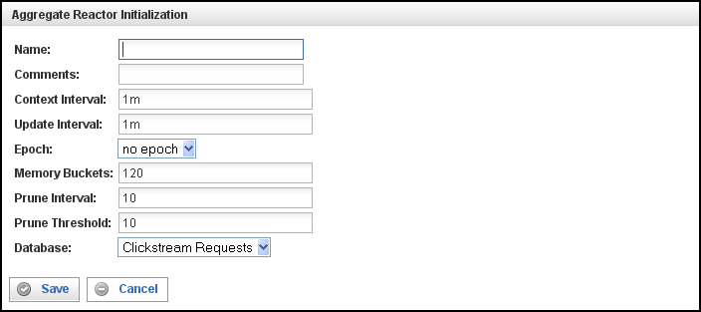

Field | Description
Name | Specify the name of this Aggregate Reactor. This can be any name you find descriptive, we recommend something which describes the data this Aggregate Reactor is gathering.  The name may contain any combination of letters and numbers.
Comments | Enter some descriptive comments about this Aggregate Reactor. Any comment you feel will help you in the future, we recommend choosing something that describes the data being gathered and/or the data being ignored.
Context Interval | Specifies how often the Memory Bucket (the context) is changed. Use a numeric value, followed by a time unit, as indicated by one of the following letters:  - S for Seconds (the default)  - M for Minute  - H for Hour  - D for Day  - W for Week  - Y for Year (365 days)  Once Context changes:  An event of type aggregate#stat-event is sent with all values.  For Unique, an event for *each* unique string is sent.  A database row is added (if a database is enabled).  A new "tick" will be present in graphs & queryService XML (for information on using the Query Service, see “Using the Query Service with the Aggregate ReactorX” on page X7X).
Update Interval | Indicates how often updates to the current Memory Bucket (update events, #update-event) are sent out.  The Update Interval must be smaller than the Context Interval and is usable only if your Context Interval is very large, and you are processing update events. For the time unit notation used to specify the duration of the Update Interval, see “Context Interval” (above).
Epoch | Defines the unit of the starting point for the Memory Bucket. For example, an epoch of a “day” means that all buckets are based on the change of the day (when a new day begins, or hour “0”). If Epoch is not defined, first bucket starts at the program start-up time. Use the drop-down list to select the Epoch.
Memory Buckets | Specifies how many Context Intervals are kept in memory. This number can be quite large, 1MB of memory can hold ~ 20,000 - 30,000 buckets.  Commonly referred as a “Bucket” or “Bin,” a Memory Bucket is a time-bound container for elements. The length of time the Memory Bucket covers (spans) is determined by the Context Interval. Total time interval is (Context Interval x Memory Buckets).  When counting events, a Memory Bucket of 1 minute is used to count all events that occur within a minute. Using 120 Memory Buckets that have a Context Interval of 1-minute (120 1-minute buckets), you can graph event frequency for a two hour span. To make fine-grain graphs, use a large Memory Bucket value, a short Context Interval, and use Grouping in the query.
Prune Interval | Specifies how often the unique values are pruned. The Prune Interval is expressed as a multiple of the Context Interval (for example 10 x 1m = 10m).
Prune Threshold | Specifies the minimum number of times a unique value must be found in order to be counted. If the minimum number is not met, instances of that value are purged and no longer tracked.  The Prune Threshold is intended to prune out (eliminate) values that are aberrations, and which would otherwise indefinitely consume an Aggregate Reactor, without providing meaningful amounts of data.  For example, assume you are looking for a particular value, say page title. If there is a page title where the value is "blue moon" and a prune threshold of 10, then if there are less than 10 counted instances of "blue moon" then this value gets dropped, and is no longer tracked (until another instance).
Database | If defined; identifies a database (that must be one of the supported database types SQLite, MySQL, Oracle, etc.) in which statistical events will be stored. The database name (specified in the reactor configuration) defines where tables will be created, and all the statistical events will be stored in this database table. Note that the database table name matches the name of the aggregate, so aggregate names are restricted by same rules as database table names.  For example, if you want to have Aggregate Reactor save its statistics on a continuous basis into a database table, then define a database, and it will happen.  If you do not define a database, you will still get:  Statistical events produced (you can use them for any normal processing, a log output reactor, or such).  The graphs (click on the graph button on aggregate).  The statistics in XML format. To see statistics in XML format, use SOAP style URI (see bottom of the graph dialog for the URI).  Feed output from Aggregate Reactor.

This creates the Aggregate Reactor in the Workspace. Double-clicking the reactor brings you to the Aggregate Reactor Configuration screen:
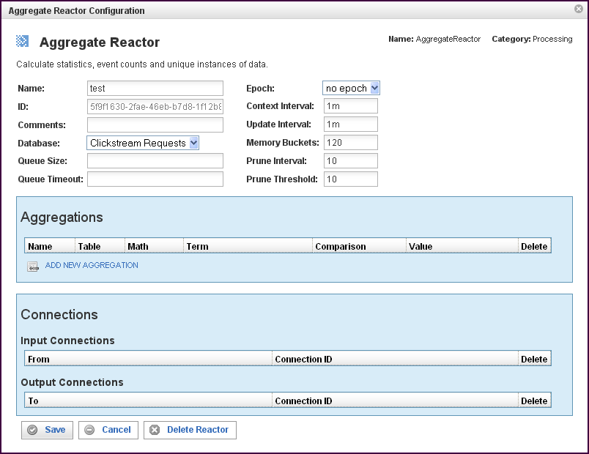

In addition to the fields you saw when adding the reactor initially (described above), you will see some additional fields and sections for Aggregations and Connections. The additional fields are:
Field | Description
ID | The reactor ID, a unique ID generated by the Pion server. This ID identifies a particular reactor.
Queue Size | The number of events allowed in the queue before triggering a flush of the queue. When the queue is flushed, the queued events are inserted (bulk-inserted) into the database specified in the Database field. The default queue size is 1000 events.
Queue Timeout | The queue timeout determines how long to wait before forcing a queue flush (a bulk-insert of queue contents to the database into the database specified in the Database field. The default queue timeout is 10s (10 seconds).

The Aggregations Section
The Aggregations section specifies the data that will be processed from the database selected above. Click on the ADD NEW AGGREGATION icon to add a new line to the table. Each line represents a data item to be processed and the processing operations for that data item.
Field | Description
Name | Identifies the aggregation. This can be any name you find descriptive, we recommend something which describes this aggregation.  The name may contain any combination of letters and numbers, and my contain underscores, but may not start with a number or an underscore.
Table | Specifies the name of the database table in which to store the Context records. The table name must be unique (within the specified database), and is not case sensitive. The name must be made up of any combination of letters and numbers.
Math | Specifies a mathematical operation to be applied to the value of the data item:  Count applies to any term, and it causes Pion to count the total number of values (unique or repeated).  If the term exists in an event, it is counted. Count returns a number n (the number of events containing the term) and a time (the amount of time in which the events occurred). Count may be used to graph how many events occurred in a specific time period. Count is a good way to count things like page hits, incidents, and frequency.  Sum applies only to numeric terms, for example clickstream#bytes, and it enables Pion to compute any or all of the following::  - SUM (add the values together).  - MIN (find the lowest value).  - MAX (find the highest value).  - AVG (calculate the average value).  - N (counts the number of values).  Sum can also compare the data values to a comparison term, such as greater-than and the value “0.”  Sum is good for presenting traffic, volume, max load, and changes in average.  Unique applies only to string terms/fields, for example clickstream#request, and it causes Pion to count the total number of unique (non-repeated) values:  - Any unique value creates a new counter (also known as a “slot" or an "accumulator").  - Once a counter is created, the number of unique values is counted.  - Upon a pruning interval, if the count is less than the pruning value, the accumulator is discarded. (See the description of prune threshold above.)  Unique is good for presenting things like a spread of status messages and the ratio of pages viewed. Unique is most useful when combined with a Regular Expression, for example "GET (.+)&" and, when Unique finds a new unique string, it starts a new unique count for that string.  Use Pruning to take out edge condition matches.
Term | Defines the value of the term to be used for the comparison logic. Specifies the data item to find. You can select a term (an identified data item) from an existing vocabulary, or you can add a new vocabulary and define the term(s) to be found.  One event consists of multiple Terms. For example, a stock event consists of terms "symbol" and "price." Note that one term may contain multiple values.
Comparison | Specifies the type of comparison to test, such as true/false or is-defined/is-not-defined. (Note, do not use TRUE/FALSE in an Aggregate Reactor).  Depending on the term that is specified in a row, an appropriate list of comparisons will appear in the comparison cell of that row. For example, if it's a date type, you'll get choices like "earlier than", whereas if it's a string type, you'll get choices like "starts with".  Like most comparisons, these two examples require a value to compare against, but a few comparisons, like “is defined,” do not require a value to compare against.  For more information on comparisons, see "Error: Reference source not foundX””“ on page Error: Reference source not foundX.
Value | Defines the data value to test against (or the regex to apply to the data values).

To delete a data item, click on the “x” in the delete column for the line describing that data item.

The Connections Section
The Connections section describes input and output connections for this Aggregate Reactor. See “Error: Reference source not found“X on page XError: Reference source not foundX for more information.

Using the Query Service with the Aggregate Reactor
Aggregate Reactor can be queried using the Query Service (QueryService). To use the Query Service, construct the query and enter it as a URL In your browser. For example:
http://host:port/query/reactors/reactor-id/aggname?VEC=1/dt/x,1/n/y&GRP=grp
Where:
- host is the host name or IP of the Pion server.
- port is the port number of your Pion installation.
- reactor-id is the ID of this Aggregate Reactor. (To obtain the reactor ID, right click on the Aggregate Reactor and select “Show XML”.)
- aggname is the name of the aggregate.
- VEC=1/dt/x,1/n/y is the list of vectors.
- grp is the number of values to group into a single data point.
Query results are returned in the form of a graph.

57BUQuery Service Parameters
All Query Service parameters are optional. When specified, Query Service parameters are in the format PARAMETER=VALUE, and parameter/value combinations are separated by the ampersand character (&).
The Query Service parameters are as follows:
- VEC (list of vectors)
The list of vectors is separated by commas. Vectors are specified using the format:
aggname?VEC=1/dt/x,1/n/y
Where:
- aggregate is the name of the aggregate.
- VEC= indicates the beginning of the list of vectors.
- dt is the DateTime
- x indicates to place this vector on the X axis of the graph.
- y indicates to place this vector on the Y axis of the graph.
List as many vectors as necessary, separating vectors in the list with commas, for example:
aggname1/dt/x, aggname2/dt/x, aggname3/dt/x, aggname4/dt/x, aggname5/dt/x, aggname6/dt/x, aggname7/dt/x[,...]
- PTS (points to display)
Points to display indicates how many data points to display on the graph. Specified as PTS=n, where n is the number of points to display. The total time frame of the graph is calculate as follows:: ((PTS * Context Interval) / GRP).
If PTS is greater than (Memory Buckets / GRP), the graph will be truncated.
- GRP (grouping)
Grouping specifies how many samples are grouped.
- 1 = No grouping
- 2 = Groups two adjacent samples together
- 3 = Groups three adjacent samples together
For example, to group 10 minute samples into a data point covering one hour, use a value of 6.
- ENC (Encoding)
Controls the encoding to be used. Specified as ENC=enc, where enc is one of the following:
- XML (Full XML)
- XML-S (Shorthand notation XML)
- XML-C (Compressed XML)
Note: The data sets can be enormous, so if your application can read it, Pion recommends that you use compressed or shorthand XML.
- DAT (Date String format)
- 0 = Time expressed as milliseconds since 1970-01-01
- 1 = Time expressed as seconds since 1970-01-01
- 2 = Time and Date in format: "01 January 2008 17:25:01"
- 3 = Time and Date in ISO format "20080101T172501"
- RND (Random data)
Returns random data, for testing purposes.
- MVY (MultiVectorY)
- 0 = Split each vector to a separate data set in XML.
- 1 = Combined multiple Y vectors into one data set in XML.

