Clickstream Reactor
The Clickstream Reactor is able take raw web traffic and organize it into logical pages and individual user sessions. It does this in order to identify users and overall session statistics such as visit length, pages viewed and more. The Clickstream reactor accomplishes this by understanding how browsers normally communicate with backend systems and how session state is maintained. Often the Clickstream Reactor works properly without changing any configuration options. The Clickstream reactor contains the ability to handle very complex and custom sessionization parameters, which may be employed by large applications to maintain state across globally distributed application instances.
The Clickstream Reactor functions as follows:
- Page detection is controlled by the page object detection.
- Requests are assigned to pages using timestamps and referrer headers -- the algorithm supports having several pages open at a time, up to the specified "maximum pages per session."
- Requests grouped within a page are ordered using timestamps (request-num).
- Pages are closed when either:
- No requests are associated with the page for a period longer than time specified by the "page timeout" parameter.
- The maximum number of pages per session is exceeded (oldest pages are closed first).
- All requests associated with a particular page will have the same session-id and page-num values in their http-event.
- When a page closes, a "page event" is generated that represents all the requests associated with a particular page.
Page events (type "urn:vocab:clickstream#page-event") contain the following clickstream vocabulary fields:
- date, time, date-time, epoch-time = timestamp for first http event associated with the page
- page-num = sequence number for the page view, starting with 1
- robot = 1 if the session is considered to be a "robot"
- bytes = total bytes for all requests and responses
- cp-rtt = the average round trip time in microseconds from the client to the Pion server
- cp-rtt-packets = the number of round trip time measurements from the client to the Pion server
- cp-rtt-sum = the sum of all round trip time measurements from the client to the Pion server
- cs-bytes = total bytes for all requests
- sc-bytes = total bytes for all responses
- page-title = title extracted from HTML content
- page-load = total time to load the page, from start of first request to end of last response
- page-load-redirect = total time for all redirected (302) page requests
- page-load-base = time-taken for the base HTML file
- page-hits = total number of HTTP requests associated with the page
- page-load-content = total time for all page object (not base HTML or redirected) requests
- page-dwell = total time from the last response to the first request for the next page view
- ps-rtt = the average round trip time in microseconds from the Pion server to the protocol server
- ps-rtt-packets = the number of round trip time measurements from the Pion server to the protocol server
- ps-rtt-sum = the sum of all round trip time measurements from the Pion server to the protocol server
- referer = copied from first http event associated with the page
- time-taken = the sum of microseconds that it took to complete all HTTP events associated with the page from the end user's perspective
The following fields are all copied from base HTML file request: session-id, session-group, uri-stem, uri-query, host, user-agent, client-ip, server-ip, status, uri, request, server-port, content-id, page-title, and content-type.
Page events may contain "sticky page fields" which are copied from http-events.
- Requests are assigned to sessions using the cookies configured in the Clickstream Reactor, and if no cookies are found, a combination of the user agent and the IP address are used for matching.
- When a session closes, a "session event" is generated that represents all the requests associated with a particular visitor session.
Session events (type "urn:vocab:clickstream#session-event") contain the following clickstream vocabulary fields:
- date, time, date-time, epoch-time = timestamp for first http event associated with the session
- session-id, session-group, date, time, date-time, referer
- session-pages = number of pages in the session
- session-requests = number of http requests in the session
- session-dwell = total dwell time for all page views
- session-length = total length of the session
- robot = 1 if the session is considered to be a "robot"
- bytes = total bytes for all requests and responses
- cs-bytes = total bytes for all requests
- sc-bytes = total bytes for all responses
- cookie-id = sessionizing cookies detected for the session
Session events may also contain "sticky fields." When found in a session event, the sticky field values are copied.
When you add a Clickstream Reactor you will be prompted for the following fields:
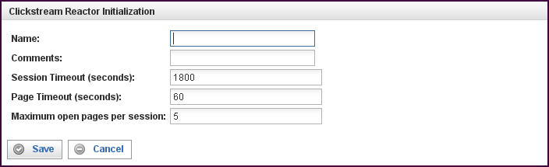

Field | Description
Name | Specify the name of this Clickstream Reactor. This can be any name you find descriptive, we recommend something which describes the session data this Clickstream Reactor is producing.  The name may be any combination of letters and numbers.
Comments | Enter some descriptive comments about this Clickstream Reactor. Any comment you feel will help you in the future, we recommend choosing something that describes the data being produced and/or the sessions being analyzed.
Session Timeout | Amount of time (in seconds) to wait before a session is considered to have timed-out. For example, if a user/browser is browsing a web site, the Clickstream Reactor will consider the user having abandoned/quit browsing the site after the specified number of seconds. The default timeout is 1800 seconds (30 minutes).
Page Timeout | Specifies the amount of time to wait (in seconds) before a page is considered to be closed. (Note that the time is measured from the last packet received, not the start time of the page.) When a page is closed, a page event is generated and delivered, along with all of its corresponding http request events, to the reactor's output connections. Any requests for objects within the page reset this timer.
Maximum open pages per session | The maximum number of concurrently open pages in any single user/browser session that the Clickstream Reactor will analyze.

This creates the Clickstream Reactor in the workspace. Double-clicking on the reactor brings you to the configuration screen:
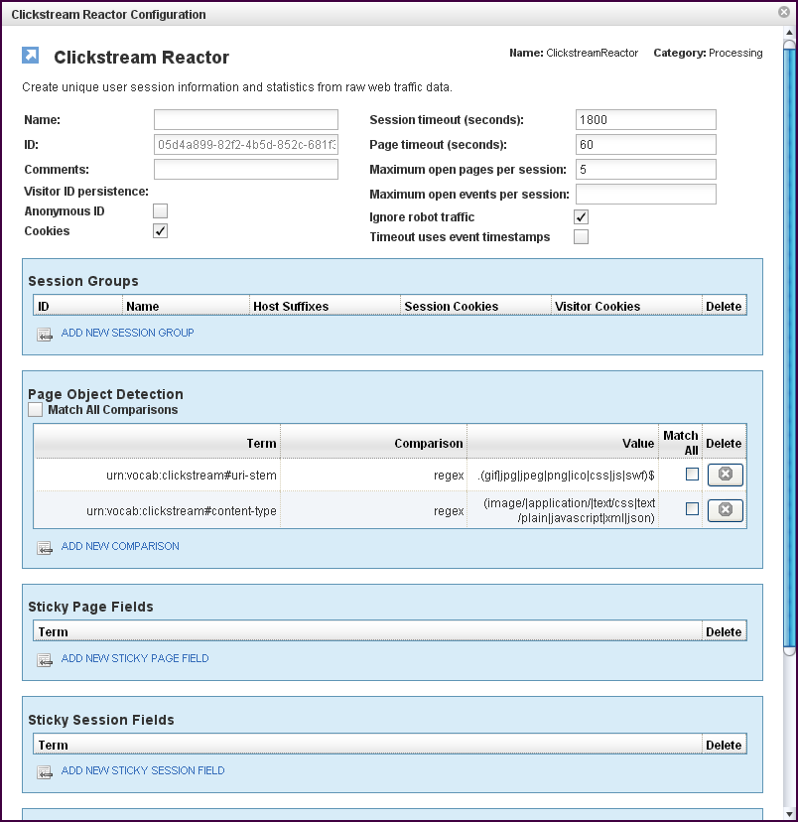
In addition to the fields you saw when adding the reactor initially (described above), you will see some additional fields and sections for Session Groups, Page Object Detection, Sticky Page Fields and Sticky Session Fields, and Connections (not shown above). The additional fields are:
Field | Description
ID | The reactor ID, a unique user-defined ID. This ID identifies a particular reactor.
Visitor ID Persistence | Allows Pion to detect repeat visitors (across sessions) and tag all the associated events (session-events, page-events and request-events) with a common "visitor-id" field so that they can be matched.  Two local databases are created and used to perform this mapping, one for "anonymous visitors" (visitors who have no cookie defined so they are identified only by IP address and user agent), and "Cookied Visitors" (visitors that do have a defined cookie).  This area contains two checkboxes:  - Anonymous ID  Fill this check box to cause all visitors with the same 16 bits of IP address and user-agent to be tagged with the same "visitor-id."  Note: This method of ID persistence is fairly inaccurate, and should be used only if no cookies are available.)  - Cookies  Fill this check box to cause repeat visitors with the same cookie values (for "visitor cookies" defined below in the session groups) to be tagged with the same visitor-id.  This is the default and is the recommended setting unless are certain that you don't need it.
Maximum open events per session | If the total number of events being cached for a particular session exceeds this value, it forces the oldest page to close and flush the associated events. This is basically a sanity check to make sure events caused by spiders and other non-human visitors don't consume too much memory.
Ignore robot traffic (check box) | When this check box is filled, all sessions detected as "robots" or "spiders" are discarded by the Clickstream Reactor.  When this check box is empty, events from sessions detected as "robots" or "spiders" are tagged with the "robot" field, but are not be discarded. A configuration file, "robots.xml" is used to control how Clickstream Reactor detects "robots."
Timeout uses event timestamps (check box) | When this check box is filled, page and session timeouts use the timestamps from events rather than system clock times to determine age.  When using PCAP file (with Sniffer Reactor) or web server log file (with Log File Input Reactor), this check box should always be filled.  When using live network interfaces, this check box should always be empty.

The Session Groups Section
The Session Groups section describes criteria which are used to determine sessions (to sessionize events).
Field | Description
ID | A short identifier that is assigned by Pion to the session-group field in all corresponding events.  A "default" identifier is reserved for use by the default session group. Sessions that do not match the Host Suffixes of any other groups will be assigned to the "default" group, regardless of the Host HTTP request header.  Note that a "default" session group is automatically generated (without cookies or host suffixes) if one is not otherwise specified in the configuration.
Name | A descriptive name for the session group.
Host Suffixes | Used to evaluate the Host HTTP request header to determine if an event belongs to this session group. Host suffixes are specified as a comma-separated list. One or more suffixes must be defined for each session group.  Note that, if a suffix of "atomiclabs.com" is specified, "atomiclabs.com" will match, and so would "pion.atomiclabs.com" and "www.atomiclabs.com" as well.
Session Cookies | Used to sessionize traffic, the names of these cookies are specified in a comma-separated list. For session cookies, you should only specify the names of cookies which have a lifetime of only the current session. Cookies of this type are discarded after the session expires.
Visitor Cookies | Used to sessionize traffic, the names of these cookies are specified in a comma-separated list. For visitor cookies, you should specify the names of cookies which have a lifetime that lasts beyond the current session.  These cookies are used for repeat-visitor detection (see "Visitor ID Persistence“ above). If the visitor returns the next day with the same visitor cookie, they will get tagged with the same visitor id (assuming "Cookies" visitor ID persistence is enabled above).  Visitor cookies are persisted in an embedded cookies database within Pion. The cookies database contains a timestamp, and can be pruned using the purge_cookies.pl script.
To add a Session Group, click on the ADD NEW SESSION GROUP link. The Session Group Initialization screen appears.
To delete a Session Group, click on the “x” at the end of the row describing that Session Group.

The Page Object Detection Section
The Page Object Detection section describes conditions that must be met in order for an event to be considered a valid page object. This section works in the same manner as a comparison (a Filter Rule Chain), see "Error: Reference source not foundX“ on page XError: Reference source not foundX for more information. If the event matches the comparison criteria, then the http request is considered to be a "page object" or component of another page view request. If the event does not match the comparison criteria, then the http request is considered to represent a new page view.
Field | Description
Match All Comparisons (check box) | When filled, indicates that ALL of the comparisons defined below must be matched.
Term | Defines the value of the term to be used for the comparison logic. Specifies the data item to find. You can select a term (an identified data item) from an existing vocabulary, or you can add a new vocabulary and define the term(s) to be found.
Comparison | Specifies the type of comparison to test, such as true/false or is-defined/is-not-defined.  Depending on the term that is specified in a row, an appropriate list of comparisons will appear in the comparison cell of that row. For example, if it's a date type, you'll get choices like "earlier than", whereas if it's a string type, you'll get choices like "starts with".  Like most comparisons, these two examples require a value to compare against, but a few comparisons, like “is defined,” do not require a value to compare against.  For more information on comparisons, see "Error: Reference source not foundX“ on page Error: Reference source not foundX.
Value
Match All (check box) | When filled, indicates that AT LEAST this comparison must be matched.
To add a row for a new comparison in the Page Object Detection section, click on the ADD NEW COMPARISON link.
To delete a Page Object Detection comparison, click on the “x” at the end of the row describing that comparison.

The Sticky Page Fields Section
The Sticky Page Fields section describes a list of terms to be copied from http-events into page-events.
Field | Description
Term | Defines the name of the Term to be copied from http events into page events.  Note that Sticky Page Fields work in a similar fashion as the "Terms to copy" section of the Fission Reactor.

To add a new Sticky Page Field, click on the ADD NEW STICKY PAGE FIELD link.
To delete a Sticky Page Field, click on the “x” at the end of the row describing that field.

The Sticky Session Fields Section
The Sticky Session Fields section describes a list of terms to be copied from page-events into session-events.
Field | Description
Term | Defines the name of the Term to be copied from page events into session events.  Note that Sticky Page Fields work in a similar fashion as the "Terms to copy" section of the Fission Reactor.
To add a new Sticky Session Field, click on the ADD NEW STICKY SESSION FIELD link.
To delete a Sticky Session Field, click on the “x” at the end of the row describing that field.

The Connections Section
The Connections section describes input and output connections for this Clickstream Reactor. See “Error: Reference source not found“X on page XError: Reference source not foundX for more information.

