Filter Reactor
The Filter Reactor can filter in or out any information based on any number of criteria you might set. For example, you could do something simple like only looking at a particular set of users of web servers. Or you could do something much more complicated such as only tracking certain individuals who are spending more than $50 on kitchen ware in their sessions.
When you add a Filter Reactor you will be prompted for the following fields:
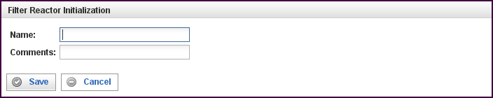

Field | Description
Name | Specify the name of this reactor. This can be any name you find descriptive, we recommend something which describes the data this reactor is processing.  The name may be any combination of letters and numbers.
Comments | Enter some descriptive comments about this reactor. Any comment you feel will help you in the future, we recommend choosing something that describes the data being processed.
This creates the Filter Reactor in the workspace. Double-clicking on the reactor brings you to the configuration screen:
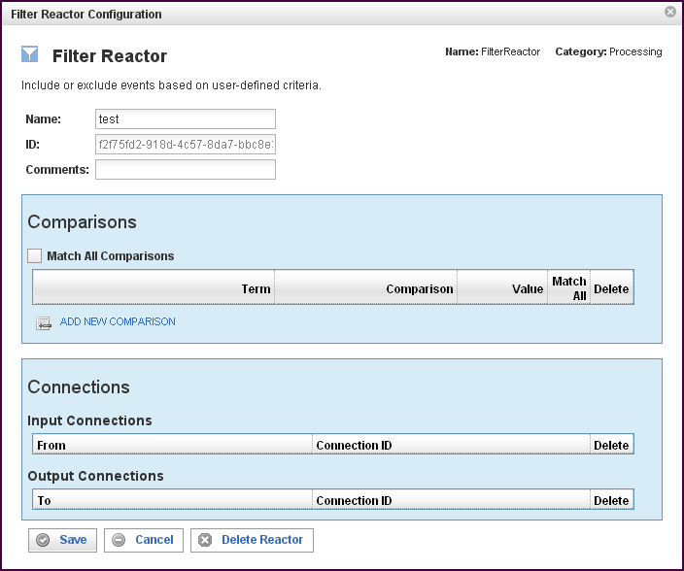

In addition to the fields you saw when adding the reactor initially (described above), you will see some additional fields and sections for Comparisons and Connections. The additional fields are:
Field | Description
ID | The reactor ID, a unique ID generated by the Pion server. This ID identifies a particular reactor.

The Comparisons Section
The Comparisons section describes the comparisons to be made in this Filter Reactor. If the event matches the comparison criteria, it will be delivered to all Output Connections. If the event does not match the comparison criteria, it is dropped. See “Error: Reference source not found“X on page Error: Reference source not foundX for more information.

Field | Description
Match All (check box) | When filled, indicates that ALL of the comparisons defined below must be matched.
Term | Defines the value of the term to be used for the comparison logic. Specifies the data item to find. You can select a term (an identified data item) from an existing vocabulary, or you can add a new vocabulary and define the term(s) to be found.
Comparison | Specifies the type of comparison to test, such as true/false or is-defined/is-not-defined.  Depending on the term that is specified in a row, an appropriate list of comparisons will appear in the comparison cell of that row. For example, if it's a date type, you'll get choices like "earlier than", whereas if it's a string type, you'll get choices like "starts with".  Like most comparisons, these two examples require a value to compare against, but a few comparisons, like “is defined,” do not require a value to compare against.  For more information on comparisons, see “Error: Reference source not found“ on page Error: Reference source not foundX.
Value
Match All (check box) | When filled, indicates that AT LEAST this comparison must be matched.
To add a row for a new comparison in the Comparison section, click on the ADD NEW COMPARISON link.
To delete a comparison, click on the “x” at the end of the row describing that comparison.

The Connections Section
The Connections section describes input and output connections for this Filter Reactor. See “Error: Reference source not found” on page XError: Reference source not foundX for more information.

