Session Filter Reactor
The Session Filter Reactor enables you to hold entire sessions until they meet certain criteria. The Session Filter Reactor must always be used after a Clickstream Reactor to ensure that the sessions are created. Using the Session Filter Reactor, you can do things such as saving full page view detail on only users that purchased a certain book or encountered an error.
When you add a Filter Reactor you will be prompted for the following fields:
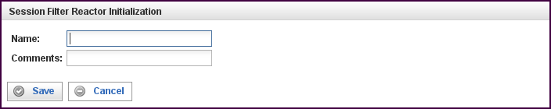

Field | Description
Name | Specify the name of this reactor. This can be any name you find descriptive, we recommend something which describes the data this reactor is processing.  The name may be any combination of letters and numbers.
Comments | Enter some descriptive comments about this reactor. Any comment you feel will help you in the future, we recommend choosing something that describes the sessions being held.
This creates the Filter Reactor in the workspace. Double-clicking on the reactor brings you to the configuration screen:
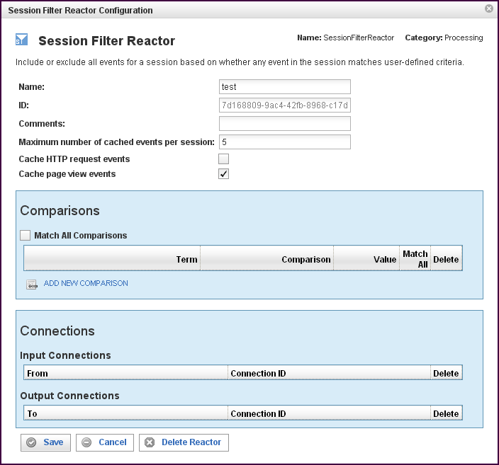

In addition to the fields you saw when adding the reactor initially (described above), you will see some additional fields and sections for Comparisons and Connections. The additional fields are:
Field | Description
ID | The reactor ID, a unique ID generated by the Pion server. This ID identifies a particular reactor.
Maximum number of cached events per session | Specifies the maximum number of cached events per session. If the total number of cached events (individual HTTP requests AND page view events) for a particular session exceeds this value, the oldest events are discarded.  This essentially creates a "rolling window" of events leading up to the point where the session passes the comparison rules. All events for the session are delivered immediately after the comparison rules are met (without caching).  Setting this value to 0 will cache all events indefinitely, but we strongly recommend that a reasonable maximum be defined unless you have VERY little traffic, because this can otherwise quickly consume all the memory available.
Cache HTTP request events (check box) | When the check box is filled, HTTP request events are cached until the comparisons are met. After the comparisons are met, all events for the session are delivered immediately.
Cache page view events (check box) | When the check box is filled, page view events are cached until the comparisons are met. After the comparisons are met, all events for the session are delivered immediately.

The Comparisons Section
The Comparisons section describes comparison to be made in this Session Filter Reactor. See “Error: Reference source not found“X on page XError: Reference source not foundX for more information.
Field | Description
Match All (check box) | When filled, indicates that ALL of the comparisons defined below must be matched.
Term | Defines the value of the term to be used for the comparison logic. Specifies the data item to find. You can select a term (an identified data item) from an existing vocabulary, or you can add a new vocabulary and define the term(s) to be found.
Comparison | Specifies the type of comparison to test, such as true/false or is-defined/is-not-defined.  Depending on the term that is specified in a row, an appropriate list of comparisons will appear in the comparison cell of that row. For example, if it's a date type, you'll get choices like "earlier than", whereas if it's a string type, you'll get choices like "starts with".  Like most comparisons, these two examples require a value to compare against, but a few comparisons, like “is defined,” do not require a value to compare against.  For more information on comparisons, see “Error: Reference source not found“X on page Error: Reference source not foundX.
Value
Match All (check box) | When filled, indicates that AT LEAST this comparison must be matched.
To add a row for a new comparison in the Comparison section, click on the ADD NEW COMPARISON link.
To delete a comparison, click on the “x” at the end of the row describing that comparison.

The Connections Section
The Connections section describes input and output connections for this Session Filter Reactor. See ”Error: Reference source not foundX“ on page XError: Reference source not foundX for more information.

