Webtrends Analytics Reactor
The Webtrends Analytics Reactor takes web user behavior information and sends it to Webtrends' servers via its native web services interface in real time. From Webtrends perspective, data collected by Pion is indistinguishable from that collected via page tags. All you need to supply is the correct Webtrends Account ID and site name to connect Pion to Webtrends.
When you add a Webtrends Reactor you will be prompted for the following fields:
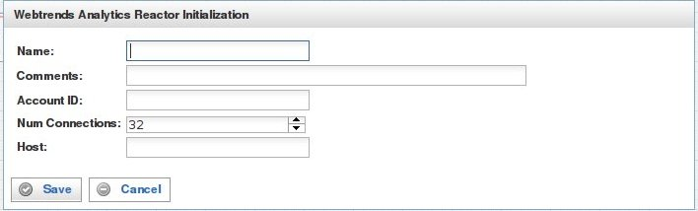

Field | Description
Name | Specify the name of this reactor. This can be any name you find descriptive, we recommend something which describes the data this reactor is processing.  The name may be any combination of letters and numbers.
Comments | Enter some descriptive comments about this reactor. Any comment you feel will help you in the future, we recommend choosing something that describes the data being stored.
Account ID | Your Webtrends DCSID . This is typically displayed next to each host name for each of your website profiles.
Num Connections | Specify the maximum number of concurrent threaded connections that will be established to deliver traffic to the Webtrends servers.  One connection is sufficient for most websites, although sites with a large volume of traffic should increase this number accordingly.
Host | This can be used to override the Pion host name string delivered to the Google Analytics servers. Normally left blank.
This creates the Webtrends Reactor in the workspace. Double-clicking on the reactor brings you to the configuration screen:
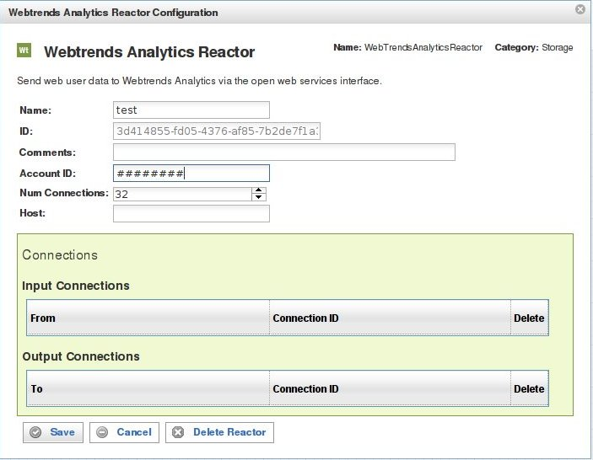
In addition to the fields you saw when adding the reactor initially (described above), you will see one additional field and the Connections section. The additional field is:
Field | Description
ID | The reactor ID, a unique ID generated by the Pion server. This ID identifies a particular reactor.

The Connections Section
The Connections section describes input and output connections for this Google Analytics Reactor. See “Error: Reference source not found“X on page XError: Reference source not foundX for more information.

