Sniffer Reactor
The Sniffer Reactor captures and decodes traffic from network interfaces. This can be live traffic traveling through a network in real time or previously captured traffic stored in a standard PCAP format. The Sniffer Reactor understands any network protocol for which you have installed a Pion plug-in (for example plug-ins are available for the HTTP, HTTPS, and SMTP protocols). With the proper plug in, Pion can see and understand traffic on the network, such as traffic between web servers and clients, and can generate events based on that traffic.
When you first add a the Sniffer Reactor you will be prompted for the following fields:
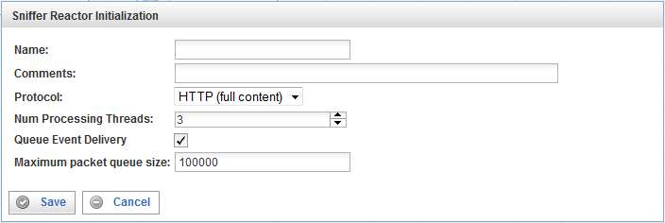
Field | Description
Name | Specify the name of this Sniffer Reactor. This can be any name you find descriptive, we recommend something which describes the network segment to which this Sniffer Reactor is listening.
Comments | Enter some descriptive comments about this Sniffer Reactor. Any comment you feel will help you in the future, we recommend choosing something that includes the contact person for the network segment and any associated work code that may be needed in the future.
Protocol | From this drop down list, select the protocol you want the Sniffer Reactor to use when listening to traffic. By default Pion supports the following protocols:  - HTTP (no content) captures the critical fields needed by web analytics tools. These fields include those pertaining to URL, host, referrer, page title, user agent, cookie and query.  - HTTP (full content) captures the critical fields needed by web analytics tools, and also captures the page content and the full client request.  Page content is saved into a special field in the clickstream term. Both server to client and client to server traffic can be captured.  For server to client traffic, page content (from the server request and the client response) is saved into a special field in the clickstream term called sc-content. The maximum amount of data in sc-content can be defined in the Protocol configuration, and the default is 512k for sc-content. Data in excess of the configured maximum is truncated.  For client to server traffic, page content (the client request and the server response) is saved into a special field in the clickstream term called cs-content.  Note that capturing using the HTTP (full content) protocol requires more memory than capturing using the HTTP (no content) protocol. More memory is required because more data must be captured and manipulated, and because the amount of data making up page content is often much more than any other field.  - SMTP (Email) captures the critical fields from SMTP-based emails, allowing you to generate events based on emails. All standard SMTP header fields and the message body are captured.  The maximum amount of data stored from the message body can be defined in the Protocol configuration (the default is 1MB).  The default is HTTP(full content) because it contains all of the information, if you are limited in memory or don’t need page content then it can be easily switched to improve performance.
Num Processing Threads (Number of Processing Threads) | Specify the number of processing threads a Sniffer reactor uses. It is useful for provisioning resources on the Pion server or in a shared environment. Adding more available processing threads can improve the performance of Pion significantly on machines with multiple processing cores.  Note: Generally you should not use more threads than you have CPUs/Cores in the Pion server.
Queue Event Delivery | Fill this check box to cause events to be delivered to other reactors by threads not affiliated with this reactor (other threads in Pion). Enabling this feature distributes workload and adds an additional memory-based work queue, which may reduce overall performance.  If this check box is empty, the feature is disabled and the processing threads of this reactor also handle the delivery of events to other reactors. Disabling this feature may improve overall performance because there will be less context switching.
Maximum packet queue size | Specify the maximum number of network packets that can be in the event queue per processing thread. We recommend that the total (this value * number of processing threads) be left at 100,000 (the default) as a reasonable start.  Note that the queue size setting has a direct impact on possible memory consumption, and that it also determines how much you can buffer in a burst. You must set the queue size to balance between these considerations according to your needs and resources.
Once the Sniffer Reactor has been added to the workspace it must be configured to listen to network traffic. By double clicking on the reactor you will open the following configuration screen:
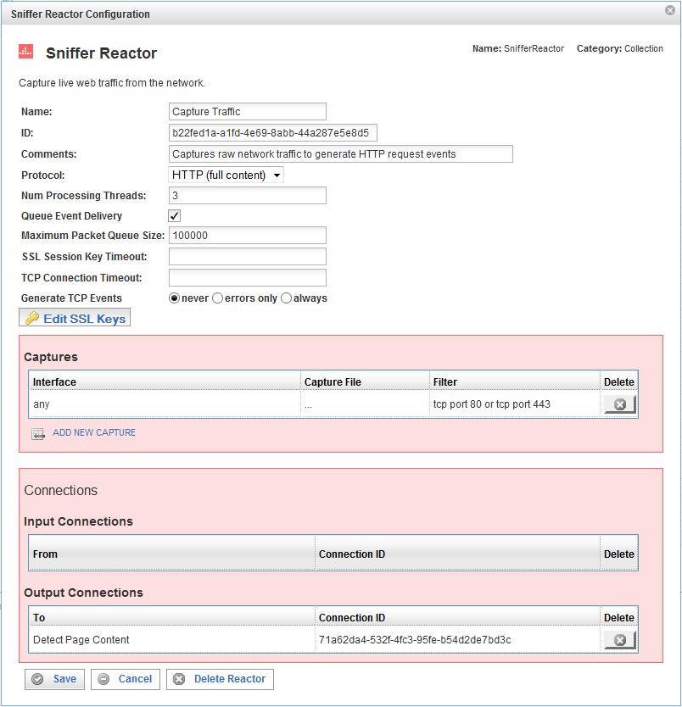
In addition to the fields you saw when adding the reactor initially you will see an Edit SSL Keys button, and sections for Captures, and Connections.

Edit SSL Keys
Clicking on the Edit SSL Keys button opens the Edit SSL Keys configuration screen, which allows you to save SSL key information, which then enables Pion to use those keys, Once Pion has the proper key, it can then decrypt the SSL encrypted data in real-time. The SSL keys are stored in a KeyStore vault (an encrypted database), and if a password is used to protect the keys, it must be entered at startup.
SSL keys are required only for sites that use SSL encrypted communications. Typically, SSL encrypted communications are used only by sites such as those common in retail, defense, and financial applications.
Note: Pion uses SSL keys that are in the PEM (Privacy Enhanced Mail) format, which is base 64 and the same format as the BER format, except that the PEM format uses header and footer lines to indicate the beginning and the end of the key.
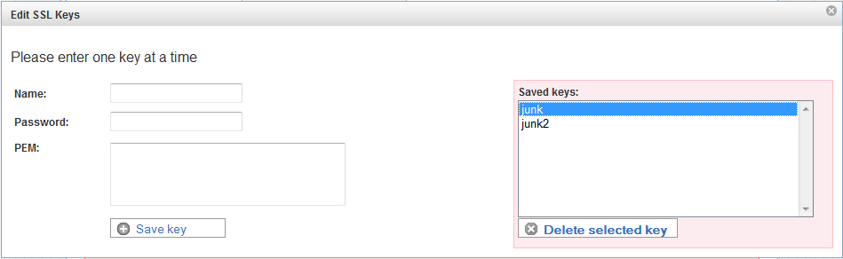
To specify an SSL key, specify the following:
Field | Description
Name | The name of the SSL key.  QUESTION; What are the naming rules for keys? (Number of characters, special characters, etc.)
Password | This is the password (or pass phrase) for this SSL key.
PEM | This field is where you enter the encryption key data. To avoid mistakes, it is best to cut and paste the key data using a text editor.  QUESTION: Does the user have to enter the header and footer lines? If so, what exactly is the format?
Saved keys | This field lists previously saved SSL keys.  To save a key, fill in the name, password, and PEM fields (above), and click Save key.  To delete a key, select the key you want to delete, and click Delete selected key.

The Captures Section
This section specifies where your Sniffer Reactor will be getting data from. Each line represents a data source and a filter to be applied to that data source. There are two types of supported data sources; Interfaces and Capture Files.

Field | Description
Interface | Specifies the network interface to use when listening to traffic.  Select the cell in the Interface column to display a drop down list of the network interface cards on the Pion server. You can then choose the interface that is receiving the live traffic you want to monitor.  The notation used to identify an interface is dependent on the operating system (Linux, Mac, or Windows). Interfaces may include:  - On Linux, Ethernet interfaces are usually eth0/eth1/ethX and lo for loopback.  - On Mac, Ethernet interfaces are usually en0/en1/enX and lo0 for loopback.  - wlan0 (or similar, for wireless interfaces)  - Other names that do not fit one of the patterns described above. In Pion, interface names are arbitrary, and you can name them anything you like.  Note: If you are running VMware, there will be many other virtual interfaces, between the VM and the host, and running Pion in a VMware instance is not recommended, because there may be too many lost packets.  To see the devices, their IP addresses, and other interface information:  - On Windows operating systems, run the command "ipconfig /all".  - On Unix-based operating systems, log in as root, and run the command "ifconfig -a".
Capture File | Specifies a file that contains saved traffic. The content of this file is used instead of live traffic from an interface. A capture file is read once, then the reactor stops. To reread the capture file, restart the Sniffer reactor.  If the traffic has already been captured in a file, simply type the full file path in the Capture File column (note: the file must be a standard .cap or .pcap file).
Filter | Defines the filters to apply to the traffic received on the interface specified above.  After selecting your traffic sources, you can filter out traffic which Pion doesn’t need to see. Although traffic can be filtered out later using other reactors, doing it at this stage (as a function of the Sniffer Reactor) is the most efficient way to remove unwanted information. The filter reactor uses the same syntax as the tcpdump utility. For example:  - To filter out HTTP traffic, you would use “tcp port 80” as your filter string to remove all non HTTP traffic.  - To filter out HTTPS traffic, you would use “tcp port 443” as your filter string to remove all non HTTPS traffic.  Complete tcpdump syntax can be found at http://www.tcpdump.org/tcpdump_man.html.
Click on the ADD NEW CAPTURE icon to add a new line to the table.
To delete a capture, click on the “x” at the end of the row describing that capture.

The Connections Section
The Connections section describes input and output connections for this Sniffer Reactor. See Error: Reference source not foundX on page XError: Reference source not foundX for more information.

