Database Output Reactor
The Database Output Reactor enables Pion to store information in almost any database. The Database Output Reactor handles the format translation, table organization and performance tuning aspects required to ensure Pion events are written with the best performance and quality possible. To ensure high performance, native database communication is available for MySQL, Oracle, Microsoft, Sybase, IBM, Informix, Centura, Interbase, PostgreSQL and SQL Lite databases. The Database Output Reactor can also send data to any ODBC compliant database for storage. Because Pion enables direct database output, it can be easily integrated into any business intelligence implementation or data warehouse without requiring custom code or a separate extract, transfer and load (ETL) tool.
When you add a Database Output Reactor you will be prompted for the following fields:
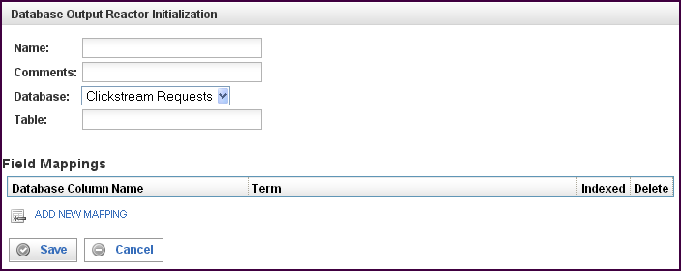

Field | Description
Name | Specify the name of this reactor. This can be any name you find descriptive, we recommend something which describes the data this reactor is storing.  The name may be any combination of letters and numbers.
Comments | Enter some descriptive comments about this reactor. Any comment you feel will help you in the future, we recommend choosing something that describes the data being stored.
Database | Select the database into which you want to write events.
Table | Specify the table in the database named above. The events will be written to this table.
This creates the Database Output Reactor in the workspace. Double-clicking on the reactor brings you to the configuration screen:
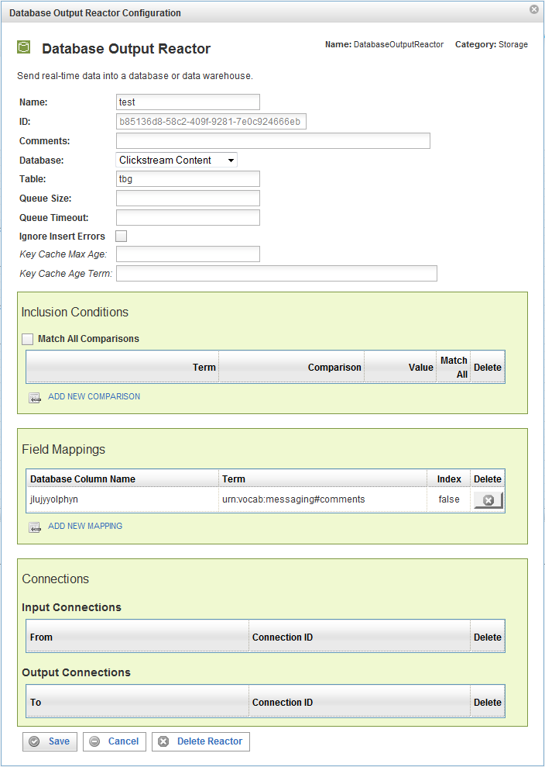
In addition to the fields you saw when adding the reactor initially (described above), you will see one additional field and the Inclusion Conditions, Field Mappings, and Connections sections.:
Field | Description
ID | The reactor ID, a unique ID generated by the Pion server. This ID identifies a particular reactor.
Queue Size | The number of events allowed in the queue before triggering a bulk insert to the table specified above. The default queue size is 1000 events.
Queue Timeout | The number of seconds to wait (the interval) before triggering a bulk insert to the table specified above. The default queue timeout is 10s (10 seconds).
Ignore Insert Errors (check box) | Inserts may fail if records already exist within the table which have the same unique index values. Fill this check box to ignore these errors.
Key Cache Max Age | Used only if a unique index is defined and this value is non-zero. Pion will maintain a memory-based cache of the most recent unique index values inserted into the database. Items in this cache are removed after the specified number of seconds has elapsed since the previous insert attempt.
Key Cache Age Term | If the key cache is enabled, this must be assigned to the event term corresponding to a timestamp for the epoch (for example urn:vocab:clickstream#epoch-time).

The Inclusion Conditions Section
The Inclusion Conditions section is used to specify the data (the terms) that are saved in the database specified. If the conditions are TRUE, the event will be inserted into the database table. If FALSE, the event will be discarded.
Field | Description
Match All Comparisons (check box) | When filled, indicates that ALL of the comparisons defined below must be matched.
Term | The vocabulary term whose value will be stored in the database column for each event inserted.
Comparison | Specifies the type of comparison to test, such as true/false or is-defined/is-not-defined.  Depending on the term that is specified in a row, an appropriate list of comparisons will appear in the comparison cell of that row. For example, if it's a date type, you'll get choices like "earlier than", whereas if it's a string type, you'll get choices like "starts with".  Like most comparisons, these two examples require a value to compare against, but a few comparisons, like “is defined,” do not require a value to compare against.  For more information on comparisons, see “Error: Reference source not found“X on page Error: Reference source not foundX.
Value
Match All (check box) | When filled, indicates that AT LEAST this comparison must be matched.
To delete a connection, click on the “x” at the end of the row describing that connection.

The Field Mappings Section
The Field Mappings section maps event vocabulary terms to database table columns..
Field | Description
Database Column Name | Specifies the name of the database column corresponding to the event term.
Term | The vocabulary term whose value will be stored in the database column for each event inserted.
Index | Controls database indexing settings. You can choose from any of the following:  True, which means an index is added to the database table for this field, making searches more efficient while making inserts less efficient. We strongly recommend this setting for all fields that you want to search using the Replay interface.  False, which means no index is used for this database field. We recommend this setting for all fields that you will not normally search using the Replay interface.  Unique, which means the database field is a unique index for the table.
To delete a field mapping, click on the “x” at the end of the row describing that mapping.

The Connections Section
The Connections section describes input and output connections for this Database Output Reactor. See “Error: Reference source not found“X on page XError: Reference source not foundX for more information.

