Content Hash Reactor
The Content Hash Reactor creates and then stores an md5 hash as an identifier (a content_id) for a specified content term in an HTTP response. This identifier is stored in a database, which is then used by the Replay feature when reviewing the user experience.
When you add a Content Hash Reactor you will be prompted for the following fields:
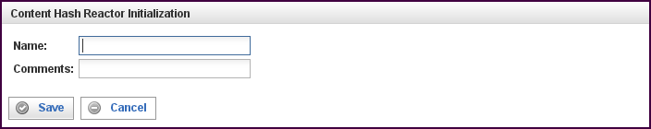

Field | Description
Name | Specify the name of this reactor. This can be any name you find descriptive, we recommend something which describes the data this reactor is processing.  The name may be any combination of letters and numbers.
Comments | Enter some descriptive comments about this reactor. Any comment you feel will help you in the future, we recommend choosing something that describes the data being processed.
This creates the Content Hash Reactor in the workspace. Double-clicking on the reactor brings you to the configuration screen:
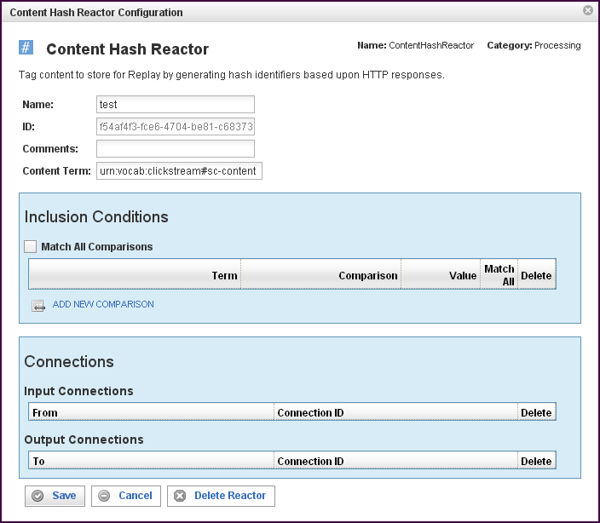
In addition to the fields you saw when adding the reactor initially (described above), you will see some additional fields and sections for Inclusion Conditions and Connections. The additional fields are:
Field | Description
ID | The reactor ID, a unique ID generated by the Pion server. This ID identifies a particular reactor.
Content Term | The source term used to generate a content hash identifier.

The Inclusion Conditions Section
The Inclusion Conditions section describes conditions that must be met in order for a prospective Content Term to be considered a new Content Term (which causes a new identifier to be generated). This section works in the same manner as a comparison (a Filter Rule Chain), see “Error: Reference source not found“X on page XError: Reference source not foundX for more information.
If an event both contains a value for the Content Term and matches the Inclusion Conditions, a hash identifier will be generated and added to the event.
If the event does not contain a value for the Content Term or it does not match the Inclusion Conditions, the event is delivered to the reactor's output connections unmodified.
Field | Description
Match All Comparisons (check box) | When filled, indicates that ALL of the comparisons defined below must be matched.
Term | Defines the value of the term to be used for the comparison logic. Specifies the data item to find. You can select a term (an identified data item) from an existing vocabulary, or you can add a new vocabulary and define the term(s) to be found.
Comparison | Specifies the type of comparison to test, such as true/false or is-defined/is-not-defined.  Depending on the term that is specified in a row, an appropriate list of comparisons will appear in the comparison cell of that row. For example, if it's a date type, you'll get choices like "earlier than", whereas if it's a string type, you'll get choices like "starts with".  Like most comparisons, these two examples require a value to compare against, but a few comparisons, like “is defined,” do not require a value to compare against.  For more information on comparisons, see “Error: Reference source not foundX”“ on page Error: Reference source not foundX.
Value
Match All (check box) | When filled, indicates that AT LEAST this comparison must be matched.
To add a row for a new comparison in the Inclusion Conditions section, click on the ADD NEW COMPARISON link.
To delete a comparison, click on the “x” at the end of the row describing that comparison.

The Connections Section
The Connections section describes input and output connections for this Content Hash Reactor. See “Error: Reference source not found“X on page XError: Reference source not foundX for more information.

